**Thanks for your purchase.**

CubeElement is what we spawn to build the floor.

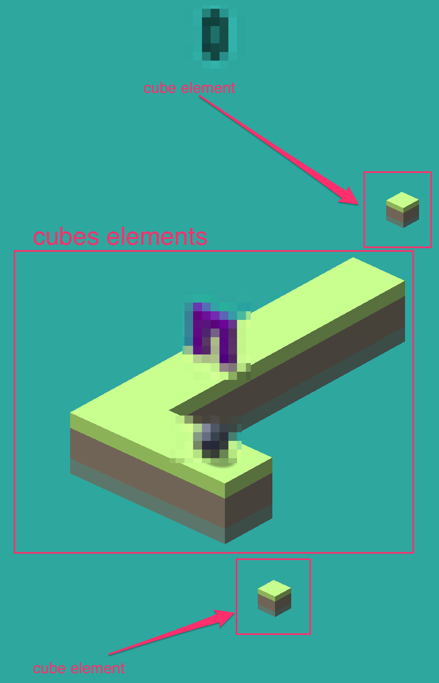

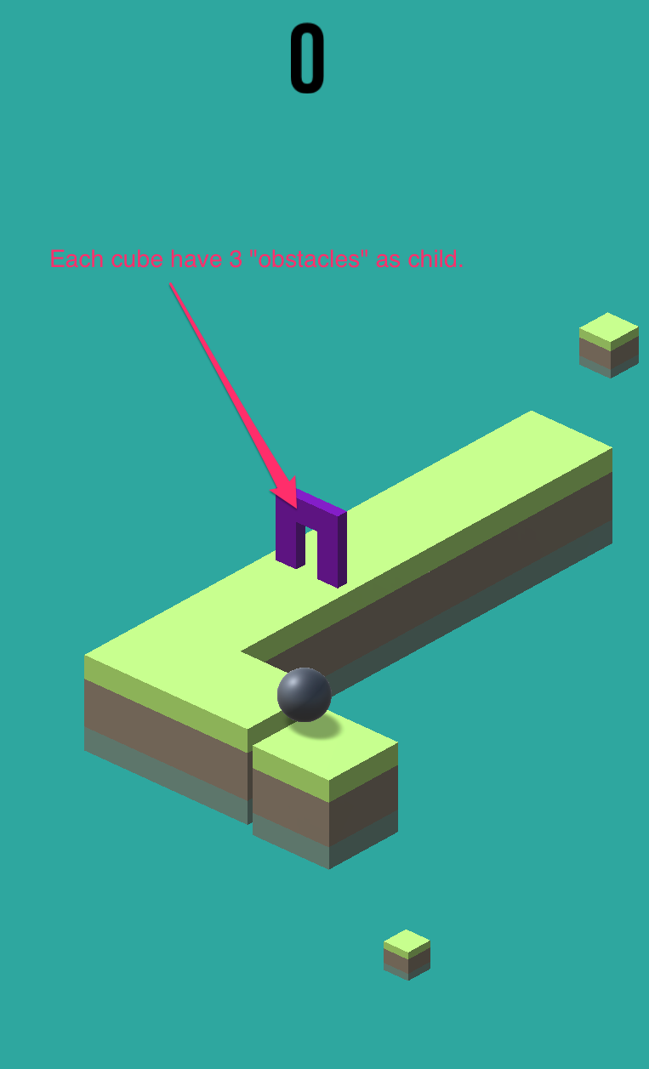

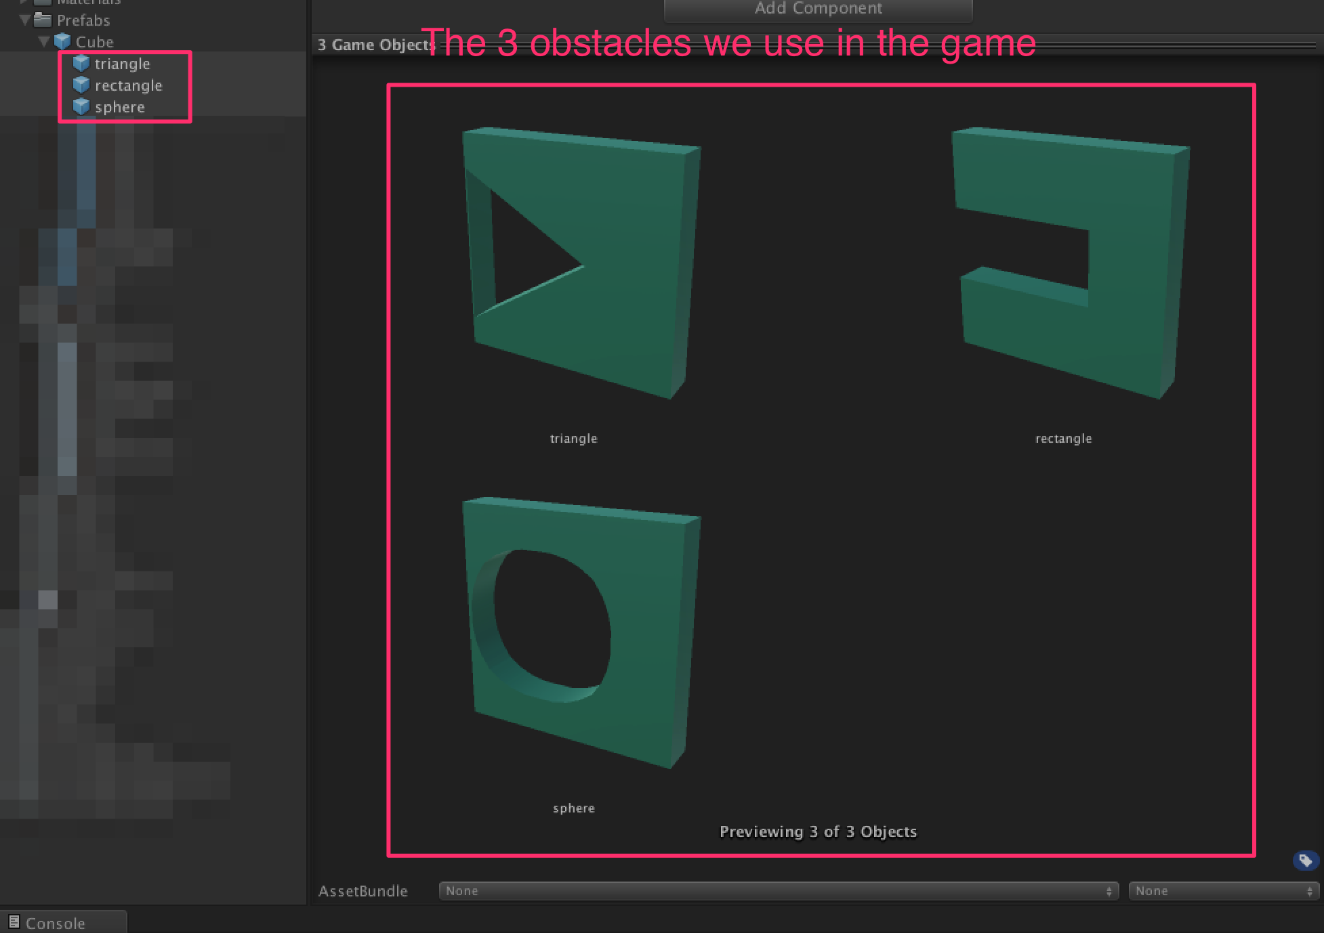

You can add new shape just by adding the object to the prefab as child. Remeber to create a new variable in the script to have somethign like this :

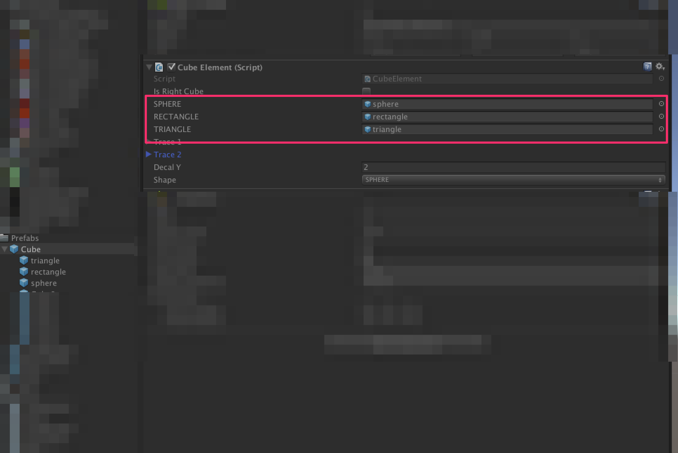

And add the new shape to the player as a child.

The player :

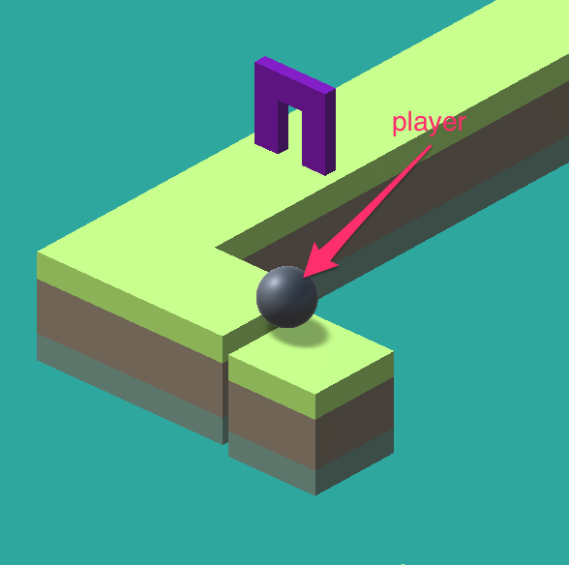

The player have 3 shapes as child. You have to correspond shape from the obstacle with the player to earn a point. If the shape is not the good one you lose.

Here the shapes :

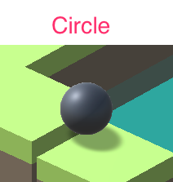 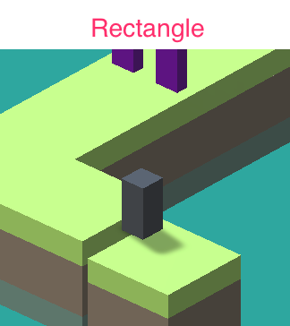 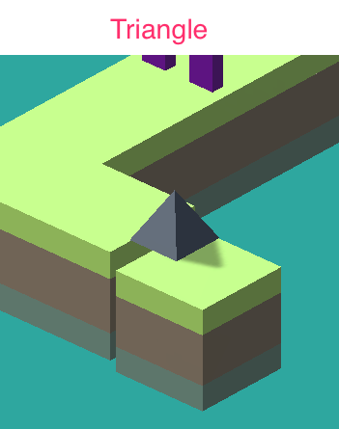

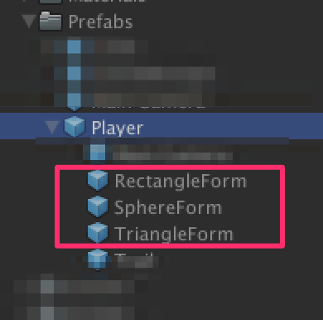

**Customize the game play / Reskin :**

Select the GameManager in the scene view :

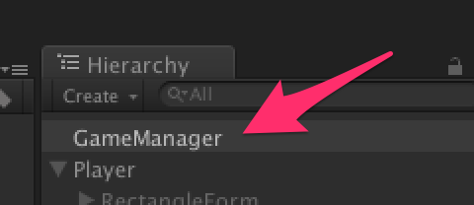

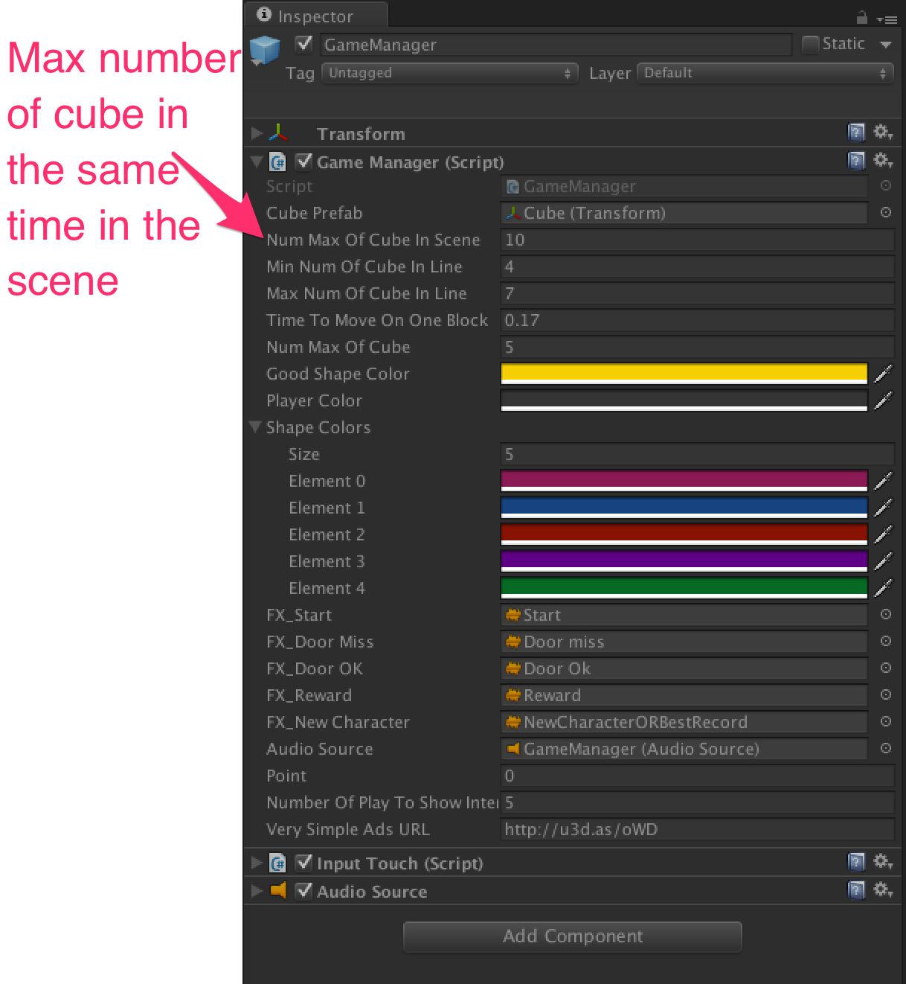

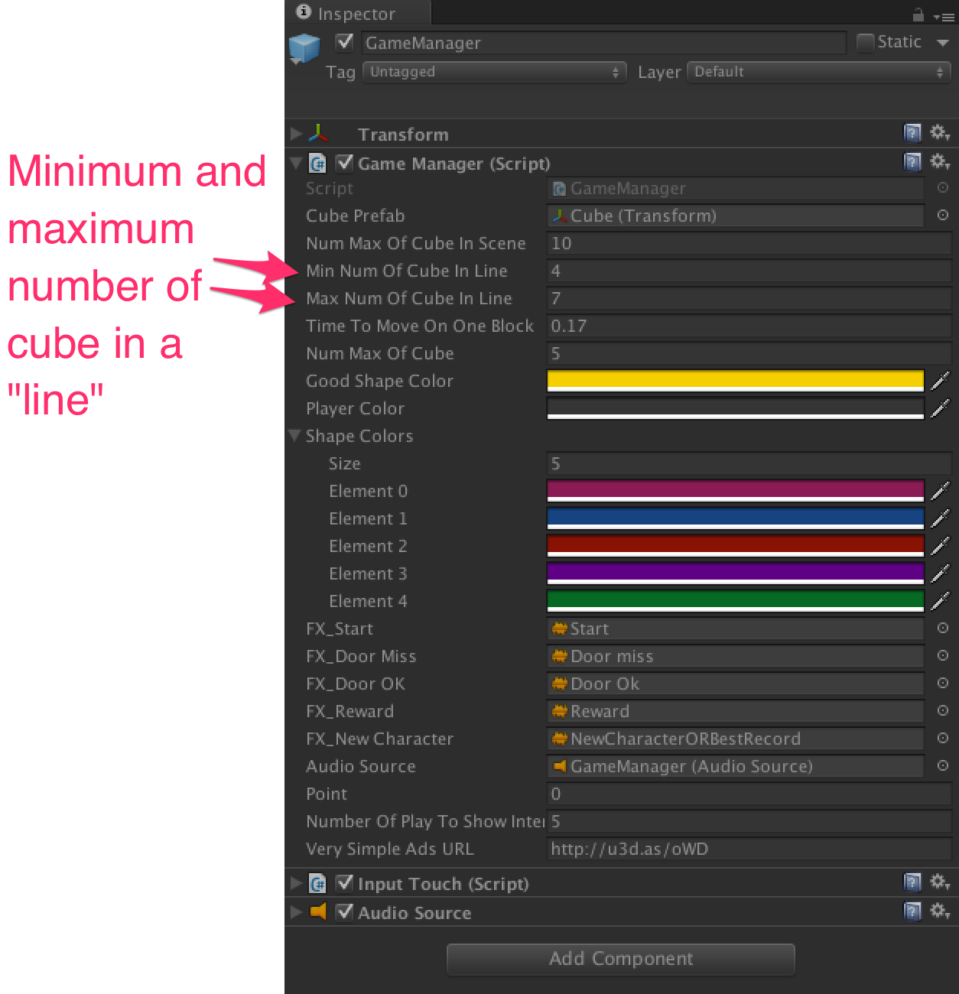

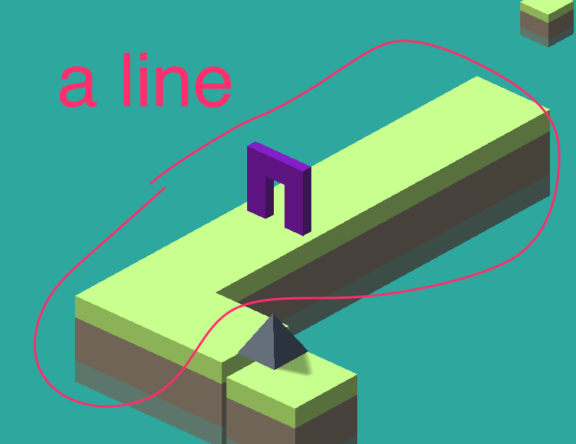

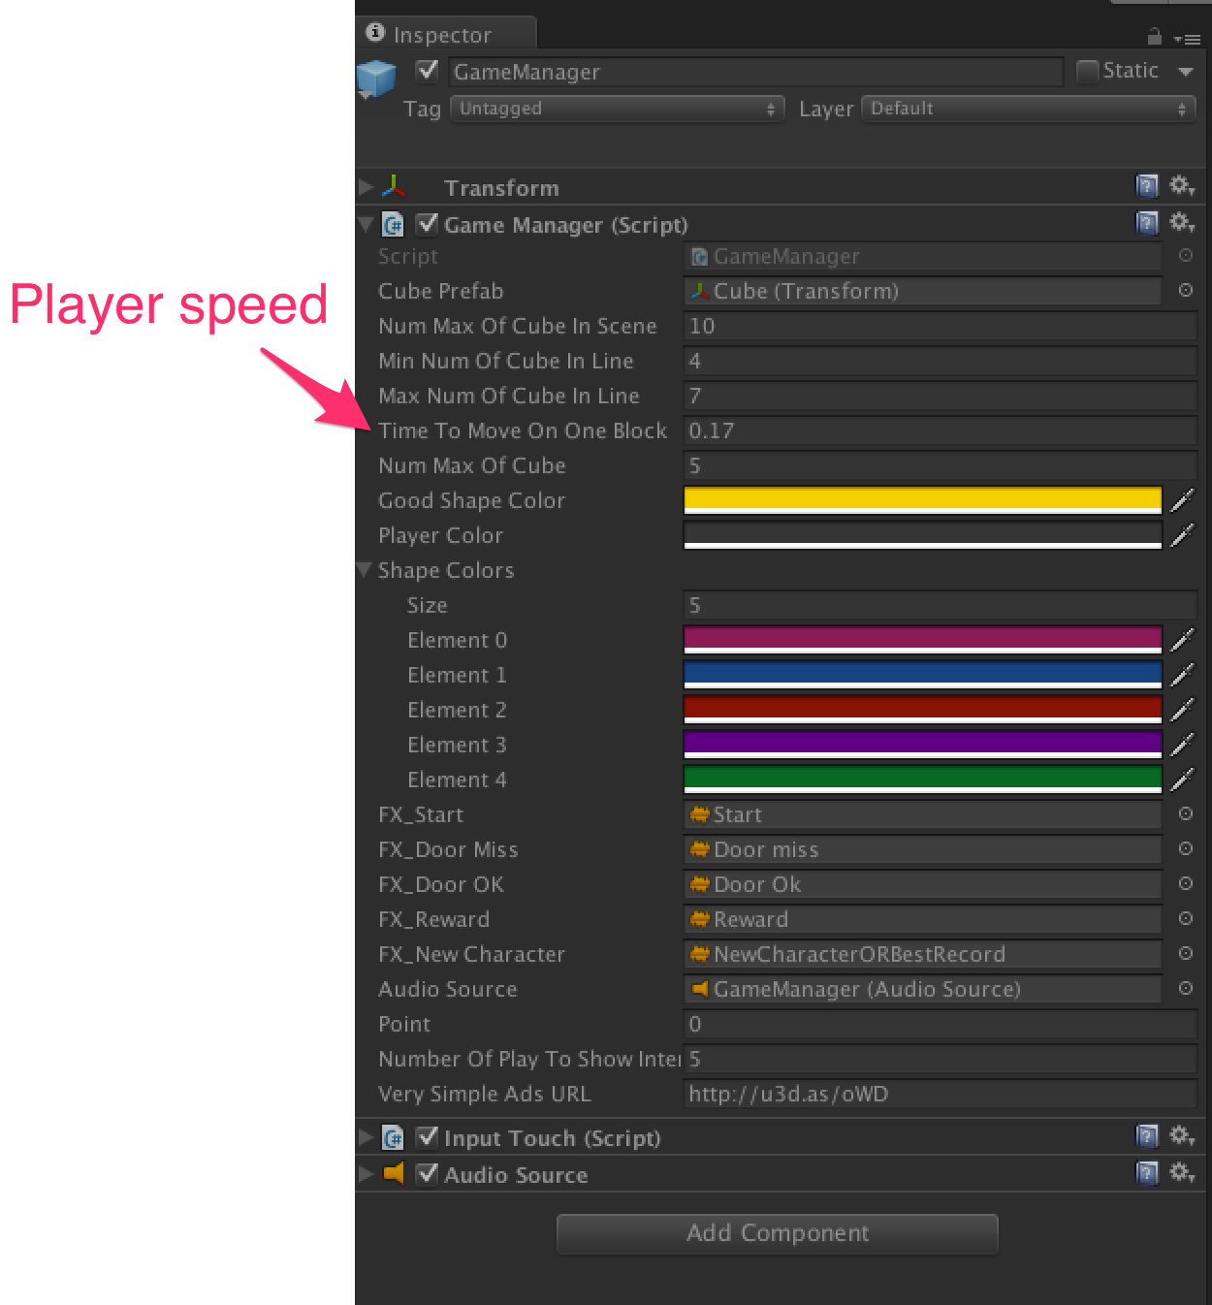

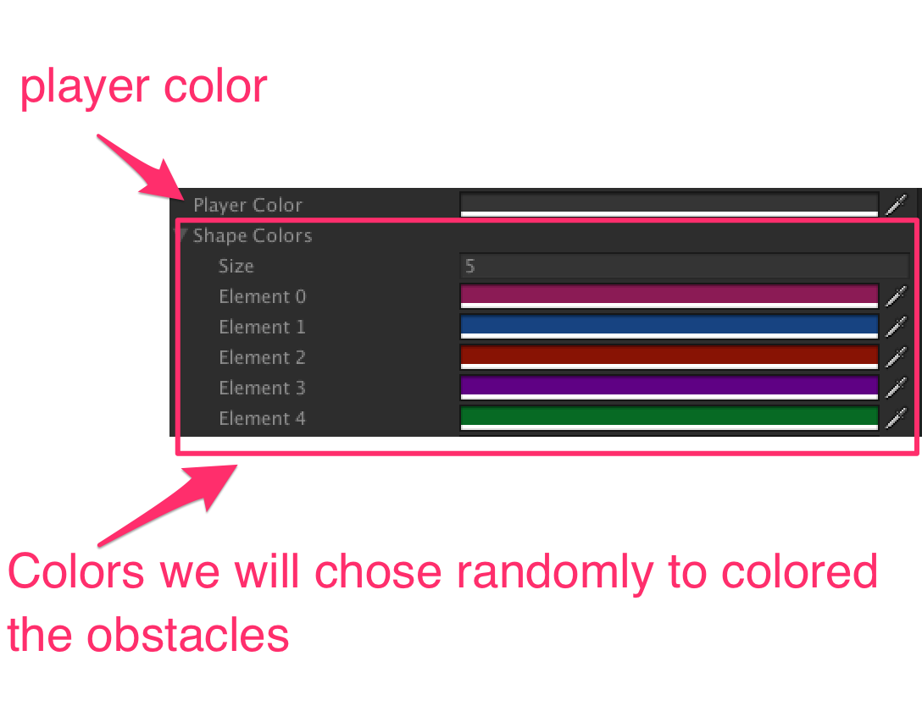

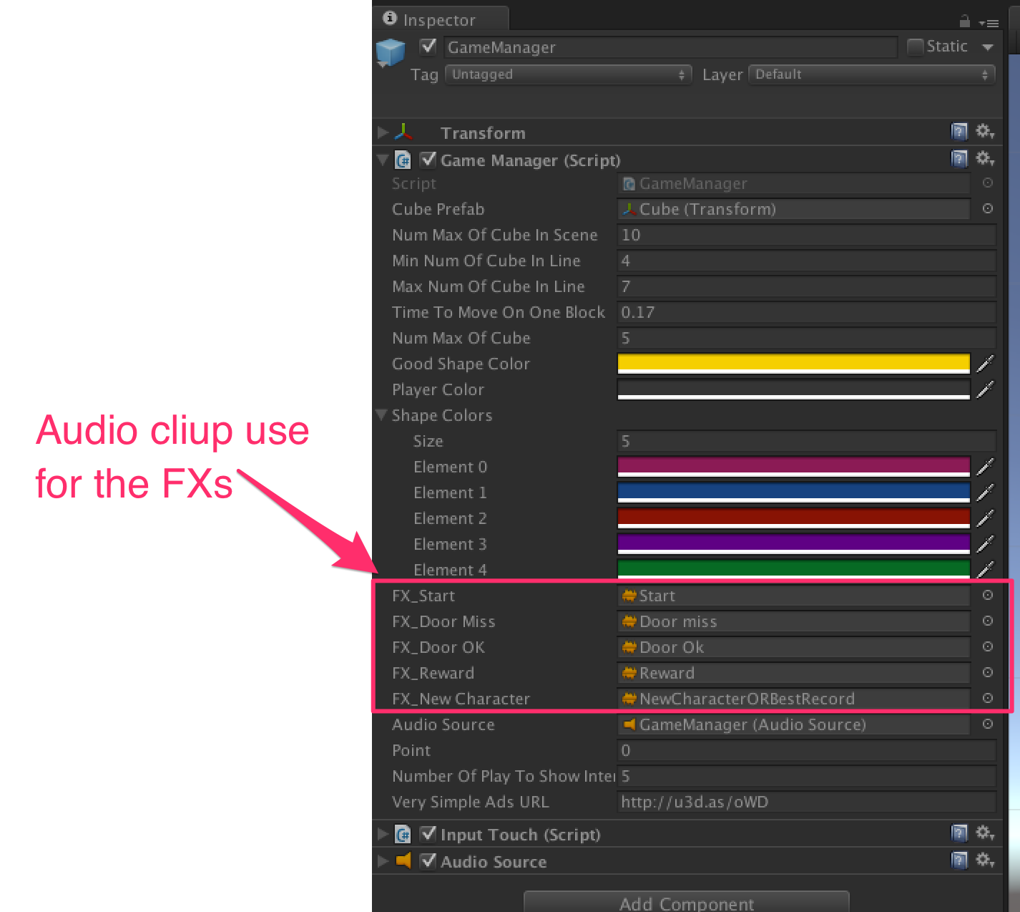

**Very Simple Ads:**

Everything is done for you : « Very Simple Ad » is already implemented.

Get it here : <http://u3d.as/oWD>

**Very Simple Leaderboard:**

Everything is done for you : « Very Simple Leaderboard » is already implemented.

Get it here : <http://u3d.as/qxf>

**Very Simple Share:**

Everything is done for you : « Very Simple Share » is already implemented.

Get it here : <http://u3d.as/u3N>

**Thanks !**

Our other assets : <http://u3d.as/9cs>

Contact : [contact@app-advisory.com](mailto:contact@app-advisory.com)

Linkedin :  <https://www.linkedin.com/in/ganbarouch>