R Notebook
BIS 581 #load libraries
VDI <- read.csv("vdi_serverlogs.csv", header=TRUE, stringsAsFactors = FALSE)
apps <- read.csv("vdi_statsapps.csv", header=TRUE, stringsAsFactors = FALSE)
join the two together
apps$VDI_ID <- as.integer(apps$VDI_ID)
## Warning: NAs introduced by coercion
usage <- VDI %>% inner_join(apps)
## Joining with `by = join_by(VDI_ID)`
#clean up
Answer the questions handed out on Blackboard Create a presentation of their findings. The audience for the presentation is the CIO, assistant CIO and some of the tech managers along with a representative from purchasing. Your R notebook will be the appendix to show how you got the answers you did. NOTE: graduate students have extra for this, see Blackboard for details
# Check the raw date range before filtering
date_check <- usage %>%
mutate(temp_date = mdy_hm(logon_DTS)) %>%
filter(year(temp_date) == 2015) %>%
summarise(
Earliest_Logon = min(temp_date, na.rm = TRUE),
Latest_Logon = max(temp_date, na.rm = TRUE)
)
print(date_check)
## Earliest_Logon Latest_Logon
## 1 2015-01-07 13:42:00 2015-11-17 09:16:00
#Data Quality Finding: The dataset for 2015 ends in late August. This implies that "Annual" totals will actually reflect an 8-month period. This is a risk to the analysis as Q4 data is missing.
crash_check <- usage %>%
filter(stop == "1900-01-01 00:00:00") %>%
tally()
total_rows <- nrow(usage)
crash_pct <- round((crash_check$n / total_rows) * 100, 2)
print(paste("Total rows with invalid stop times:", crash_check$n))
## [1] "Total rows with invalid stop times: 541645"
print(paste("Percentage of dataset affected:", crash_pct, "%"))
## [1] "Percentage of dataset affected: 17.02 %"
#Approximately 17% of the application logs indicate crashes (invalid stop times). To prevent skewing the "Average Application Duration" metric, we will convert these specific errors to NA and exclude them from duration calculations. However, we will retain these rows for "Total User" counts, as the user was still present on the system.
# Data Wrangling & Cleaning
# Based on the assessment above, we apply the following cleaning rules:
#
# Date Conversion: Convert character strings to Date/Time objects.
#
# Scope Filtering: Limit to Year 2015 and Machine Names starting with "CMU".
#
# Error Handling: Convert '1900-01-01' stop times to NA.
#
# Feature Engineering: Calculate app_duration.
# STEP 1: DATA WRANGLING (Clean & Filter)
# We take the raw 'usage' data and apply the CIO's rules:
# 1. Fix the dates (mdy_hm based on your screenshots)
# 2. Filter for Year 2015
# 3. Filter for VDI machines (Start with "CMU")
usage_2015_clean <- usage %>%
mutate(
# 1. Fix Date Formats
logon_DTS = mdy_hm(logon_DTS),
logout_DTS = mdy_hm(logout_DTS),
start = ymd_hms(start),
stop = ymd_hms(stop)
) %>%
# 2. Filter for Year 2015 & VDI Machines ("CMU")
filter(year(logon_DTS) == 2015) %>%
filter(str_detect(comp_name, "^CMU")) %>%
mutate(
# 3. Fix Data Errors (Apps that crashed)
stop = na_if(stop, ymd_hms("1900-01-01 00:00:00")),
# 4. Create Duration Column
app_duration = as.numeric(difftime(stop, start, units = "mins"))
)
## Warning: There were 2 warnings in `mutate()`.
## The first warning was:
## ℹ In argument: `start = ymd_hms(start)`.
## Caused by warning:
## ! 10 failed to parse.
## ℹ Run `dplyr::last_dplyr_warnings()` to see the 1 remaining warning.
# Verify cleaning
summary(usage_2015_clean$app_duration)
## Min. 1st Qu. Median Mean 3rd Qu. Max. NA's
## 0.00 0.00 2.00 25.98 24.00 1179.00 36319
# General CIO Questions
# --- PART A: GENERAL QUESTIONS (For Everyone) ---
# 1. Calculate Daily Traffic
daily_stats <- usage_2015_clean %>%
mutate(day = as_date(logon_DTS)) %>%
group_by(day) %>%
summarise(users_today = n_distinct(userid))
# 2. Print The Answers
print(" GENERAL CIO REPORT ")
## [1] " GENERAL CIO REPORT "
print(paste("1. Total Unique Users:", n_distinct(usage_2015_clean$userid)))
## [1] "1. Total Unique Users: 3013"
print(paste("2. Average Users Per Day:", round(mean(daily_stats$users_today), 0)))
## [1] "2. Average Users Per Day: 139"
print(paste("3. Highest Users in a Single Day:", max(daily_stats$users_today)))
## [1] "3. Highest Users in a Single Day: 577"
# --- PART B: GROUP I-L SPECIFIC QUESTIONS ---
# Question 1: Top 3 users by logins using Windows Remote OS
top_windows_users <- usage_2015_clean %>%
# Filter for any OS containing "Windows" (case insensitive)
filter(str_detect(remote_od, regex("Windows", ignore_case = TRUE))) %>%
group_by(userid) %>%
summarise(login_count = n()) %>% # Count how many times they appear
arrange(desc(login_count)) %>% # Sort Highest to Lowest
head(3) # Keep Top 3
print("TOP 3 USERS (WINDOWS OS) ")
## [1] "TOP 3 USERS (WINDOWS OS) "
print(top_windows_users)
## # A tibble: 3 × 2
## userid login_count
## <chr> <int>
## 1 userid5179 2695
## 2 userid25643 2072
## 3 userid25647 1677
# Question 2: Top 3 applications by length of time run
top_apps_time <- usage_2015_clean %>%
group_by(app_name) %>%
summarise(
# Sum minutes, ignoring the NAs (crashes)
total_minutes = sum(app_duration, na.rm = TRUE)
) %>%
arrange(desc(total_minutes)) %>% # Sort Highest to Lowest
head(3) # Keep Top 3
print("TOP 3 APPS (BY DURATION)")
## [1] "TOP 3 APPS (BY DURATION)"
print(top_apps_time)
## # A tibble: 3 × 2
## app_name total_minutes
## <chr> <dbl>
## 1 WINWORD 872215
## 2 firefox 839361
## 3 devenv 623168
# --- PART C: VISUALIZATION ---
# (Required for the report)
ggplot(top_apps_time, aes(x = reorder(app_name, -total_minutes), y = total_minutes, fill = app_name)) +
geom_col() +
labs(title = "Most Used Applications (2015)",
subtitle = "Ranked by Total Runtime (Minutes)",
x = "Application Name",
y = "Total Minutes") +
theme_minimal() +
theme(legend.position = "none")
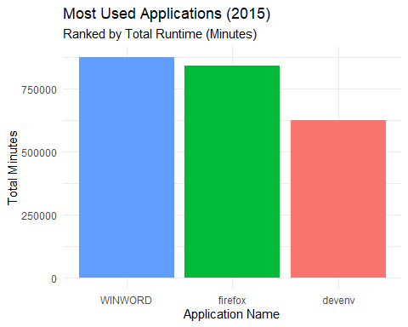
# RESOURCE ANALYSIS
# We want to know: Do the "Top Apps" also use the most CPU?
cpu_analysis <- usage_2015_clean %>%
filter(!is.na(avg_cpu)) %>% # Remove the bad CPU rows
group_by(app_name) %>%
summarise(
avg_cpu_usage = mean(avg_cpu),
total_minutes = sum(app_duration, na.rm = TRUE)
) %>%
arrange(desc(avg_cpu_usage)) %>% # Sort by Heaviest CPU load
head(5)
print("--- HEAVIEST CPU APPS ---")
## [1] "--- HEAVIEST CPU APPS ---"
print(cpu_analysis)
## # A tibble: 5 × 3
## app_name avg_cpu_usage total_minutes
## <chr> <dbl> <dbl>
## 1 Ch3 Hands On pg 142 81 20
## 2 Ch10PublishersContacts.vshost 77.9 5
## 3 AirMedia 57 99
## 4 instsf450 55 0
## 5 ch5.4 homework.vshost 54.8 23
# Quick Chart for the CIO
ggplot(cpu_analysis, aes(x = reorder(app_name, avg_cpu_usage), y = avg_cpu_usage)) +
geom_col(fill = "darkred") +
coord_flip() + # <--- THIS FLIPS THE CHART SIDEWAYS
labs(title = "Top 5 CPU-Intensive Applications",
subtitle = "Apps utilizing >50% CPU on average",
x = "Application Name",
y = "Average CPU Usage (%)") +
theme_minimal()
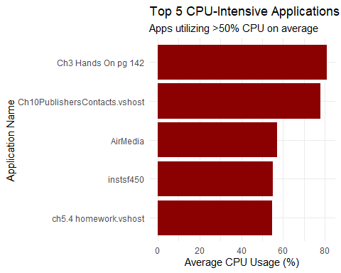
#The High CPU: Student code is often unoptimized. If a student writes an infinite loop or a heavy calculation for "Chapter 3 Hands On," it will spike the CPU to 81% or 100%, exactly as your data shows.

