**[SYNTHESIS] CHAPTER 10. RECURRENT NEURAL NETWORK**

Rudresh Mishra, Ricardo Rodriguez

IMT Atlantique

1. **Basics Concepts of Recurrent Nets**

Recurrent neural networks or RNNs are a family of neural networks for processing sequential data x(1), . . . , x(τ). They can scale to much longer sequences than would be practical for networks without sequence-based specialization. Most recurrent networks can also process sequences of variable.

A traditional fully connected feedforward network would have separate parameters for each input feature. For example, it would be necessary to learn all of the rules of the language separately at each position in the sentence.

A recurrent neural network shares the same weights across several time steps. Each member of the output is a function of the previous members of the output and each member of the output is produced using the same update rule applied to the previous outputs.

1. **Basic RNN Structure**

We define the structure of a RNN:

The RNN model described below has only one state which has one input at each time stamp and outputs its last state at the end of the sequence. the exact model is shown below.

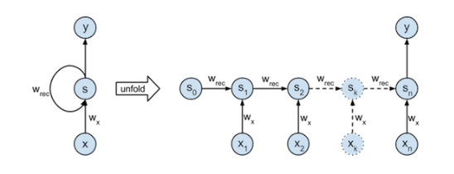 the left part of the model shows the sequence graphical illustration which is described by



where Sk is the state at time k, Xk an input at time k, Wrec and Wx are parameters like the weights parameters in network.

the right part has an unfolded version of it with respect to the time over a sequence of length n.

1. **Different RNN Architecture**

**Bidirectional RNN**:- The RNN which moves forward and backwards with respect to time sequentially.

**Encoder and Decoder:**- a sequence to sequence model aims to map a fixed-length input with a fixed-length output where the length of the input and output may differ.

**Deep Recurrent Network**:-In the case of the perceptron, we make the network deeper by adding more hidden to the hidden layer.

**Recursive Neural Network:-**  it generalizes the chain structure into the tree.

The different RNN with gates is the **Gated RNN** which comprise of **Long short term memo**ry (Lstm) and **Gated recurrent unit**(GRU). these neural networks have a tendency to forget the old information.

1. **Application**

few of the key application in the field of RNN are:-

* Conversational UI is the biggest field of use for speech recognition these days.
* Chatbots are smaller relatives of fully-fledged Conversational interfaces.
* Speech-to-text applications. Sound is another medium where content marketing can thrive.
* Ad Fraud, Spam Detection, Bot Detection - Anomaly Detection.
* Stock Price Forecasting - Predictive Analytics