TITLE: SMARTSTOCK SCREENER AND RECOMMENDATION SYSTEM
PRESENTED BY: RUDRO KANTO DE
INSTITUTE: MEGHNAD SAHA INSTITUTE OF TECHNOLOGY
YEAR: 4th
DURATION: 01-03-2025 TO 03-10-2025

INDEX

TOPIC | PAGE NUMBER
PROBLEM STATEMENT | 3
ABSTRACT AND PURPOSE | 4
SYSTEM DESIGN | 5
TECHNOLOGIES USED | 6
WORKFLOW | 7
IMPLEMENTATION DETAILS | 7
PRACTICAL IMPLEMENTATION | 8
LOGIC BEHIND CANDLESTICK PATTERNS | 19
RESULTS AND EVALUATION | 21
CONCLUSION AND FUTURE SCOPE | 21

PROBLEM STATEMENT:
Stock market analysis often requires juggling multiple tools: data sources, charting platforms, and manual screening. Beginners find this overwhelming, while advanced users struggle with repetitive workflows.
This project addresses the problem by:
- Providing a single integrated platform for candlestick analysis and recommendations using EOD data.
- Automating repetitive tasks like fetching daily OHLC data, filtering recommendations, and exporting results.
- Offering a clean, intuitive GUI that lowers the barrier to entry for technical analysis.
The goal is to make stock screening accessible, automated, and visually clear, while showcasing robust software engineering practices.

ABSTRACT AND PURPOSE:
This project is a comprehensive desktop application developed to assist retail investors, students, and aspiring analysts in examining stock market behaviour using End-of-Day (EOD) data. Unlike real-time trading platforms, the focus here is on daily OHLC (Open, High, Low, Close) values, which are widely used in technical analysis to identify patterns and trends. The application integrates multiple functionalities — candlestick pattern recognition, stock screening, and recommendation generation — into a single, unified interface. By leveraging Yahoo Finance as the data source, the system ensures reliability and accessibility of market information. Visualization is achieved through Matplotlib and mplfinance, enabling clear and professional candlestick charts. The user interface is built with Tkinter, providing an intuitive, interactive environment where users can navigate seamlessly between modules such as the homepage, screener, recommendations, and market overview. Together, these components create a tool that bridges the gap between raw financial data and actionable insights.
The primary purpose of the project is to simplify technical analysis for beginners while also offering advanced features for more experienced users. Many retail investors struggle with fragmented tools and complex workflows; this application addresses that challenge by consolidating essential analysis techniques into one platform. Features such as multi-timeframe candlestick charting (daily and weekly), automated detection of key patterns (Doji, Engulfing, Insider Candle, Gap Up/Down), and recommendation generation make the system both educational and practical. The modular design ensures scalability, allowing new patterns or data sources to be added without disrupting existing functionality. The outcome is a robust, placement-ready project that demonstrates technical depth in data handling, visualization, and GUI development, while also showcasing practical usability. For academic evaluation and campus placements, the project highlights not only programming skills but also the ability to design a system that is strategic, user-friendly, and impactful in real-world financial contexts.

SYSTEM DESIGN:
The system is designed using a modular architecture, ensuring clarity, scalability, and ease of maintenance. Each module performs a distinct function but integrates seamlessly with the others to provide a unified analytical platform.
- HOMEPAGE MODULE
- Serves as the entry point of the application.
- Displays charts based on daily OHLC data.
- Implements chart refresh and navigation logic, ensuring smooth transitions to other modules.
- SCREENER MODULE
- Enables stock filtering and exploration based on various candlestick patterns
- Helps users narrow down large stock datasets to focus on stocks that meet specific conditions.
- Acts as a bridge between raw data and recommendations, giving users control over what subset of stocks to analyse.
- RECOMMENDATION MODULE
- Implements candlestick pattern recognition algorithms (Doji, Engulfing, Insider Candle, Gap Up/Down).
- Generates actionable signals such as Buy, Sell or Watch based on End of Day data.
- Displays results in a Treeview table with colour coded tags for easier interpretation.
- Allows users to filter recommendations and export them to CSV format for further analysis.
- MARKET OVERVIEW MODULE
- Implements a treeview table with colour coded tags for gainers, losers and also returns the output for volume shockers.
- Helps us understand the top gainers and losers of stocks in a particular order and helps us analyse further.
- SETTINGS
- Offers customization options for user preferences

TECHNOLOGIES USED:
- Python:
- Python serves as the foundation of the project, providing simplicity, readability, and a vast ecosystem of libraries.
- Its versatility allows seamless integration of data handling, visualization, and GUI development.
- Python’s modular structure ensures that each component (pattern detection, charting, recommendations) can be developed and maintained independently.
- Tkinter
- Tkinter is used to design the desktop interface of the application.
- It provides interactive elements such as buttons, frames, menus, and tables (Treeview), enabling smooth navigation between modules.
- The GUI ensures that complex stock analysis is presented in a clear and accessible format, making the tool beginner-friendly while still powerful for advanced users.
- Tkinter’s flexibility allows integration with charts and data tables, creating a cohesive user experience.
- Matplotlib & mplfinance
- Matplotlib is employed for general plotting and embedding charts into the Tkinter interface.
- mplfinance, a specialized extension of Matplotlib, is used to generate candlestick charts and other financial visualizations.
- Pandas
- Pandas is the backbone for data manipulation and preprocessing.
- It handles tasks such as reading CSV files, cleaning datasets, filtering values, calculating weekly highs/lows, and exporting results.
- Pandas’ DataFrame structure makes it easy to manage large volumes of stock data efficiently.
- yfinance
- yfinance is used to fetch End-of-Day (EOD) OHLC (Open High Low Close) data directly from Yahoo Finance.
- It provides reliable access to historical and current daily stock prices, including open, high, low, close, and volume.
- This ensures that the system always works with authentic market data, eliminating the need for manual data entry.

WORKFLOW:
The workflow begins with user navigation through a sidebar menu, leading to the homepage where daily OHLC data is visualized in candlestick charts. From there, users can access the recommendation module, which applies candlestick pattern recognition algorithms to generate actionable Buy, Sell, or Watch signals. Each recommendation can be validated through detailed chart visualization, ensuring transparency in the detection process. Finally, users can filter results according to their preferences and export them to CSV for further analysis. This structured workflow ensures that the application is both intuitive and effective, guiding users from raw data to meaningful insights in a seamless manner.

IMPLEMENTATION DETAILS:
  - Chart Section: Implemented with FigureCanvasTkAgg inside a LabelFrame. Charts are based on daily OHLC data.
  - Recommendation Page: Built with Treeview for tabular display. Integrated candlestick plotting via mplfinance.
  - Data Handling: Used yfinance to fetch EOD (End of Day) OHLC data. Pandas handled filtering, cleaning, and exporting.
  - Navigation: Implemented modular nav_items with lambda functions and wrappers to manage page transitions.
  - Challenges Overcome:
  - Chart conflicts between homepage and recommendation page were solved by isolating chart loops and using Toplevel() windows.
  - Multi‑index OHLC data from Yahoo Finance was normalized to single‑index columns.
  - UI scaling issues were resolved with responsive layouts (pack, grid, and columnconfigure).

PRACTICAL IMPLEMENTATION:

- Homepage before Login: The login page consists a table of advancers and decliners and rotating charts of top 50 stocks. Unless the user has logged in the user cannot access other options in the system

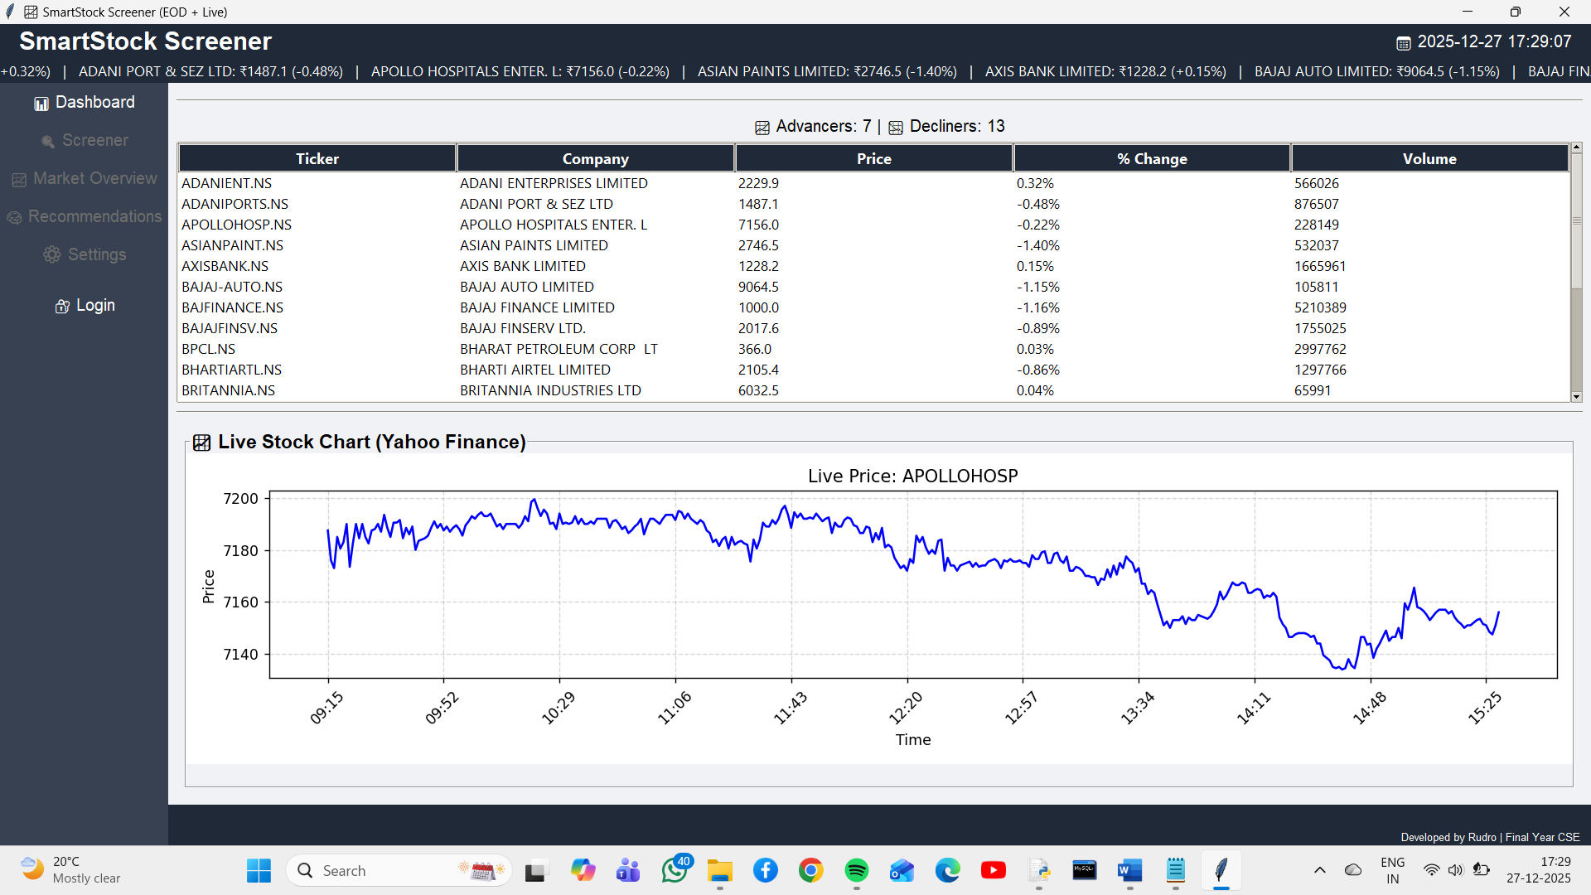

- The login page appears once the user clicks on the login button. The login consists of the username that is the e-mail id that the user used during registration. If the user has not registered, they can register. In case the users have forgotten their passwords they have the option to change their passwords.

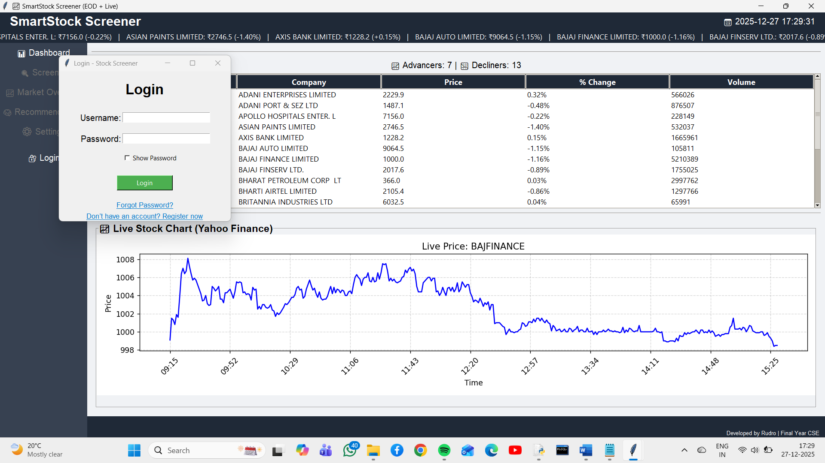

- Once the user is logged in, he can access all functionalities of the system. There are no remaining barriers and all the buttons become active once the user has logged in.

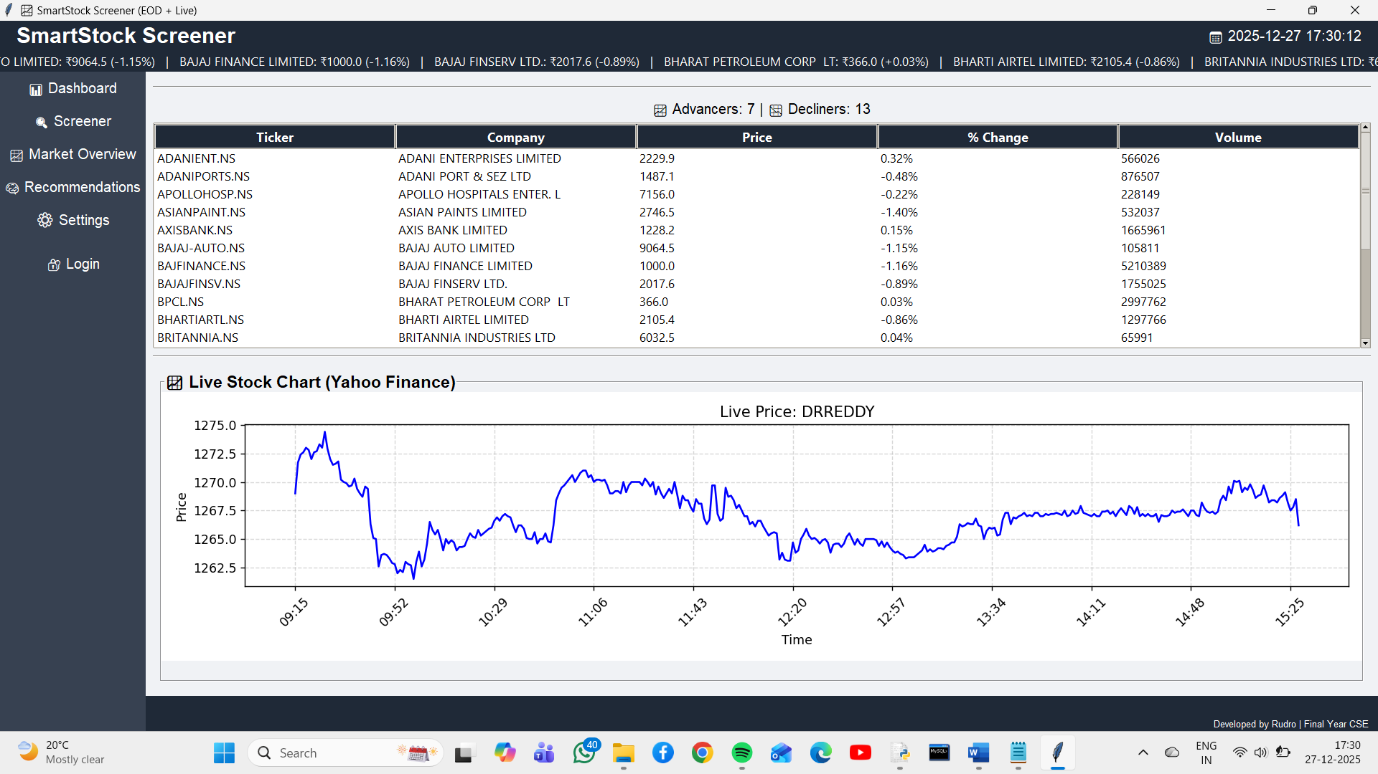

- In the screener page, users can filter out stocks based on various candlestick patterns (Doji, Engulfing, insider candle and Gap up/down) these options are available for both daily and weekly data offering users much better clarity and insight on market patterns and a platform for further analysis.

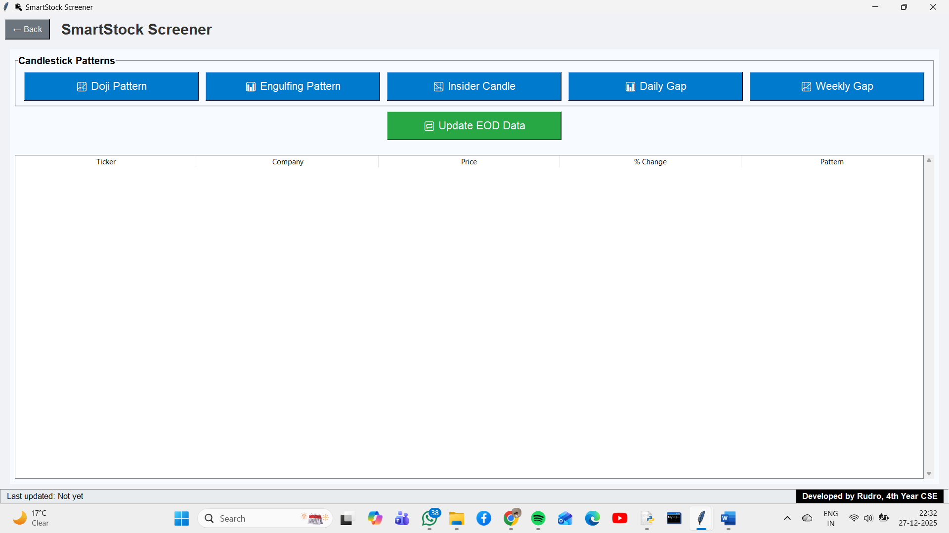

- After updating EOD Data, a popup appears informing the user that the data for stocks have been updated to the latest day, this is necessary to ensure that the results are based on the current data

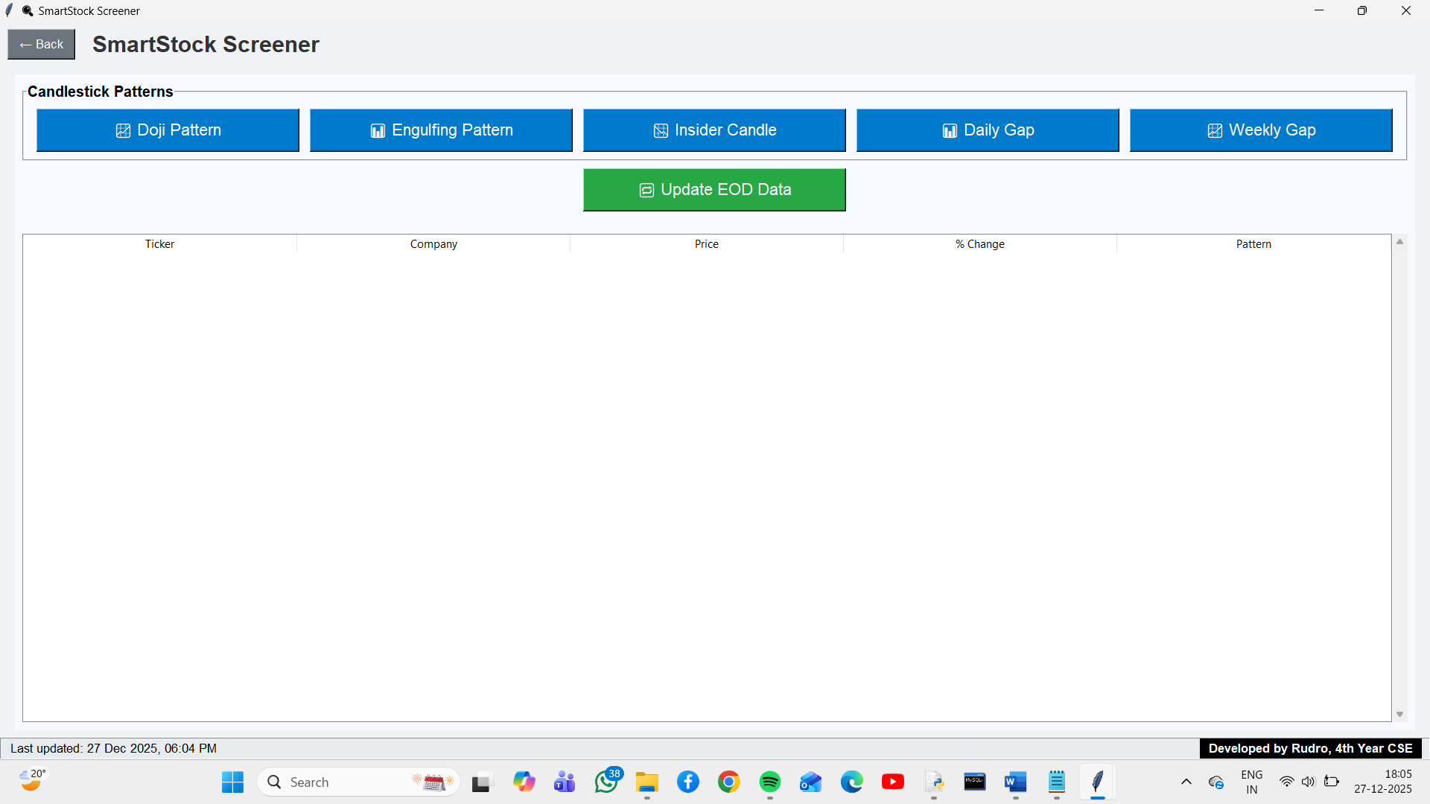
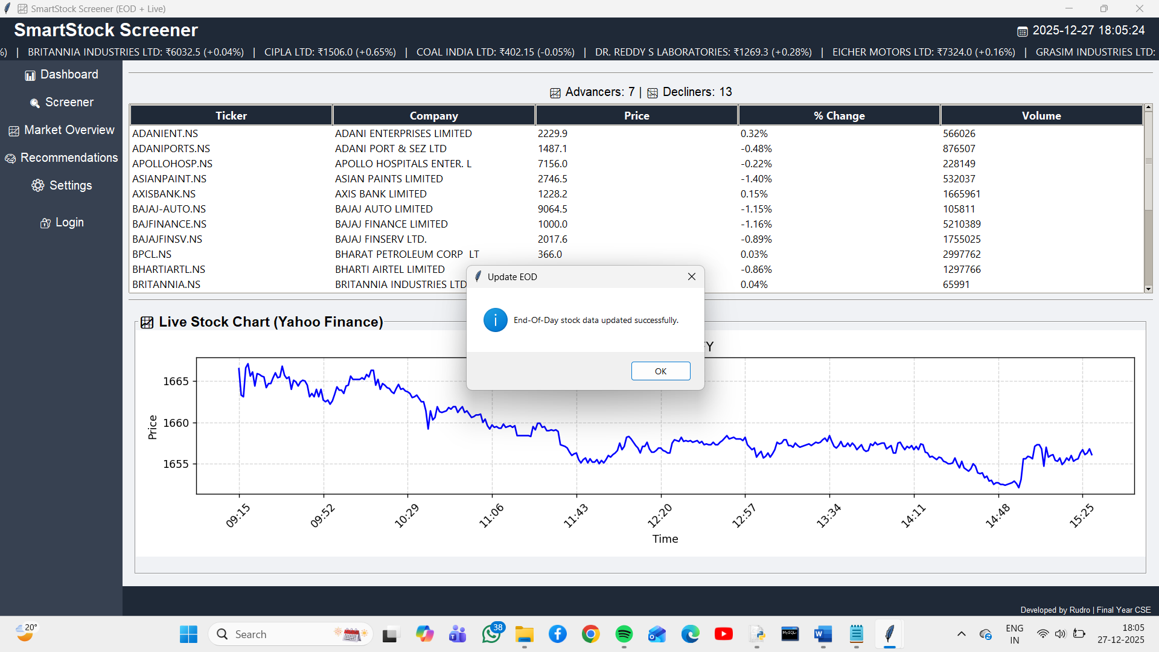

- Output of Daily Doji- The users are informed when the screening is completed the output is displayed in the form of a table that displays the closing price and also the percentage change in price along with the pattern. The output displayed below is for the doji pattern based on daily data but users have the option to apply the screening process to the stocks based on weekly data.

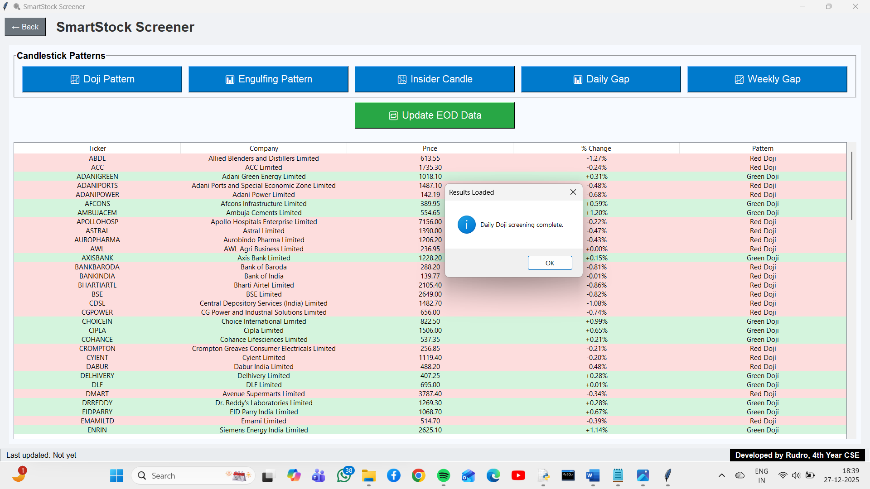

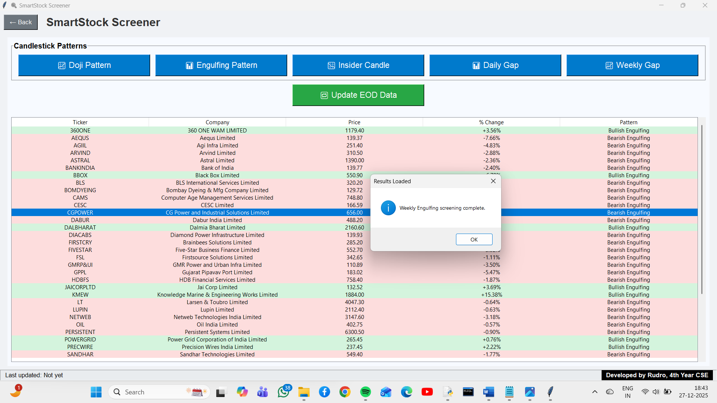
- Output of Weekly Engulfing- The output is akin to the output of doji screening

- Output of Weekly Gap Up
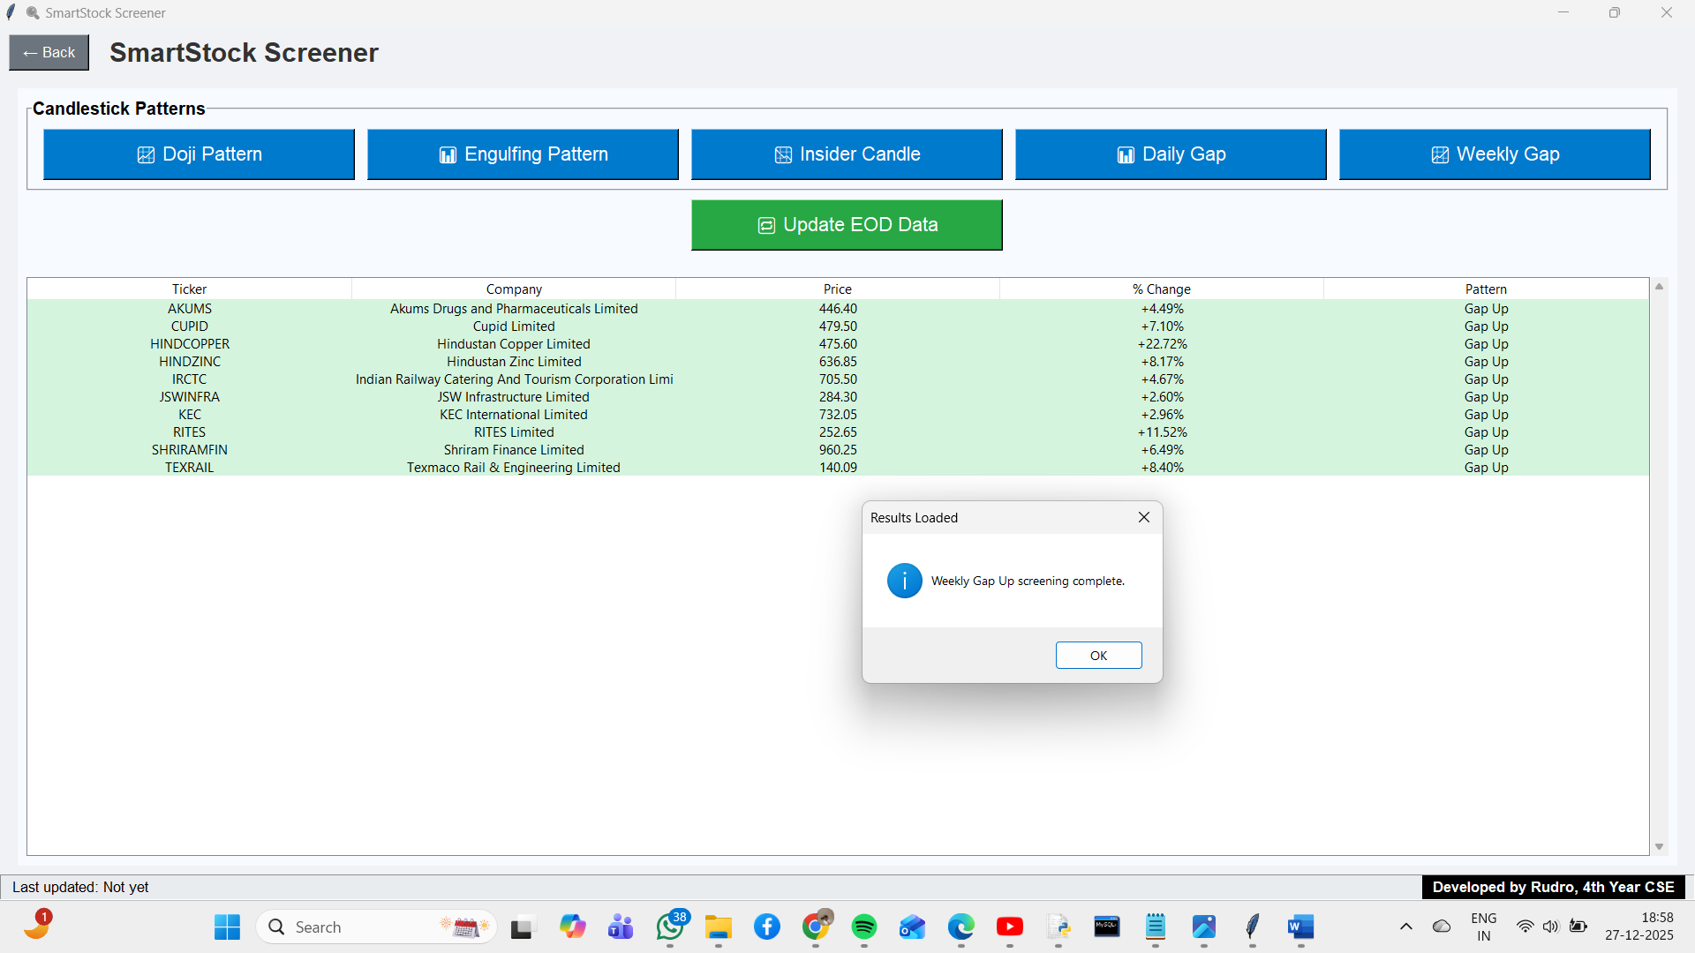

.

- In the Market-Overview page, there are three options- Gainers, Losers and Volume Shockers for both Price up and Price Down data. They are displayed based on the table format that is also used to display

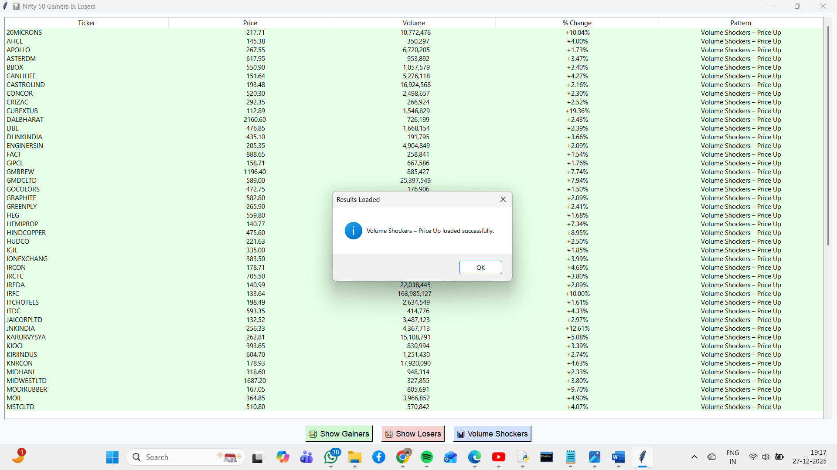

- In the Recommendation Page, the system predicts the recommendations to the users based on the candlestick patterns that were used in the screener page and patterns for both daily and weekly patterns are calculated for all candlestick patterns. In case there are stocks that fall in two candlestick patterns and one pattern is based on daily data and another on weekly data, then the pattern pertaining to the weekly data is preferred. The image below is the table of recommended stocks to be sold.

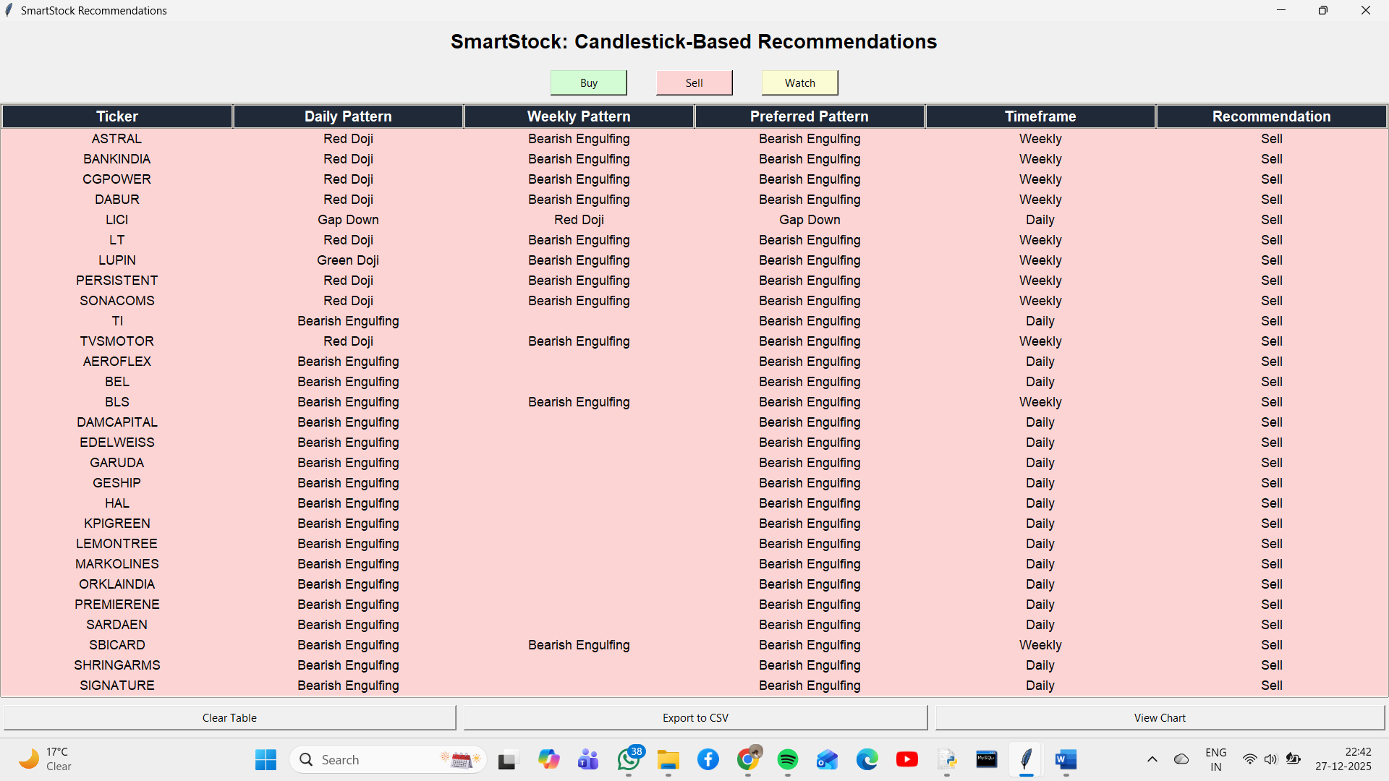

- The image below is the table of recommended stocks to be bought. The table of stocks to be bought/sold can also be downloaded in the form of a CSV file for further examination and analysis by clicking on the ‘Export to CSV’ button.

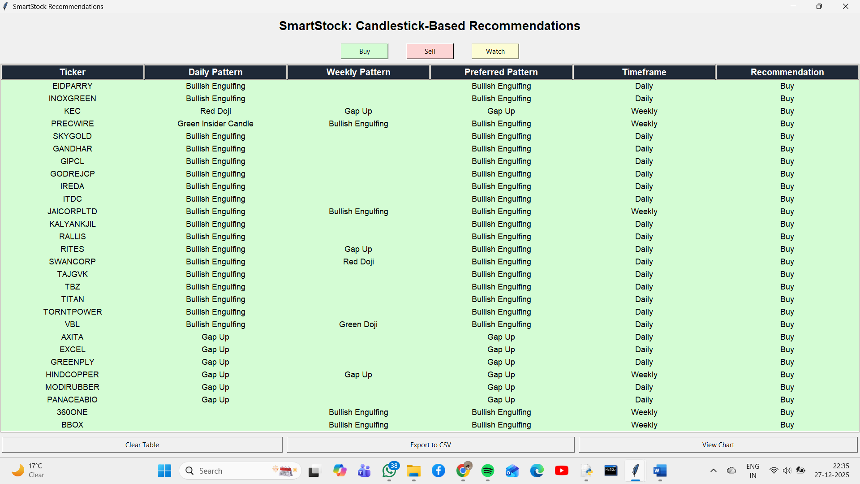

- For deeper analysis into individual stocks, they can be selected by clicking on them and then click on ‘View Chart’ button. This gives us the price and volume of the individual stocks over a certain period of time

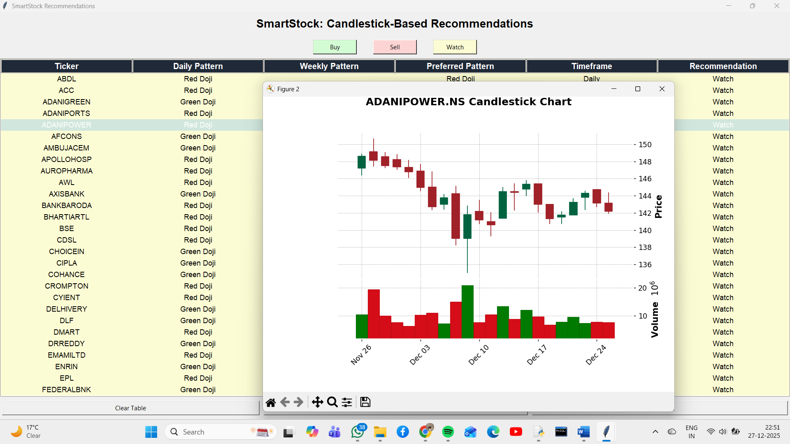

LOGIC BEHIND THE DIFFERENT CANDLESTICK PATTERN:

- Doji: To identify Doji candlestick patterns, the system compares the difference between the opening and closing prices against a 1% threshold of the closing price. It further checks that the upper and lower shadows are nearly equal within a 0.5% tolerance. If these conditions are met, the candlestick is classified as a bullish or bearish Doji depending on whether the close is higher or lower than the open. Otherwise, no Doji is detected. This is applicable to both daily and weekly patterns.

- Engulfing: The requirement to identify this pattern is at least two consecutive trading days are required to compare the previous day’s candlestick with the current day’s candlestick.
To detect daily engulfing patterns, the system compares two consecutive candlesticks. A bullish engulfing is identified when a bearish candle is followed by a larger bullish candle that completely covers the previous day’s range, with a benchmark volume and price thresholds. Conversely, a bearish engulfing is identified when a bullish candle is followed by a larger bearish candle that engulfs the prior day. These conditions ensure that only strong reversal signals are captured, reducing noise and improving recommendation accuracy.
In addition to daily engulfing detection, the system also evaluates weekly engulfing patterns. This involves segmenting stock data into consecutive weeks, determining weekly open and close prices, and calculating average weekly volume. The engulfing conditions are then applied to these weekly candlesticks, allowing the system to capture longer-term reversal signals. Furthermore, the weekly logic records the percentage change between consecutive weeks, providing a broader perspective on market trends and strengthening the reliability of recommendations.

- Insider Candle: The Insider Candle logic identifies situations where the current day’s candlestick is fully contained within the range of the previous day’s candlestick. Depending on whether the current candle is bullish or bearish, it is classified as a Green Insider Candle or Red Insider Candle. This pattern highlights periods of consolidation and potential reversal, with filters applied for volume and price thresholds to ensure significance
The weekly insider candle logic builds upon the daily version by segmenting data into consecutive weeks, calculating weekly open/close prices, and ensuring that the current week’s candlestick is fully contained within the range of the previous week. Additional requirements include computing weekly highs and lows, averaging weekly volume, and applying thresholds for minimum volume and price. The system also records the percentage change between weekly closes, making the weekly insider candle detection more robust and suitable for identifying medium-term consolidation or reversal signals.

- Gap Up/Down for daily data: The system detects Gap Up and Gap Down patterns by comparing consecutive trading days. A Gap Up occurs when the current day’s trading range opens and trades entirely above the previous day’s high, with strong volume confirming bullish sentiment. Conversely, a Gap Down occurs when the current day’s trading range opens and trades entirely below the previous day’s low, with strong volume confirming bearish sentiment. These checks ensure that only significant gaps backed by liquidity are captured, improving the reliability of recommendations.

- Gap Up/Down for weekly data: The weekly gap detection logic compares consecutive weekly candlesticks. A Gap Up occurs when the current week’s trading range opens and trades entirely above the previous week’s high, with strong volume confirming bullish sentiment. Conversely, a Gap Down occurs when the current week’s trading range opens and trades entirely below the previous week’s low, with strong volume confirming bearish sentiment. By averaging weekly volume and applying price thresholds, the system ensures that only significant weekly gaps are captured, making the recommendations more reliable for medium-term analysis.

RESULTS AND EVALUATION:
  - Successfully integrated EOD candlestick charts for analysis.
  - Built a recommendation engine that categorizes stocks into ‘Buy’, ‘Sell’, and ‘Watch’ based on candlestick patterns.
  - Enabled CSV export of filtered recommendations with timestamps.
  - Achieved a modular GUI where each page (Homepage, Screener, Recommendations, Overview, Settings) is self‑contained and scalable.
  - Demonstrated robustness by handling empty data and UI conflicts gracefully.

CONCLUSION & FUTURE SCOPE:
This project demonstrates a complete stock analysis platform combining data visualization, automation, and GUI design using End‑of‑Day data. It solves the problem of fragmented workflows by offering a unified, beginner‑friendly tool.
Future Enhancements:
- Add real‑time intraday data support for live monitoring of all stocks.
- Integrate machine learning models for predictive recommendations.
- Provide portfolio tracking and performance analytics.
- Enhance UI/UX with themes, dashboards, and interactive chart controls.
- Deploy as a web or mobile app for broader accessibility.

