Community-Based Cold Storage Solution for Smallholder Farmers

INTRODUCTION
Agriculture remains a critical part of rural livelihoods in India, especially for small and marginal farmers who depend on timely sale of produce for income. However, a major challenge in the post-harvest stage is the lack of affordable and accessible storage infrastructure. In many rural areas, farmers are forced to sell their produce immediately after harvesting because they do not have nearby cold storage facilities or cannot afford private storage options. This often leads to distress selling, higher post-harvest losses, and lower income realisation.
Perishable crops such as fruits and vegetables are particularly vulnerable to these challenges. During peak harvest periods, supply often exceeds local demand, causing prices to fall sharply. Without proper storage, farmers lose bargaining power and are unable to wait for better market conditions. This creates a cycle in which produce quality declines, wastage increases, and farm earnings remain unstable.
This project proposes a community-based cold storage solution designed for practical implementation at the village level. The model is based on shared infrastructure managed by an FPO or cooperative structure, with the goal of making cold storage more accessible, affordable, and operationally realistic for smallholder farmers. The project also integrates sustainability considerations through solar support and reduced food loss, while maintaining a strong business and feasibility perspective.

PROBLEM STATEMENT
Small and marginal farmers often face post-harvest challenges due to limited access to affordable cold storage facilities. As a result, perishable produce such as fruits and vegetables must be sold immediately after harvest, leading to distress selling and reduced income.
Poor storage infrastructure also contributes to significant post-harvest losses. Exposure to heat, moisture, and handling delays reduces produce quality and market value, particularly during peak harvest periods when prices are already low. Existing cold storage facilities are often located far from villages and remain too expensive for many small farmers.
These challenges highlight the need for a practical and affordable storage solution that allows farmers to store produce locally, reduce wastage, and sell when market conditions are more favorable. Therefore, a community-based cold storage model offers a viable approach to improving farmer income, storage accessibility, and supply chain efficiency.

PROPOSED COMMUNITY COLD STORAGE MODEL
The proposed solution is a community-based cold storage facility designed to serve small and marginal farmers through a shared infrastructure model. Instead of each farmer investing in private storage, the facility is collectively managed by a Farmer Producer Organization (FPO), allowing members to access cold storage services at a significantly lower cost. This approach improves affordability while ensuring that storage infrastructure can be utilized efficiently throughout the year.
Parameter | Assumption
Ownership Model | FPO-Managed Community Facility
Target Beneficiaries | Small and Marginal Farmers
Farmers Served | 100 Farmers
Storage Capacity | 20 MT
Produce Type | Mixed Fruits & Vegetables
Cold Storage Type | Multi-Commodity Cold Room
Power Source | Grid + Solar PV + Diesel Generator
Staffing | 1 Operator + 1 Part-Time Technician
Storage Fee | ₹4,000 per Farmer per Year
The model is designed around a 20 MT multi-commodity cold storage unit capable of handling fruits and vegetables produced by approximately 100 farmers. Farmers register with the FPO and can book storage space based on their requirements. Upon arrival at the facility, produce undergoes a basic quality inspection to assess freshness and suitability for storage. The produce is then allocated storage space according to available capacity.
To support daily operations, the facility is managed by a trained operator responsible for bookings, inventory management, and farmer coordination. A part-time technician oversees refrigeration equipment, temperature monitoring systems, and routine maintenance activities. This staffing structure keeps operating costs manageable while ensuring reliable performance.
The operational workflow follows a simple process: farmer registration, storage booking, quality inspection, cold storage allocation, storage and temperature monitoring, produce withdrawal, and payment settlement. Digital records or a basic mobile-based booking system can be used to improve transparency and reduce administrative effort.
The facility is powered primarily through grid electricity, supported by a rooftop solar PV system and a backup diesel generator. This hybrid power arrangement improves reliability and reduces the risk of spoilage during power outages, which are common in many rural areas.

INFRASTRUCTURE REQUIREMENTS
The proposed community cold storage facility requires a basic but reliable infrastructure setup that can support safe storage, temperature control, and day-to-day operations. Since the project is designed for a village-level implementation, the infrastructure should remain practical, cost-conscious, and easy to maintain.
Parameter | Specification
Annual Throughput | 400 MT
Average Storage Duration | 18 Days
Storage Cycles per Year | ~20 Cycles
Solar Capacity | ~10 kW Rooftop System
Backup Power | Diesel Generator
Facility Life | 10 Years
Monitoring System | Temperature Sensors & Inventory Tracking
The facility is assumed to have a storage capacity of 20 MT, which is sufficient for a shared community model serving around 100 farmers. A small insulated storage building is required to maintain low internal temperatures and reduce energy loss. The cold room structure should include insulation panels, proper sealing, and storage racks.
The refrigeration system is the most important technical component of the facility. It must be capable of maintaining stable temperature suitable for mixed fruits and vegetables. Since rural power supply can be inconsistent, the facility should operate on a hybrid energy model consisting of grid electricity, rooftop solar support, and a backup diesel generator. This arrangement improves reliability and reduces the risk of spoilage during outages.
Basic monitoring equipment is also necessary to track temperature, storage conditions, and inventory. Sensors or simple digital monitoring devices can help the operator ensure that produce remains within safe storage limits.
From an operational perspective, the project requires one full-time operator and one part-time technician. The operator manages bookings, inventory, and farmer coordination, while the technician handles refrigeration checks and maintenance support. The land requirement is modest, and the facility can be placed close to the village for easy access.
Overall, the infrastructure must be strong enough to support reliable cold storage, but simple enough to remain affordable and manageable for a community-based model.

COST AND FEASIBILITY ANALYSIS
A key strength of this project is that it is designed to be financially realistic for a small community-scale facility. The total capital expenditure is estimated at ₹50 lakh, which covers land development, building construction, insulation, refrigeration equipment, electrical systems, solar support, backup power, storage racks, sensors, and initial training. This is a modest but practical investment for a shared facility managed by an FPO or cooperative.
Capital Cost Estimate
Component | Estimated Cost (₹)
Land Development & Site Preparation | 2,00,000
Building & Civil Construction | 12,00,000
Insulation Panels & Cold Room Structure | 6,00,000
Refrigeration System | 15,00,000
Electrical & Control Systems | 3,00,000
Solar PV System | 5,00,000
Backup Generator | 3,00,000
Storage Racks & Handling Equipment | 2,00,000
Sensors & Monitoring Equipment | 1,00,000
Staff Training & Commissioning | 1,00,000
Total CAPEX | 50,00,000
The annual operating cost is estimated at ₹7.5 lakh, including electricity, operator salary, technician support, maintenance, insurance, and miscellaneous expenses. This recurring cost is manageable when distributed across multiple users in a community model.
Annual Operating Cost Estimate
Expense | Annual Cost (₹)
Electricity | 2,50,000
Operator Salary | 1,80,000
Technician Salary | 1,20,000
Maintenance & Repairs | 1,00,000
Insurance & Compliance | 50,000
Miscellaneous | 50,000
Total OPEX | 7,50,000
The facility is expected to generate value through three main sources. First, reduced post-harvest losses save about ₹10 lakh per year. Second, storage fees from 100 farmers contribute around ₹4 lakh per year. Third, better market timing allows farmers to sell produce at improved prices, creating an additional estimated benefit of ₹3 lakh per year. Together, these benefits result in a total annual benefit of ₹17 lakh.
After subtracting annual operating costs, the net annual benefit is approximately ₹9.5 lakh. Based on the total project cost of ₹50 lakh, the estimated payback period is around 5.3 years. For a rural infrastructure project, this is a reasonable payback horizon because the project is not only financially viable but also socially useful and operationally relevant.
Overall, the cost structure shows that the project is feasible as a shared infrastructure model. It is not designed to maximize commercial profit, but to create a practical balance between affordability, service access, and long-term sustainability.

OPERATIONAL WORKFLOW
The operational workflow of the community cold storage facility is designed to be simple, transparent, and easy for farmers to use. The process begins with farmer registration, where members of the FPO or cooperative are added to the storage system. This creates a basic user database and ensures that the facility is accessible only to verified participants.
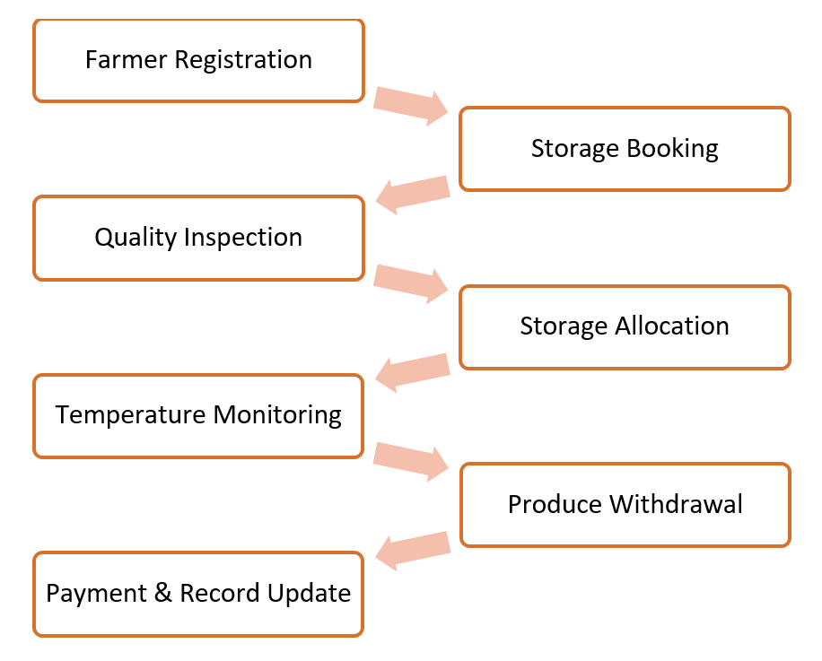
Once registered, farmers submit a storage booking request based on the quantity of produce they wish to store. Bookings can be handled through a manual register or a simple digital system, depending on the level of technology available. This helps the operator manage capacity and avoid overcrowding. When produce arrives, it is first checked through a basic quality inspection. This ensures that only suitable produce is stored and that spoiled or damaged items do not affect the rest of the stock. After inspection, the produce is allocated space inside the cold room based on availability, crop type, and expected storage duration.
During storage, the operator and technician monitor temperature conditions and maintain inventory records. Regular checks help ensure that produce remains fresh and that the refrigeration system is functioning properly. This stage is important because even short temperature fluctuations can affect produce quality. When farmers want to withdraw their produce, the inventory is verified, and the items are released in an orderly manner. Finally, payment is settled based on the storage duration and quantity stored.
This workflow keeps the system practical and avoids unnecessary complexity while still maintaining proper control, traceability, and fairness.

SUSTAINABILITY AND CLIMATE BENEFITS
The proposed community cold storage facility provides several sustainability and climate-related benefits while also supporting the economic well-being of farmers. One of the most significant advantages is the reduction of post-harvest losses. By maintaining suitable storage conditions, the facility helps preserve the quality of fruits and vegetables that would otherwise deteriorate due to heat, humidity, and delayed transportation.
Metric | Before | After | Improvement
Post-Harvest Loss (%) | 15 | 5 | -66.70%
Storage Access (%) | 10 | 100 | 900%
Average Holding Period (Days) | 1 | 10 | 900%
Average Annual Farmer Income (₹) | 80,000 | 90,000 | 12.50%
Farmers Served | 0 | 100 | New Service
Community Storage Capacity (MT) | 0 | 20 | New Infrastructure
Reducing food wastage improves the efficient use of resources such as water, land, energy, and labor. By extending the shelf life of produce, cold storage reduces losses and supports more sustainable agricultural practices.
The facility also strengthens climate resilience by helping farmers manage spoilage risks caused by rising temperatures and unpredictable weather conditions. In addition, the integration of rooftop solar power reduces dependence on conventional electricity and supports renewable energy adoption.
The community-based model promotes shared resource utilization, allowing multiple farmers to benefit from a single infrastructure facility. Overall, the project delivers economic, environmental, and social benefits by reducing food loss, improving resource efficiency, and supporting sustainable rural development.

IMPLEMENTATION CHALLENGES
Although the proposed community cold storage model is designed to be practical and affordable, its successful implementation depends on addressing several operational and financial challenges.
Reliable electricity supply is critical, as power interruptions can affect storage conditions and increase the risk of spoilage. While the facility includes solar support and a backup generator, maintaining uninterrupted operation remains important. Financing is another challenge, as the estimated ₹50 lakh capital investment may require support through subsidies, grants, or concessional loans.
Regular maintenance of refrigeration and monitoring equipment is essential to ensure efficient performance and avoid costly downtime. In addition, farmer participation and adoption are crucial for achieving high facility utilization. Awareness programs and transparent management practices can help encourage consistent usage.
Governance and coordination issues may also arise in a community-managed facility, making clear operational guidelines necessary. Seasonal fluctuations in production can further affect utilization rates, requiring effective booking and capacity management systems.
Despite these challenges, appropriate planning, technical support, and institutional management can make the project both practical and sustainable in a rural setting.

RECOMMENDATIONS
Based on the analysis conducted in this project, several measures can improve the effectiveness, financial viability, and long-term sustainability of the proposed community cold storage facility.
- Implement the facility through an FPO or cooperative structure to ensure transparent management and equitable access.
- Utilize government subsidies, grants, and concessional financing to reduce the initial capital burden.
- Expand the use of solar energy over time to lower operating costs and improve energy security.
- Introduce a simple digital booking and inventory management system to improve operational efficiency and transparency.
- Conduct regular training programs for operators and farmers to enhance technical skills and encourage adoption.
- Establish clear operational guidelines for storage allocation, fee collection, and inventory management.
- Carry out periodic performance reviews to monitor utilization, financial performance, and post-harvest loss reduction.
- Strengthen farmer awareness and outreach activities to maximize facility utilization and long-term sustainability.
By combining effective governance, financial support, renewable energy integration, digital tools, and capacity building, the proposed community cold storage model can become a scalable and sustainable solution for strengthening rural agricultural infrastructure.

CONCLUSION
The Community-Based Cold Storage Solution demonstrates how shared infrastructure can reduce post-harvest losses, improve produce quality, and enhance income opportunities for smallholder farmers. The proposed 20 MT FPO-managed facility combines affordable storage access with a practical operational model supported by grid electricity, solar power, and backup generation.
The feasibility analysis indicates that the project is financially viable, with benefits arising from reduced wastage, storage revenue, and improved market timing. In addition, the model supports sustainability by reducing food loss, improving resource efficiency, and strengthening climate resilience.
Although challenges such as financing, maintenance, and farmer adoption exist, they can be addressed through effective governance, institutional support, and capacity building. Overall, the project presents a practical and sustainable approach to strengthening rural agricultural infrastructure and improving farmer livelihoods.

Author: Rudrransh Saxena
rudrransh1709@gmail.com

ANALYSIS DASHBOARD
