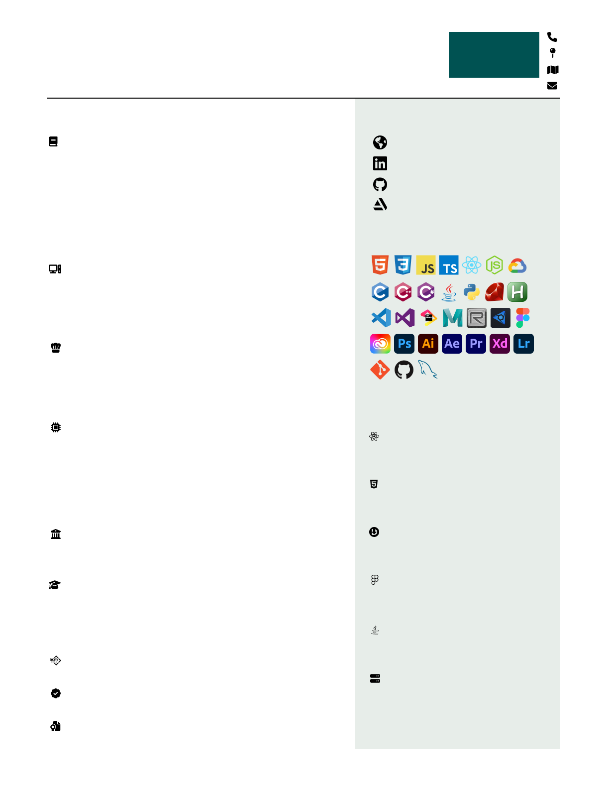

|  |
| --- |
| *System for easy backups and recovery of files* |

|  |
| --- |
| Bash, RoboCopy |

|  |
| --- |
| **File Backup and Sync** |

|  |
| --- |
| *Created with Swing* |

|  |
| --- |
| Java |

|  |
| --- |
| **File Explorer** |

|  |
| --- |
| *Design, Website* |

|  |
| --- |
| Adobe, Figma |

|  |
| --- |
| **Apex Studios** |

|  |
| --- |
| *Mobile App, Website, Design* |

|  |
| --- |
| Adobe, HTML, CSS, JS |

|  |
| --- |
| **Down** |

|  |
| --- |
| *Event and Website Fall 2022* |

|  |
| --- |
| HTML, CSS |

|  |
| --- |
| **Hacktoberfest at the Beach** |

|  |
| --- |
| *2021, 2022, 2023* |

|  |
| --- |
| React, Typescript |

|  |
| --- |
| **BeachHacks Website** |

|  |
| --- |
| **Projects** |

|  |
| --- |
| **Skills** |

|  |
| --- |
| artstation.com/rudyrsdev |

|  |
| --- |
| github.com/rudyrsdev |

|  |
| --- |
| linkedin.com/in/rudyrsdev |

|  |
| --- |
| rudyrs.vercel.app |

|  |
| --- |
| **Links** |

|  |
| --- |
| AP Score of 4 and Certified since 2015 |

|  |
| --- |
| **Certified Spanish Speaker** |

|  |
| --- |
| Member Since 2018 |

|  |
| --- |
| **Phi Theta Kappa Honor Society** |

|  |
| --- |
| President 2023 | VP 2022 | Design 2021 |

|  |
| --- |
| **Association for Computing Machinery** |

|  |
| --- |
| **Other Info** |

|  |
| --- |
| *Graduated in May 2019* |

|  |
| --- |
| A.A. in Natural Science | GPA 3.1 |

|  |
| --- |
| **Cerritos College** |

|  |
| --- |
| *Graduated in May 2023* |

|  |
| --- |
| B.S in Computer Science | GPA 3.2 |

|  |
| --- |
| **California State University of Long Beach** |

|  |
| --- |
| **Education** |

|  |
| --- |
| Personal Computer Building  Hardware and Software Repair |

|  |
| --- |
| *Lakewood, CA (562)-631-3609* |

|  |
| --- |
| Master PC Builder | May 2020 - Ongoing |

|  |
| --- |
| **Co-Owner, Hardware Technician** |

|  |
| --- |
| Cooking and Dishwasher  Info System, Repair and Consultant |

|  |
| --- |
| *Cerritos, CA (562)-924-3211* |

|  |
| --- |
| Shipmates | Feb 2014 - May 2015 |

|  |
| --- |
| **Chef, Technical Support** |

|  |
| --- |
| System Administrator  Hardware and Software Repair |

|  |
| --- |
| *Anahiem, CA (714)-828-7898* |

|  |
| --- |
| New Life ADHC | Jan 2019 - Ongoing |

|  |
| --- |
| **Technical Support** |

|  |
| --- |
| **Work Experience** |

|  |
| --- |
| I have a strong background in both computer science and graphic design. I have been utilizing these skills for over eight years, both in my studies and in professional settings. I am particularly passionate about projects that merge these two fields. |

|  |
| --- |
| **Summary** |

|  |
| --- |
| rodolfo.rudy.sandoval@gmail.com |

|  |
| --- |
| RedactedPlease RequestFull Resume |

|  |
| --- |
| **Rodolfo** |

|  |
| --- |
| Sandoval |