**Project “GroundhogDay” 1-Page GDD**

*Diablo meets daily Life of Dennis*

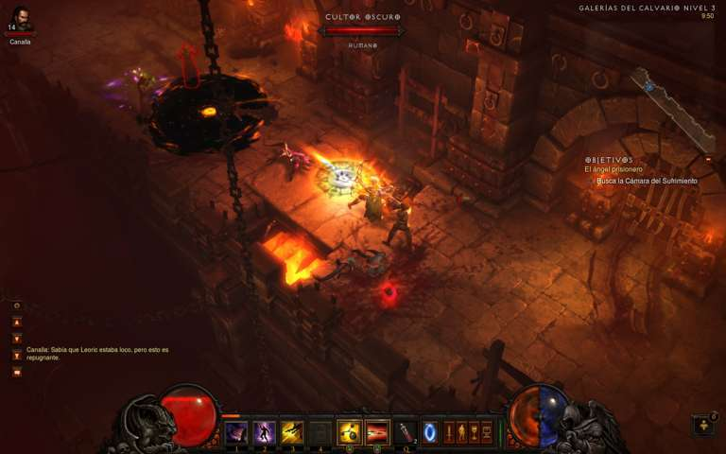

**Genre:** RPG, 3rd person fixed camera RPG.  
**Target Audience:** M for Mature.

**Controls:** Keyboard & Mouse, Controller

**Thematic Setting:** Medieval fantasy – knights, dragons, swords, bows

**Tech Stack:** Unity, Blender, Gimp/Photoshop, Audacity

**Platform(s):** Steam - PC, Mac?

**Game Moment:**  simple level flows with combat with a few different enemies

**Game Summary:** Project „GroundhogDay“ is a Diablo style RPG with elements of Dennis‘ life and how it combats him every day. The modern day elements are made into medieval monsters and situations to better encompass the theme. The hero is quite confident that he can combat the evil in this world which are his daily tasks but some of it get increasingly more hard.

**Core Player Experience:** Funny, getting more and more diffcult

**Central Theme:** Grind to win, special Lucky moments (Rübner-Glück)

**Design Pillar:** Making daily moments into battles

**Anticipated Remarkability:**

**Anticipated Steam Early Access Launch date:** Q4 2018

**Feature Development Priorities:**

**Comparative Products:** Diablo series, torchlight 2

**Health and Damage Philosophies:**

|  |  |
| --- | --- |
| Skalierung Philosophies (Ordnung 1-10) | |
| Roguelike/Permadeath – No cost save points | 8 |
| No healing – Tons of healing | 7 |
| 1-hit health – Unkillable | 7 |
| Easy combat skill – hardcore combat skill | 4 |
| Relaxing combat – stressful combat | 6 |
| No player upgrades – everything is upgradable | 6 |
| All combat – all story | 4-5 |