**Project “GroundhogDay” 1-Page GDD**

*Diablo meets daily Life of Dennis*

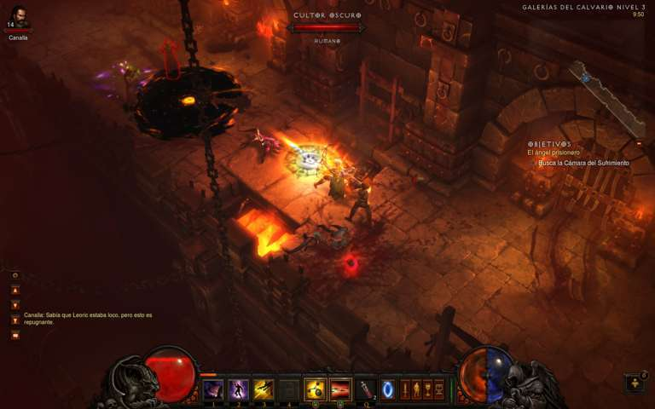

**Genre:** RPG, 3rd person fixed camera RPG.  
**Target Audience:** M for Mature.

**Controls:** Keyboard & Mouse, Controller

**Thematic Setting:** Medieval fantasy – knights, dragons, swords, bows

**Tech Stack:** Unity, Blender, Gimp/Photoshop, Audacity

**Platform(s):** Steam - PC, Mac?

**Game Moment:**  simple level flows with combat with a few different enemies

**Game Summary:**

**Core Player Experience:**

**Central Theme:**

**Design Pillar:**

**Anticipated Remarkability:**

**Anticipated Steam Early Access Launch date:**

**Feature Development Priorities:**

**Comparative Products:**