**Homework 2: Image Enhancement Using Spatial Filters**

**Report Template**

**Please keep the title of each section, and note that the questions listed in Part III should be retained.**

**Part I. Implementation (5%):**

**Please provide screenshots of your code snippets, and explain your implementation.**

**Part II. Results & Analysis (10%):**

**Please provide your observations and analysis for the following parts.**

* **Gaussian filter**
  + **Try three different σ and compare the results**
  + **Try three different filter sizes and compare the results.**
* **Median filter**
  + **Try three different filter sizes and compare the results.**
* **Smoothing Spatial Filters**
  + **Compare the results of Gaussian filter and median filter.**
* **Laplacian filter**
  + **Compare the results of two laplacian filters.**

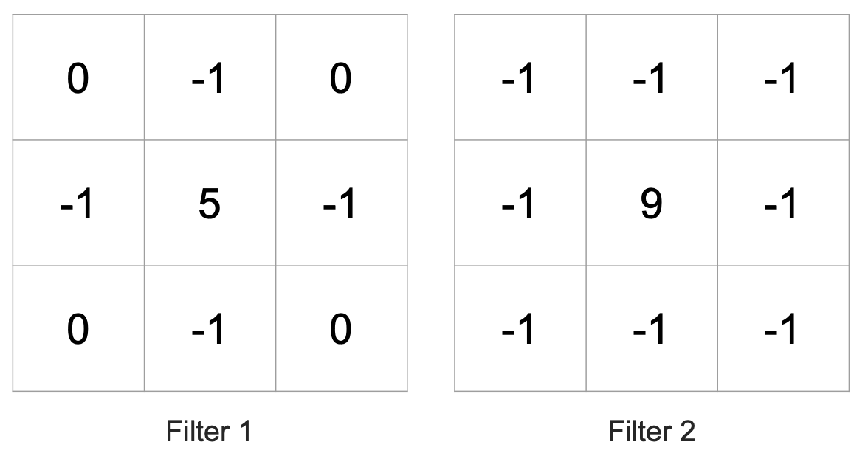

**Part III. Answer the questions (15%):**

1. Please describe a problem you encountered and how you solved it.
2. What padding method do you use, and does it have any disadvantages? If so, please suggest possible solutions to address them.
3. What problems do you encounter when using Gaussian filter and median filter to denoise images? Please suggest possible solutions to address them.
4. What problems do you encounter when using Laplacian filters to sharpen images? Please suggest possible solutions to address them.