Cairo University Faculty of Engineering

Computer Engineering Department

Fall 2022

Image Processing Smart-Elevator

Team 19

|  |  |  |  |
| --- | --- | --- | --- |
| **Name** | **Sec**  **.** | **BN**. | **E-mails** |
| Karim Mahmoud Saqer | 2 | 9 | [kareemsaqer1@gmail.com](mailto:kareemsaqer1@gmail.com) |
|  |  |  |  |
|  |  |  |  |
|  |  |  |  |
|  | | | |

# Face Detection:

## Algorithm Used:

We Used Viola Jones Algorithm for face detection.

It detects the faces using ADA Boost to find the best feature and train a classifier.

For each feature it will present a weak classifier then we get a strong classifier by the all weak-ones. The features are presented by taking a rectangular part of image and divide it to some parts and get the difference between them.

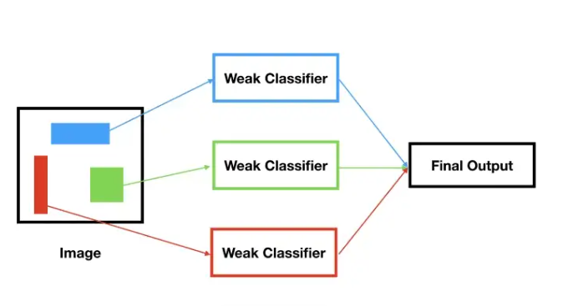

This gives the following outline of the algorithm:

1. Initialize the weights
2. Normalize the weights
3. Select best classifier
4. Update the weights based on the chosen classifier

## Results and performance:

We set a data of faces and background images and train the model then we gave it a photo to detect the faces and the result was detecting all the faces with some ratio of error on the background.

## Conclusion and References:

It must apply more number of features to get more accuracy in this model.

The references we looked in:

1. <https://medium.datadriveninvestor.com/understanding-and-implementing-the-viola-jones-image-classification-algorithm-85621f7fe20b>
2. <https://github.com/sunsided/viola-jones-adaboost/blob/master/viola-jones.ipynb>

# 2- Face Recognition:

# 3- Additional Comments:

4- **Work Divison:**

|  |  |
| --- | --- |
| Name | Role |
| Karim SaqerDonia Gameel | Face Detection |
| Rufaida MohammedDoaa Magdy | Face Recognition |