Designing a Python Data Pipeline
for Hospitality Analytics
Week 2 Task - Detailed Design Document
Internship Project: Hospitality / Hospital Analytics
Prepared by: Rufeena
October 2026

1. Introduction and Objectives
Hospitality businesses such as hotels, resorts and serviced apartments generate a continuous stream of booking, occupancy, pricing and guest data. This data usually arrives from several systems (property management systems, online travel agencies, direct booking engines) in inconsistent formats, with duplicates, missing values and typing errors. Analysts cannot trust dashboards built directly on such data.
This document presents the design and a working implementation of a Python data pipeline that automatically collects hospitality booking data, processes and cleans it, and stores it in a form that is ready for analysis in SQL and Power BI.

1.1 Objectives
- Map the complete flow from data collection to storage of clean data.
- Describe every pipeline component, the Python libraries used, and the reasons for choosing them.
- Provide pseudocode and real code outlines for the key parts of the pipeline.
- Define automation strategies: scheduling, error handling, retries and logging.
- Show that the design is realistic by delivering a fully runnable, tested implementation.

1.2 Scope and Assumptions
The pipeline is batch-oriented (a daily run is enough for revenue and occupancy reporting). Source data contains one row per booking with the 13 columns listed in Section 2. Storage defaults to SQLite so that the project runs anywhere without setup, and can be switched to MySQL by changing a single connection string.

2. Data Description
The pipeline expects booking records with the following fields. Raw files are read as text so that no value is silently altered before validation.
Column | Type after cleaning | Description
booking_id | text (unique key) | Unique reservation identifier
guest_name, email, country | text | Guest details (title-cased / lower-cased / standardised)
room_type | category | Standard, Deluxe, Suite or Family (many raw spellings mapped)
check_in, check_out, booking_date | datetime | Stay dates and date the booking was made
adults, children | integer | Guest counts (missing children = 0)
room_rate | decimal | Nightly rate (missing values imputed by room-type median)
status | category | Confirmed, Completed, Cancelled, No-Show
booking_channel | category | Direct, Booking.com, Expedia, Agoda, Walk-in, Corporate

To test the pipeline, a generator script creates a deliberately messy file (inconsistent casing and abbreviations, two date formats, missing rates, invalid emails, impossible dates and 5% duplicate rows) so that every cleaning rule is exercised.

3. Pipeline Architecture
The pipeline is a linear sequence of four stages coordinated by an orchestrator. Each stage is a separate Python module with a single responsibility, which keeps the code testable and lets any stage be replaced independently.
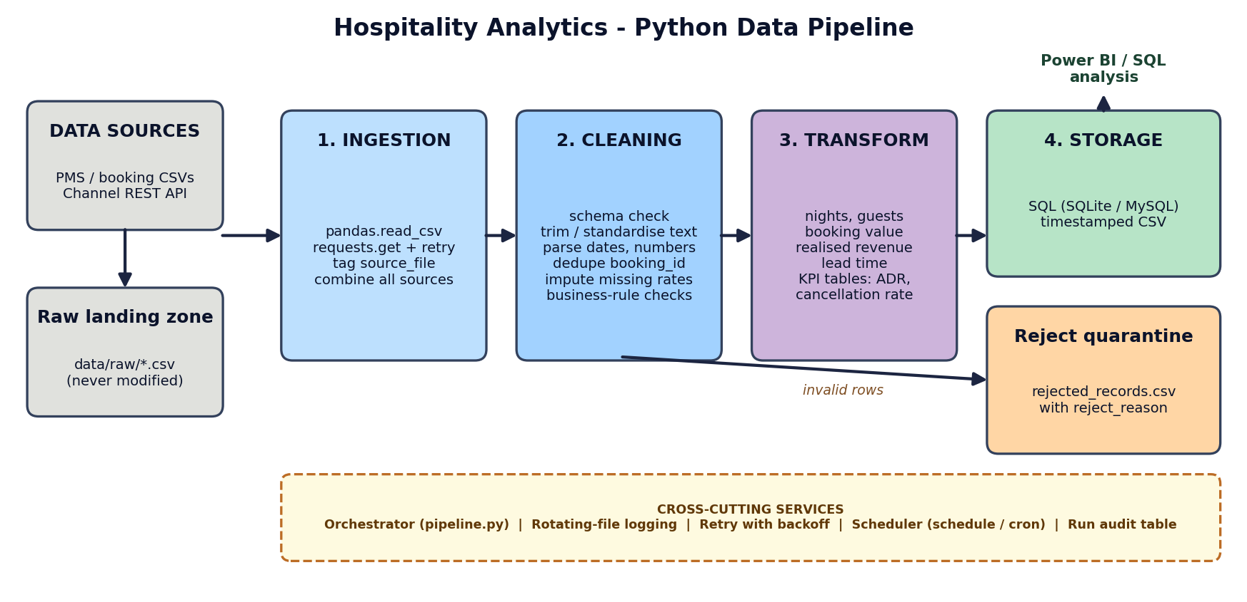
Figure 1: End-to-end pipeline flow

3.1 Text Description of the Flow
Data sources -> Ingestion -> Cleaning and Validation -> Transformation -> Storage -> Analytics (SQL / Power BI)

3.2 Stage Transitions
From | To | What is handed over | Failure behaviour
Sources | Ingestion | CSV files / JSON records | Unreadable file skipped and logged; API call retried
Ingestion | Cleaning | One combined raw DataFrame (all text) with source_file tag | Run aborts if no data from any source
Cleaning | Transformation | Validated clean DataFrame | Invalid rows diverted to reject file with reason
Cleaning | Storage | Rejected DataFrame | Saved as rejected_records.csv for review
Transformation | Storage | Fact table + KPI tables | Nothing stored if transformation fails
Storage | Analytics | SQL tables and CSV files | SQL load is one transaction (all or nothing)

4. Component Description

4.1 Data Ingestion (ingest.py)
Purpose: collect raw data from every configured source into one DataFrame without changing its content.
- CSV files: pathlib globbing finds every *.csv in data/raw/; pandas.read_csv(dtype=str) loads each one. A source_file column is added for lineage, so any bad record can be traced back to its file.
- REST API: requests.get with a timeout and raise_for_status() fetches JSON booking lists, wrapped by a retry decorator (exponential backoff: 2s, 4s, 8s).
- Resilience: one corrupt file is logged and skipped rather than stopping the whole run.

4.2 Data Cleaning and Validation (clean.py)
Purpose: turn untrusted raw data into reliable data. Cleaning is rule-based and every rule is logged with counts.
Step | Method (pandas) | Example
Schema validation | Compare columns with REQUIRED_COLUMNS | Missing 'room_rate' column stops the run early
Whitespace and case | str.strip(), str.title(), str.lower() | ' john SMITH ' -> 'John Smith'
Category standardisation | str.lower().map(dictionary) | 'dlx', 'Deluxe Room' -> 'Deluxe'; 'canceled' -> 'Cancelled'
Type conversion | to_datetime / to_numeric with errors='coerce' | '31-31-2025' -> NaT instead of a crash
Mixed date formats | Parse ISO first, then day-first fallback | '2025-03-01' and '01/03/2025' both read correctly
De-duplication | drop_duplicates(subset='booking_id', keep='last') | Repeated exports of the same booking
Missing values | fillna with 0 / 'Unknown' / group median | Missing rate -> median of that room type
Business rules | Boolean masks collected into reject_reason | check_out <= check_in, adults < 1, rate <= 0
Email check | Regex; invalid values blanked, row kept | 'not-an-email' -> empty

Rows that break a hard business rule are never silently dropped; they are written to a reject file with a plain-text reason so that the data owner can correct the source.

4.3 Data Transformation (transform.py)
Purpose: add analytical value to clean records and pre-compute common hospitality KPIs.
Derived field / KPI | Formula
nights | check_out - check_in (days)
booking_value | nights x room_rate
realized_revenue | booking_value, or 0 if Cancelled / No-Show
lead_time_days | check_in - booking_date (never below 0)
ADR (Average Daily Rate) | realised revenue / sold room-nights, per month
Cancellation rate % | cancelled bookings / total bookings x 100
Channel and room-type revenue | Group-by aggregates for channel mix analysis

4.4 Data Storage (load.py)
- SQL database (SQLAlchemy + pandas.to_sql): tables fact_bookings, kpi_monthly, kpi_channel, kpi_room_type and pipeline_runs. SQLite is the default; MySQL works by setting PIPELINE_DB_URL, which matches the MySQL and Power BI stack of the wider analytics project.
- CSV archive: each run writes timestamped files plus a *_latest.csv copy for quick access and an audit trail.
- Transactional, idempotent load: all tables are loaded inside one transaction using full-refresh (replace), so a failed or repeated run can never leave half-loaded or duplicated data.
- Audit table: every run inserts status, row counts, duration and error text into pipeline_runs.

4.5 Technology Summary
Purpose | Library | Why
Data handling | pandas | Vectorised cleaning, grouping and date logic
API ingestion | requests | Simple HTTP with timeouts and error status handling
Database access | SQLAlchemy | One API for SQLite, MySQL, PostgreSQL
Scheduling | schedule (or cron / Airflow) | Readable daily jobs in pure Python
Logging | logging + RotatingFileHandler | Console and file logs with size-based rotation
Testing | pytest | Fast unit tests for cleaning and transformation rules

5. Pseudocode and Code Outlines

5.1 Overall Pseudocode
FUNCTION run_pipeline():
start_timer(); log('run started')
TRY
raw = ingest_all() # CSV + API, retries on API errors
clean, rejected = clean(raw) # validate, standardise, dedupe
IF clean is empty THEN RAISE error
fact = add_features(clean) # nights, revenue, lead time
tables = {fact, monthly_kpis, channel_kpis, room_type_kpis}
save_csv(each table, rejected) # timestamped archive
save_sql(tables + run_audit_row) # single transaction
status = SUCCESS
CATCH any error
status = FAILED; log(error + traceback)
RETURN run_summary # exit code 0 / 1 for schedulers

5.2 Ingestion Outline
def ingest_csv(directory):
frames = []
for path in sorted(directory.glob('*.csv')):
try:
df = pd.read_csv(path, dtype=str) # keep everything as text
df['source_file'] = path.name
frames.append(df)
except Exception as exc:
log.error('Skipping %s: %s', path.name, exc)
return pd.concat(frames, ignore_index=True)

@retry(exceptions=(requests.RequestException,))
def _fetch(url):
r = requests.get(url, timeout=15)
r.raise_for_status()
return r.json()

5.3 Cleaning Outline
def clean(df):
validate_schema(df)
df['room_type'] = df['room_type'].str.lower().map(ROOM_TYPE_MAP)
for col in ('check_in', 'check_out', 'booking_date'):
df[col] = parse_dates(df[col]) # ISO first, then day-first
df = df.drop_duplicates('booking_id', keep='last')
median = df.groupby('room_type')['room_rate'].transform('median')
df['room_rate'] = df['room_rate'].fillna(median)
reasons = build_reject_reasons(df) # boolean business rules
rejected = df[reasons != '']
return df[reasons == ''], rejected

5.4 Transformation and Storage Outline
def add_features(df):
df['nights'] = (df.check_out - df.check_in).dt.days
df['booking_value'] = df.nights * df.room_rate
df['is_cancelled'] = df.status.isin(['Cancelled', 'No-Show'])
df['realized_revenue'] = df.booking_value.where(~df.is_cancelled, 0.0)
return df

@retry()
def save_sql(tables, db_url):
engine = create_engine(db_url)
with engine.begin() as conn: # all-or-nothing transaction
for name, df in tables.items():
df.to_sql(name, conn, if_exists='replace', index=False)

6. Automation Strategies

6.1 Scheduling
Option | When to use | Example
schedule library (scheduler.py) | Simple, self-contained Python service | schedule.every().day.at('02:00').do(job)
cron (Linux / macOS) | Server deployment, no extra code | 0 2 * * * cd /app && python main.py
Windows Task Scheduler | Windows hosts | Daily trigger running python main.py
Apache Airflow / Prefect | Many pipelines, dependencies, UI and alerting | DAG task calling run_pipeline()

A 02:00 daily run is chosen because it follows the night audit when the property management system finalises the day, and it finishes before the morning revenue meeting. main.py returns exit code 0 on success and 1 on failure, which any scheduler can use to trigger alerts.

6.2 Error Handling
- Fail fast on structural problems: a missing required column or no input data stops the run with a clear message before any data is stored.
- Isolate bad data, not the whole run: unreadable files are skipped; invalid rows go to the reject file.
- Retries with exponential backoff: temporary API or database failures are retried 3 times (2s, 4s, 8s) before raising.
- Coercion instead of crashes: errors='coerce' turns unparseable dates and numbers into missing values that validation then catches.
- Atomic loads: database writes happen in one transaction, so consumers never see partial data.
- Top-level safety net: the orchestrator catches every exception, logs the traceback and records FAILED in the audit table.

6.3 Logging and Monitoring
The logging module writes the same messages to the console and to logs/pipeline.log (RotatingFileHandler, 1 MB x 5 files). Each stage logs row counts, for example: "Cleaning: 525 in | 25 duplicates removed | 20 rejected | 480 clean". The pipeline_runs table keeps a permanent history of status, counts and duration, so trends (a sudden rise in rejects, or a slower run) are visible with a simple SQL query. For production, the scheduler's critical-level log can be connected to email or Slack.

6.4 Other Best Practices Applied
- Configuration through environment variables - no passwords or paths hard-coded; the same code runs in development and production.
- Raw data is never modified, so any run can be reproduced from the original files.
- Idempotency: re-running the pipeline gives the same result and never duplicates rows.
- Modular design with one module per stage, plus unit tests for cleaning and KPI formulas.
- Data lineage through the source_file column and timestamped output files.
- Data-quality visibility: rejected rows are preserved with reasons instead of being deleted.

7. Implementation and Test Results
The design was implemented and executed end to end. The unit tests (pytest) cover schema validation, standardisation, de-duplication, rejection of impossible dates and revenue calculations. Other tested scenarios were API ingestion from a local mock endpoint and a deliberate failure with no input data, which produced a FAILED status, a logged error and a non-zero exit code.

7.1 Sample Run Summary
Metric | Result
Raw rows ingested | 525
Duplicates removed | 25
Rows rejected (invalid dates) | 20
Clean rows stored | 480
Run status / duration | SUCCESS / 0.11 s

7.2 Example KPI Output (sample data)
Revenue and cancellation rate by booking channel from the generated sample data (values are illustrative because the sample is synthetic):
Channel | Bookings | Realised revenue | Cancellation %
Corporate | 80 | 52,397.55 | 31.2
Walk-in | 80 | 47,151.96 | 43.8
Booking.com | 77 | 47,102.07 | 33.8
Expedia | 96 | 44,784.04 | 50
Agoda | 85 | 33,643.90 | 50.6
Direct | 62 | 29,119.58 | 43.5

7.3 How to Run
pip install -r requirements.txt
python generate_sample_data.py 500 # create messy sample data
python main.py # run once
python -m pytest -q # run tests
python scheduler.py # daily automation

8. Limitations and Future Enhancements
- Incremental (upsert) loading by booking_id for very large tables instead of full refresh.
- Data-quality framework (e.g. Great Expectations) for declarative checks and reports.
- Real-time ingestion with a message queue if live occupancy dashboards are required.
- Orchestration with Airflow for dependency management, retries and a monitoring UI.
- Direct Power BI connection to the SQL tables for automatically refreshed dashboards.
- Containerisation with Docker for consistent deployment.

9. Conclusion
The designed pipeline covers every required stage - ingestion, cleaning, transformation and storage - and is supported by automation, error handling and logging that allow it to run unattended. Because it is implemented with widely used Python libraries and verified with tests on realistic messy data, it is a realistic, extensible foundation for hospitality analytics, and its clean SQL tables can feed Power BI dashboards on occupancy, revenue, ADR and cancellations.

