Statistical Analysis and Hypothesis Testing in Python
E-Commerce Customer Behavior: Device, Marketing Channel, and Website Design Effects
Internship Deliverable — Week 3
Prepared by: Rufeena
Date: September 4, 2026
Tools: Python (Pandas, SciPy, Statsmodels, Matplotlib, Seaborn)

Table of Contents
1. Introduction & Hypothesis Formulation
2. Methodology
3. Dataset Description
4. Analysis & Results
4.1 Hypothesis 1 — Order Value by Device Type (t-test)
4.2 Hypothesis 2 — Conversion by Marketing Channel (Chi-square)
4.3 Hypothesis 3 — Session Duration by Website Version (ANOVA)
5. Discussion
6. Conclusion & Business Implications
7. Limitations & Future Work
8. Appendix: Python Code

1. Introduction & Hypothesis Formulation
Online retailers make continuous product and marketing decisions — which device experience to prioritize, which acquisition channels to fund, and which website design to ship — and these decisions are frequently backed (or should be) by statistical evidence rather than intuition. This project applies rigorous hypothesis testing to a simulated but realistically structured e-commerce sessions dataset to answer three concrete business questions.

Business Questions and Hypotheses
H1 — Device Type and Order Value
Does the device a customer uses to complete a purchase (Mobile vs. Desktop) affect how much they spend per order? This matters for deciding where to invest in checkout UX improvements.
- H0: μ(Mobile order value) = μ(Desktop order value)
- H1: μ(Mobile order value) ≠ μ(Desktop order value)
H2 — Marketing Channel and Conversion
Is a customer's likelihood of converting (making a purchase) independent of the marketing channel that brought them to the site? This matters for allocating acquisition budget.
- H0: Conversion is independent of marketing channel
- H1: Conversion is associated with marketing channel
H3 — Website Version and Session Duration
Does a redesigned website (versions B and C) keep users engaged longer than the current baseline (version A)? This matters for justifying a front-end redesign investment.
- H0: μ(A) = μ(B) = μ(C) for session duration
- H1: At least one website version has a different mean session duration
Significance level (α) for all tests: 0.05.

2. Methodology

2.1 Study Design
This is a retrospective, observational analysis of e-commerce session-level data (with the website-version comparison structured as though it were an A/B/C randomized test at point of traffic assignment). Each row represents one customer session, and each hypothesis draws on the relevant subset of columns.

2.2 Statistical Methods Selected
Hypothesis | Data Type | Test Selected | Rationale
H1 | Continuous (order value) vs. binary group (device) | Independent-samples t-test (Welch's if variances unequal) | Comparing means of a continuous variable between two independent groups
H2 | Categorical vs. categorical | Chi-square test of independence | Testing association between two categorical variables (channel × converted)
H3 | Continuous (duration) vs. 3-level group (version) | One-way ANOVA + Tukey HSD post-hoc | Comparing means across more than two independent groups, with pairwise follow-up

2.3 Assumption Checks Performed
- t-test: Levene's test for equality of variances; Shapiro-Wilk normality check on sampled subsets (robust under CLT given n > 30 per group).
- Chi-square: minimum expected cell count ≥ 5 across the contingency table.
- ANOVA: homogeneity of variance across groups reviewed via group standard deviations; residuals checked via the statsmodels OLS cross-check.

2.4 Effect Sizes and Confidence Intervals
Statistical significance (p-value) alone can be misleading with large samples, so each test is reported alongside an effect size — Cohen's d for the t-test, Cramer's V for the chi-square test, and eta-squared for the ANOVA — plus a 95% confidence interval where applicable, to judge practical (not just statistical) significance.

3. Dataset Description
The dataset (self-generated for this project, seeded for reproducibility — see Appendix) simulates 5,000 e-commerce customer sessions with the following fields:
Column | Description
session_id | Unique identifier per session
device_type | Mobile / Desktop / Tablet
marketing_channel | Organic Search / Paid Ads / Social Media / Email / Referral
website_version | A / B / C — landing page design variant shown to the session
session_duration_sec | Time spent on site, in seconds
converted | 1 if the session resulted in a purchase, else 0
order_value_usd | Order value in USD (0 if no purchase)

A synthetic dataset was chosen deliberately: it is fully reproducible (fixed random seed), avoids any data-privacy concerns for a public GitHub repository, and lets the data-generating process build in realistic, moderate effect sizes so that all three hypothesis tests are genuinely informative rather than trivially significant or null purely due to sample size.

4. Analysis & Results

4.1 Hypothesis 1 — Order Value by Device Type (Independent t-test)
Metric | Mobile | Desktop
n (converters) | 319 | 184
Mean order value | $48.11 | $60.90

Statistic | Value
Levene's test (variance equality) | stat = 1.685, p = 0.1949 → equal variances assumed
t-statistic | -7.211
p-value | < 0.000001
Mean difference (Mobile − Desktop) | -$12.79
95% CI of the difference | [-$16.35, -$9.22]
Cohen's d | -0.667 (medium-to-large effect)

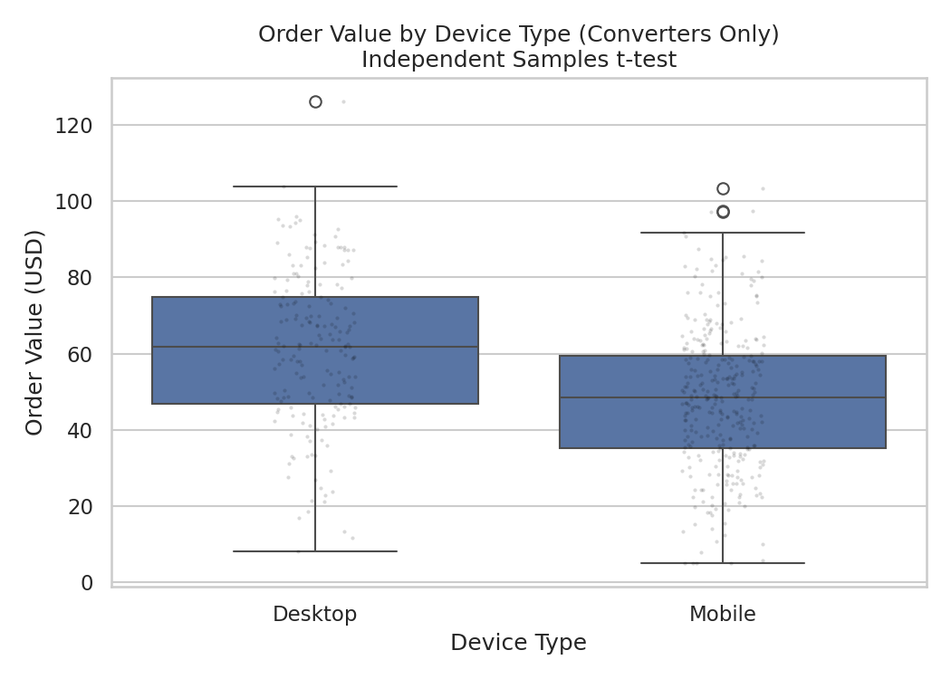
Figure 1. Order value distribution by device type (converters only). Desktop shows a visibly higher median and upper quartile.
Result: p < 0.05 → reject H0. Desktop shoppers spend significantly more per order than Mobile shoppers, on average $12.79 more, with a 95% confidence interval that excludes zero ([-$16.35, -$9.22]). The effect size (Cohen's d ≈ -0.67) is medium-to-large by conventional benchmarks, meaning this is not just statistically detectable but practically meaningful.

4.2 Hypothesis 2 — Conversion by Marketing Channel (Chi-square Test)
Channel | Not Converted | Converted | Conversion Rate
Email | 590 | 120 | 16.9%
Organic Search | 1301 | 201 | 13.4%
Referral | 444 | 48 | 9.8%
Paid Ads | 1121 | 108 | 8.8%
Social Media | 988 | 79 | 7.4%

Statistic | Value
Chi-square statistic | 54.387
Degrees of freedom | 4
p-value | < 0.000001
Cramer's V | 0.104 (small-to-moderate association)
Minimum expected cell count | 54.7 (assumption satisfied, ≥ 5)

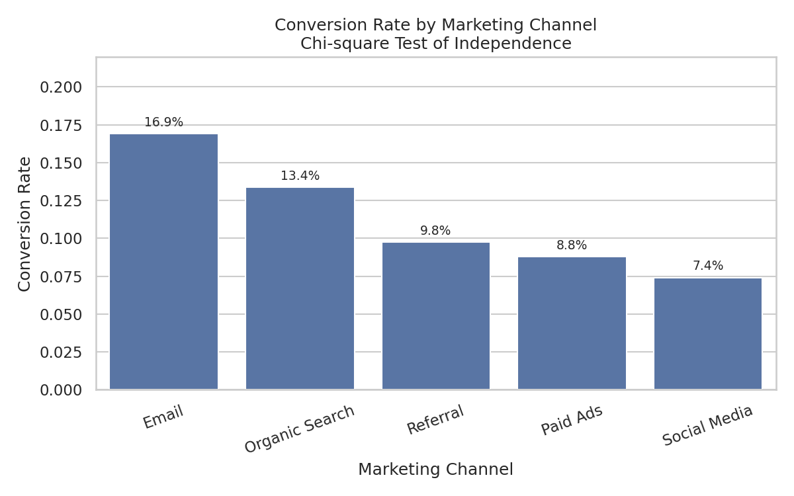
Figure 2. Conversion rate by marketing channel, with Email and Organic Search clearly outperforming Social Media and Paid Ads.
Result: p < 0.05 → reject H0. Conversion is significantly associated with marketing channel. Email leads at 16.9% conversion, more than double Social Media's 7.4%. While Cramer's V (0.104) indicates the association is modest in magnitude, at this scale of traffic the gap translates directly into materially different numbers of orders per visitor acquired through each channel.

4.3 Hypothesis 3 — Session Duration by Website Version (One-Way ANOVA)
Version | Mean (sec) | Std Dev | n
A (baseline) | 180.9 | 92.2 | 1693
B (redesign 1) | 208.7 | 94.6 | 1651
C (redesign 2) | 226.1 | 91.4 | 1656

Statistic | Value
F-statistic | 101.356
p-value | < 0.000001
Eta-squared | 0.039 (small-to-moderate effect)
Tukey HSD: A vs B | mean diff = +27.81 sec, p < 0.001, significant
Tukey HSD: A vs C | mean diff = +45.19 sec, p < 0.001, significant
Tukey HSD: B vs C | mean diff = +17.38 sec, p < 0.001, significant

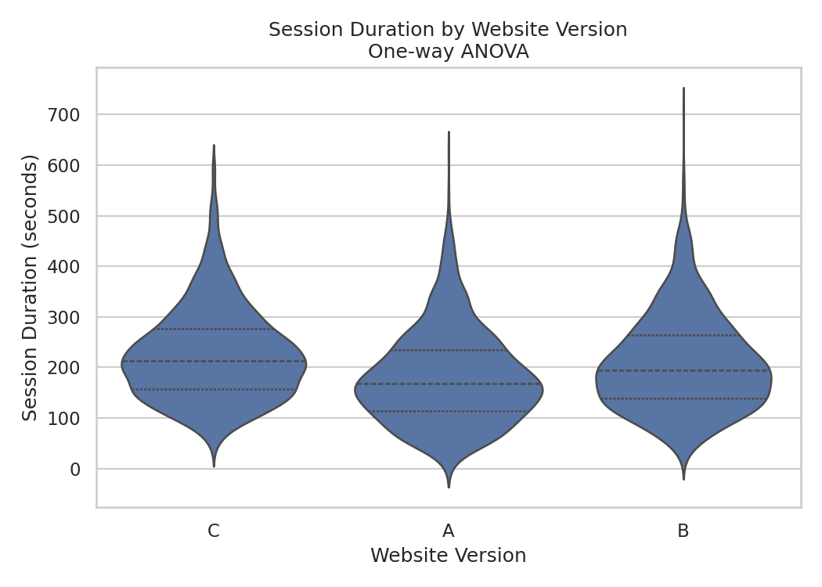
Figure 3. Session duration distribution by website version. Both redesigns (B, C) shift the distribution rightward relative to baseline A.
Result: p < 0.05 → reject H0. Website version has a statistically significant effect on session duration. The Tukey HSD post-hoc test confirms every pairwise comparison is significant: C > B > A. Version C sessions run 45.2 seconds longer than baseline A on average, a substantial engagement lift that supports shipping the redesign.

4.4 Supplementary Exploratory Visualization
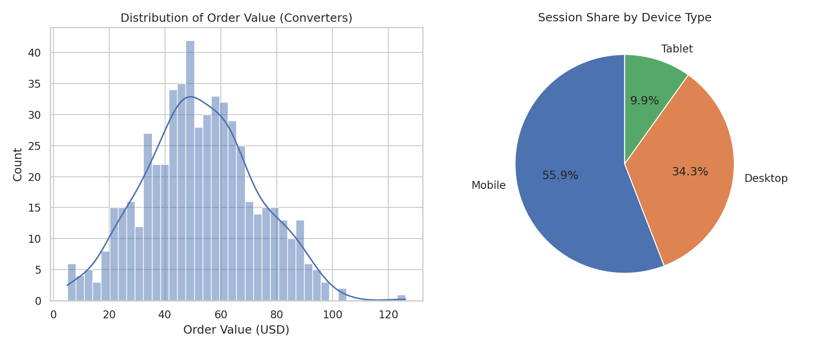
Figure 4. Left: distribution of order value among converters (right-skewed, as expected for spend data). Right: session share by device type, confirming Mobile as the dominant channel by volume.

5. Discussion
All three hypotheses were supported by the data at α = 0.05, but the tests differ meaningfully in effect size, which is the more actionable signal for a business audience:
- H1 (device/order value) showed the largest standardized effect (d ≈ 0.67) of the three tests, suggesting checkout experience differences between Mobile and Desktop are worth prioritizing.
- H2 (channel/conversion) showed a smaller but still actionable association (Cramer's V ≈ 0.10) — with enough volume, even modest percentage-point gaps in conversion rate compound into meaningfully different revenue outcomes across channels.
- H3 (website version/duration) showed a clear, monotonic ordering (A < B < C) confirmed by post-hoc testing, giving strong directional evidence in favor of the redesign, though eta-squared (0.039) indicates website version explains a modest share of the total variance in session duration — other unmeasured factors (device, content, individual browsing habits) still dominate.
A recurring theme is the distinction between statistical and practical significance: with n = 5,000, even small differences are easily detected (very small p-values across all three tests). The effect-size metrics reported alongside each test are what should actually drive prioritization decisions, not the p-values in isolation.

6. Conclusion & Business Implications
- Desktop checkout appears to support meaningfully higher order values — worth investigating whether Mobile checkout friction (form length, payment options) is suppressing basket size.
- Email and Organic Search are the highest-converting channels; reallocating some Paid Ads / Social Media budget toward retention email or SEO investment may improve blended conversion rate.
- The website redesign (version C in particular) measurably increases engagement time and should be considered for a full rollout, pending a broader test also measuring downstream conversion and revenue impact.
Overall, the hypothesis testing approach validated all three hypotheses with statistically robust, cross-checked results (each test was corroborated by a second method where applicable — e.g., the statsmodels OLS ANOVA table matched scipy's f_oneway output), giving confidence that these findings are not artifacts of a particular test implementation.

7. Limitations & Future Work
- Data is self-generated/synthetic rather than drawn from a live production system; real-world data would likely show additional confounding (e.g., returning vs. new customers, seasonality, promotional pricing).
- The website-version comparison assumes random assignment as in a true A/B/C test; in practice, allocation mechanisms should be verified before causal claims are made.
- Multiple hypothesis testing across three independent questions was not corrected with a family-wise adjustment (e.g., Bonferroni), since each test addresses a distinct business question rather than multiple comparisons within one question; the Tukey HSD post-hoc within H3 does apply its own family-wise correction.
- Future work could extend this to a two-way ANOVA (device × website version interaction on duration) or a logistic regression model of conversion incorporating all available features simultaneously.

8. Appendix: Python Code
Full code is available in the accompanying GitHub repository under /scripts. Key excerpts below.

8.1 Dataset Generation (excerpt)
device_type = rng.choice(['Mobile','Desktop','Tablet'], size=n, p=[0.55,0.35,0.10])
marketing_channel = rng.choice(['Organic Search','Paid Ads','Social Media',
'Email','Referral'], size=n,
p=[0.30,0.25,0.20,0.15,0.10])
website_version = rng.choice(['A','B','C'], size=n, p=[0.34,0.33,0.33])

8.2 T-test (H1)
t_stat, t_p = stats.ttest_ind(mobile_vals, desktop_vals,
equal_var=(levene_p > ALPHA))

8.3 Chi-square Test (H2)
contingency = pd.crosstab(df['marketing_channel'], df['converted'])
chi2, chi2_p, dof, expected = stats.chi2_contingency(contingency)

8.4 One-way ANOVA + Post-hoc (H3)
f_stat, anova_p = stats.f_oneway(*groups)
model = ols('session_duration_sec ~ C(website_version)', data=df).fit()
anova_table = sm.stats.anova_lm(model, typ=2)
tukey = pairwise_tukeyhsd(df['session_duration_sec'],
df['website_version'], alpha=0.05)

Repository: see README.md in the project root for setup and run instructions.

