SmartWindow
A SmartWindow is a SmartContainer that has its own window and default frame. A SmartWindow can be he main window of an application or a subindow.
After you create the SmartObjetct masters tou need to build an application screen, the first step in assembling the screen is to open a SmartContainer, sucj as a SmartWindow. The you can insert instances of he SmatObjetts into the SmartWindow and link them together to ptouce your application screen
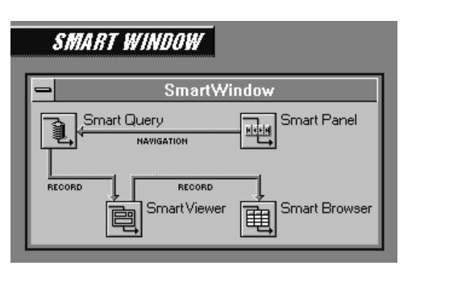
A SmartContainer such as a SmartWindow has the following important functions in a SmartObject application:
Create, initialize, and destrioy theit contents.
Manege paging
Create links between the objects it contains
Pass links from a contained SmartObject to an object extremal to the SmartContainer
What are SmartObjects?
SmartObjetcts are external procedures that encapsulate standerd UI and fuctionlity. The set of SmartObjects provided with the ADM are useful for typical database applications.
For example, most database aplications view data, so the ADM provides a SmartV8Viewer Object. A SmartV8Viwer’s main purpose is to display data. Most databse applications alos define a set of records to fetch from a database, so the ADM provides a SmartV8Query object.
A SmartV8Query’s main purpose is to fetch records from a databse and make them available to other objects. Each of these SmartObjects represents a component part of a typical databse application.

Each SmartObject must know how to interact with other SmartObjects. For example, the SmartV8Query and SmartV8Viewer work together in predefined ways. The SmartV8Query tells the SmartV8Viewer what records to display on the application screen. Each of these objects expects the other to behave in specific ways; each has responsibilities to the other.
As a developer, you can quickly assemble SmartObjects together to build many different application screens. If a SmartObject behaves in way that you don't like, you can customize it or override its default behaviors. If the set of available SmartObjects does not suit your needs, you can create new SmartObjects, giving them different behaviors better suited to the role you assign them in your application.
Why Use the ADM?
ABL is a rich language that gives developers much leeway as to how they solve development problems. As a conseguence, you might be unsure of how to best approach.
Maintainability – Organizing your development process so that applications are easy to maintain.
Standard look and feel – Establishing a consistent look and feel to give your applications a professional touch and enhance usability
AppBuilder Tool Bar
Use the Tool Bar as a shortcut for some of the more frequently used AppBuilder menu commands
Create a new AppBuilder procedure file.
A special class of a OpenEdge procedure file generated by the AppBuilder. AppBuilder procedure files include window procedure (.w) files, SmartObject master (.w) files, method library (. i) files, structured include (. I) files, and structured procedure (.p) files.
Open an existing AppBuilder procedure file.
Save the contents of the current buffer to the current procedure file.
Current Buffer: The contents displayed in the current design window or current Section Editor window.
Current procedure file: The AppeBuilder procedure file associated with the current window
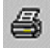Print the currently selected procedure.
Display the Procedure Settings dialog box for the current procedure file.
A dialog box that allows you to modify characteristics for the current procedure. To access, choose the Procedure Settings button on the Tool Bar

Run ABL code for the current procedure.
ABL code: An application development language which is a highly readable syntax employing a default behavior while performing the work of multiple 3GL statements.
Current procedure: The AppBuilder procedure associated with the current window
Access the Section Editor for the Selected procedure.
Code section editor: An AppBuilder editor used to edit code in the current AppBuilder procedure file. When you invoke the Section Editor, it defaults to the Trigger section of the AppBuilder procedure file for the current object, if possible, and otherwise displays the Main Block code. Access the Section editor by selecting the button on the Tool Bar of the AppBuilder window. See also the Section Editor Window.
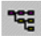Access the list objects dialog box, which displays a list of current basic objects and SmartObject instances.
List Objects dialog box: A dialog box that lists of all the basic objects and SmartObject instances in an AppBuilder session. The List Objects dialog box displays the name, type, label/title, and parent for each basic object and SmartObject instance. It also displays whether each object is currently viewed, enabled, or hidden, and displays the name of the database and database table associated with each object.
You can sort the objects list and access the property sheet for an objects list and access the property sheet for an object in the list. You access the List Objects dialog box by selecting its button (pictures below) on the Tool Bar of the AppBuilder window
Basic object: A visual element of a graphical user interface such as a menu, a frame, a window, or a fill-in. Basic objects are also known as user-interface components (UICs).
SmartObject instance: A copy of a SmartObject master running in memory. Many SmartObject instances can be created from a single SmartObject master file.
Access the Property Sheet for the selected object, or show the properties for the selected SmartObject instance.
Property Sheet: Dialog boxes for basic objects and SmartObject instances that you use to define and modify characteristics for the selected object. Object Property Sheets allow you to modify characteristic such as name, title, dimension, layout, and run-time attributes, while SmartObject instance Property Sheets allow you to edit instance attributes. Access the object Property Sheet by double clicking on the object.

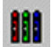Set background and foreground colors for all selected objects.

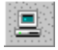Local development mode. This button appears only if you are licensed to use WebSpeed. For more information see WebSpeed Development Mode.
WebSpeed Development Mode: The AppBuilder has two development modes, one for client/server applications and one for WebSpeed applications. These modes affect how the AppBuilder compiles, runs and saves objects.
The client/server mode is also known as the local mode. In this mode, any files that you create are saved to a local directory, and objects that you run are run by a local OpenEdge client. However, the client could be connected to a remote database.
The WebSpeed mode is also known as the remote mode. In this mode, any files that you create are saved to your Web server/Transaction server machine. Note that your Web server might be located on the same machine as the AppBuilder.
The key factor is that any work you do (saving and running objects) in the AppBuilder while it is in WebSpeed mode takes place in a Web environment. In WebSpeed mode, any objects that you run are served by your Web server and run by the WebSpeed Transaction Server.
To select the development mode, toggle the development mode button on the right side of the AppBuilder toolbar. This is the Development Mode button in remote (WebSpeed) mode:
This is the development Mode button in local (client/server) mode:
If you are developing only WebSpeed applications, you will probably work in the remote development mode so that all your objects are saved to and tun by the Transaction Server.
If you are building OpenEdge and WebSpeed Applications or objects that you eventually want to run in both environments, you might altemate between development modes. Keep in mind that if the AppBuilder is in local (client/server) mode, you cannot run Web objects.
Note: The “Save” option saves objects to their place of origin, regardless of the AppBuilder Development mode. To change the “Save” Location, you must use “Save As”.
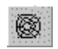Remote development mode. This button appears only if you are licensed to use WebSpeed. For more information see WebSpeed Development Mode.

AppBuilder Object Palette
Use the Object Palette to insert basic objects and SmartObject instances, and to create SmartObject masters. On Windows, you can also insert ActiveX controls. You can resize the Object Palette with your mouse, and you can also add custom basic objects and SmartObjects to the Palette.
Menu: Provide access to the Object Palette pull-down menu
A vertically displayed list of menu elements (menu items and submenus) appearing when the user selects a menu tittle in a menu bar.

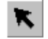Disable insertion mode and change icon to pointer image.
Insertion mode: In insertion mode, the mouse no longer serves as a pointer and can only be used to drew and insert field-level objects, SmartObject instances, and OCXs. In insertion mode, when the pointer is located in a design window, the AppeBuilder displays the pointer as an icon corresponding to the object being inserted. You can lock the AppBuilder in insertion mode by clicking the mouse select button on an icon in the Object Palette Twice.
Pointer: An arrow symbol representing movement of the mouse. By positioning the pointer and clicking buttons on the mouse, you can select data, icons, objects, and commands to initiate and complete actions. When you make a selection on the object palette, the AppBuilder activates insertion mode and displays the pointer as an icon representing the basic object or SmartObject type being inserted.
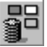 Insert database fields
Insert a query
A set of instructions used to find the contents of one or more tables in your database. Creating a query consists of selecting the following:
- Tables that comprise the query
- Criteria you want to use to process the information in the query
- Fields you want to display
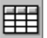Insert a browse
An object which displays the results of a database query.
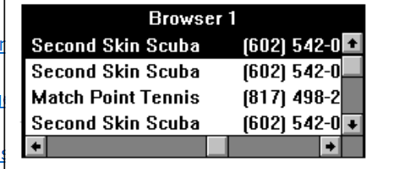
An object which displays the results of a database

Insert a frame
A display area within a window used to display field-level objects and SmartObject instances.
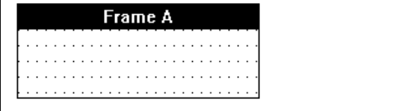
Insert a rectangle
A decorative parallelogram (all of whose angles equal 90 degrees) displayed in a frame or in a frame background. Rectangles are display-only and cannot receive user input. Its edge consists of a foreground color and its interior consists of a background color.
Insert an image
A field-level object used to display an image from a graphics file. The DEFINE IMAGE Statement creates an image object and optionally makes an association between the object and an association between the object and an operating system image file at complete time. Use of the image-size options without the FILE option creates an image object that is associated with an image file at run time.
Insert a radio set
A series of buttons representing a single field or variable, with each button representing a different value. Derived from the preset tuning button on many automobile radios, when one button is selected, any previously selected button is deselected.
Insert a toggle box
A small box that represents a logical value, sometimes called a check box. Only values of type LOGICAL, with or without extents, can be viewd as toggle boxes. The presence (true) or absence (false) of filling in the toggle box indicates the current value.
Insert a slider
Insert a button
Insert a selection list
Insert an editor
Insert a combo box
Insert a fill-in
Insert a text object
Insert a an ocx
Insert a spin buttons (ActiveX)
Insert a combo box (ActiveX)
Insert a time (ActiveX)
Insert a SmartDataObject instance or create a SmartDataObject master
Insert a Simple SmartObject
Insert a SnartFolder instance
Insert a SmartPanel instance
Insert a SmartDataBrowser instance or create a SmartDataBrowser master
Insert a SmarDataViewer instance or create a SmartDataViewer master
Insert a SmartDataField
Insert a SmartFilter
Insert a SmartToolbar
Insert a SmartContainer instance
Create a SmartBusinessObject master or insert an instance
Insert a SmartConsumer object instance
Insert a SmartRouter object instance
Create a custom SmartB2BObject master or insert a custom or dynamic instance
Insert a SmartSender object instance
Insert a SmartReceiver object instance

