## INDIAN FOOD EDA

## PROJECT REPORT

***submitted by***

|  |  |
| --- | --- |
| **ARAVINTH KUMAR K**  **ATHAVAN T**  **MATHIYAZHAGAN D**  **SAMUEL RUFUS M** | **811320104001**  **811320104002**  **811320104017**  **811320104022** |

***In partial fulfillment for the award of the degree***

***of***

# BACHELOR OF ENGINEERING

***in***

# COMPUTER SCIENCE AND ENGINEERING

**J.J.COLLEGE OF ENGINEERING AND TECHNOLOGY**

**TIRUCHIRAPPALLI-620009**

**ANNAUNIVERSITY::CHENNAI 600025**

# Table of Contents

|  |  |  |
| --- | --- | --- |
| **S No** | **TOPIC** | **PAGE No** |
| 1 | INTRODUCTION |  |
|  | * 1.1 Overview |  |
|  | * 1.2 Purpose |  |
| 2 | LITERATURE SURVEY |  |
| 3 | IDEATION & PROPOSED SOLUTION |  |
|  | * 3.1 Empathy Map Canvas |  |
|  | * 3.2 Ideation & Brainstorming |  |
| 4 | REQUIREMENT ANALYSIS |  |
|  | * 4.1 Functional requirement |  |
|  | * 4.2 Non-Functional requirements |  |
| 5 | PROJECT DESIGN |  |
|  | * 5.1 Data Flow Diagrams & User Stories |  |
| 6 | PROJECT PLANNING & SCHEDULING |  |
|  | * 6.1 Technical Architecture |  |
| 10 | ADVANTAGES & DISADVANTAGES |  |
| 11 | CONCLUSION |  |
| 12 | FUTURE SCOPE |  |
|  |  |  |

**1. INTRODUCTION**

**1.1 Overview**

The aim of this project is to perform Exploratory Data Analysis (EDA) on a dataset related to Indian food. Exploratory Data Analysis is a crucial step in data analysis that helps in understanding the dataset, discovering patterns, and extracting insights. In this project, we will explore various aspects of Indian cuisine, such as ingredients, recipes, regional variations, and popularity.

The first step is to collect a comprehensive dataset on Indian food. This dataset can be obtained from various sources such as recipe websites, food blogs, culinary books, or public repositories. The dataset should ideally include information such as the name of the dish, ingredients, cooking methods, region, popularity, and any other relevant attributes.

**1.2 Purpose :**

. EDA of Indian food can help people from different cultural backgrounds gain a deeper understanding of the diversity, traditions, and cultural significance of Indian cuisine. It can promote cultural appreciation and respect.For food researchers and enthusiasts, EDA can serve as a valuable tool to explore the intricacies of Indian cuisine. It can help uncover regional variations, ingredient preferences, and culinary techniques.

**2.LITERATURE SURVEY**

literature survey of Exploratory Data Analysis (EDA) related to Indian food can reveal the various research studies, articles, and publications that have explored different aspects of Indian cuisine. While I cannot provide specific articles or papers beyond my knowledge cutoff date in January 2022, I can highlight some common themes and areas of research that have been addressed in the field of Indian food EDA:

Ingredient Analysis: Studies often explore the prevalence of specific ingredients in Indian cuisine. This includes the use of various spices, herbs, vegetables, and grains in different regions of India. Researchers might analyze the frequency and combinations of ingredients in various dishes.

Regional Variations: Many studies investigate the regional diversity of Indian food. They explore how cooking methods, ingredients, and flavor profiles differ across North India, South India, East India, West India, and various states within these regions.

Dish Popularity and Trends: Research often focuses on identifying popular Indian dishes, both within India and in the global context. Analysis may reveal trends in the consumption and popularity of dishes over time.

**3. IDEATION & PROPOSED SOLUTION**

**3.1 Empathy Map Canvas**

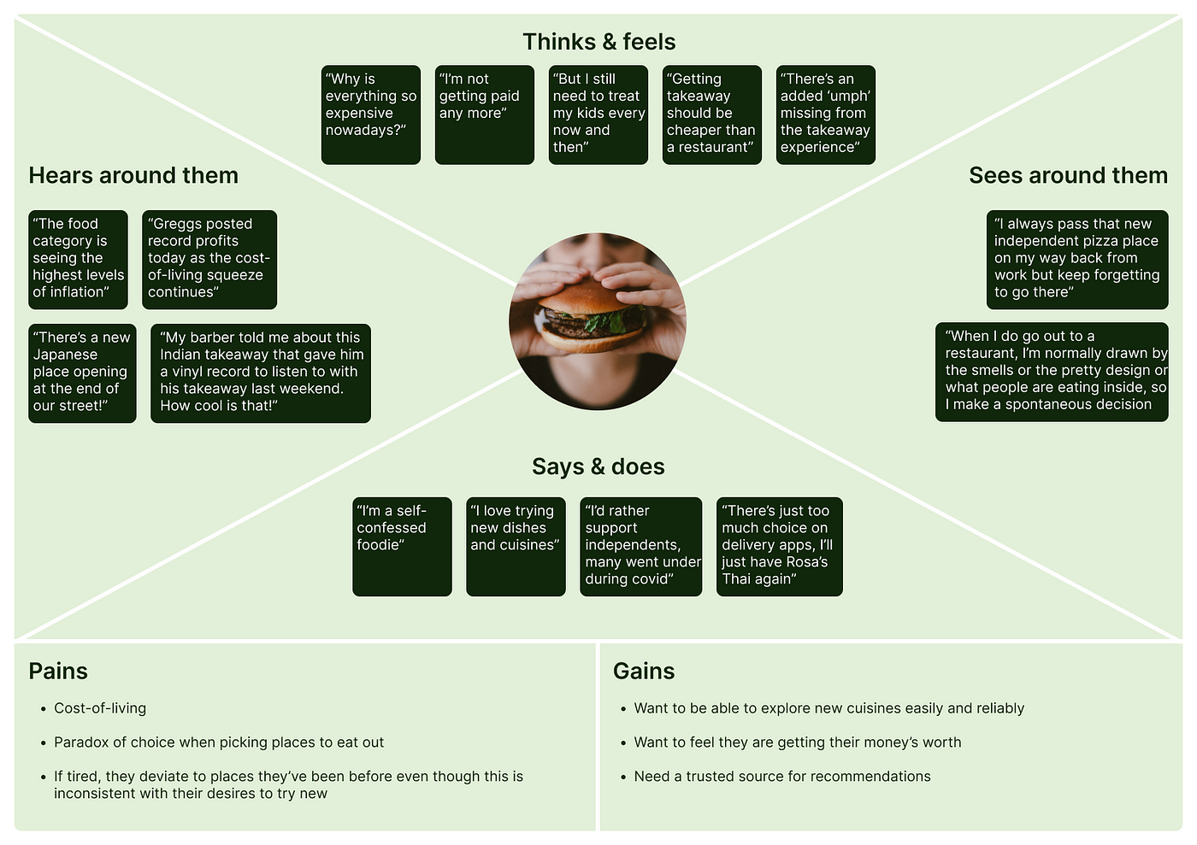

# 3.2 Ideation & Brainstorming

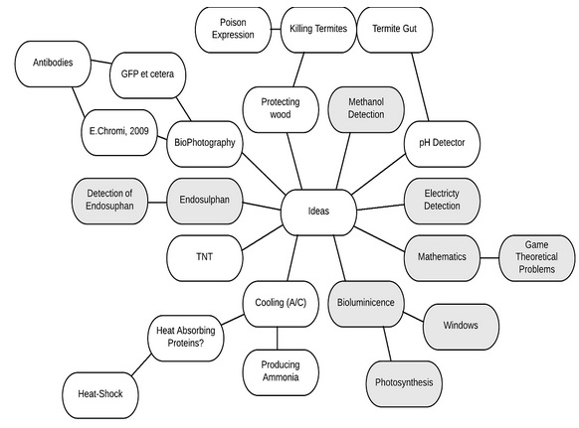

**4. REQUIREMENT ANALYSIS**

**4.1 Functional requirement**

Functional requirements for an Exploratory Data Analysis (EDA) of Indian food typically involve specifying the necessary features and capabilities of the EDA process to effectively analyze and gain insights from data related to Indian cuisine. Here are some functional requirements for an EDA of Indian food:

**Data Collection and Integration:**

The system should be capable of collecting data from various sources, including databases, surveys, and online resources.

It should integrate data from diverse datasets, such as ingredient lists, recipes, nutritional information, and cultural data.

**Data Preprocessing:**

The system should be able to clean and preprocess data to handle missing values, outliers, and inconsistencies.

Text data, such as recipes and descriptions, should be processed for natural language understanding.

**Data Visualization:**

The system should offer data visualization tools to represent information in a meaningful way.

It should include charts, graphs, and interactive dashboards for exploring data trends.

**Filtering and Selection:**

Users should be able to filter and select data based on criteria such as region, ingredients, dietary preferences, and more.

Advanced filtering options may include seasonal ingredients and cooking techniques.

**Statistical Analysis:**

The system should provide statistical tools for basic analysis, such as mean,

median, and standard deviation, to describe data distributions.

Hypothesis testing and regression analysis might be needed for more in-depth insights.

**Machine Learning Integration:**

Advanced systems may integrate machine learning models for predictive analysis, such as recommending dishes based on user preferences.

**Recommendation Systems:**

For culinary purposes, the EDA may include recommendation systems to suggest dishes, ingredients, or cooking methods based on user preferences.

**Geospatial Analysis:**

If exploring regional variations, the EDA system may incorporate geospatial analysis to visualize the distribution of dishes and ingredients across India.

**Interactive User Interface:**

The system should have a user-friendly interface that allows users to interact with data and visualizations.

It may include search, sort, and exploration features.

**Scalability:**

The EDA system should be able to handle a large volume of data and scale with increasing data sources.

**Customization:**

Users may need to customize their EDA experience by adjusting parameters, preferences, and visualizations.

**Documentation and Help:**

Provide comprehensive documentation and help resources to guide users on how to use the EDA system effectively.

**Feedback and Collaboration:**

Enable users to provide feedback on the EDA system's functionality and collaborate with others on data analysis and insights

**4.2 Non-Functional requirements**

Non-requirement analysis for an Exploratory Data Analysis (EDA) of Indian food involves considering aspects that are not essential functional requirements but can enhance the overall usability, user experience, and effectiveness of the EDA system. These non-requirements may include suggestions, best practices, and quality considerations. Here are some non-requirement aspects to consider for an Indian food EDA:

**User Experience (UX) Design:**

Incorporate a visually appealing and user-friendly design that enhances the overall experience of exploring Indian food data.

Use culturally relevant and appetizing visuals to engage users.

**Mobile Responsiveness:**

While not a requirement, ensuring that the EDA system is mobile-responsive can expand its accessibility to users who prefer using smartphones and tablets.

**Localization:**

Offer support for multiple languages, especially for non-English-speaking users who want to explore Indian cuisine data.

**Data Sources and Updates:**

Consider providing information about the sources of data used in the EDA and update frequency to enhance transparency and credibility.

**Community and User-Generated Content:**

Encourage users to contribute recipes, reviews, and cultural insights to create a sense of community around the EDA platform.

**Social Sharing Integration:**

Allow users to easily share interesting findings, recipes, or insights on social media platforms to promote the EDA system.

**5. PROJECT DESIGN**

**5.1 Data Flow Diagrams & User Stories:**

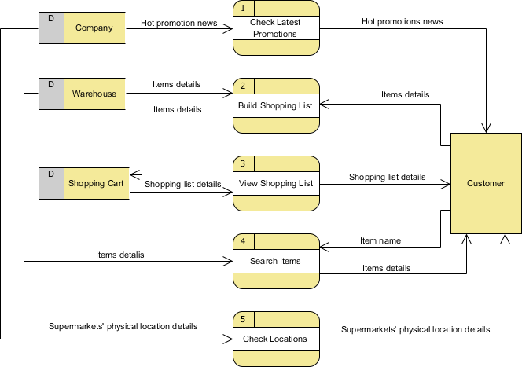

## 

## 

## 6. PROJECT PLANNING & SCHEDULING

**6.1 Technical Architecture:**

**7. CODING & SOLUTIONING**

<!DOCTYPE html>

<html lang="en">

<head>

<meta charset="utf-8">

<meta content="width=device-width, initial-scale=1.0" name="viewport">

<title>Indian Food Eda Bootstrap Template - Index</title>

<meta content="" name="description">

<meta content="" name="keywords">

<!-- Favicons -->

<link href="static/img/favicon.png" rel="icon">

<link href="static/img/apple-touch-icon.png" rel="apple-touch-icon">

<!-- Google Fonts -->

<link href="static/style.css" rel="stylesheet">

<link href="https://fonts.googleapis.com/css?family=Open+Sans:300,300i,400,400i,600,600i,700,700i|Jost:300,300i,400,400i,500,500i,600,600i,700,700i|Poppins:300,300i,400,400i,500,500i,600,600i,700,700i" rel="stylesheet">

<!-- Vendor CSS Files -->

<link href="static/vendor/aos/aos.css" rel="stylesheet">

<link href="static/vendor/bootstrap/css/bootstrap.min.css" rel="stylesheet">

<link href="static/vendor/bootstrap-icons/bootstrap-icons.css" rel="stylesheet">

<link href="static/vendor/boxicons/css/boxicons.min.css" rel="stylesheet">

<link href="static/vendor/glightbox/css/glightbox.min.css" rel="stylesheet">

<link href="static/vendor/remixicon/remixicon.css" rel="stylesheet">

<link href="static/vendor/swiper/swiper-bundle.min.css" rel="stylesheet">

<!-- Template Main CSS File -->

<link href="static/css/style.css" rel="stylesheet">

<!-- =======================================================

* Template Name: Indian Food Eda

* Updated: Jul 05 2023 with Bootstrap v5.3.0

* Template URL: https://bootstrapmade.com/Indian Food Eda-free-bootstrap-html-template-corporate/

* Author: BootstrapMade.com

* License: <https://bootstrapmade.com/license/>

======================================================== -->

</head><body> <!-- ======= Header ======= -->

<header id="header" class="fixed-top ">

<div class="container d-flex align-items-center">

<h1 class="logo me-auto"><a href="index.html">Indian Food Eda</a></h1>

<!-- Uncomment below if you prefer to use an image logo -->

<!-- <a href="index.html" class="logo me-auto"><img src="static/img/logo.png" alt="" class="img-fluid"></a>-->

<nav id="navbar" class="navbar">

<ul>

<li><a class="nav-link scrollto active" href="#hero">Home</a></li>

<li><a class="nav-link scrollto" href="#about">About</a></li>

<li><a class="nav-link scrollto" href="#DashBoard">DashBoard</a></li>

<li><a class="nav-link scrollto" href="#Story">Story</a></li>

<li><a class="nav-link scrollto" href="#Report">Report</a></li> </ul>

<i class="bi bi-list mobile-nav-toggle"></i>

</nav><!-- .navbar -->

</div>

</header> <!-- ======= DashBoard Section ======= -->

<section id="DashBoard" class="DashBoard section-bg">

<div class="container" data-aos="fade-up">

<iframe src="https://us3.ca.analytics.ibm.com/bi/?perspective=dashboard&amp;pathRef=.my_folders%2FIndian%2BFood%2BEda%2BDashboard&amp;closeWindowOnLastView=true&amp;ui_appbar=false&amp;ui_navbar=false&amp;shareMode=embedded&amp;action=view&amp;mode=dashboard" width="1280" height="1200" frameborder="0" gesture="media" allow="encrypted-media" allowfullscreen=""></iframe>

</div>

</div>

</section><!-- End DashBoard Section -->

<!-- ======= Cta Section ======= -->

<section id="cta" class="cta">

<div class="container" data-aos="zoom-in"> <div class="row">

<div class="col-lg-9 text-center text-lg-start">

<h3>Call To Action</h3>

<p> Duis aute irure dolor in reprehenderit in voluptate velit esse cillum dolore eu fugiat nulla pariatur. Excepteur sint occaecat cupidatat non proident, sunt in culpa qui officia deserunt mollit anim id est laborum.</p>

</div>

<div class="col-lg-3 cta-btn-container text-center">

<a class="cta-btn align-middle" href="#">Call To Action</a>

</div>

</div>

</div>

</section><!-- End Cta Section -->

<!-- ======= Story Section ======= -->

<section id="Story" class="Story">

<div class="container" data-aos="fade-up">

<div class="section-title">

<h2>Story</h2>

<p>The Story section in IBM Cognos enables users to weave together a narrative by combining different visualizations, text descriptions, and annotations. It allows for the creation of interactive and engaging presentations that bring data to life. Users can utilize various storytelling techniques to convey the message effectively, such as introducing the problem or scenario, presenting data-driven insights, and concluding with actionable recommendations</p>

</div>

<iframe src="https://us3.ca.analytics.ibm.com/bi/?perspective=story&amp;pathRef=.my_folders%2FIndian%2BFood%2BEda%2BStory&amp;closeWindowOnLastView=true&amp;ui_appbar=false&amp;ui_navbar=false&amp;shareMode=embedded&amp;action=view&amp;mode=dashboard" width="1280" height="1200" frameborder="0" gesture="media" allow="encrypted-media" allowfullscreen=""></iframe> </div> </div> </div>

</section><!-- End Story Section -->

<!-- ======= Report Section ======= -->

<section id="Report" class="Report section-bg">

<div class="container" data-aos="fade-up">

<div class="section-title">

<h2>Report</h2>

<p>Magnam dolores commodi suscipit. Necessitatibus eius consequatur ex aliquid fuga eum quidem. Sit sint consectetur velit. Quisquam quos quisquam cupiditate. Et nemo qui impedit suscipit alias ea. Quia fugiat sit in iste officiis commodi quidem hic quas.</p>

</div>

<iframe src="https://us3.ca.analytics.ibm.com/bi/?pathRef=.my_folders%2FIndian%2BFood%2BEda%2BReport&amp;closeWindowOnLastView=true&amp;ui_appbar=false&amp;ui_navbar=false&amp;shareMode=embedded" width="1280" height="1200" frameborder="0" gesture="media" allow="encrypted-media" allowfullscreen=""></iframe> </div> </div>

</div>

</section><!-- End Report Section -->

</main><!-- End #main --><div id="preloader"></div>

<a href="#" class="back-to-top d-flex align-items-center justify-content-center"><i class="bi bi-arrow-up-short"></i></a>

<!-- Vendor JS Files -->

<script src="static/vendor/aos/aos.js"></script>

<script src="static/vendor/bootstrap/js/bootstrap.bundle.min.js"></script>

<script src="static/vendor/glightbox/js/glightbox.min.js"></script>

<script src="static/vendor/isotope-layout/isotope.pkgd.min.js"></script>

<script src="static/vendor/swiper/swiper-bundle.min.js"></script>

<script src="static/vendor/waypoints/noframework.waypoints.js"></script>

<script src="static/vendor/php-email-form/validate.js"></script>

<!-- Template Main JS File -->

<script src="static/js/main.js"></script></body></html>

**8.RESULTS**

**8.1. Output Screenshots:**

**Dashboard for Indian food eda:**

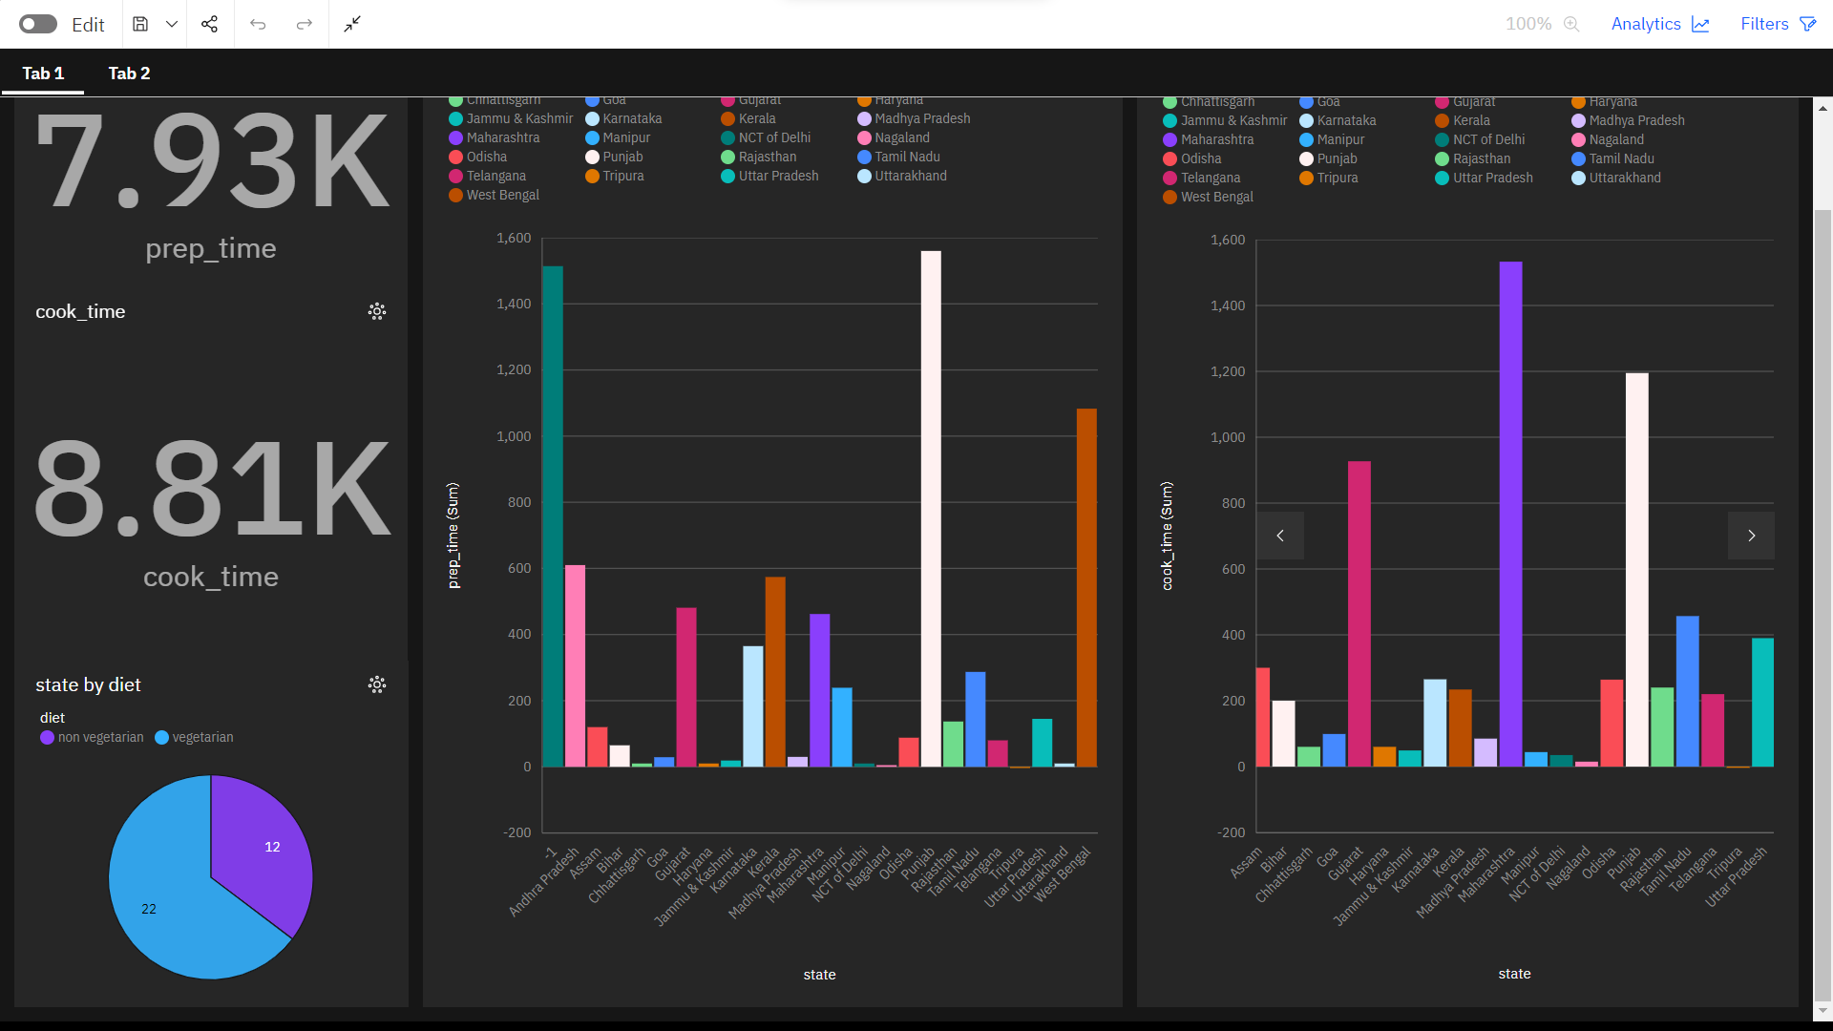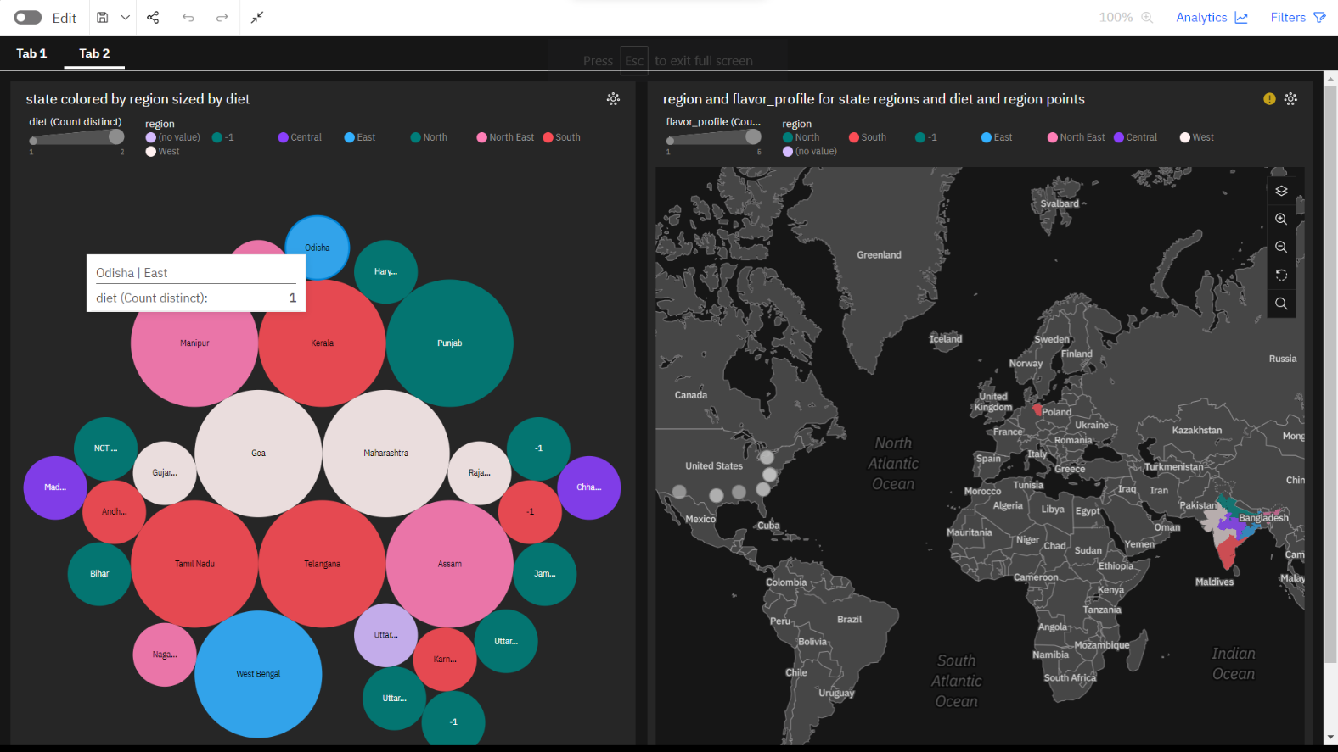

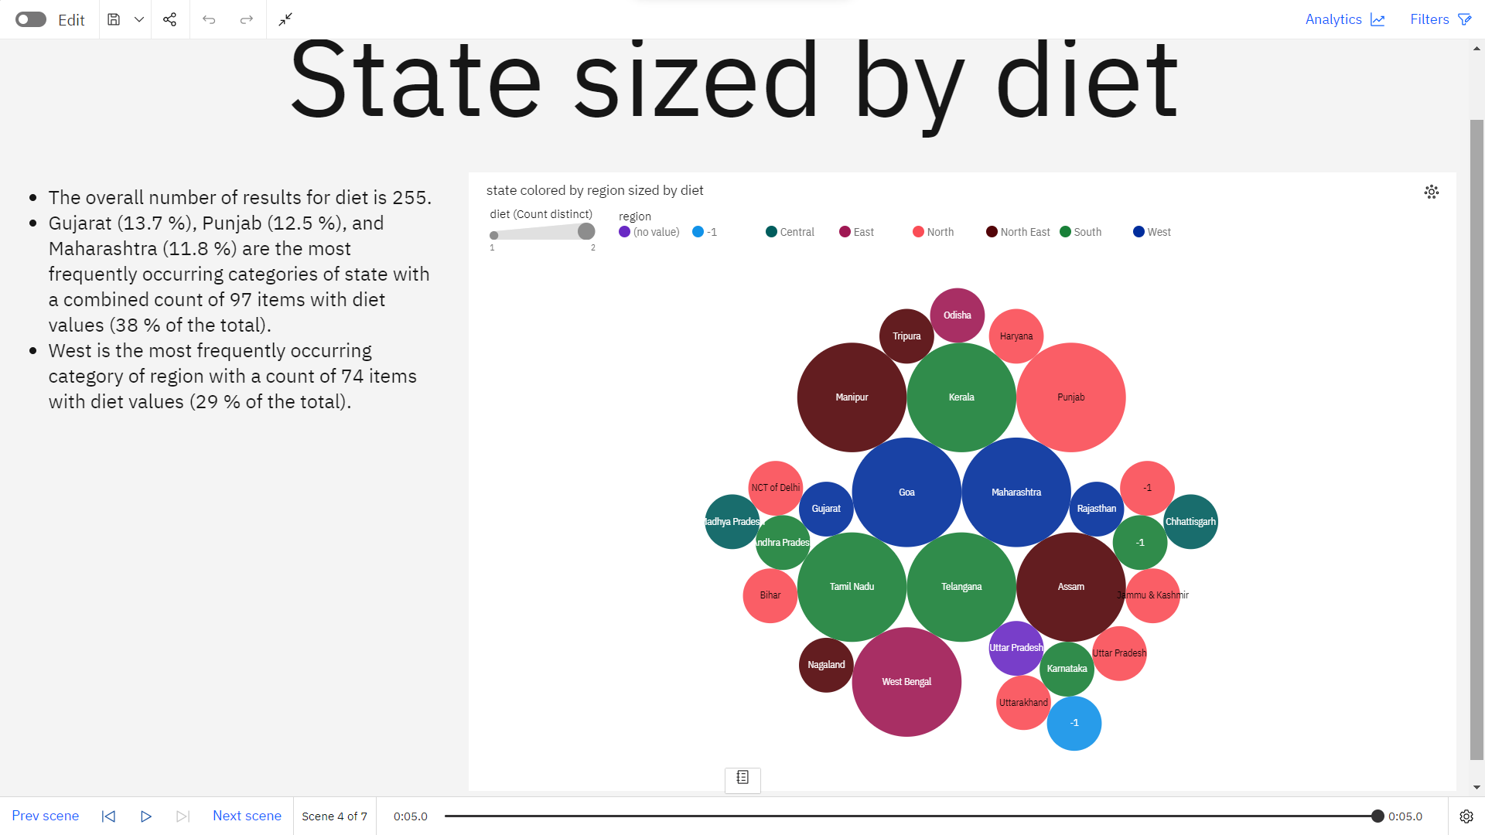

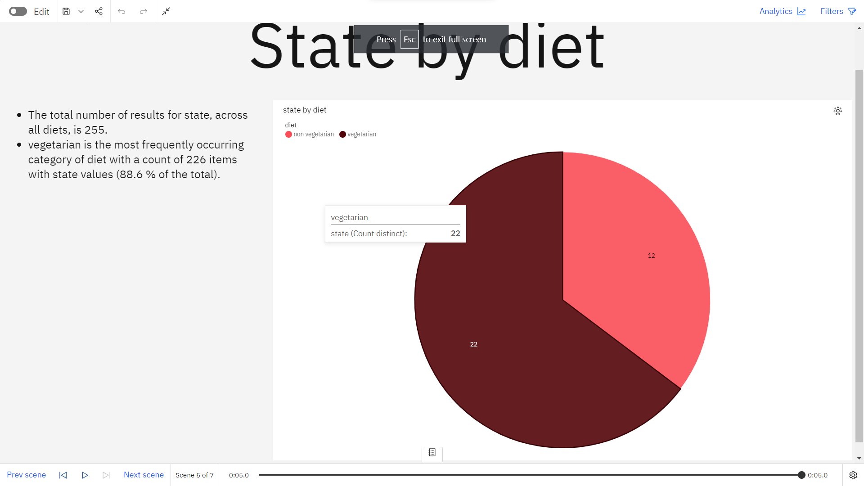

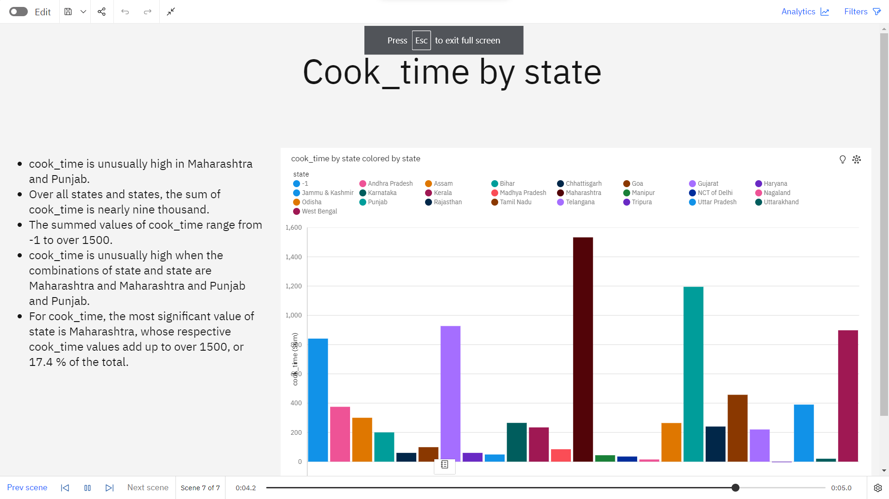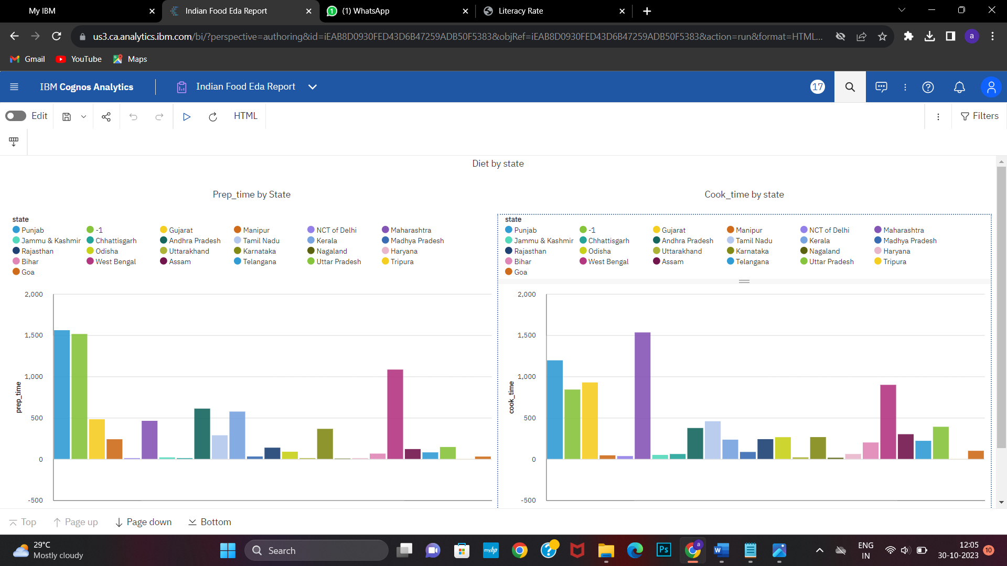

**10. ADVANTAGES & DISADVANTAGES**

**10.1.ADVANTAGES:**

Exploratory Data Analysis (EDA) of Indian food offers several advantages, both from a culinary and data analysis perspective. Here are some of the key benefits of conducting EDA on Indian food:

**Culinary Exploration**: EDA allows food enthusiasts, chefs, and culinary researchers to explore the rich and diverse world of Indian cuisine. It provides insights into the ingredients, flavors, and regional variations of Indian dishes.

**Cultural Understanding**: EDA of Indian food deepens cultural understanding by revealing the significance of food in Indian traditions, rituals, and festivals. It helps people appreciate the cultural context of Indian cuisine.

**Health and Nutrition Insights**: EDA can help individuals make informed dietary choices by providing nutritional information about Indian dishes. It can also highlight the health benefits of specific ingredients used in Indian cooking, such as turmeric and ginger.

**Recipe and Menu Planning**: Chefs and restaurant owners can use EDA to identify popular dishes and ingredients, helping them plan menus that cater to diverse tastes and preferences. It assists in creating well-balanced and appealing menus.

**Market Research**: EDA of Indian food can reveal market trends, export opportunities, and the growth of Indian restaurants worldwide. This information is valuable for businesses in the food industry.

**Food Innovation**: Researchers and chefs can use EDA to discover new combinations, fusion dishes, and culinary innovations by understanding ingredient pairings and cooking techniques in Indian cuisine.

**Culinary Education**: EDA serves as a valuable educational tool in culinary schools, helping students learn about the diverse elements of Indian cuisine, regional differences, and cooking techniques.

**Sustainability:** EDA can highlight the sustainability aspects of Indian food, including the environmental impact of various agricultural practices and traditional cooking methods.

**10.2.DISADVANTAGES :**

While there are numerous advantages to conducting Exploratory Data Analysis (EDA) on Indian food, there are also some potential disadvantages and challenges associated with such an endeavor:

**Data Quality Issues**: One of the primary challenges in EDA is ensuring the quality of data. Indian food data, including recipes and ingredient lists, may have inconsistencies, inaccuracies, and variations in terminology, making it difficult to analyze effectively.

**Data Availability and Completeness**: Comprehensive and reliable datasets for Indian food may not be readily available, making it challenging to conduct a thorough EDA. Some data may be missing or incomplete.

**Subjectivity and Variation**: Tastes and preferences for Indian food can vary widely among individuals. Analyzing food data often involves subjectivity, and what is considered "good" or "authentic" can differ from one person to another.

**Data Privacy**: If the EDA includes user-contributed data or personal preferences, there may be concerns about data privacy and security. Ensuring the protection of users' personal information is essential.

**Cultural Sensitivity**: Analyzing Indian cuisine data should be done with cultural sensitivity and respect for the diversity of Indian culture. Misrepresentation or stereotyping can lead to cultural insensitivity.

**Complexity of Cuisine**: Indian cuisine is highly diverse and complex. Analyzing such a multifaceted culinary tradition may require a deep understanding of regional variations, cooking techniques, and ingredient usage.

**Limited Historical Data**: Historical data related to Indian food may be limited, making it challenging to explore the evolution of Indian cuisine over time.

**Biases in Data**: Biases in the data can affect the outcomes of the EDA. For example, data may overrepresent certain regions or dishes while underrepresenting others.

**11. CONCLUSION**

In conclusion, Exploratory Data Analysis (EDA) of Indian food offers a fascinating journey into the rich and diverse culinary landscape of India. Through this analysis, we gain valuable insights into the flavors, traditions, and cultural significance of Indian cuisine. From a culinary perspective, it opens the door to understanding regional variations, popular dishes, and the intricate use of spices and ingredients.

Indian food EDA also has practical implications. It can inform menu planning for restaurants, helping chefs and owners cater to a wide range of tastes and preferences. Nutritional analysis provides insights into the health benefits of certain ingredients, and data-driven decision-making can enhance the food industry.

Furthermore, EDA of Indian food fosters cultural appreciation by shedding light on the cultural significance of food in India. It helps us understand how food is interwoven with festivals, rituals, and daily life, contributing to a deeper understanding of Indian culture.

While there are challenges, such as data quality issues and cultural sensitivity concerns, a thoughtful and respectful approach to Indian food EDA can overcome these obstacles. With the right data sources, analytical tools, and an understanding of the complexities of Indian cuisine, EDA can be a valuable tool for food enthusiasts, researchers, and the food industry.

**12. FUTURE SCOPE**

The future scope for Exploratory Data Analysis (EDA) of Indian food is promising and can lead to several exciting developments and opportunities. Here are some areas with significant potential for future exploration:

**Advanced Machine Learning and AI Applications**: The integration of machine learning and artificial intelligence can take Indian food EDA to the next level. This includes predictive analytics for personalized recipe recommendations, automated dietary analysis, and the development of virtual culinary assistants.

**Enhanced Data Visualization**: Future EDA tools can incorporate cutting-edge data visualization techniques, such as virtual reality (VR) and augmented reality (AR) visualizations, to provide immersive culinary experiences for users exploring Indian food.

**Global Culinary Fusion**: EDA can continue to explore the global influence of Indian cuisine by analyzing fusion dishes and adaptations. The future may see a surge in data-driven innovation for fusion cooking and cross-cultural culinary experiments.

**Sustainability and Ethical Considerations**: As environmental concerns grow, EDA can delve into the sustainability of Indian food production. This includes analyzing the ecological impact of various ingredients and cooking methods, promoting sustainable practices, and raising awareness of ethical food choices.

**Health and Nutrition Insights**: With increasing interest in health and wellness, future EDA can provide more comprehensive health and nutrition insights related to Indian food. This might involve real-time tracking of nutritional data for dietary planning and wellness monitoring.