Azure Monitoring & Auto-Alert System – Project Documentation

1. Architecture Diagram
[Insert Architecture Diagram Here – VNet → Subnet → VM → Storage Account → Azure Monitor → Alert → Action Group]

2. Project Overview
This project demonstrates a real-world Azure Monitoring and Alerting setup for a production-like virtual machine. It includes VM deployment, networking, diagnostics logging, Azure Monitor alerts, action group notifications, backup snapshots, and cost management alerts. The objective is to showcase end-to-end Azure administration skills that are essential for Azure Support Engineer and Cloud Administrator roles.

3. Step-by-Step Implementation
- 1. Create Resource Group (rg-monitoring-project).

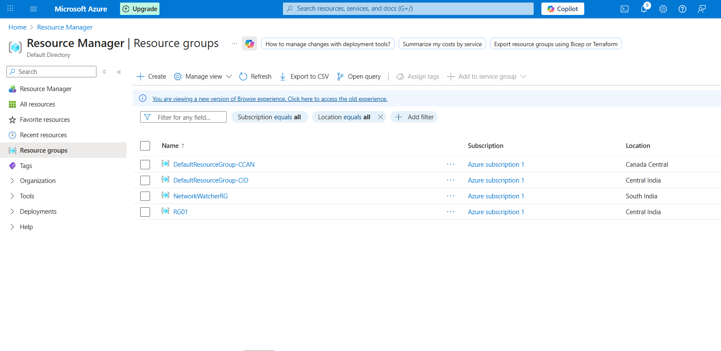

- 2. Create Virtual Network (vnet-project) with subnet (subnet-web).

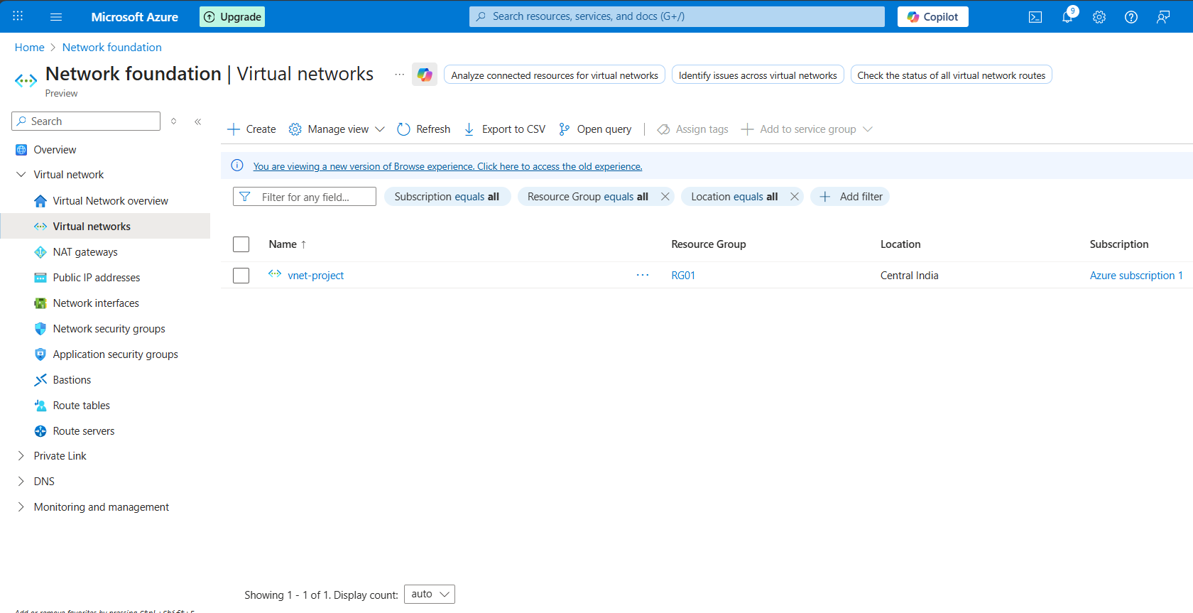

- 3. Deploy a VM (vm-webserver) using Windows or Linux.
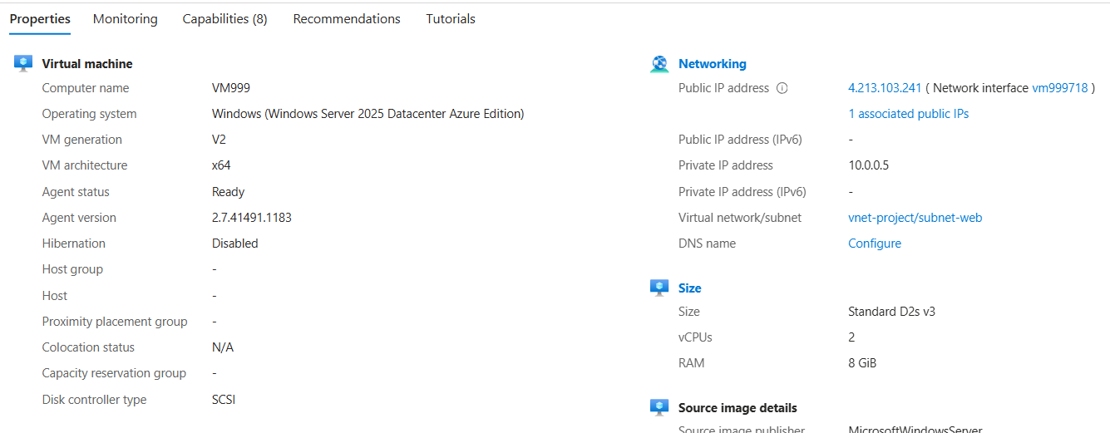

- 4. Install a web server (Apache/IIS) using Run Command.

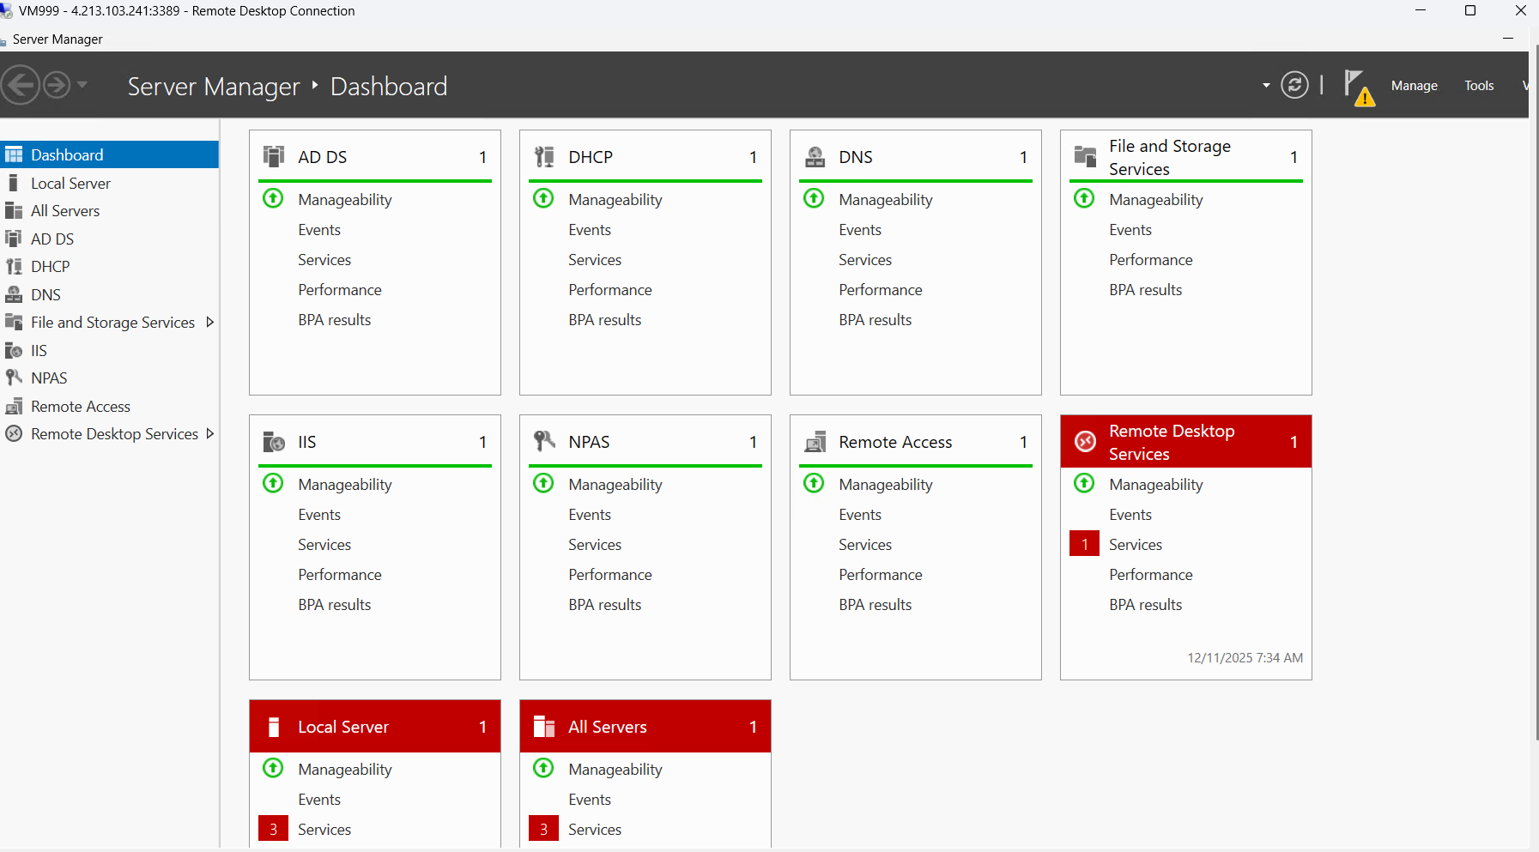

- 5. Create a Storage Account for logs.

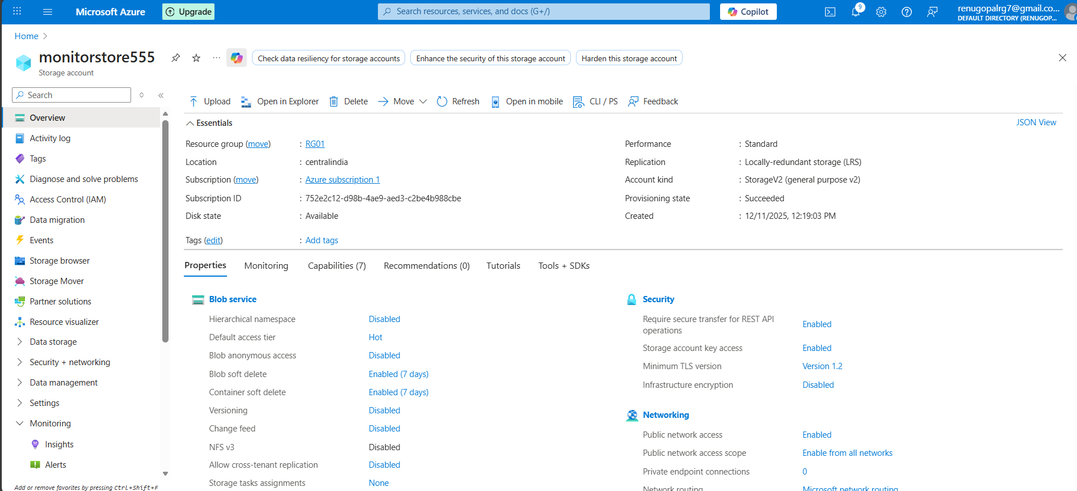

- 6. Enable Diagnostics Logging to Storage Account.

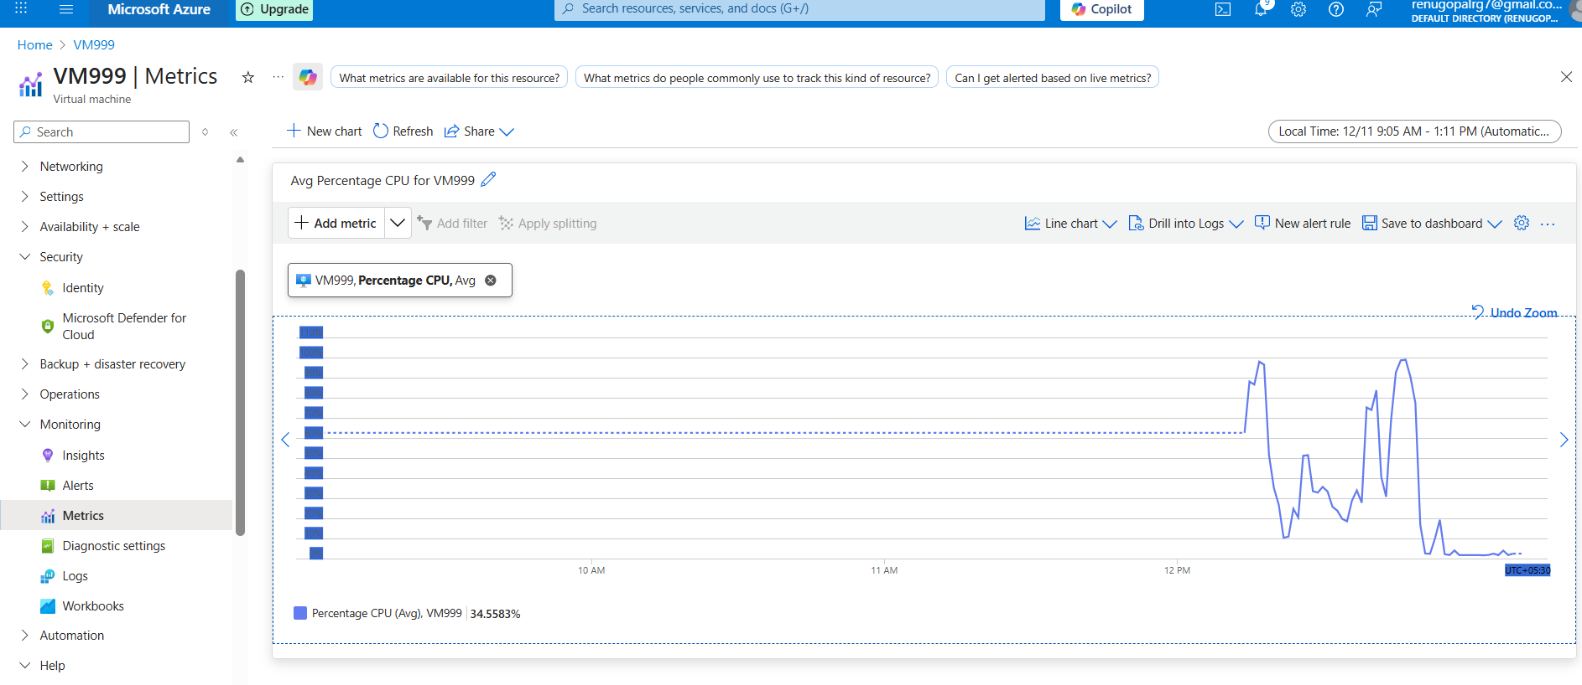

- 7. Create Azure Monitor Metric Alert (CPU > 80%).

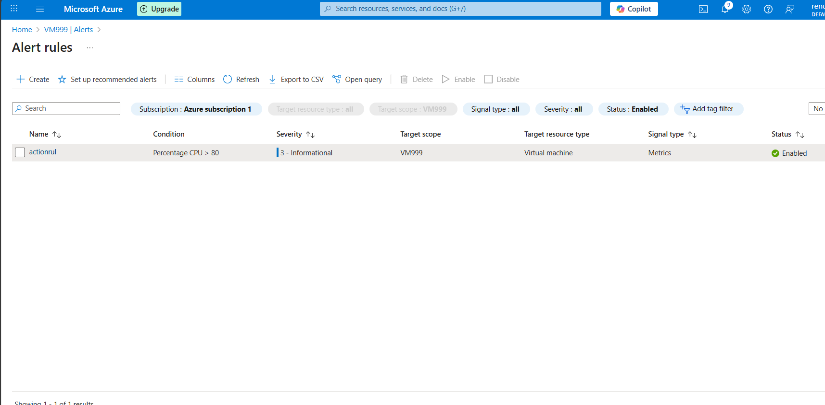

- 8. Create Action Group with Email Notification.

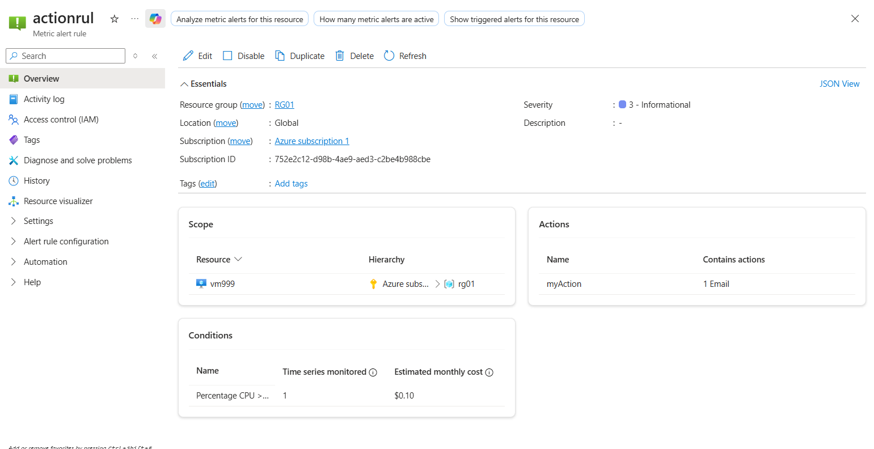
- 9. Trigger CPU load to test alert.

- 10. Create VM Snapshot for Backup.

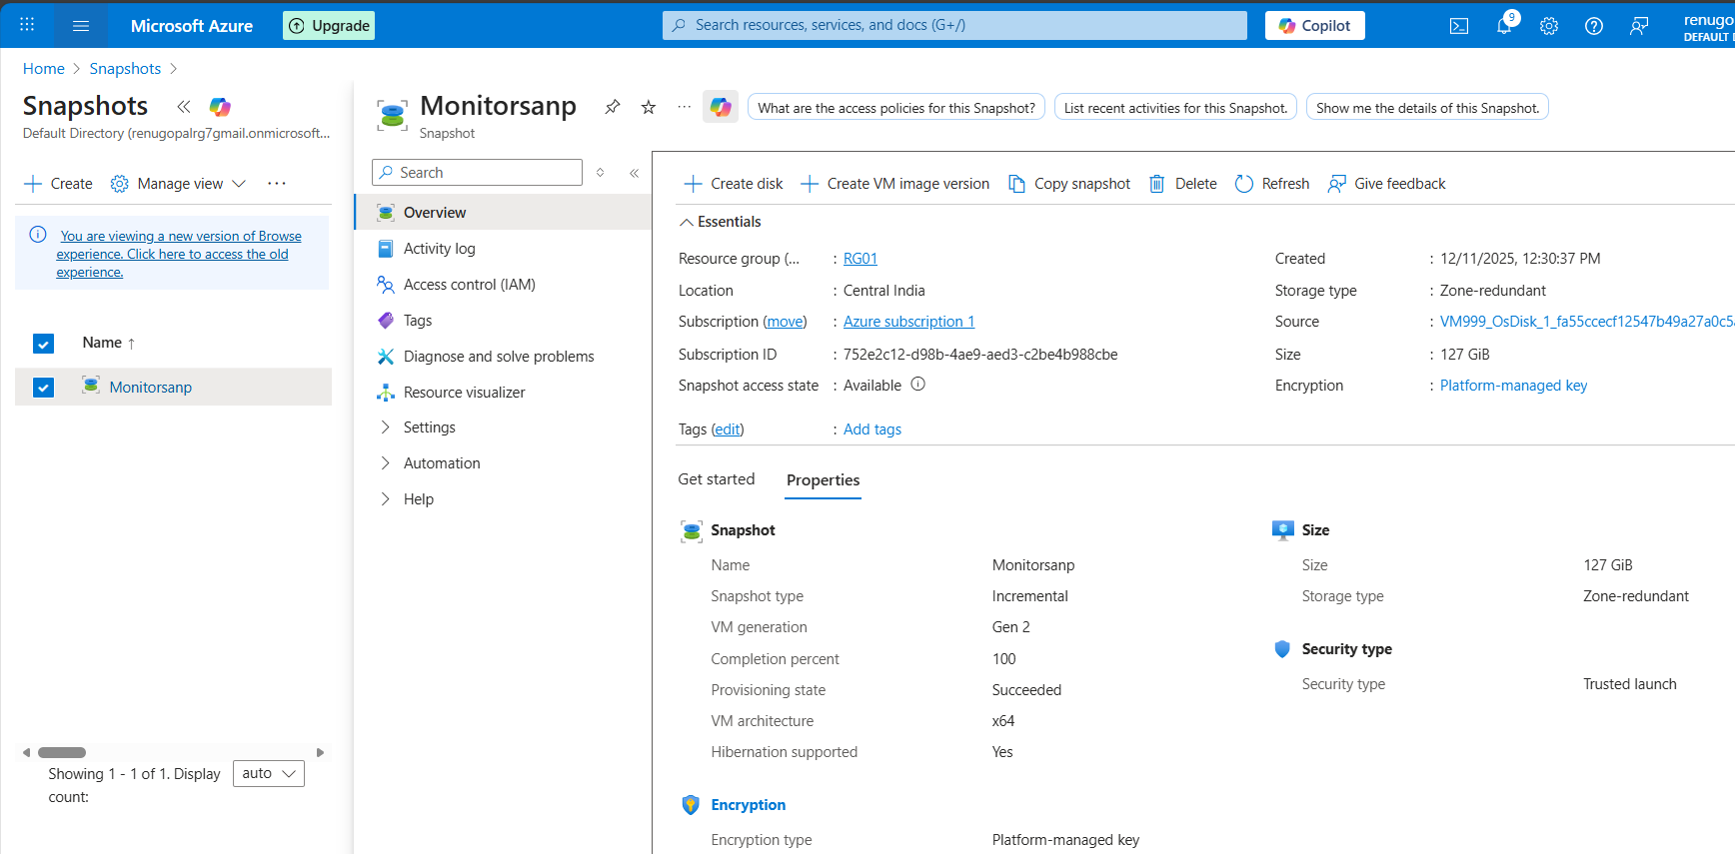

- 11. Configure Cost Budget + Alerts.

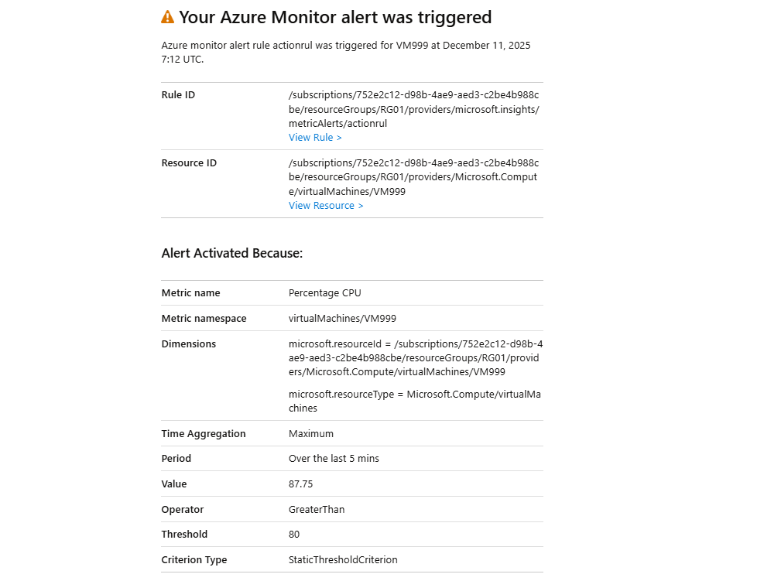

4. Resume-Ready Project Summary
Implemented an end-to-end Azure Monitoring and Alert Automation project using the Azure Portal. Configured VM diagnostics, storage logging, CPU metric alerts, email action groups, and backup snapshots. Validated alerting system by generating artificial CPU load. Demonstrated Azure administration skills, cost management, and incident response practices used in real-world cloud operations.

BY
SAMUEL RUFUS M

