**Tree Leaf Recognition**

TO-DO:

* try adding pre-trained model
* try different layers
* try different image-scales (runtime vs accuracy)
* try greyscale instead of colored?
* try different amount of epochs
* try augmentation
* implement model in tensorboard (https://tinyurl.com/tensorboardkiel)

Data:

1125 scans of 15 different tree leaf types on a white background. All orientated vertically.

Base model:

Ein Bild, das Text, Screenshot, Schrift, Zahl enthält.

Ein Bild, das Text, Screenshot, Schrift, Zahl enthält.

Pretrained model (VGG19):

**Very Deep Convolutional Networks for Large-Scale Image Recognition**

*Karen Simonyan, Andrew Zisserman*

In this work we investigate the effect of the convolutional network depth on its accuracy in the large-scale image recognition setting. Our main contribution is a thorough evaluation of networks of increasing depth using an architecture with very small (3x3) convolution filters, which shows that a significant improvement on the prior-art configurations can be achieved by pushing the depth to 16-19 weight layers. These findings were the basis of our ImageNet Challenge 2014 submission, where our team secured the first and the second places in the localisation and classification tracks respectively. We also show that our representations generalise well to other datasets, where they achieve state-of-the-art results. We have made our two best-performing ConvNet models publicly available to facilitate further research on the use of deep visual representations in computer vision.

Last layer from pretrained model: “block2_pool”

Ein Bild, das Text, Screenshot, Karte Menü, Schrift enthält.

Ein Bild, das Text, Screenshot, Schrift, Zahl enthält.

Ein Bild, das Text, Screenshot, Schrift, Zahl enthält.

Complete pretrained model (last layer: block5_pool):

Ein Bild, das Text, Screenshot, Karte Menü, Schrift enthält.

Ein Bild, das Text, Screenshot, Schrift enthält.

Ein Bild, das Text, Screenshot, Schrift, Zahl enthält.

Augmentation:

**Settings 1:**

* Basemodel
* Rotation: 40
* Width_shift: 0.2
* Height_shift: 0.2
* Shear_range: 0.2
* Zoom_range: 0.2
* Horizontal_flip: True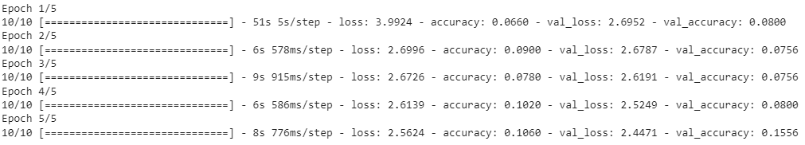

**Settings 2:**

* Basemodel
* Rotation: 180
* Horizontal_flip: True

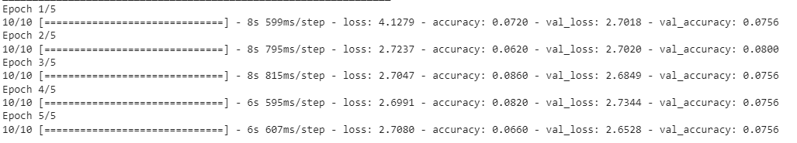

**Setting 3:**

* Basemodel
* Rotation: 180
* Width_shift: 0.2
* Height_shift: 0.2
* Shear_range: 0.2
* Zoom_range: 0.2
* Vertical_flip: True
* Channel_shift_range: 25

