Functional Specification   
Android Team Score Application

# History

|  |  |  |  |
| --- | --- | --- | --- |
| Release # | Date | Author | Change Description |
| 1.0 | 2/17/2024 | Vince Gamble | Draft Functional Specification |
|  |  |  |  |

# Introduction:

This Functional Specification documents the requirement for "Team Score Card" app. The App will provide score keeping for one to four individuals along with predefine scoring game determined by the user.

## Requirements:

The App will run on an Android device running the OS Android 11 or higher.

## Operation

Launching the App will display the last saved round and display the game summary screen from when the application exits. The Resume game will allow the user to review the current scores and continue scoring the game. If the saved golf course no longer exists then the user will be provided with a “Select Course or Add a New Course" screen.

Features  
The bottom navigation bar will allow the user to switch between scoring displays.

1. Gross – The actual strokes a player had for the hole.
2. GHIN – The cap strokes are determined by the player’s handicap.
3. Net – The net adjusted stroke score determined by the player’s handicap.
4. Stableford - Awards points for the number of strokes taken on each hole in relation to par,
5. Point Quota - Player earn points for their scores on each hole,
6. Team Match Play - Team with the lowest total score for the hole wins the hole.
7. Player Match Play - The player with the lowest total score for the hole wins the hole.
8. 9 Game - Three golfers in which points are given based on the golfer's score.

# Top Level Team Score MenuApplication Screens

The application has four main screens –

Game Summary Screen - will display players overall scores and details and with the Team scores. Game Summary Screen – Menu – Display the “About App” and the “Contact email address.”

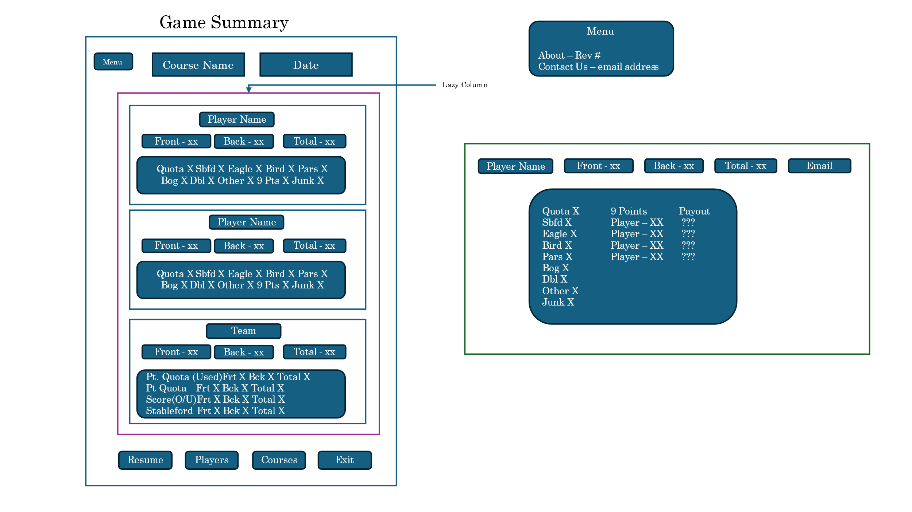

Courses Screen – will display a list of available courses.

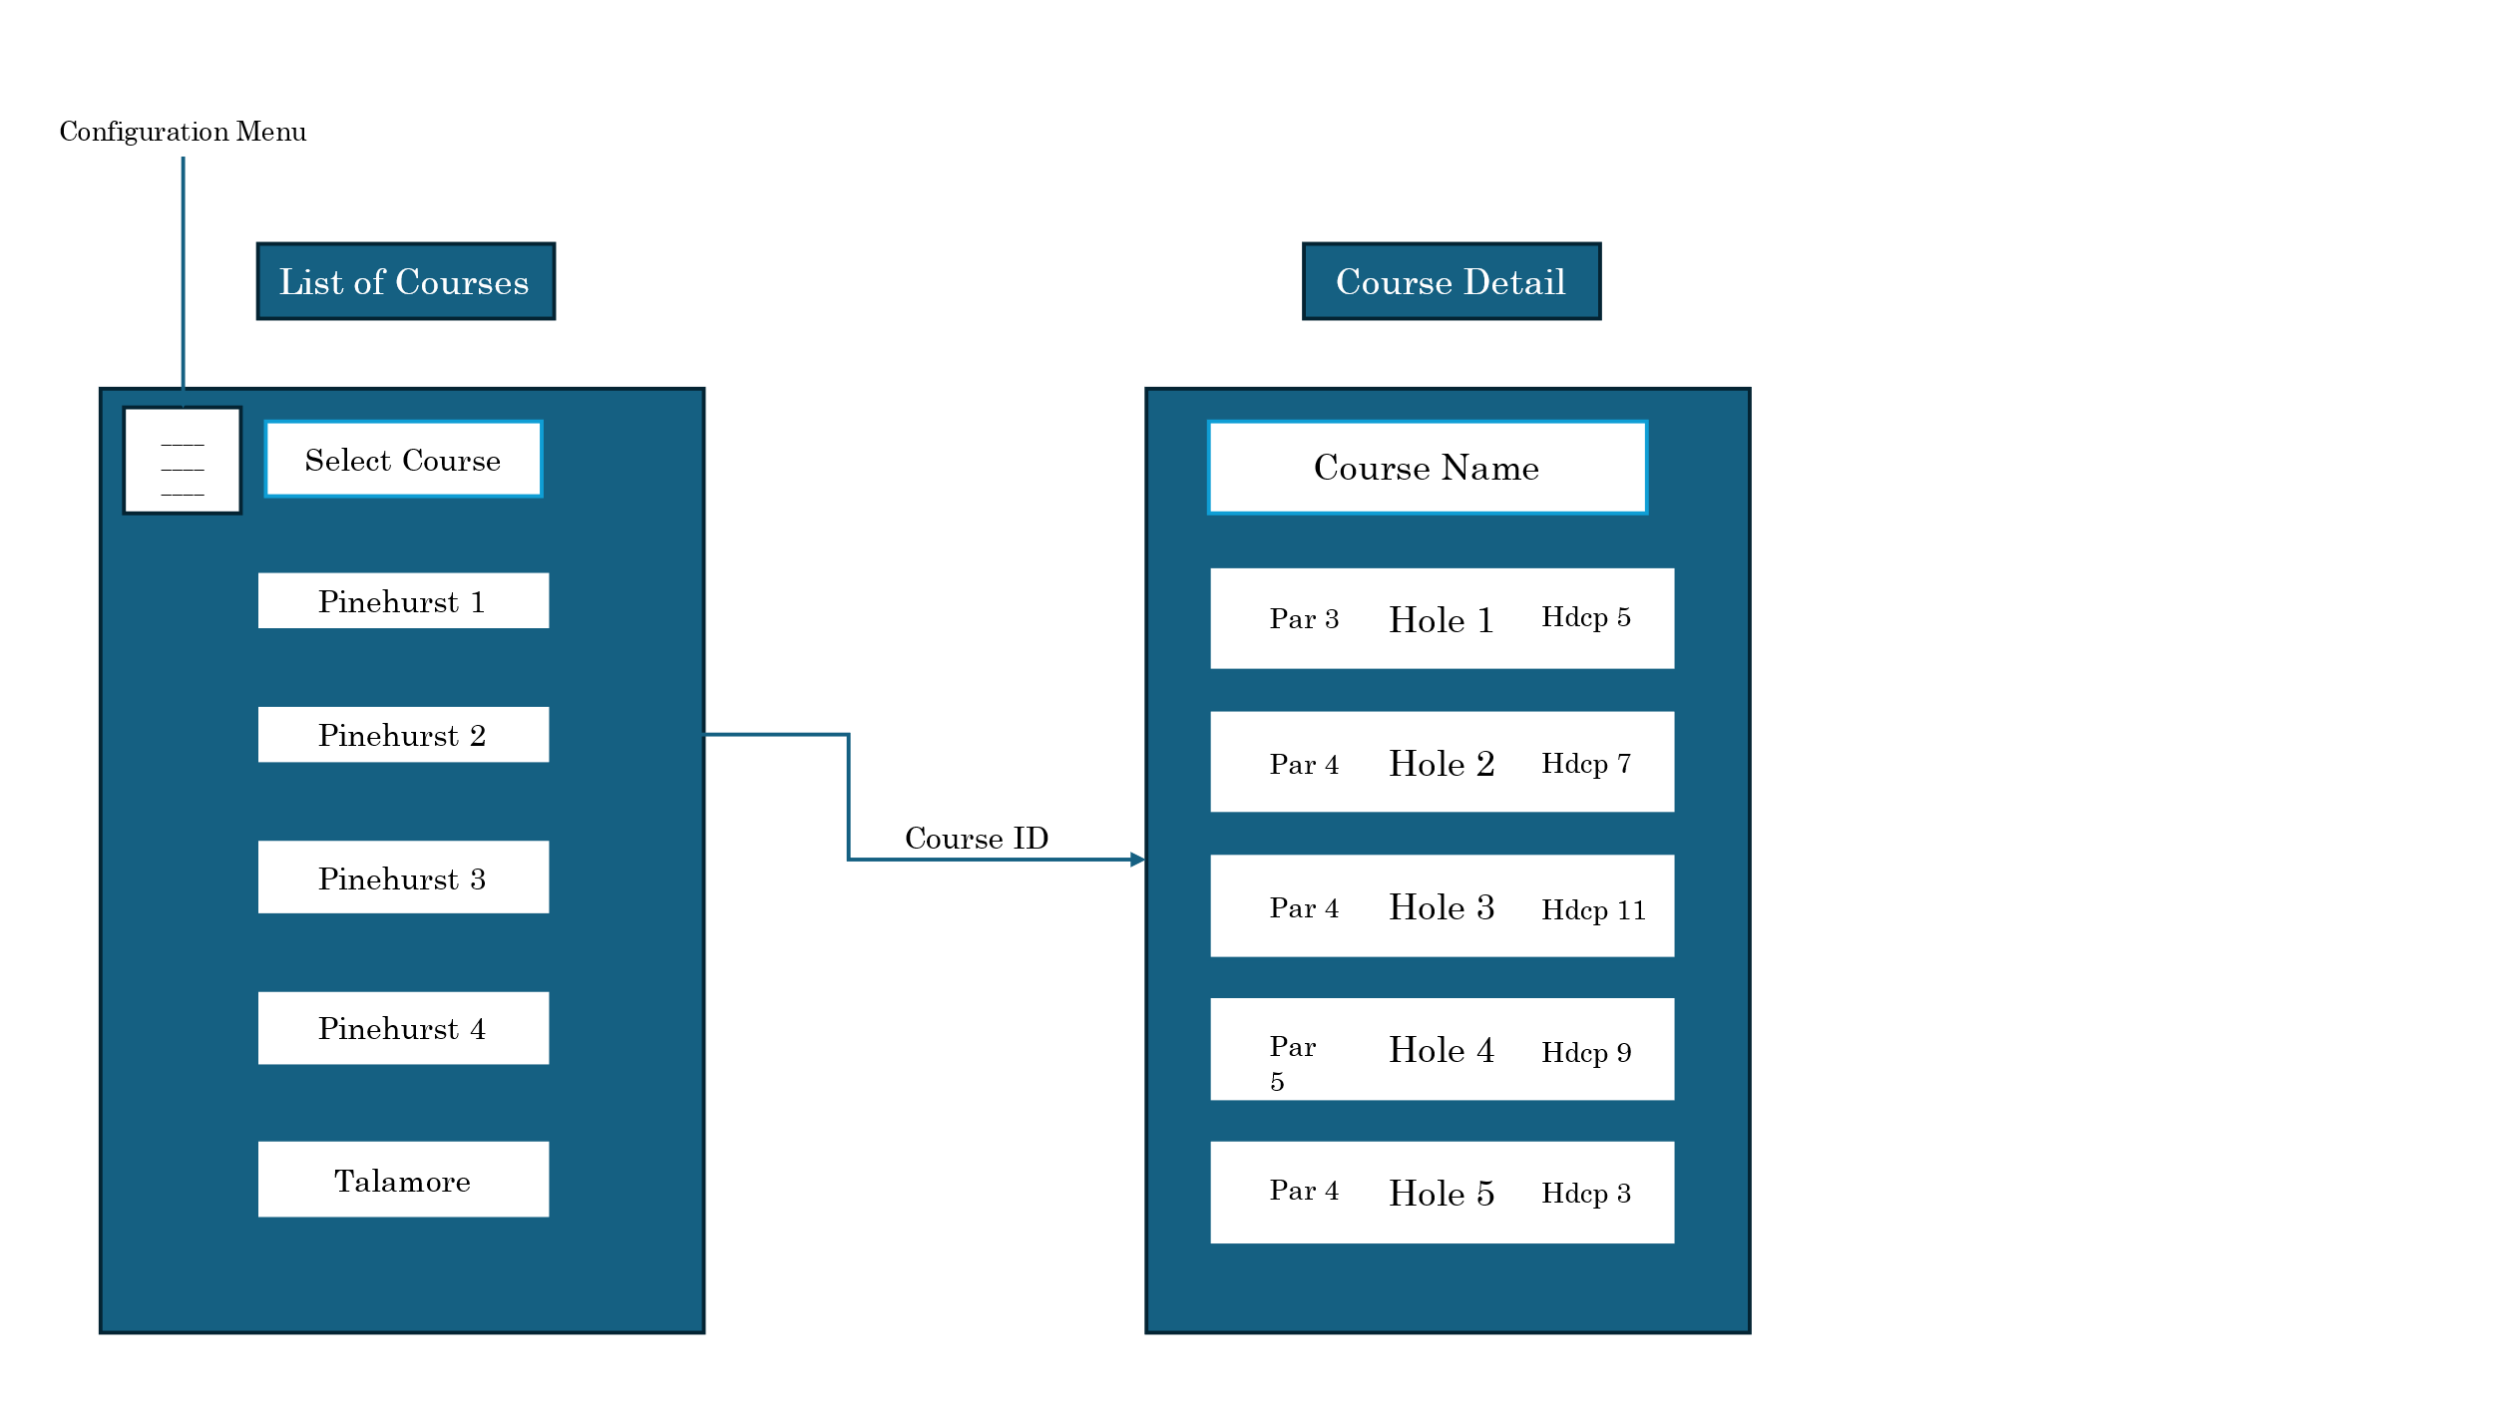

Courses Screen - Configuration Menu – will allow the user to configure the following:

1. Point Quota
2. Email Address
3. Player’s Junk
4. Backup
5. Restore

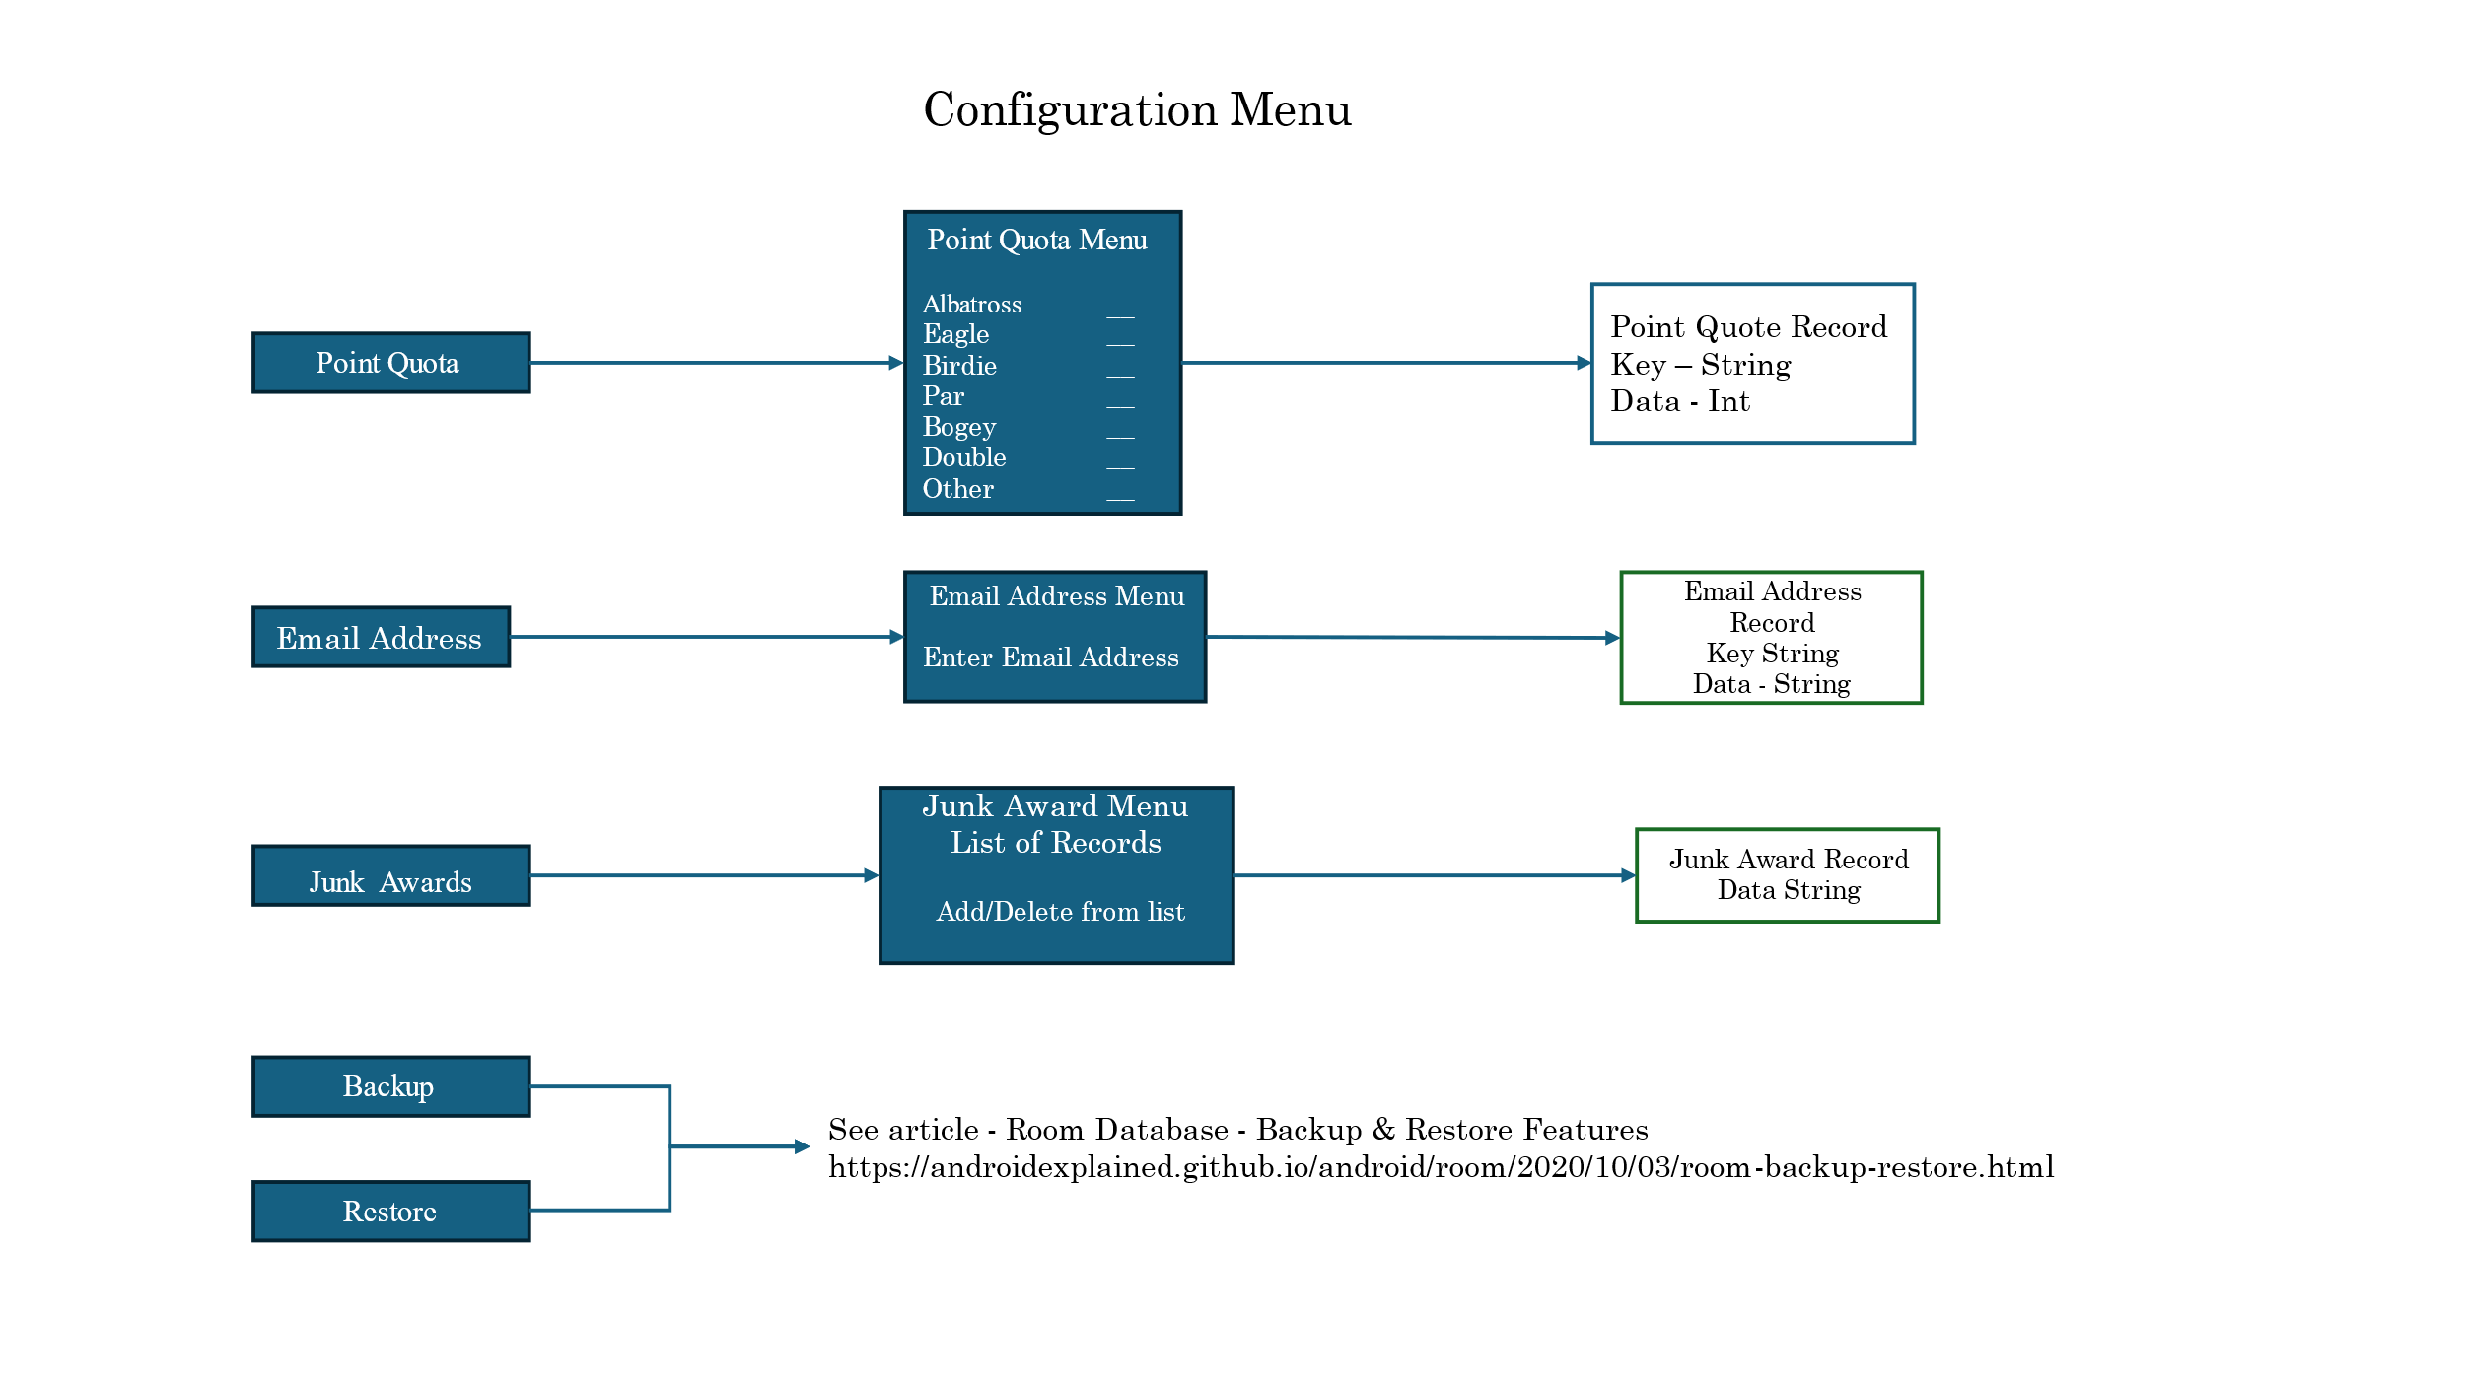

Course Detail – will display the course name, par, and handicaps for each hole.

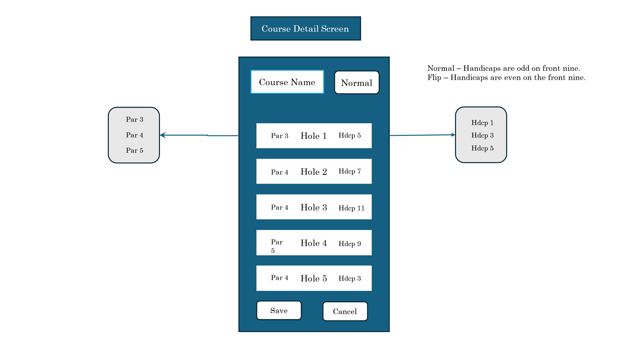

Score Card – will display the current player’s score.

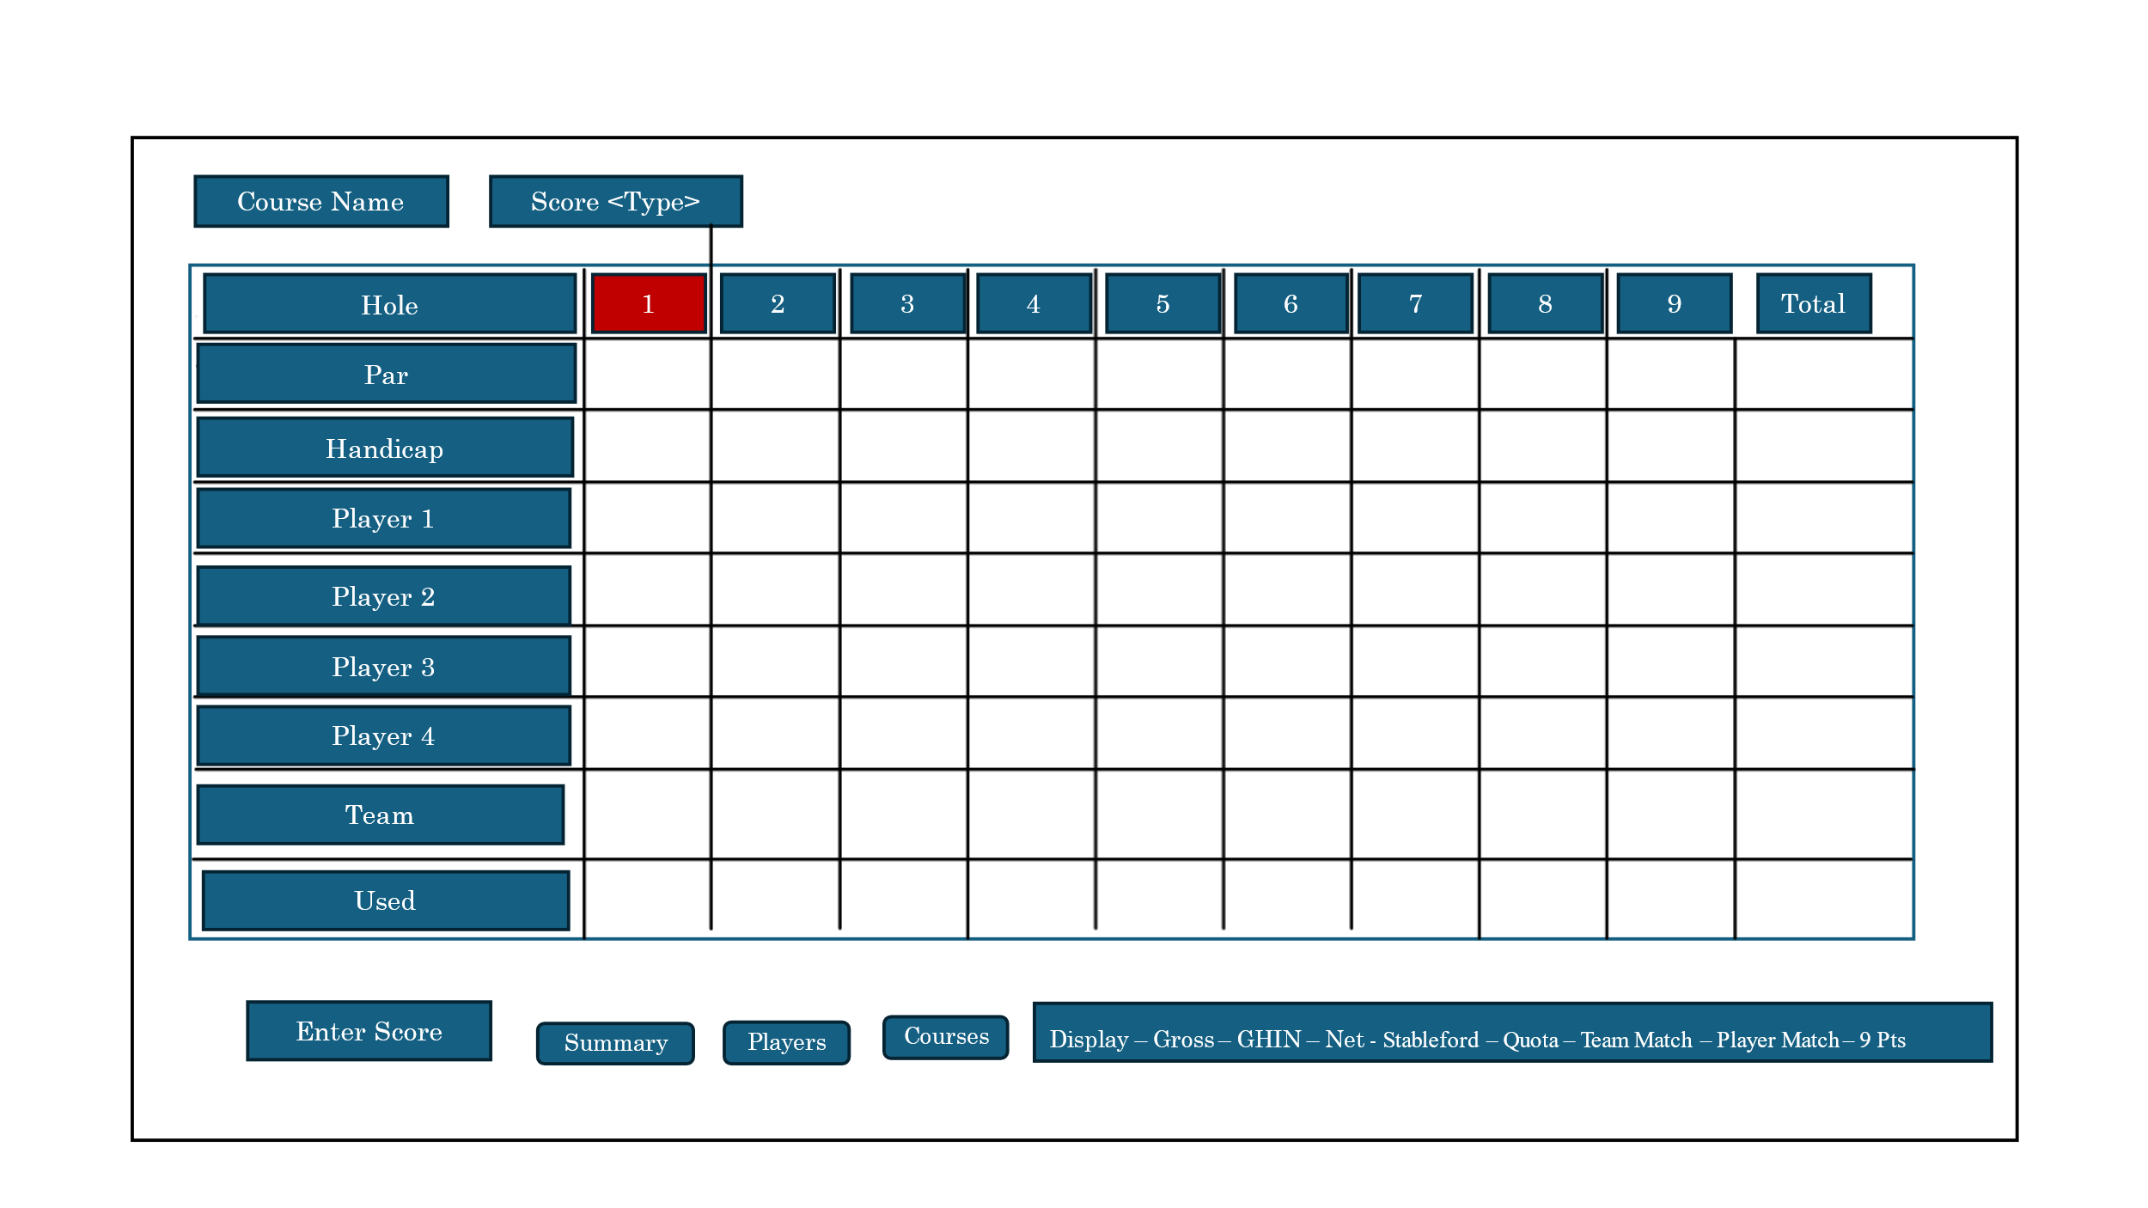

## Enter Player’s Score Screen

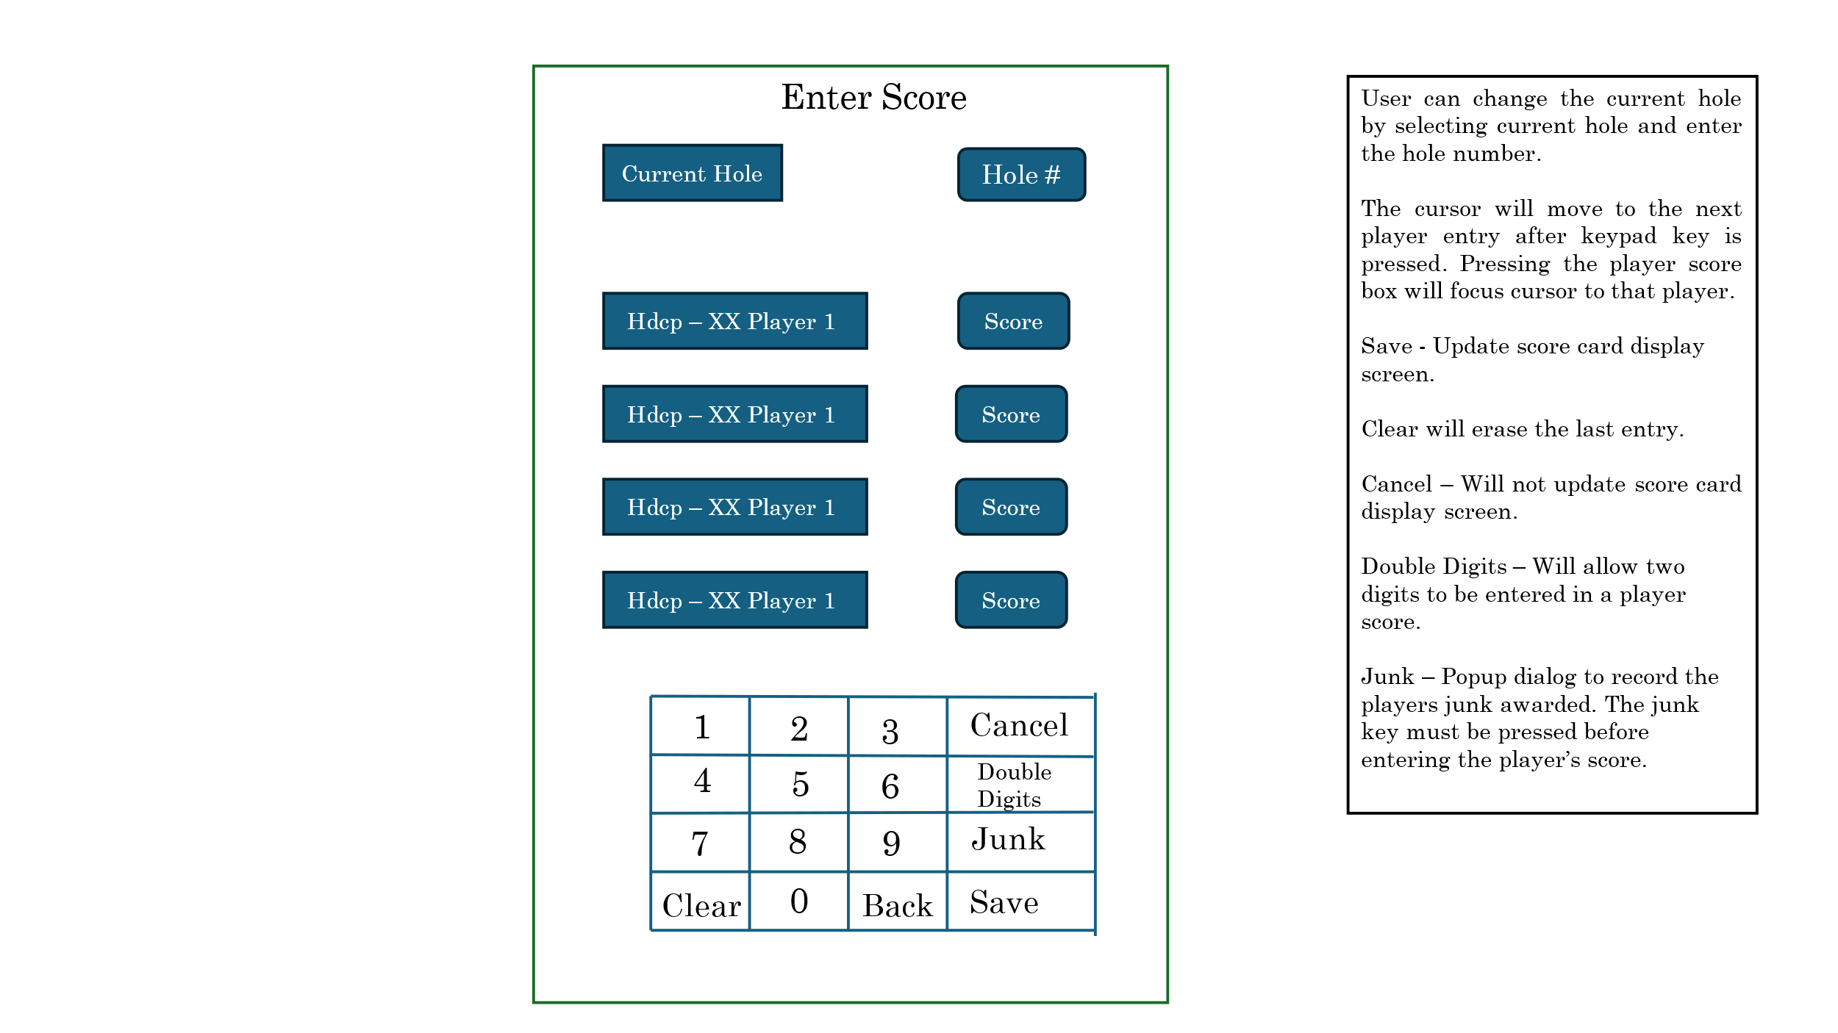

# Architecture:

## Point Quota Scoring:

The points used for the Point Quote scoring game are configured from the Select Course Menu. The Point Quota score for a player is derived from the Target score minus the player handicap. The player must accumulate that many points before the player is over their quota. Therefore, the player's total score will start off with a negative number (Handicap - Target) i.e. 19 - 36 = -19. The front nine will show a total target value of half the points required. (i.e. Total equal to 9) The back nine would use the total target value added to the total points accumulated for the player score.

## Stableford Scoring

Handicaps are factored in when playing a Stableford event. Therefore, the points for a Stableford game are determined by the player’s net score.

Standard Stableford points values are:

* -1 Points – Other – Triple Bogey
* 0 Points – Double Bogey or Worse (Two strokes or more over par)
* 1 Point – Bogey (One stroke over par)
* 2 Points – Par
* 3 Points – Birdie (One stroke under par)
* 4 Points – Eagle (Two strokes under par)
* 5 Points – Albatross/Double Eagle (Three strokes under par)
* 6 Points – Condor (Four strokes under par)

## Junk Awards

Closest to Pin

Polie

Green side sandy

Sandy

Birdies

Chippies

Putt made longer than the flagstick.

Fairway bunkers

Clouseau

The team total would be the accumulation of each player's target and points scored.

Feature Display Player Score Data Class

There is one class for each player, the class holds the net, gross, point quote and Team Player Score Data class.

Startup:  
Read the database for the player's gross hole scores and save the data local  
Calculate the net and point quote scores   
Populate the player's Team and used scores

Team Player Score Data Class

This class will hold of the team scores for each player depending on the team selection when saving the player score.

## Database Layout

Database records  
 Golf course - Name and hole handicaps  
 Player record - Player Name, handicap, and 18 hole scores  
 Current hole  
 Point Quota record