Curriculum Vitae

Chinese Name | 周建宇  Zhou Jianyu | Gender | Male | 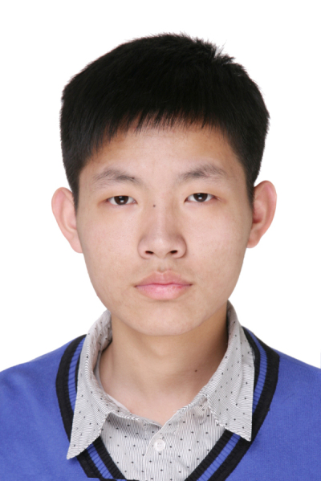
English Name | David Zhou | Date of Birth | Oct 19, 1994
Major | Computer Science and Technology | Department | Computer Science and Technology
Email | zjythu@163.com | Mobile Phone | (+86)18810918292
Address | Room 303A, Building 2, Zijing Apartment of Tsinghua University, Beijing, China
Education and Skills | Educational background  ·Bachelor’s degree in Computer Science, Tsinghua University. (Aug 2013 - July 2017 Expected).  ·Second Bachelor’s degree in Management, Tsinghua University. (Sep 2014 – July 2017 Expected).  Scholastic attainment  ·Total credits owned: 238 (170 required for graduation), top5%.  ·Overall GPA: 81.3 out of 100.  Professional programming skills  ·Proficient in C++, python and Java  ·Basically master JavaScript, MATLAB, HTML5, CSS and R  Good English skills  ·Able to talk freely in English.  ·Got 7 in IELTS in Senior high.  ·Got 579 in CET6 in freshman year.
Projects | Flying Car  ·Independently designed and implemented a virtual driving system.  ·Recognition of simple gesture is powered by the API from Leap Motion device.  RoboWheel  ·Independently designed and implemented a mobile robot.  ·Components of robot is supplied by the ROBOTERRA company.  ThuBitCoin  ·A Bitcoin transaction system with Hadoop distributed system.  ·Source code is available on https://github.com/ZhouDavid/ThuBitCoin.  ShadowCats  ·A website for kids to learn programming with game playing.  ·Source code is available on https://github.com/chenwenxiao/shadowcats.  16-bit THCO MIPS  ·Designed and implemented a 16-bit MIPS CPU with VHDL on FPGA.  ·VGA and keyboard are also implemented in our Computer with other two members.  China Crowdsourcing  ·A crowdsourcing website (http://www.chinacrowds.com) for users to issue and solve problems online.  ·Independently designed and implemented all web pages with HTML, CSS and JavaScript.  ·Source code is available on https://github.com/ZhouDavid/ChinaCrowdSource  Academic Activities  ·Involved in MCM (Mathematical Contest in Modeling) with other two members and completed a paper An Optimal Strategy for Goodgrant Foundation.  ·Independently involved in Kaggle competition for San Francisco Crime Classification and got 318th place out of 2335 groups, top 15%
Extracurricular Experience | ·Chairman of Tsinghua Curriculum Advisory Committee, 2016.  ·Vice-chairman of Student Union of department of Computer Science and Technology, Tsinghua University, 2016.  ·Leader of the group of summer service and learning program in Rural China(SSLP), 2014.  ·Principal of Tenor voice part of Tsinghua Chorus Team.  ·Started the first rock bank in department of CST of THU and being the coryphaeus of bank.
Oversea Experience | 2015.7: Participate in the Summer Program of Research in Hong Kong & Macau at Hong Kong Baptist University .  2014.7: Participate in the Future Global Leaders Summer Program held at the University of California, San Diego, U.S.  2009-2012: As a tourist to Korea, Singapore, Austria, Belgium, Germany, France etc..
Scholarships and Awards | ·Successful Participant Award in Mathematical Contest in Modeling, 2015.  ·The Artistic Excellence Award and Social Practice Award in THU,2014.  ·The Best Original Music Award in the 24th campus singing competition of THU,2014.  ·The Artistic Excellence Scholarship in THU，2015.
Hobbies &Interests | ·Singing, Piano, Violin, Guitar and Saxophone.  ·Martial arts, Table tennis, Basketball, Swimming.

