DAILY WORK REPORT
PROJECT | SC 93 Widening, Phase 2 | CONTRACT NO. | P-0293-24
LOCATION | Clemson, SC | DATE | Thursday, October 15, 2026
PRIME CONTRACTOR | Palmetto Site Works | REPORT NO. | 42
INSPECTOR | Tyler Bowles | WORKERS ON SITE | 10

WEATHER

AM | PM | 7 AM | Noon | 4 PM | High / low | Precip. | Wind
Clear | Partly cloudy | 55 F | 71 F | 76 F | 78 / 52 F | 0.00 in | 9 mph

Weather from Open-Meteo for 34.6834, -82.8374.
CONTRACTOR FORCES

Contractor | Classification | No. | Hours
Palmetto Site Works | Foreman | 1 | 8
Palmetto Site Works | Laborer | 4 | 8
Palmetto Site Works | Operator | 2 | 8
Upstate Concrete | Finisher | 3 | 6

EQUIPMENT

Description | No. | Status | Hours
CAT 320 excavator | 1 | Working
Skid steer | 1 | Working
Smooth drum roller | 1 | Idle

WORK PERFORMED

Description | Location | Quantity
Excavated and backfilled the storm drain trench from station 12+50 to 14+00, about 150 linear feet of 24 inch RCP installed | Sta. 12+50 to 14+00 | 150 linear feet
Poured the curb and gutter on the east side, about 18 cubic yards | east side | 18 cubic yards

MATERIALS RECEIVED

- Received six loads of number 57 stone.

TESTS AND INSPECTIONS

- Ran a slump test on the second truck, four inch slump, and made one set of cylinders.
- Nuclear gauge density tests on the trench backfill all passed.

VISITORS

- Tom Reed from the county came by at 2 PM to look at the drainage.

DELAYS, PROBLEMS AND RFIS

- Lost about an hour in the morning waiting on the first concrete truck.
- Found an unmarked water line at station 13+20, contractor stopped and called the utility, we need an RFI.

SAFETY

- Trench box was in place all day, one worker without a vest, talked to the foreman about it.

REMARKS

- Weather on site: Weather was clear and cool in the morning, warming up after lunch.
- October 15th, Highway 93 widening near Clemson.

CERTIFICATION

I certify that this report is a true record of the work and conditions observed.
INSPECTOR  __________________________________ ____________  Signature Date | REVIEWED BY (RESIDENT ENGINEER)  __________________________________ ____________  Signature Date

PHOTOGRAPHS

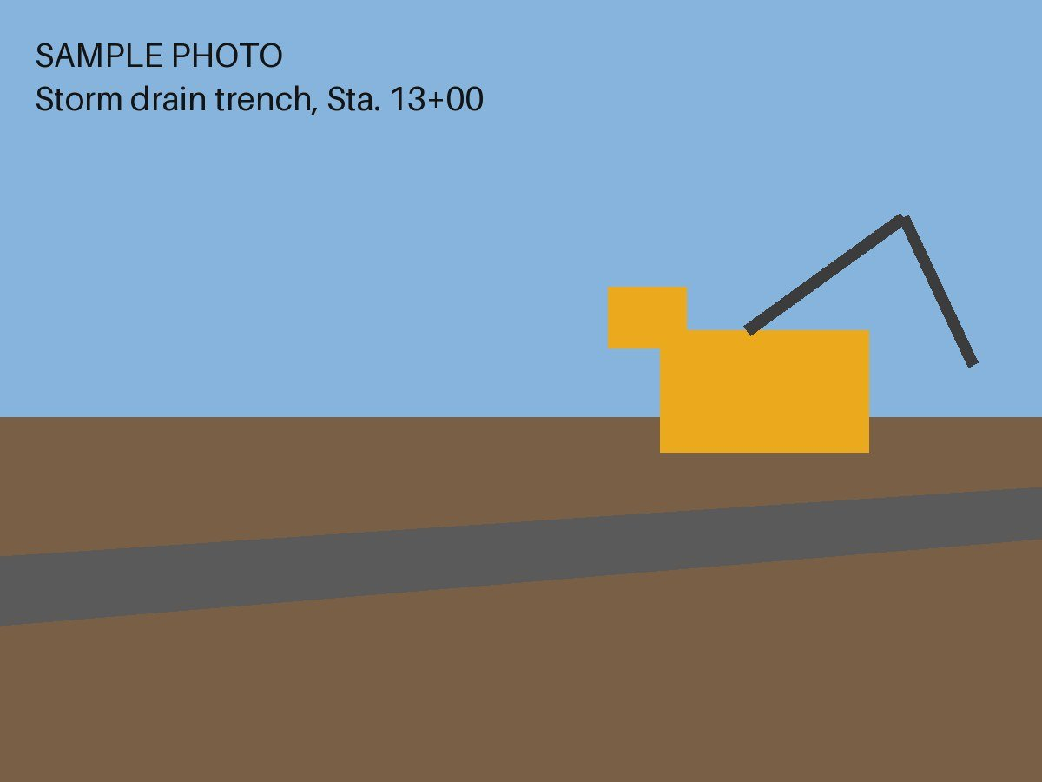  Photo 1. 10:42 AM. Open storm drain trench with trench box in place and excavator working near Sta. 13+00. | 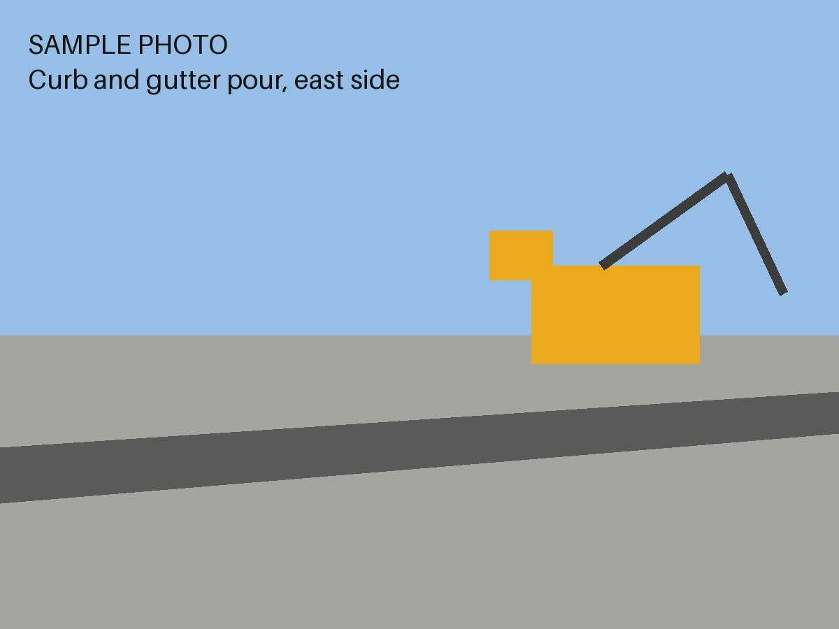  Photo 2. 2:18 PM. Fresh curb and gutter on the east side after the afternoon pour.

