|  |
| --- |
|  |
| Portfolio Question 7  Assessment Task 2 |
| |  |  |  | | --- | --- | --- | | Ben Royans [P205225] | 4/30/20 | Java III | |

|  |
| --- |
|  |
| Portfolio Question 7  Assessment Task 2 |
| |  |  |  | | --- | --- | --- | | Ben Royans [P205225] | 4/30/20 | Java III | |

TABLE OF CONTENTS

UML 1

Design Specifications 2

Specification 2

Review 2

Version Control 3

Selection 3

Commit Type/Strategy 3

Debugging 4

Testing 5

Test Table 5

Screenshots 6

Information Repositories 9

BlackBoard 9

GitHub 9

Performance Screenshots 10

Unit Testing 11

References 12

# UML

Below are the class diagrams for the classes used in this project.

# Design Specifications

## Specification

An application is required to transfer data files between remote locations via a sockets protocol.

## Review

The application will be developed in JavaFX to provide the user with a UI and ease of file selection when transferring files. The Server and the Client applications will be separate coding projects in order to separate their logic, however some functions will be shared between the two.

# Version Control

## Selection

GitHub will be used as the system to manage the version control for this project, with a commit being made after each development session.

## Commit Type/Strategy

The type of commit being made will follow this simple flow chart:

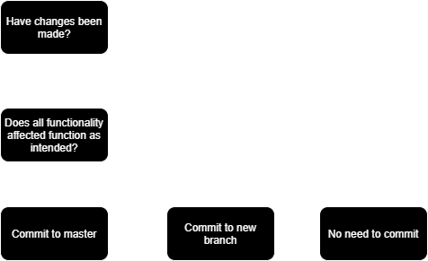

*Figure 1. Version control commit type flowchart.*

Changes to the code that have not been fully tested or are not completely functional as intended will be committed to a new branch. The new branch will continue to be developed until it meets the criteria to be committed to the master branch.

# Debugging

Below are some screenshots of the debugging process.

# Testing

## Test Table

|  |  |  |  |  |
| --- | --- | --- | --- | --- |
| **Case #** | **Functionality Tested** | **Data/Procedure**  **Used** | **Expected**  **Outcome** | **Pass / Fail** |
| 1 |  |  |  | PASS |
| 2 |  |  |  | PASS |
| 3 |  |  |  | PASS |
| 4 |  |  |  | PASS |
| 5 |  |  |  | PASS |
| 6 |  |  |  | PASS |
| 7 |  |  |  | PASS |
| 8 |  |  |  | PASS |

## Screenshots

|  |  |
| --- | --- |
| **Case #** | **Screenshot** |
| 1 |  |
| 2 |  |
| 3 |  |
| 4 |  |
| 5 |  |
| 6 |  |
| 7 |  |
| 8 |  |

# Information Repositories

## BlackBoard

The assessment specifications and requirements have been supplied through BlackBoard. BlackBoard also provides the learning content used for this assessment task and will provide the methods for deployment (handing in the assessment).

## GitHub

GitHub will be used as version control software for the project. Regular and systematic commits to either the master or branches of the code will provide a safety net for unexpected errors on the working application.

Public link to repository: <https://github.com/RuggedRadius/JavaIII_AT2.7/>

# Performance Screenshots

## Server

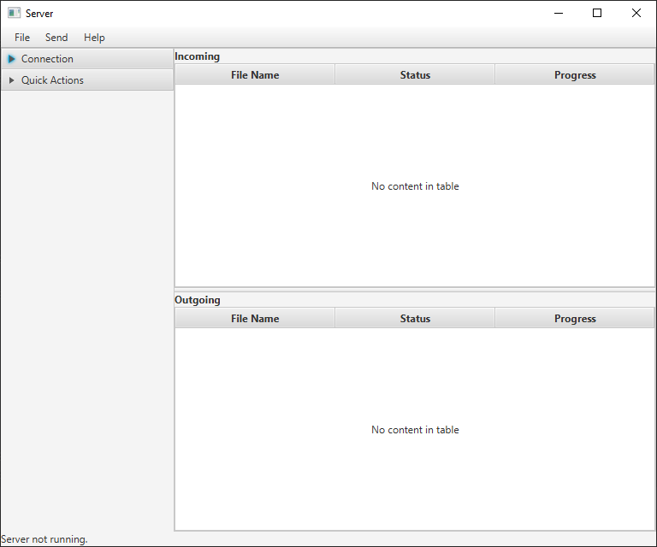

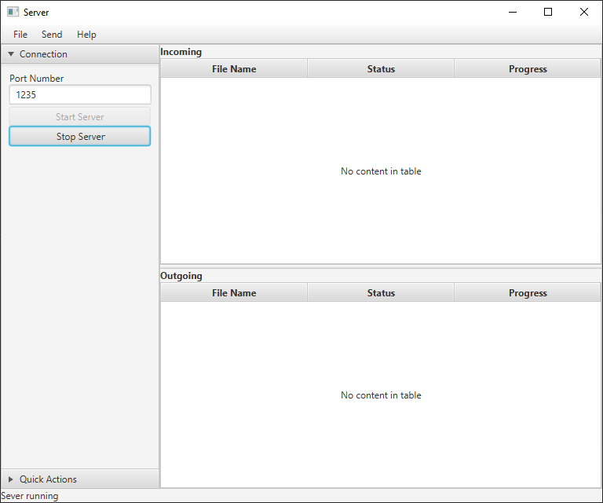

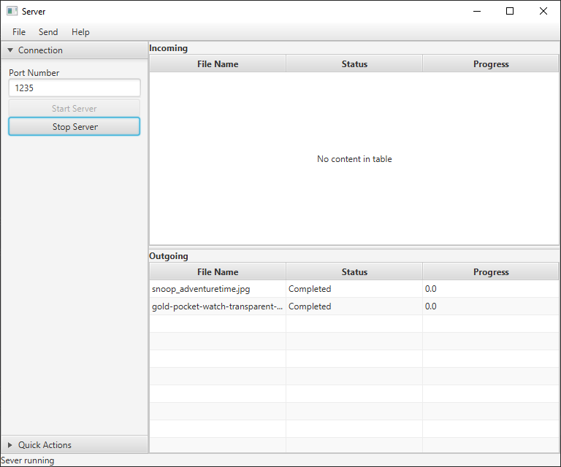

## Client

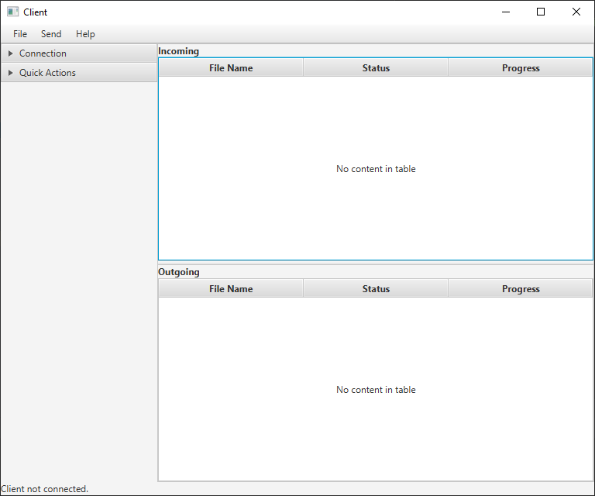

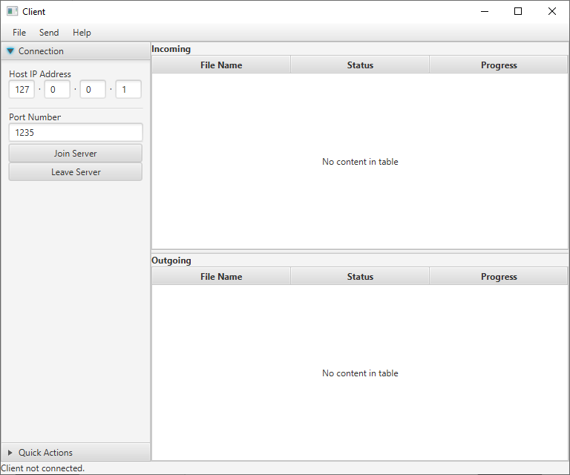

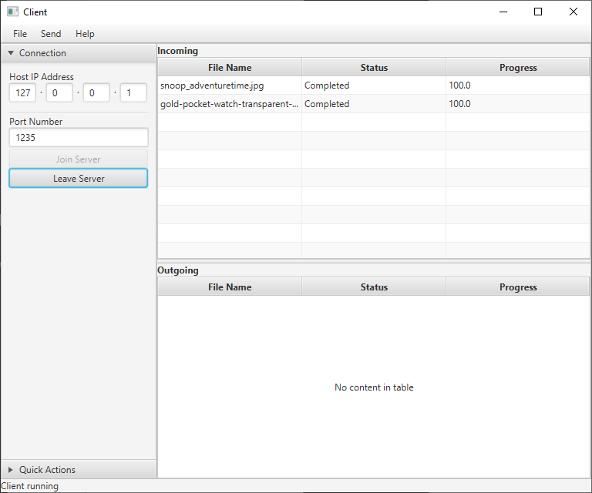

# Unit Testing

Junit 5 was used to complete the unit testing for this project. The Junit test class is included in the project files. Below is a screenshot of the Junit tests completing successfully.

# References

Bechtold, S. (2020). *JUnit 5 User Guide*. Retrieved from Junit: https://junit.org/junit5/docs/5.3.0-RC1/user-guide/index.html#installation

Lacar, J. (2014). *How to test method without no return value by using JUnit.* Retrieved from Code Ranch: https://coderanch.com/t/611976/engineering/test-method-return-JUnit

South Metropolitan TAFE. (2020). *Session 10 - Testing*. Retrieved from BlackBoard: https://blackboard.southmetrotafe.wa.edu.au/webapps/blackboard/content/listContent.jsp?course_id=_12140_1&content_id=_1170302_1