Name: Rughma Malik
Reg no: 2023-BSE-54
Course: Cloud Computing Lab
Section: V-B
LAB 12
Terraform Provisioners, Modules & Nginx Reverse Proxy/Load Balancer
Task 0 Lab Setup (Codespace & GH CLI)
Create Codespace & connect:
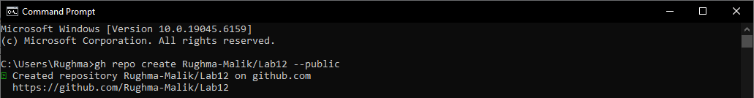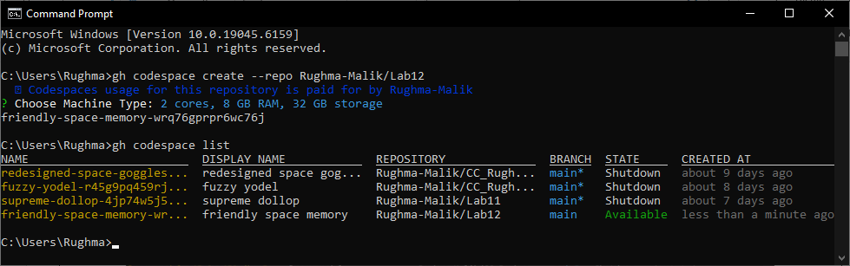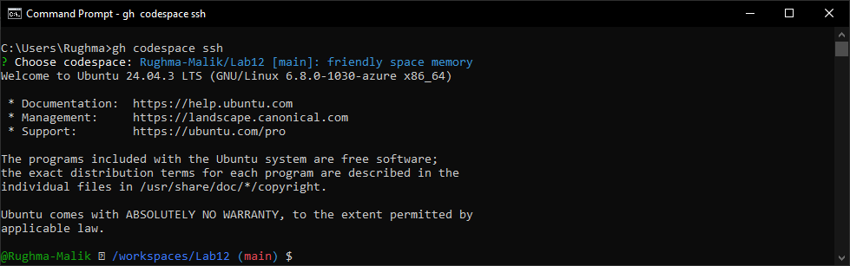

Task 1 — Organize Terraform code into separate files
In this task, you will split a monolithic Terraform configuration into separate, well-organized files following best practices.
- Create the initial project structure:
mkdir -p ~/Lab12
cd ~/Lab12
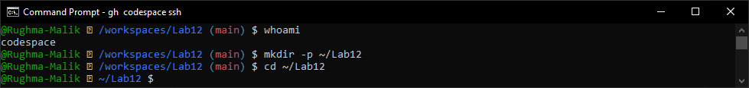
- Create all required files:
touch main.tf variables.tf outputs. tf locals.tf terraform.tfvars entry-script.sh
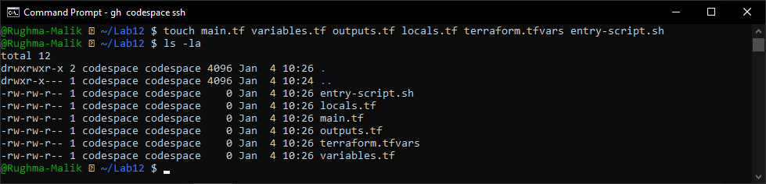
- Create variables.tf with the following content:
variable "vpc_cidr_block" {}
variable "subnet_cidr_block" {}
variable "availability_zone" {}
variable "env_prefix" {}
variable "instance_type" {}
variable "public_key" {}
variable "private_key" {}
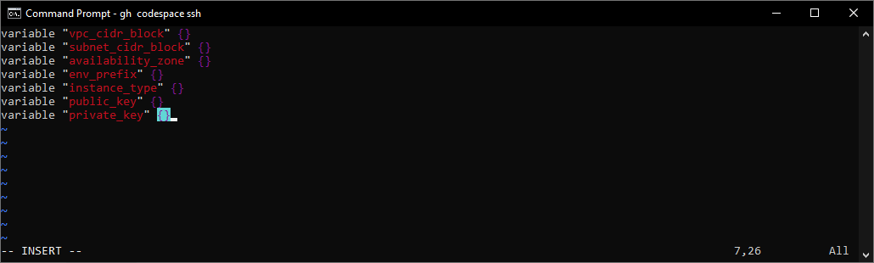
- Create outputs.tf with the following content:
output "aws_instance_public_ip" {
value = aws_instance.myapp-server.public_ip
}
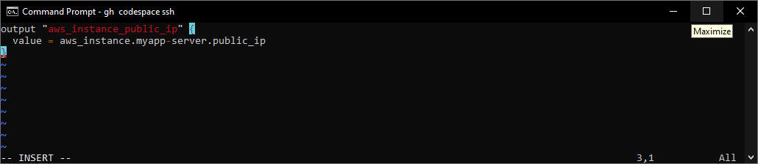
- Create locals.tf with the following content:
locals {
my_ip = "${chomp(data.http.my_ip.response_body)}/32"
}
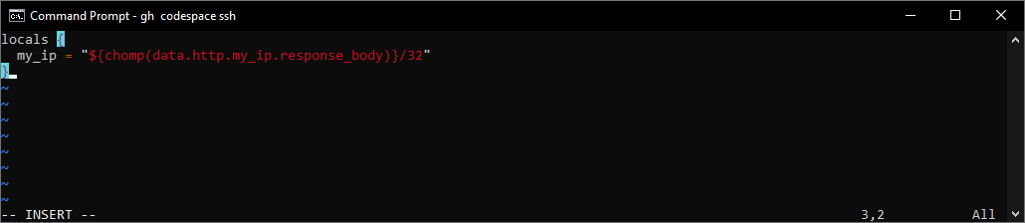
- Create terraform.tfvars with the following content:
vpc_cidr_block = "10.0.0.0/16"
subnet_cidr_block = "10.0.10.0/24"
availability_zone = "me-central-1a"
env_prefix = "dev"
instance_type = "t3.micro"
public_key = "~/.ssh/id_ed25519.pub"
private_key = "~/.ssh/id_ed25519"
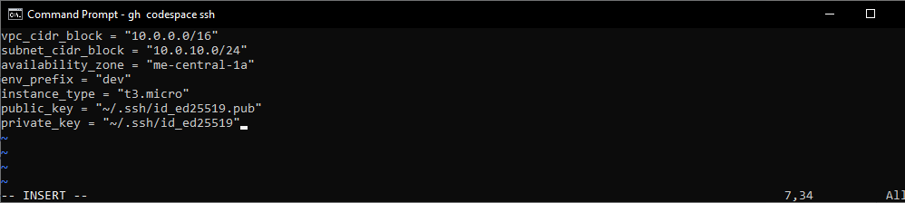
- Create main.tf with the following content:
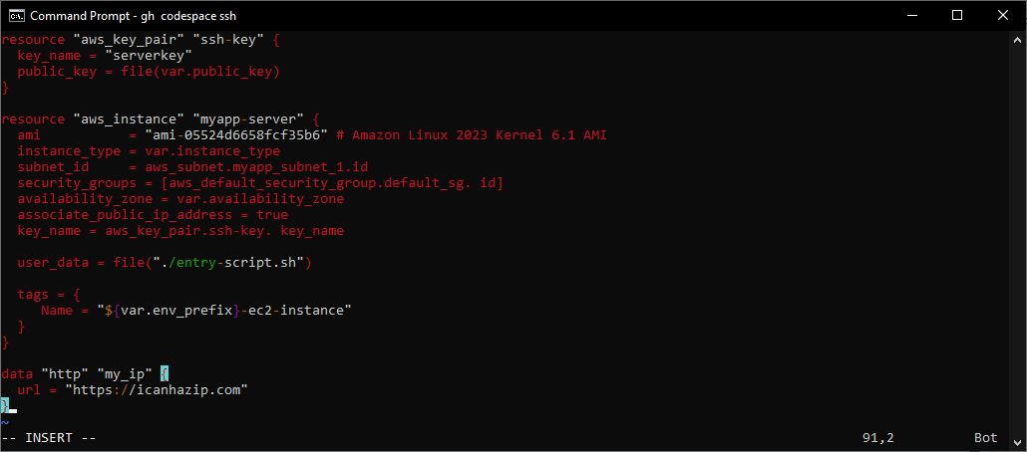
- Create entry-script.sh with the following content:
#!/bin/bash
set -e
yum update -y
yum install -y nginx
systemctl start nginx
systemctl enable nginx
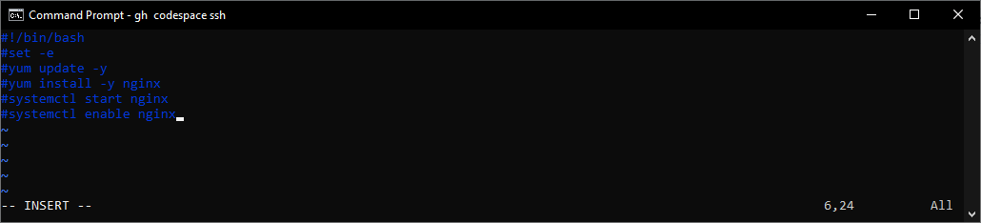
- Generate SSH key pair if not already exists:
ssh-keygen -t ed25519 -f ~/.ssh/id_ed25519 -N ""
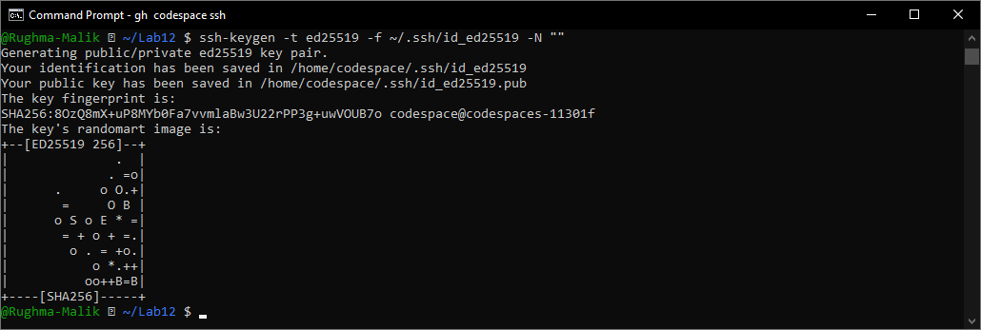
- Initialize Terraform:
terraform init
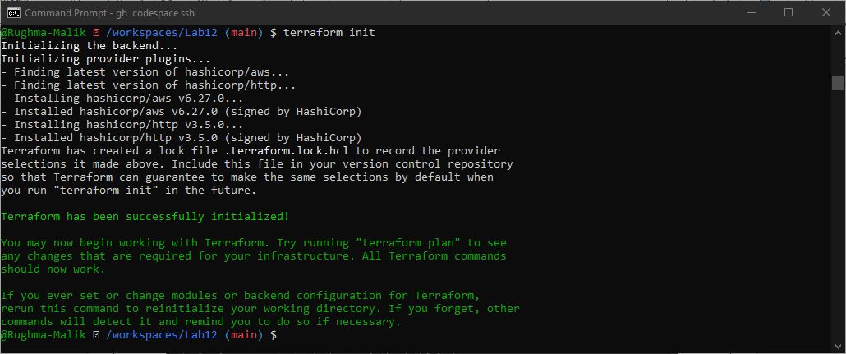
- Apply the configuration:
terraform apply -auto-approve
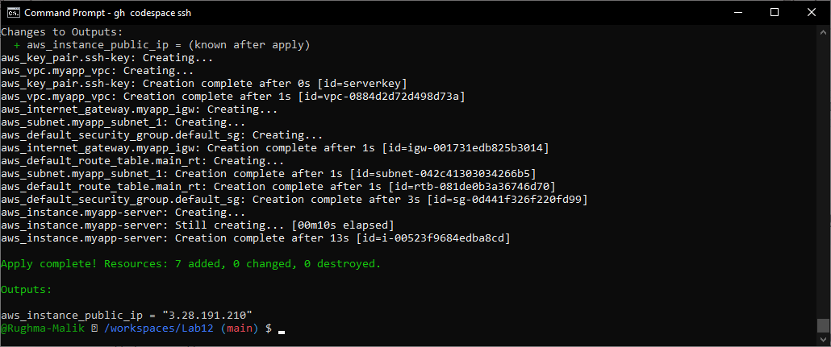
- Display the output:
terraform output
- Test nginx in browser:
- Open browser and navigate to http://<public-ip>
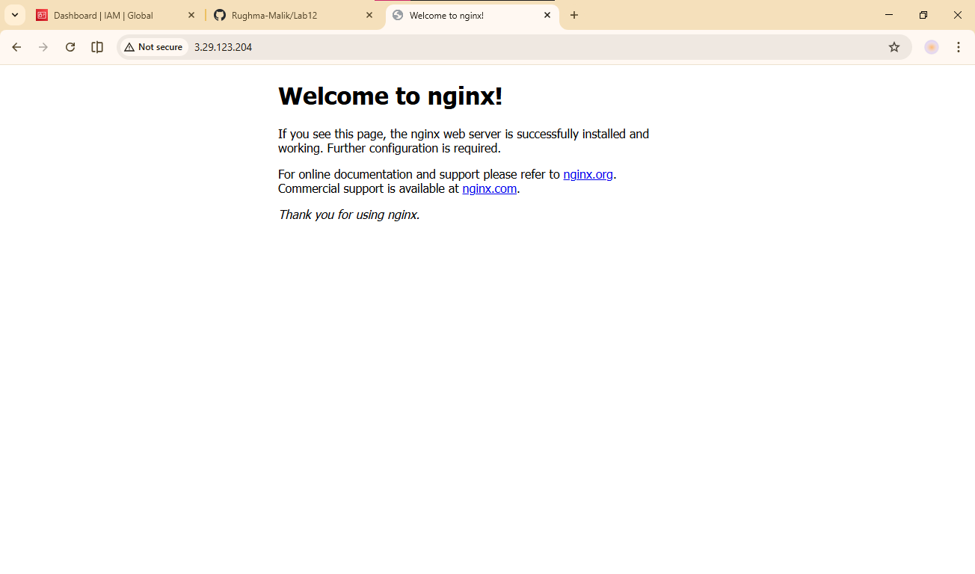
- Destroy resources:
terraform destroy
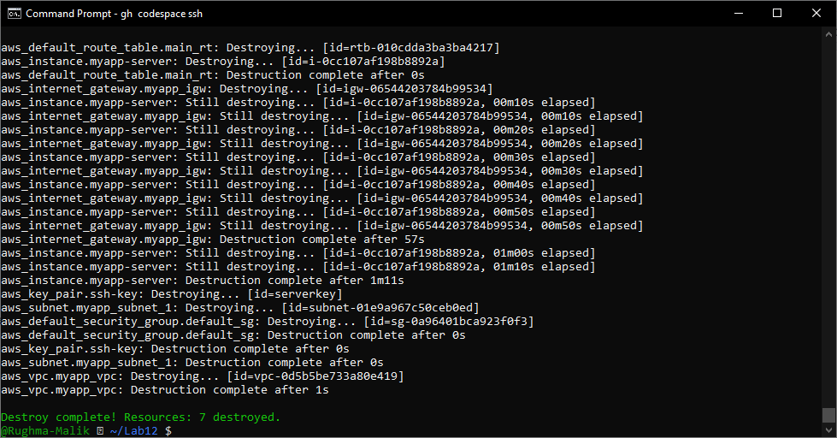

Task 2 — Use remote-exec provisioner
In this task, you will replace the user_data approach with the remote-exec provisioner to install and configure nginx.
- Modify the aws_instance resource in main.tf to use remote-exec provisioner:
Replace the user_data line with the following provisioner block:
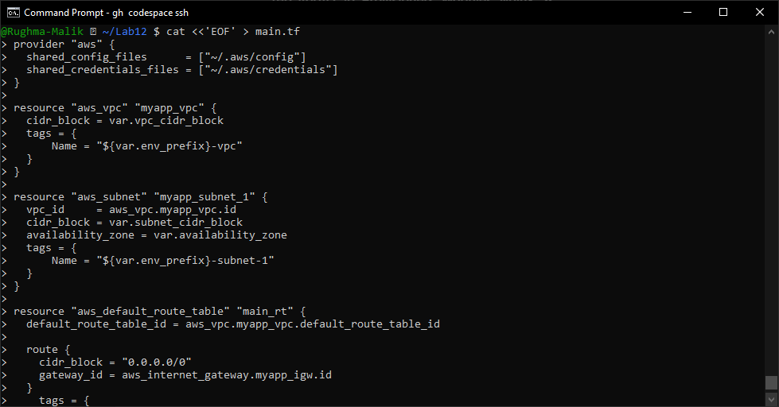
- Apply the configuration:
terraform apply -auto-approve
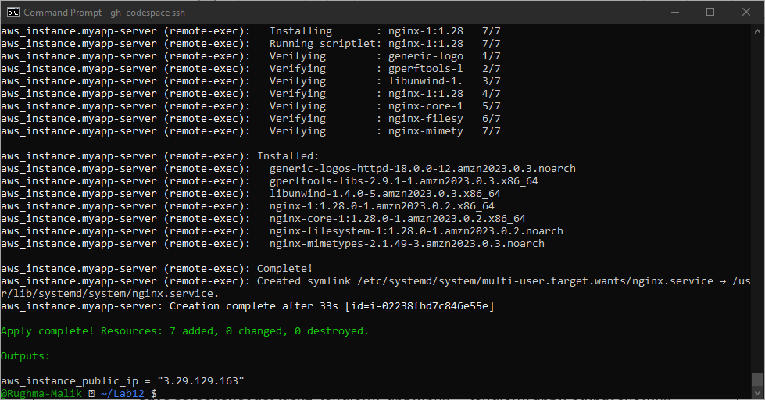
- Display the output:
terraform output
- Test nginx in browser:
- Open browser and navigate to http://<public-ip>
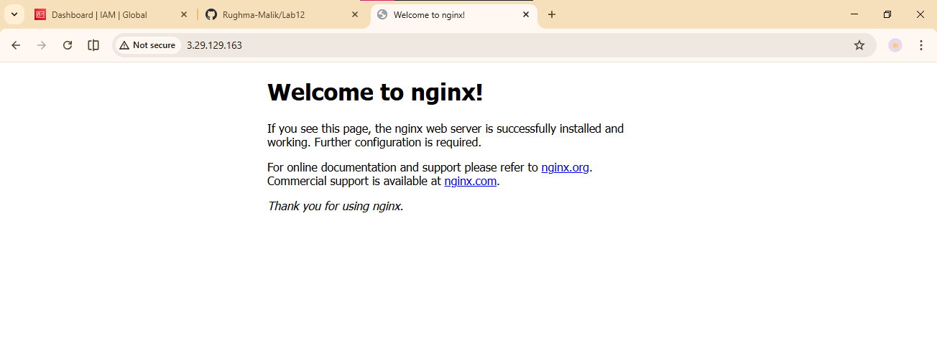

Task 3 — Use file and local-exec provisioners
In this task, you will add the file provisioner to upload the script and the local-exec provisioner to log instance information locally.
- Modify the aws_instance resource in main.tf to include all three provisioners:
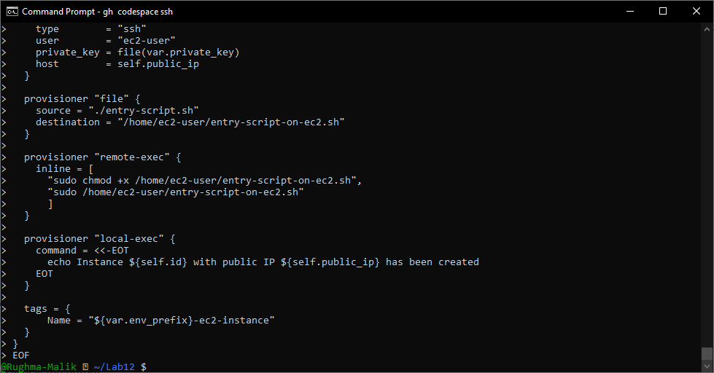
- Apply the configuration:
terraform apply -auto-approve
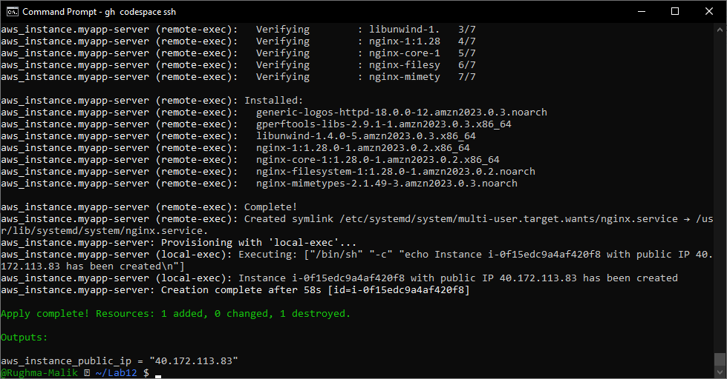
- Display the output:
terraform output
- Test nginx in browser:
- Open browser and navigate to http://<public-ip>
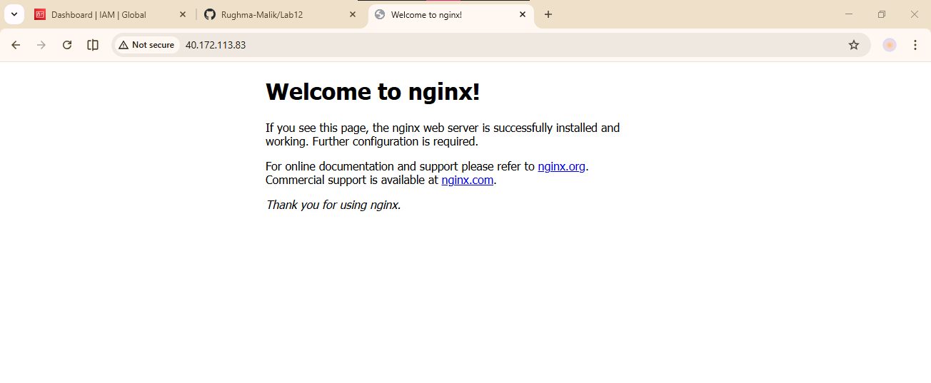
- Destroy the resources:
terraform destroy
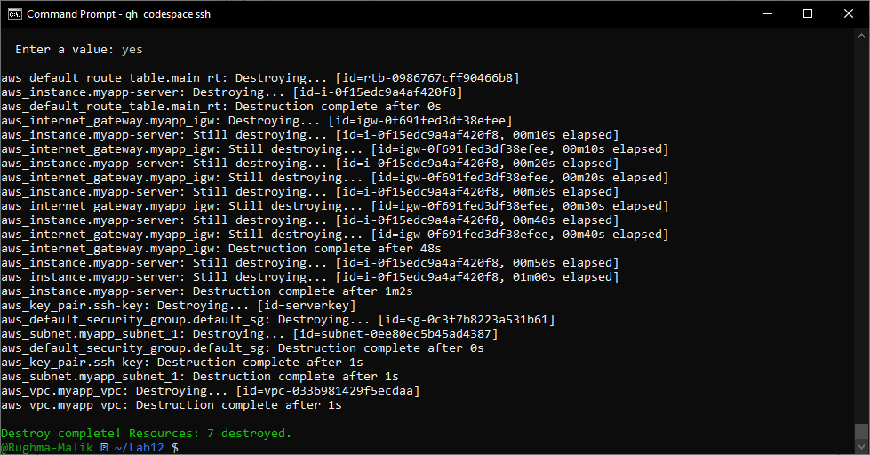
- Remove the provisioners and restore user_data:
Replace the connection and provisioner blocks with:
user_data = file("./entry-script.sh")
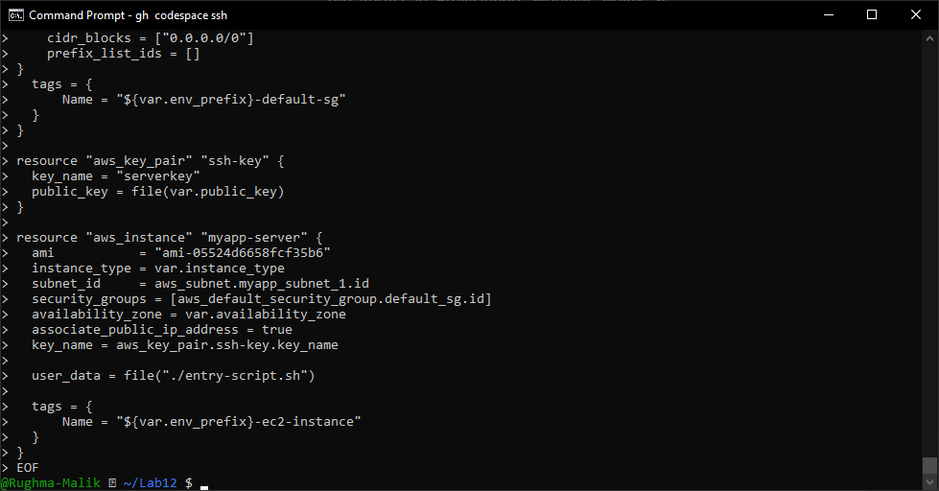

Task 4 — Create Terraform modules (subnet module)
In this task, you will create a reusable subnet module to organize your infrastructure code better.
- Create the module directory structure:
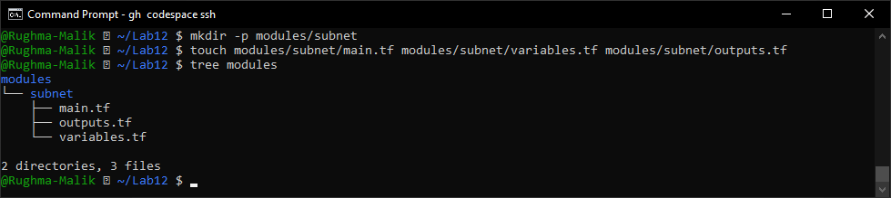
- Create modules/subnet/variables.tf:
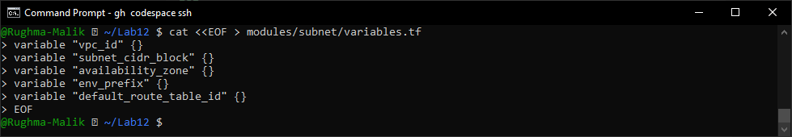
- Create modules/subnet/main.tf:
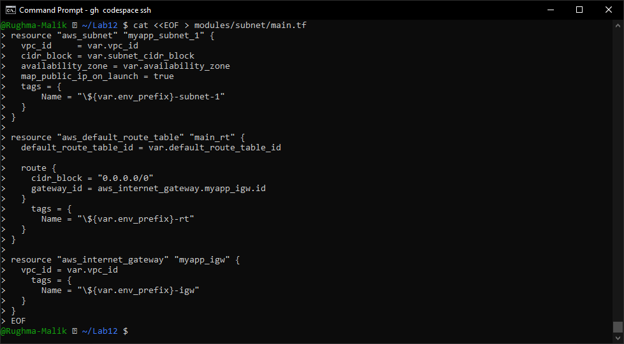
- Create modules/subnet/outputs.tf:
output "subnet" {
value = aws_subnet.myapp_subnet_1
}
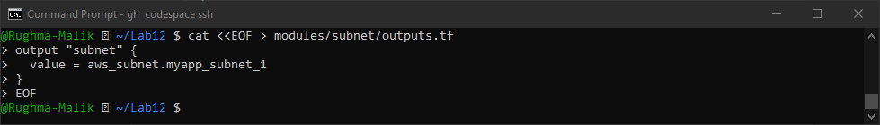
- Modify the root main.tf to use the subnet module:
Remove the subnet, route table, and internet gateway resources and replace them with:
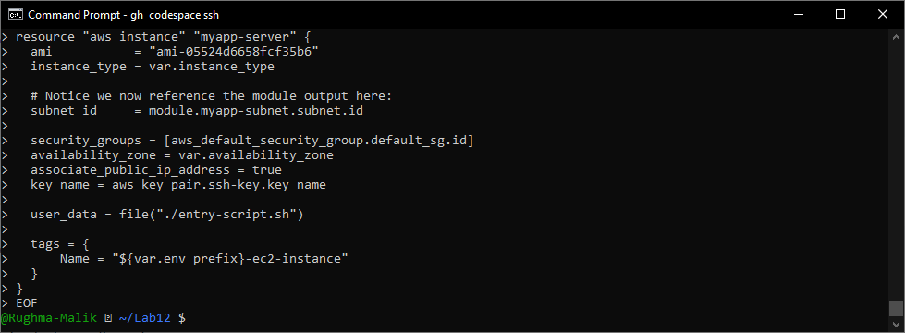
- Initialize Terraform to download the module:
terraform init
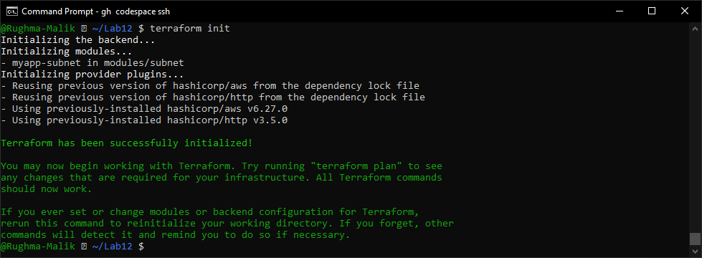
- Apply the configuration:
terraform apply -auto-approve
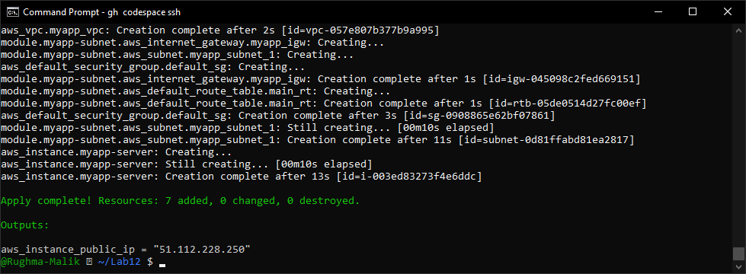
- Display the output:
terraform output
- Test nginx in browser:
- Open browser and navigate to http://<public-ip>
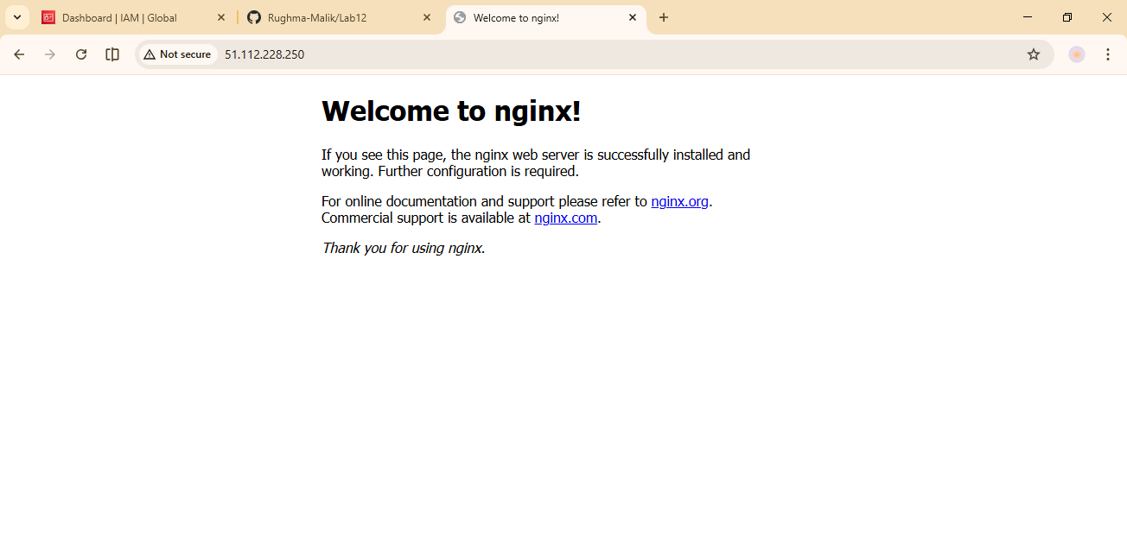

Task 5 — Create webserver module
In this task, you will create a reusable webserver module for EC2 instances.
- Create the webserver module directory structure:
mkdir -p modules/webserver
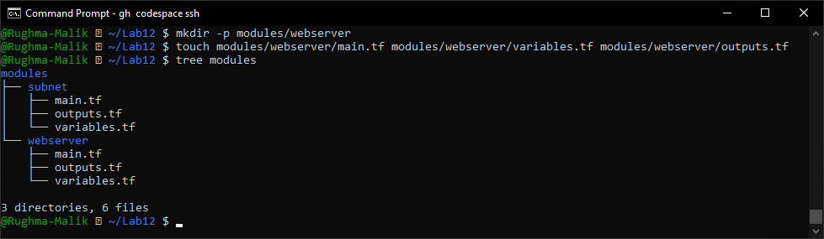
- Create modules/webserver/variables.tf:
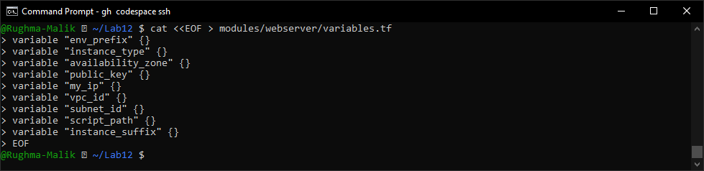
- Create modules/webserver/main.tf:
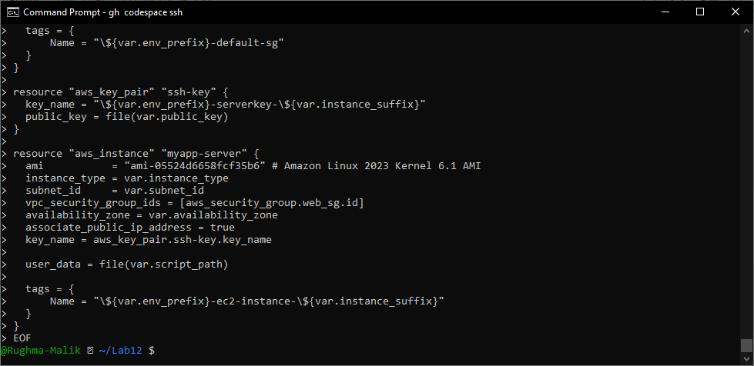
- Create modules/webserver/outputs.tf:
output "aws_instance" {
value = aws_instance.myapp-server
}
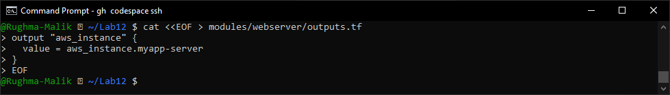
- Modify the root main.tf:
Remove the security group, key pair, and instance resources. Replace them with:
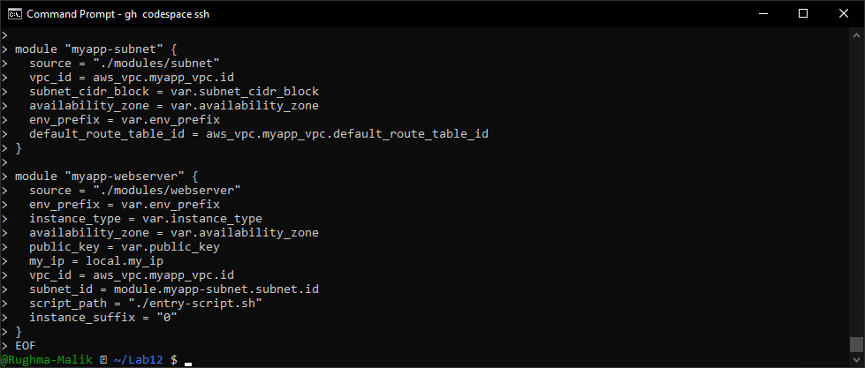
- Update outputs.tf:
output "webserver_public_ip" {
value = module.myapp-webserver.aws_instance.public_ip
}
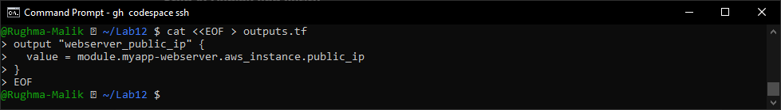
- Initialize Terraform:
terraform init
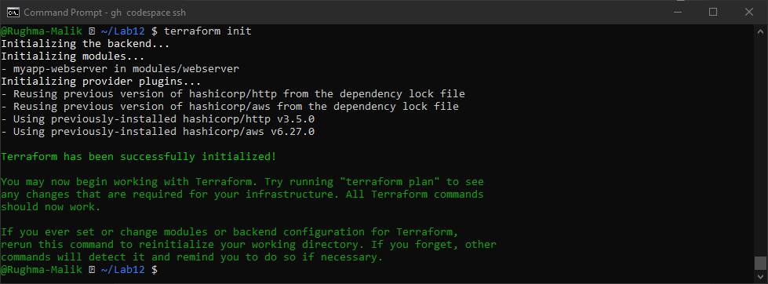
- Apply the configuration:
terraform apply -auto-approve
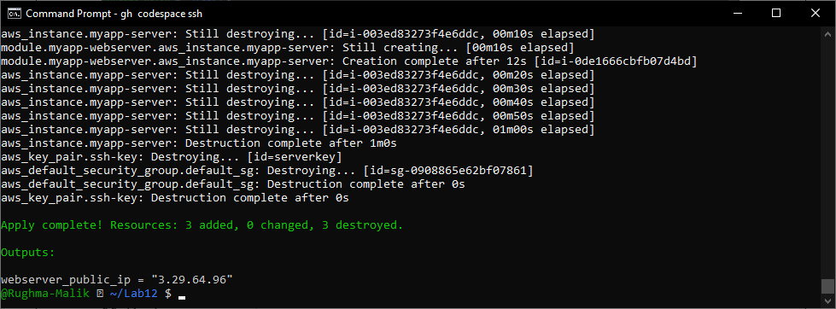
- Display the output:
terraform output
- Test nginx in browser:
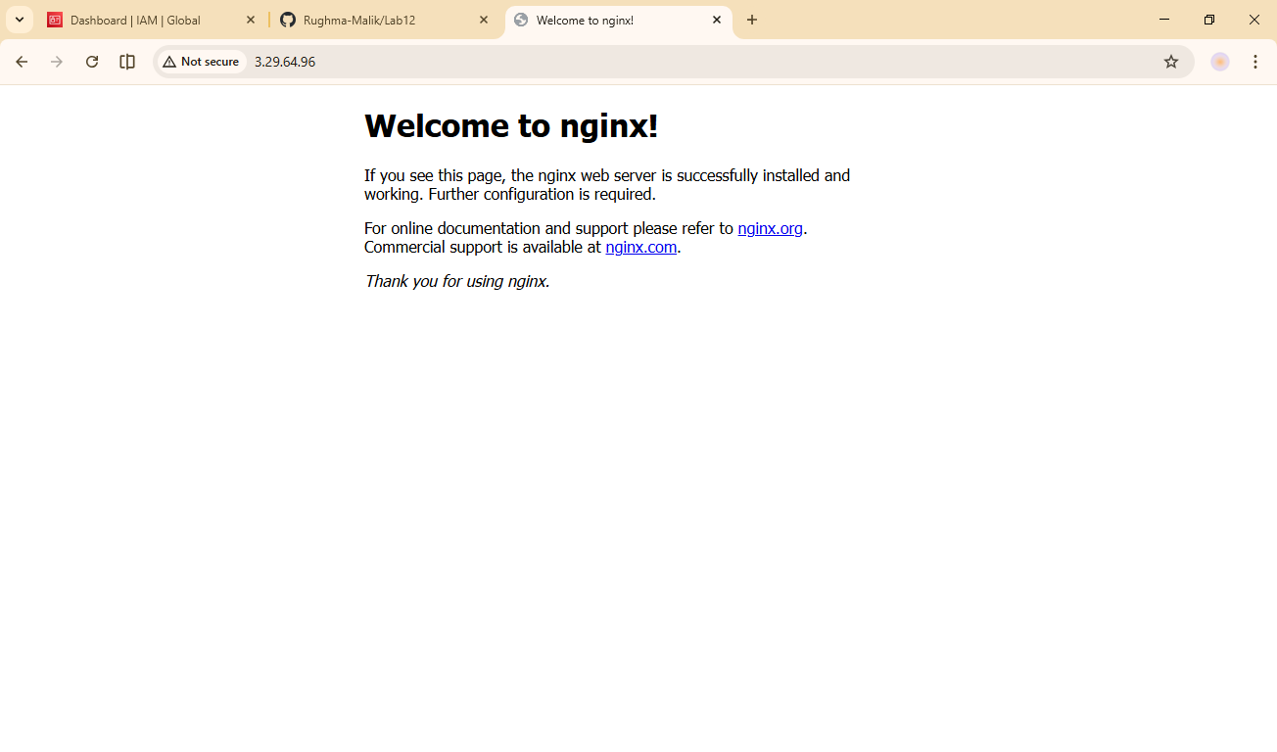
- Destroy resources:
terraform destroy
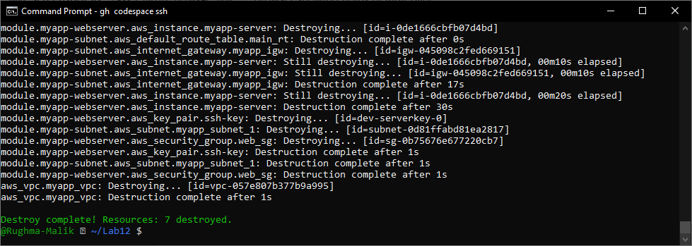

Task 6 — Configure HTTPS with self-signed certificates
In this task, you will configure Nginx to serve traffic over HTTPS using self-signed certificates.
- Update entry-script.sh with SSL configuration:
systemctl restart nginx
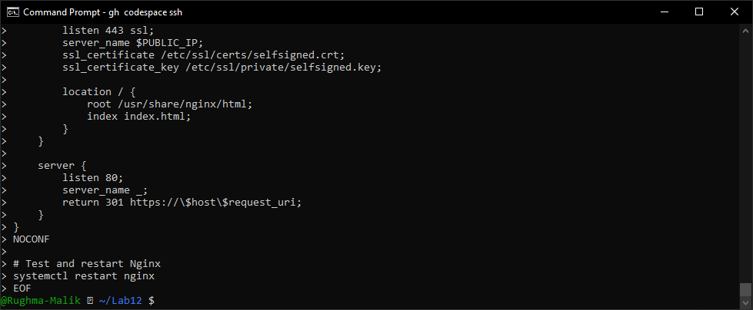
- Apply the configuration:
terraform apply -auto-approve
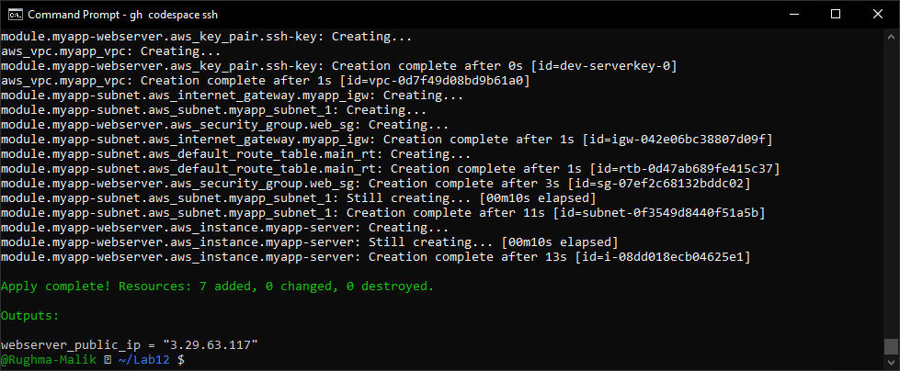
- Display the output:
terraform output
- Test HTTPS in browser:
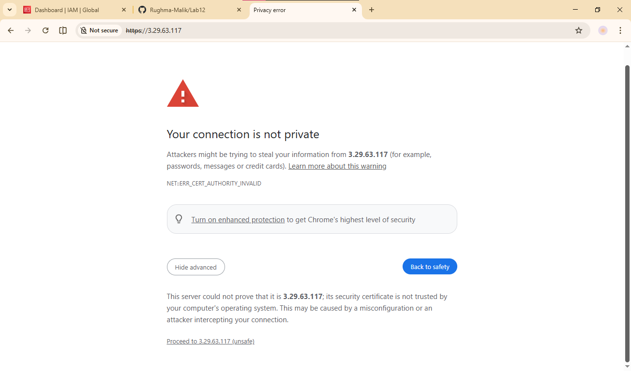
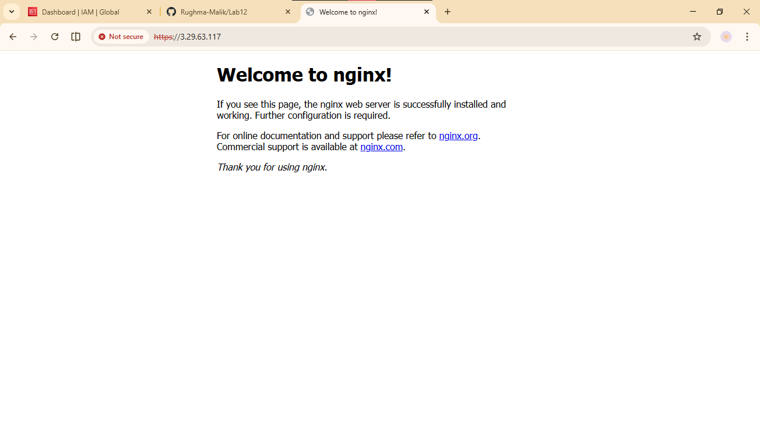
- Verify HTTP to HTTPS redirect:
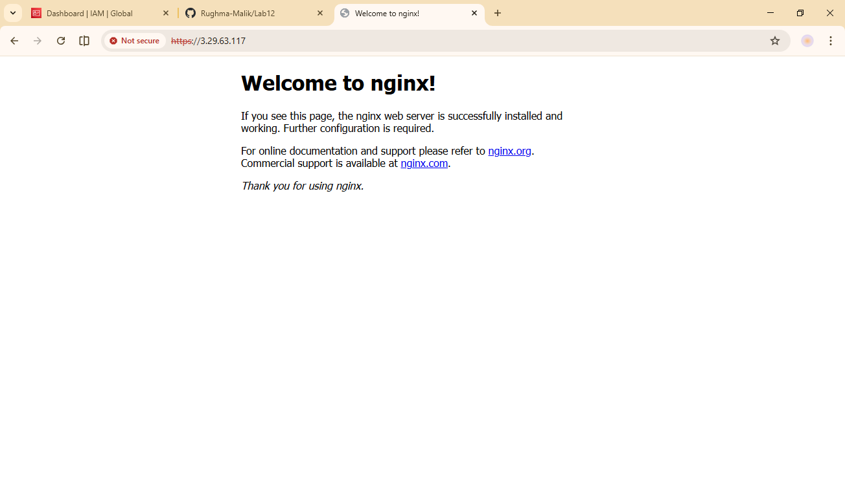

Task 7 — Configure Nginx as reverse proxy
In this task, you will create a backend web server and configure Nginx to act as a reverse proxy.
- Create apache.sh script for backend web server:
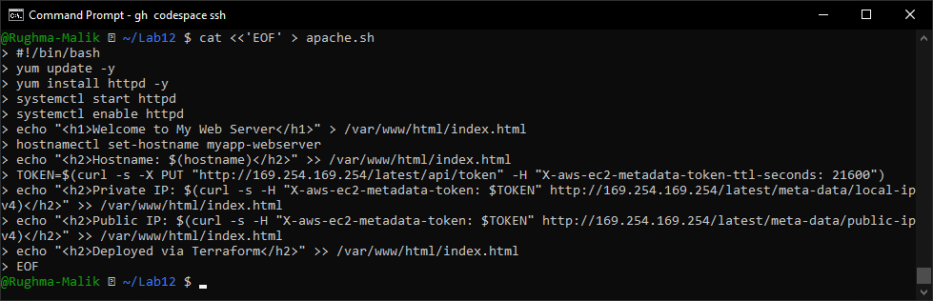
- Add the backend web server module to main.tf:
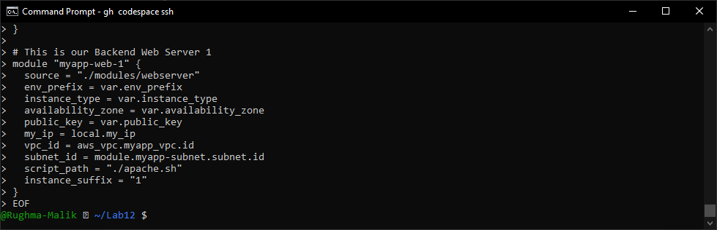
- Update outputs.tf:
output "aws_web-1_public_ip" {
value = module.myapp-web-1.aws_instance.public_ip
}
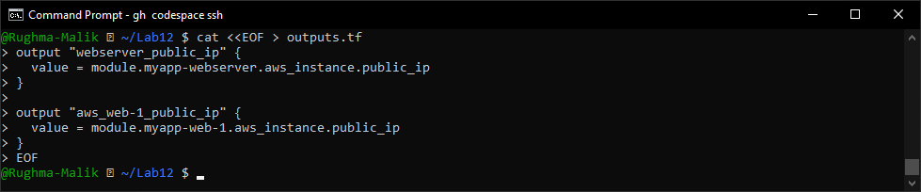
- Apply the configuration:
terraform apply -auto-approve
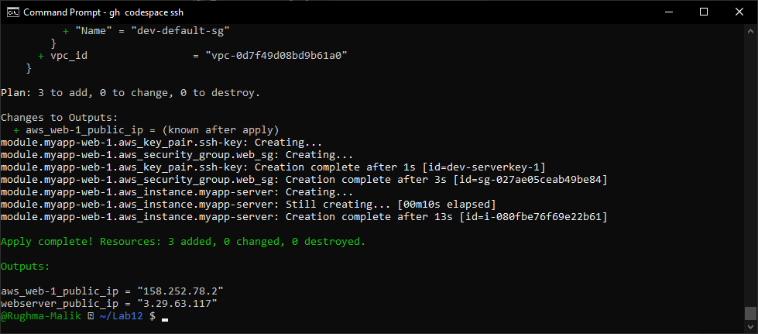
- Get the outputs:
terraform output
- SSH into the webserver (Nginx proxy server):
ssh ec2-user@<webserver-public-ip>
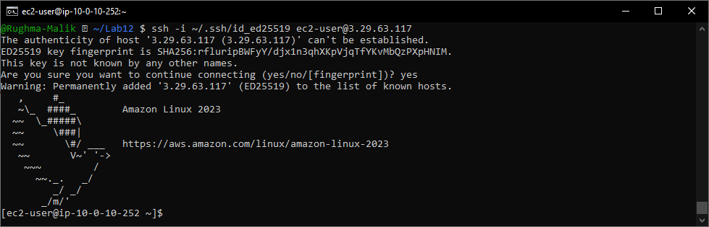
- Edit the Nginx configuration:
sudo vim /etc/nginx/nginx.conf
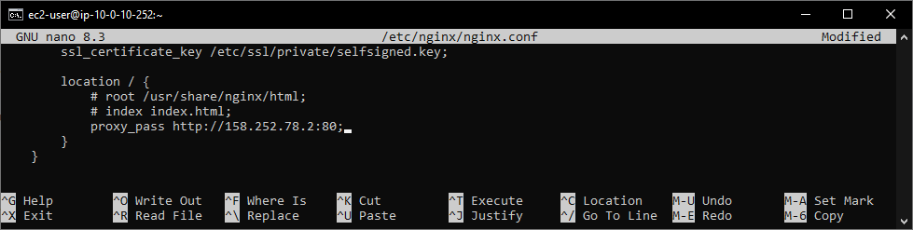
- Restart Nginx:
sudo systemctl restart nginx
- View Nginx logs and configuration files:
cat /var/log/nginx/error.log
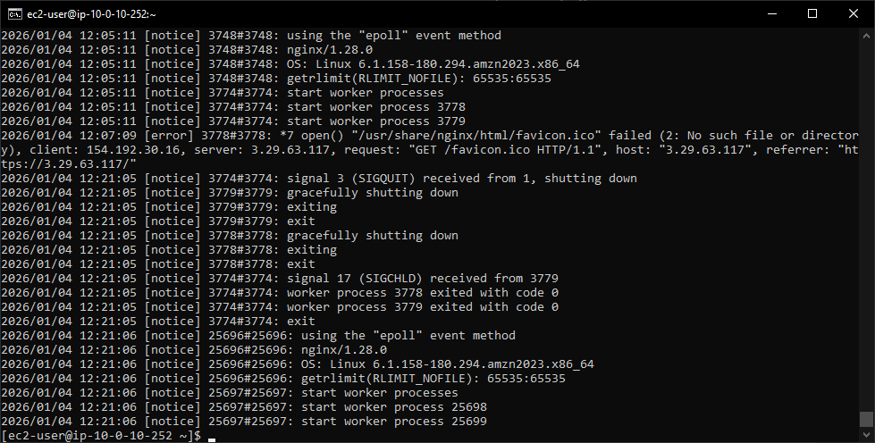
cat /var/log/nginx/access.log
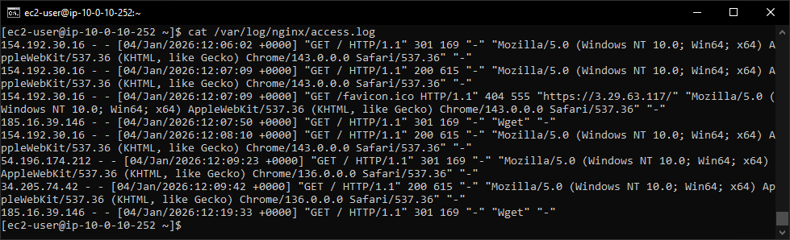
cat /etc/nginx/mime.types
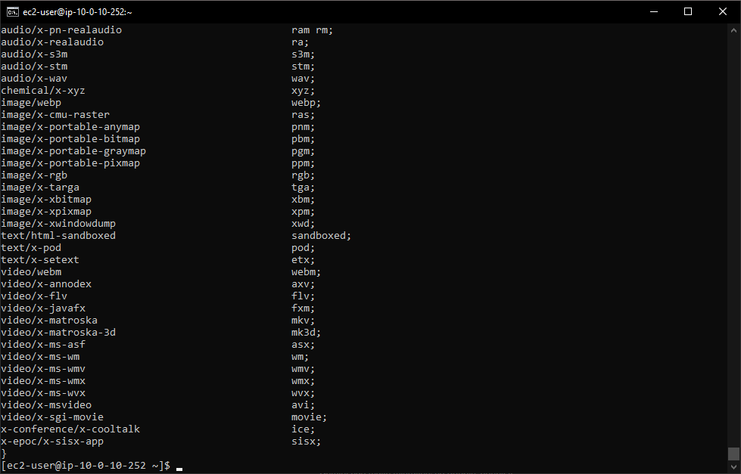
cat /etc/ssl/certs/selfsigned.crt
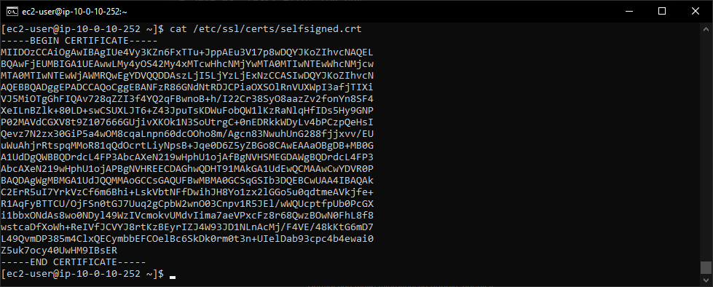
sudo cat /etc/ssl/private/selfsigned.key
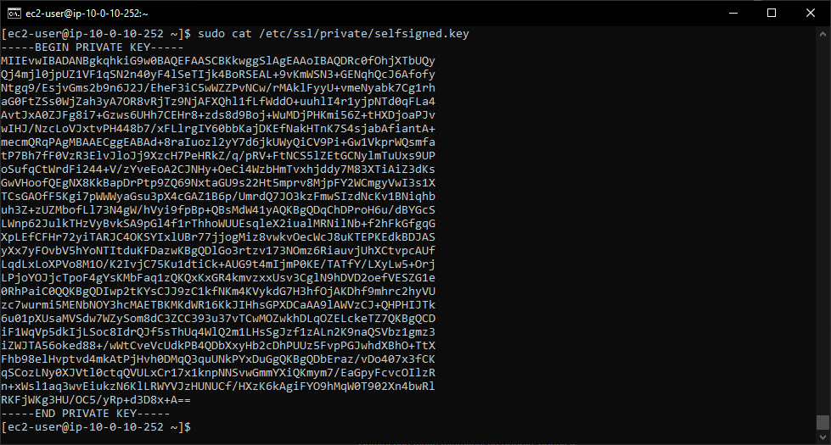
- Test reverse proxy in browser:
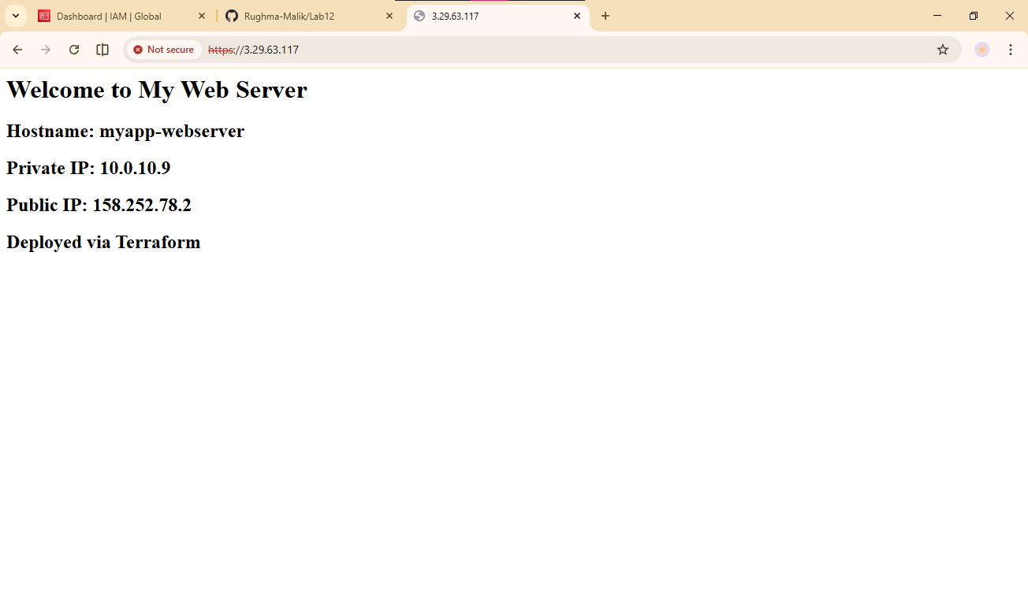

Task 8 — Configure Nginx as load balancer
In this task, you will add a second backend server and configure Nginx to load balance between them.
- Add the second web server module to main.tf:
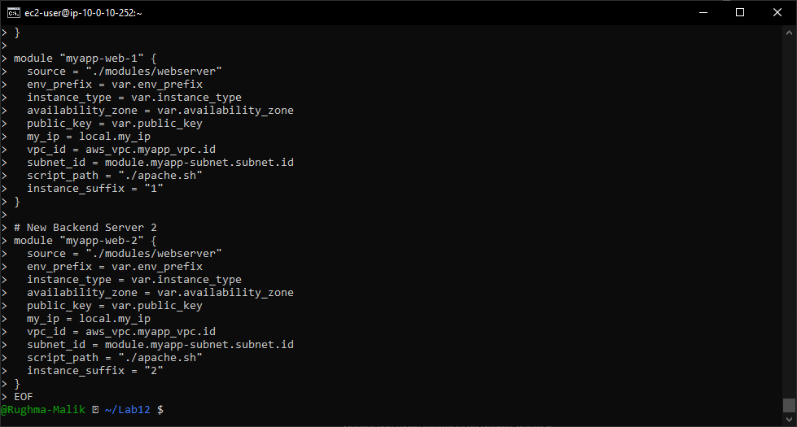
- Update outputs.tf:
output "aws_web-2_public_ip" {
value = module. myapp-web-2.aws_instance.public_ip
}
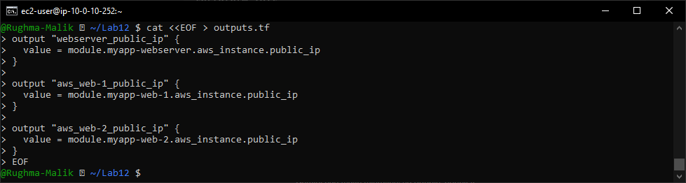
- Apply the configuration:
terraform apply -auto-approve
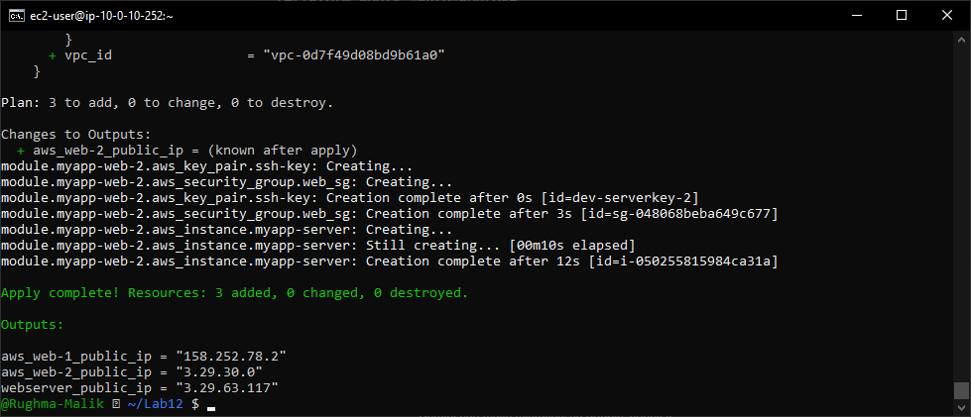
- Get all outputs:
terraform output
- SSH into the webserver (Nginx proxy):
ssh ec2-user@<webserver-public-ip>
- Edit Nginx configuration for load balancing:
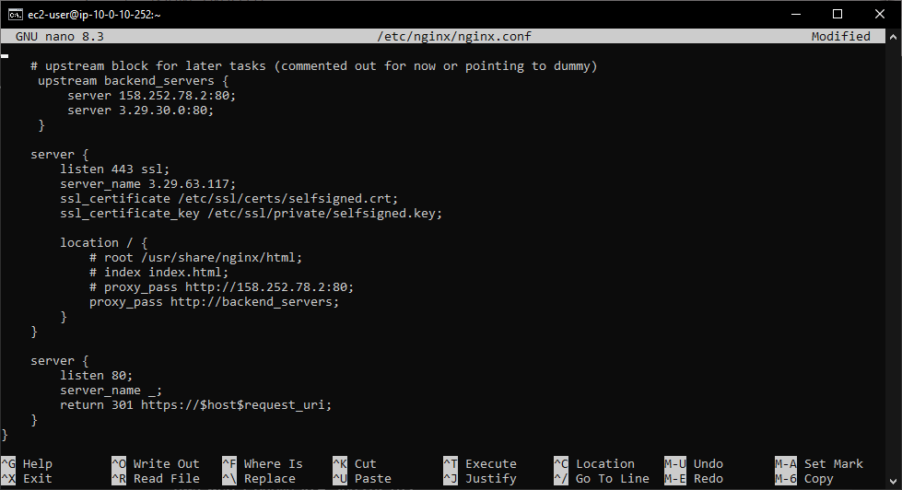
- Restart Nginx:
sudo systemctl restart nginx
- Test load balancing in browser:
- Open browser and navigate to https://<webserver-public-ip>
- Reload the page multiple times
- You should see the content alternating between web-1 and web-2 (check the hostname/IP in the page)
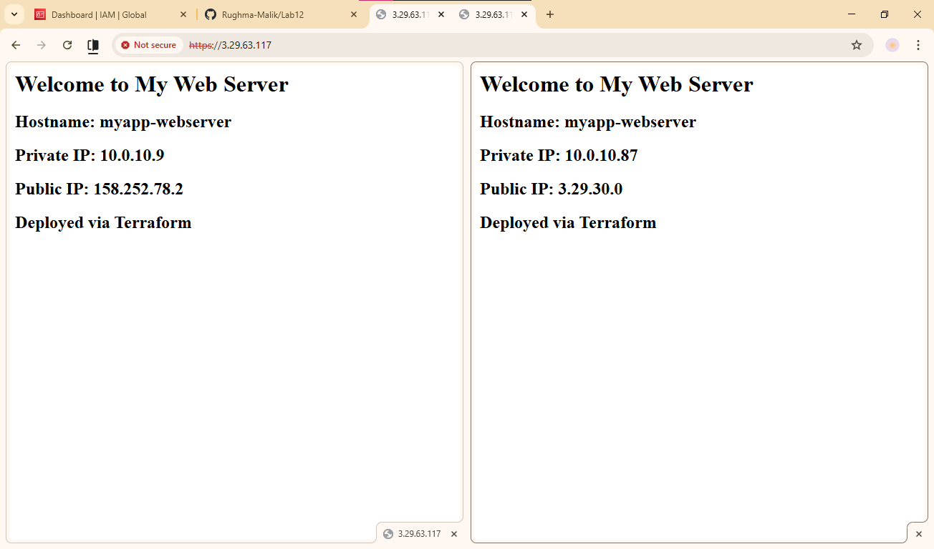

Task 9 — Configure high availability with backup servers
In this task, you will configure one server as primary and another as backup for high availability.
- SSH into the webserver:
ssh ec2-user@<webserver-public-ip>
- Edit Nginx configuration for high availability:
sudo vim /etc/nginx/nginx.conf
Update the upstream block to make web-2 a backup:
upstream backend_servers {
server <web-1-public-ip>:80;
server <web-2-public-ip>:80 backup;
}
- Save screenshot as: task9_nginx_conf_ha_web1_primary.png — nginx.conf with web-2 as backup.
- Restart Nginx:
sudo systemctl restart nginx
- Test in browser:
- Open browser and navigate to https://<webserver-public-ip>
- Reload multiple times
- You should ONLY see web-1 (primary server)
- Save screenshot as: task9_ha_web1_only.png — browser showing only web-1 content on multiple reloads.
- Switch backup configuration:
sudo vim /etc/nginx/nginx.conf
Update to make web-1 backup:
upstream backend_servers {
server <web-1-public-ip>:80 backup;
server <web-2-public-ip>:80;
}
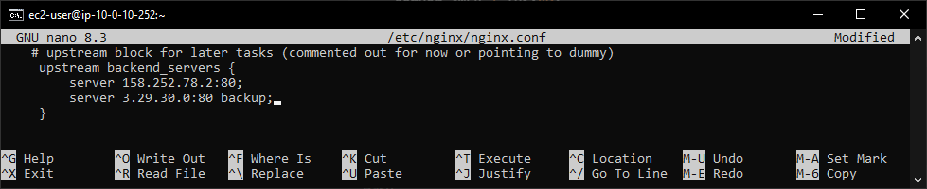
- Restart Nginx:
sudo systemctl restart nginx
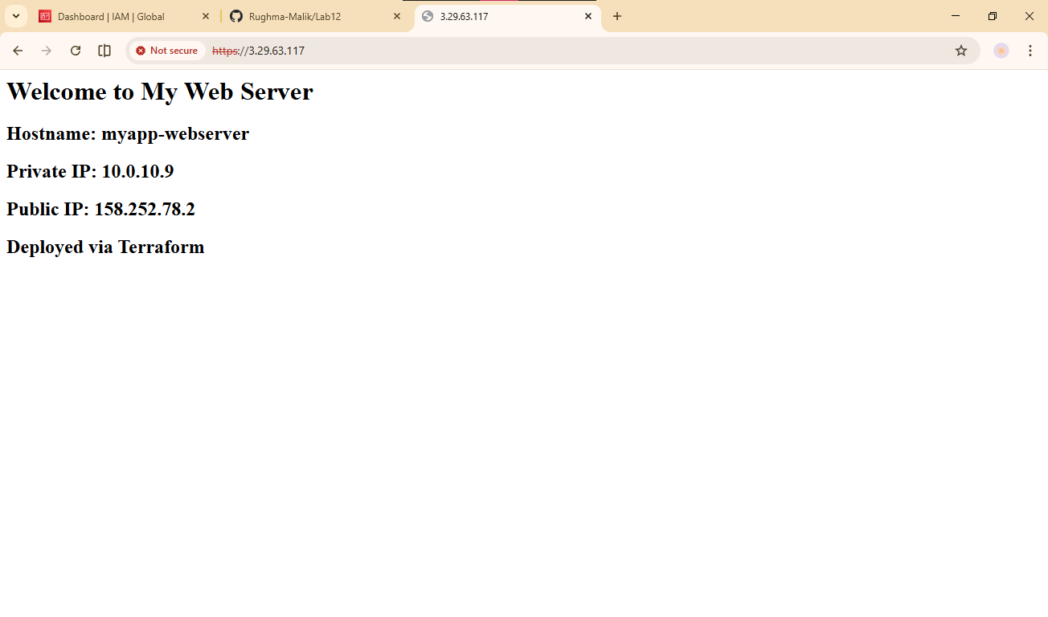
- Test in browser:
- Reload multiple times
- You should ONLY see web-2 (now the primary server)
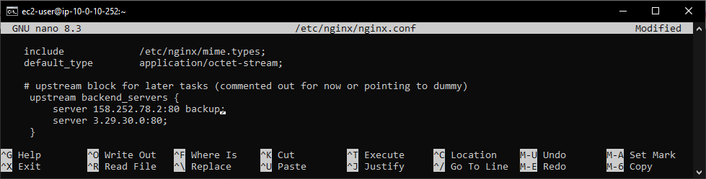
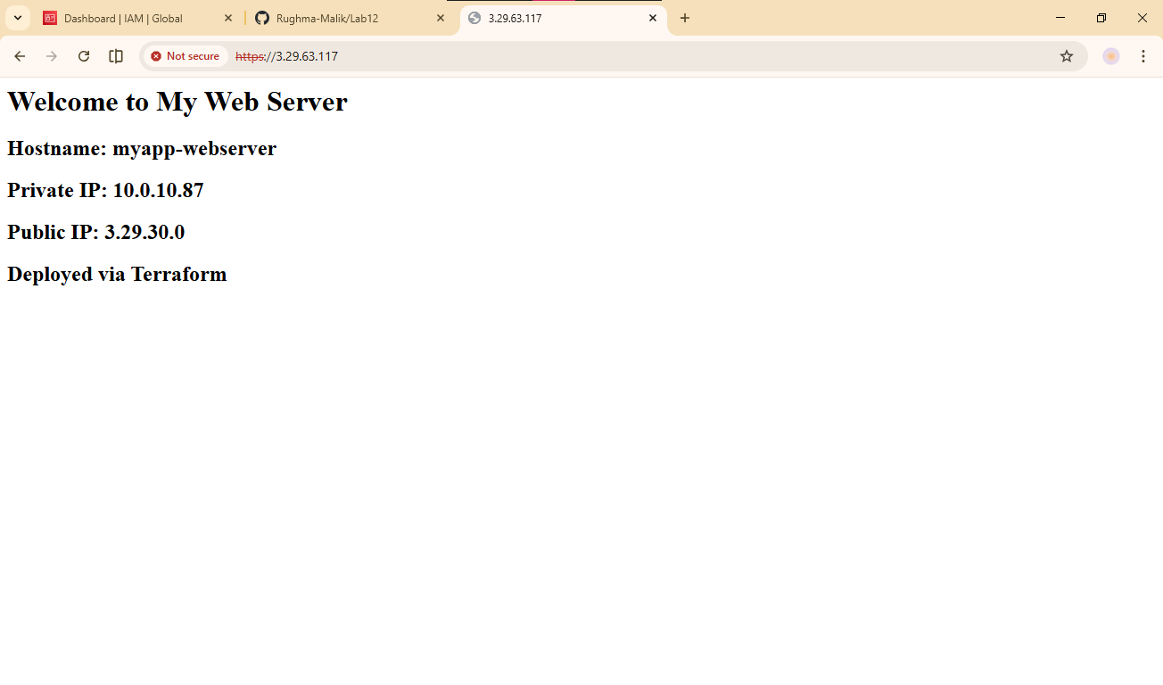

Task 10 — Enable Nginx caching
In this task, you will enable caching in Nginx to improve performance.
- SSH into the webserver:
ssh ec2-user@<webserver-public-ip>
- Edit Nginx configuration to enable caching:
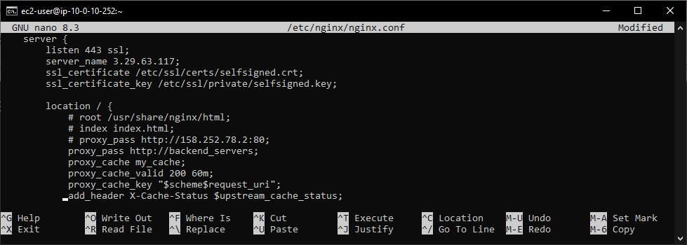
- Restart Nginx:
sudo systemctl restart nginx
- Test caching in browser:
- Open browser developer tools (F12)
- Navigate to Network tab
- Visit https://<webserver-public-ip>
- Check response headers for X-Cache-Status
- First request should show MISS
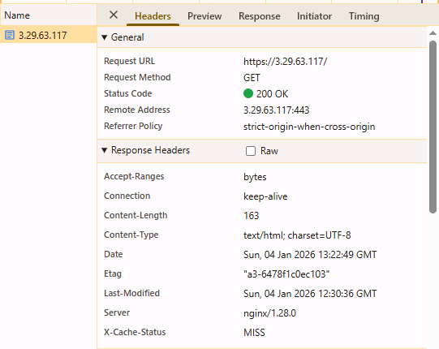
- Reload the page
- Second request should show HIT
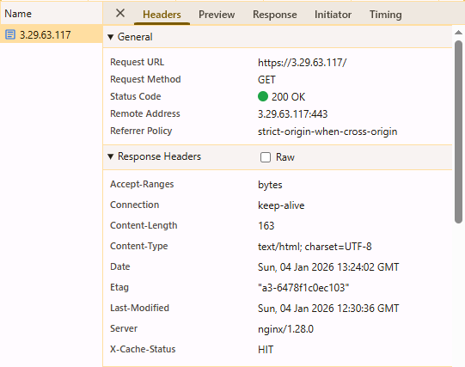
- Verify cache directory:
ls -la /var/cache/nginx/
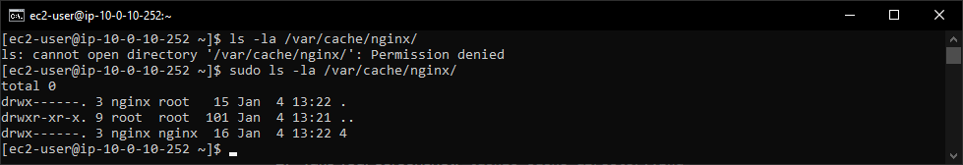

Cleanup
- Exit SSH sessionDestroy all resources:
terraform destroy
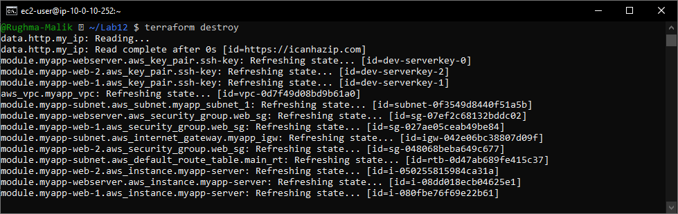
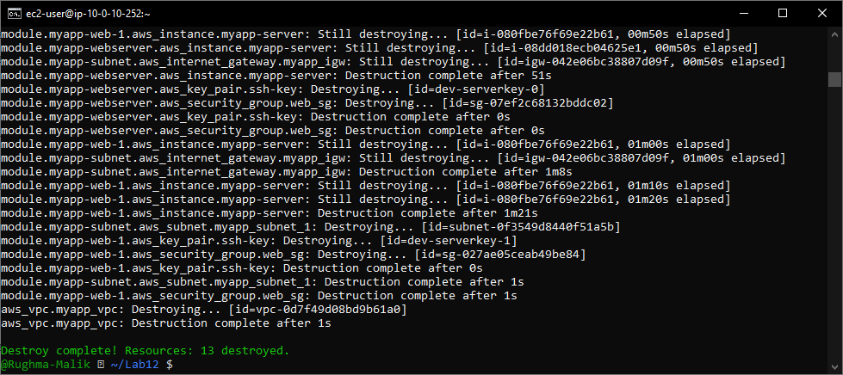

- Verify state files:
cat terraform.tfstate
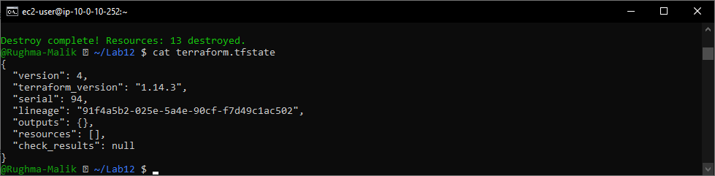
- List all project files:
tree
