Name: Rughma Malik
Reg no: 2023-BSE-54
Course: Cloud Computing Lab
Section: V-B
LAB 12
Terraform Provisioners, Modules & Nginx Reverse Proxy/Load Balancer
Task 0 Lab Setup (Codespace & GH CLI)
Create Codespace & connect:
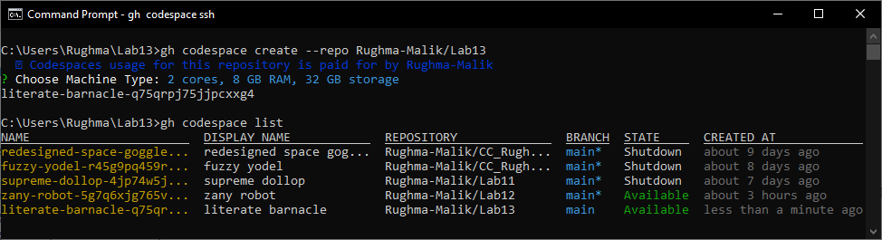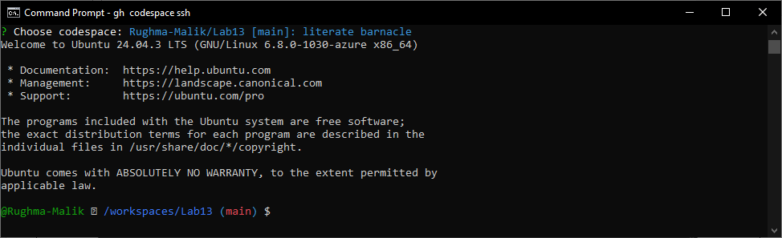

Task 1 — Create IAM Group and Output Details
In this task, you will create an IAM group named "developers" and output its details.
- Create the initial project structure:
mkdir -p ~/Lab13
cd ~/Lab13
- Create the main Terraform file:
touch main.tf
- Create main.tf with AWS provider configuration:
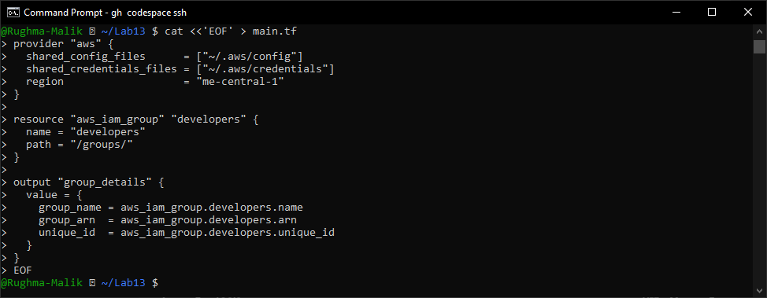
- Initialize Terraform:
terraform init
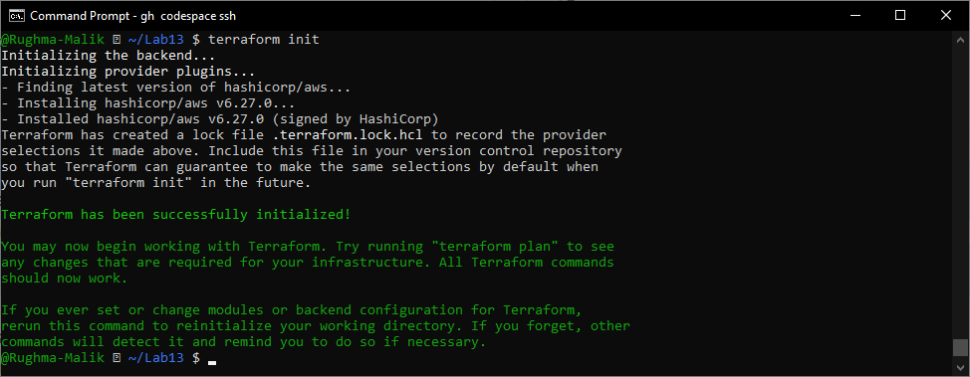

- Apply the configuration:
terraform apply -auto-approve
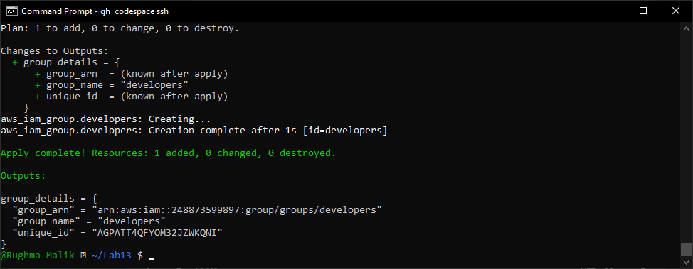
- Display the output:
terraform output
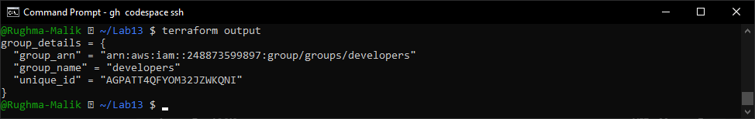
- Verify the group in AWS Console:
- Navigate to IAM → Groups in AWS Console
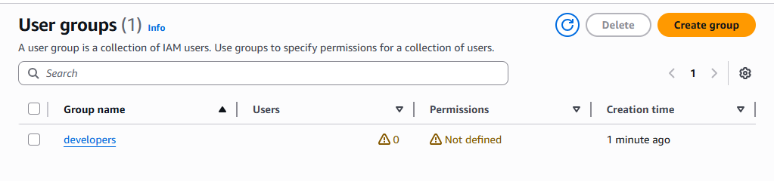

Task 2 — Create IAM User with Group Membership
In this task, you will create an IAM user named "loadbalancer" and add it to the developers group.
- Update main.tf to add the IAM user resource:
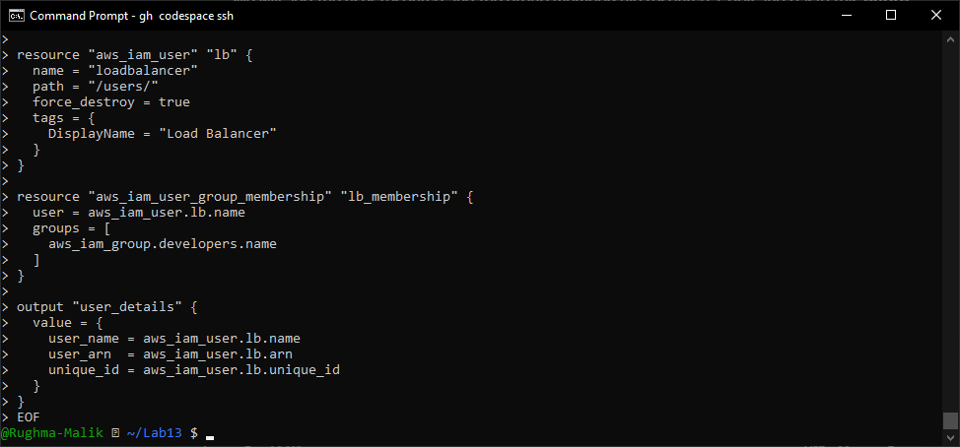
- Apply the configuration:
terraform apply -auto-approve
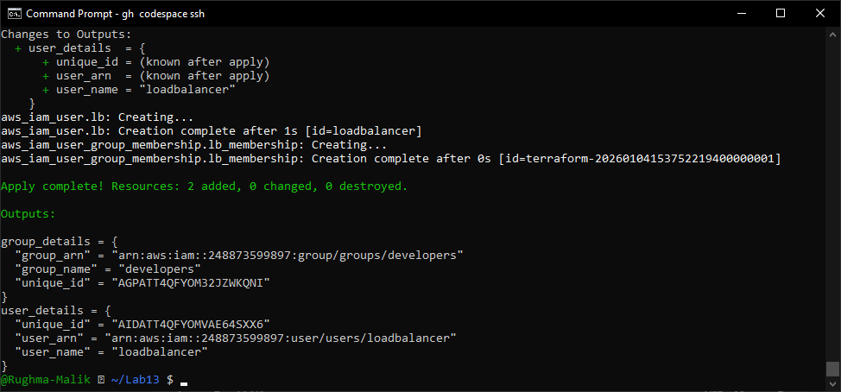
- Display the outputs:
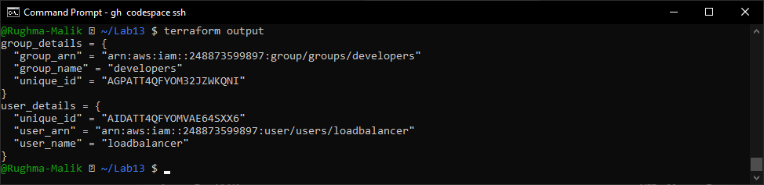
- Verify the user in AWS Console:
- Navigate to IAM → Users in AWS Console
- Click on "loadbalancer" user
- Check the "Groups" tab
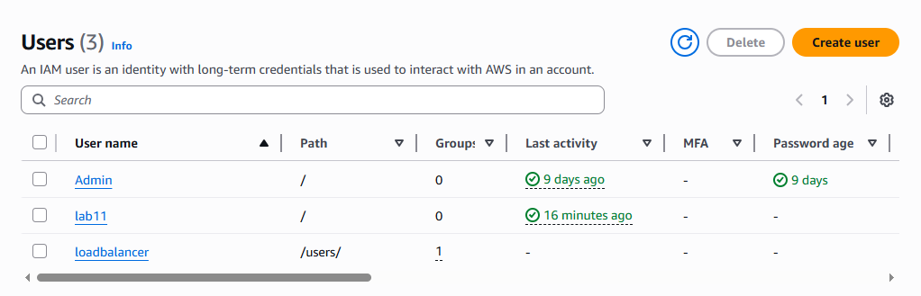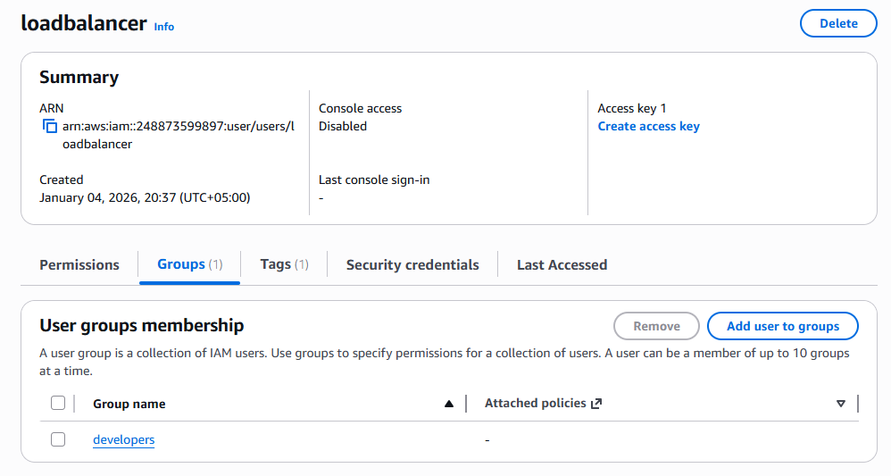

Task 3 — Attach Policies to IAM Group
In this task, you will attach AWS managed policies (AmazonEC2FullAccess and IAMUserChangePassword) to the developers group.

- Update main.tf to add policy attachments:
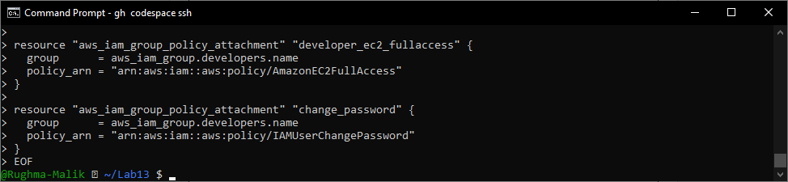
- Apply the configuration:
terraform apply -auto-approve
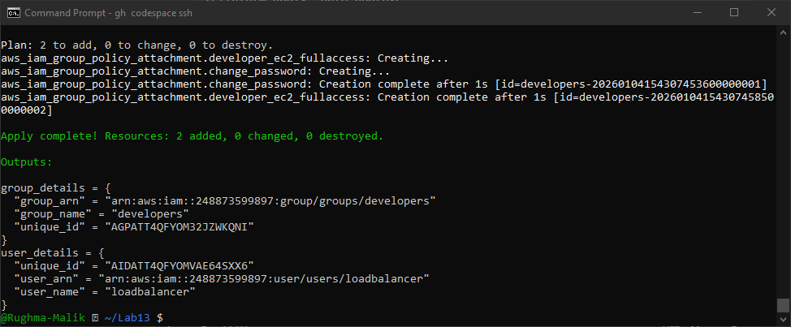
- Verify policies in AWS Console:
- Navigate to IAM → Groups → developers
- Click on "Permissions" tab
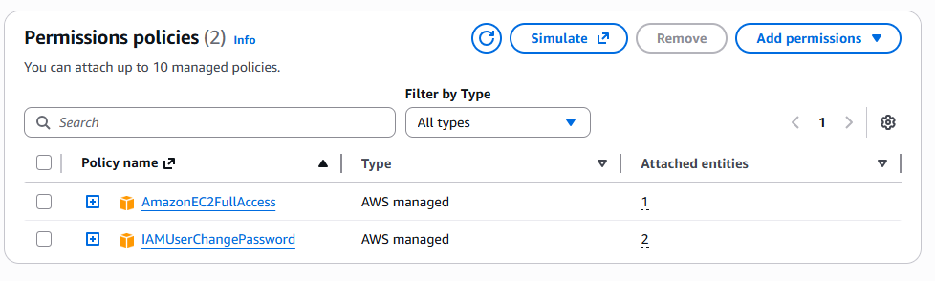

Task 4 — Create Login Profile for IAM User
In this task, you will create a login profile for the loadbalancer user using a bash script and null_resource provisioner.
- Create variables.tf file:
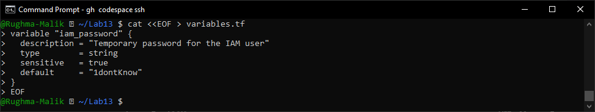
- Create the bash script create-login-profile.sh:
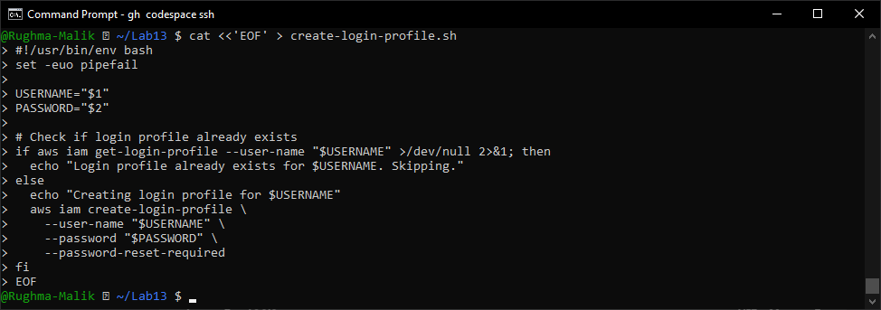
- Make the script executable:
chmod +x create-login-profile.sh
- Update main.tf to add the null_resource provisioner:
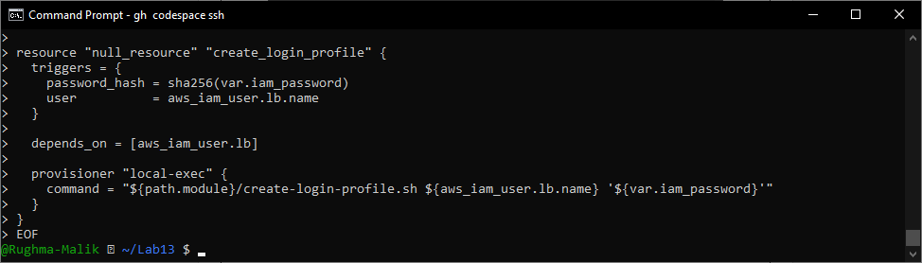
- Apply the configuration with a custom password:
terraform apply -auto-approve -var="iam_password=MySecurePass123!"
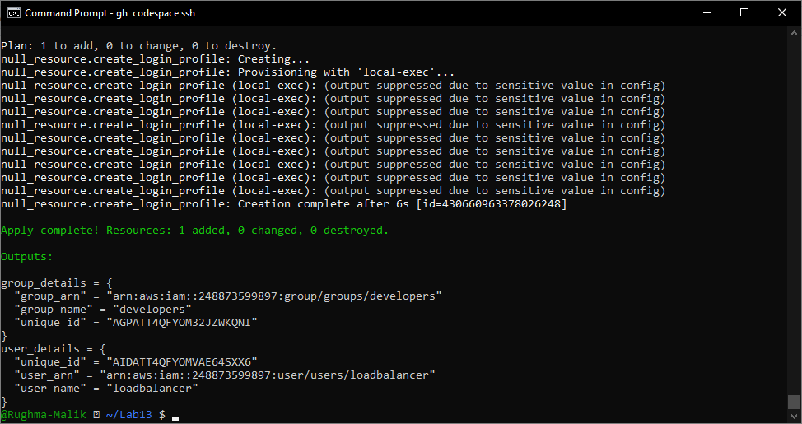
- Verify login profile creation:
aws iam get-login-profile --user-name loadbalancer
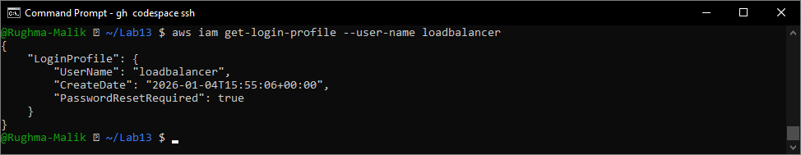
- Test login in AWS Console:
- Open AWS Console login page
- Sign in as IAM user with username "loadbalancer" and the password you set
- You should be prompted to change password
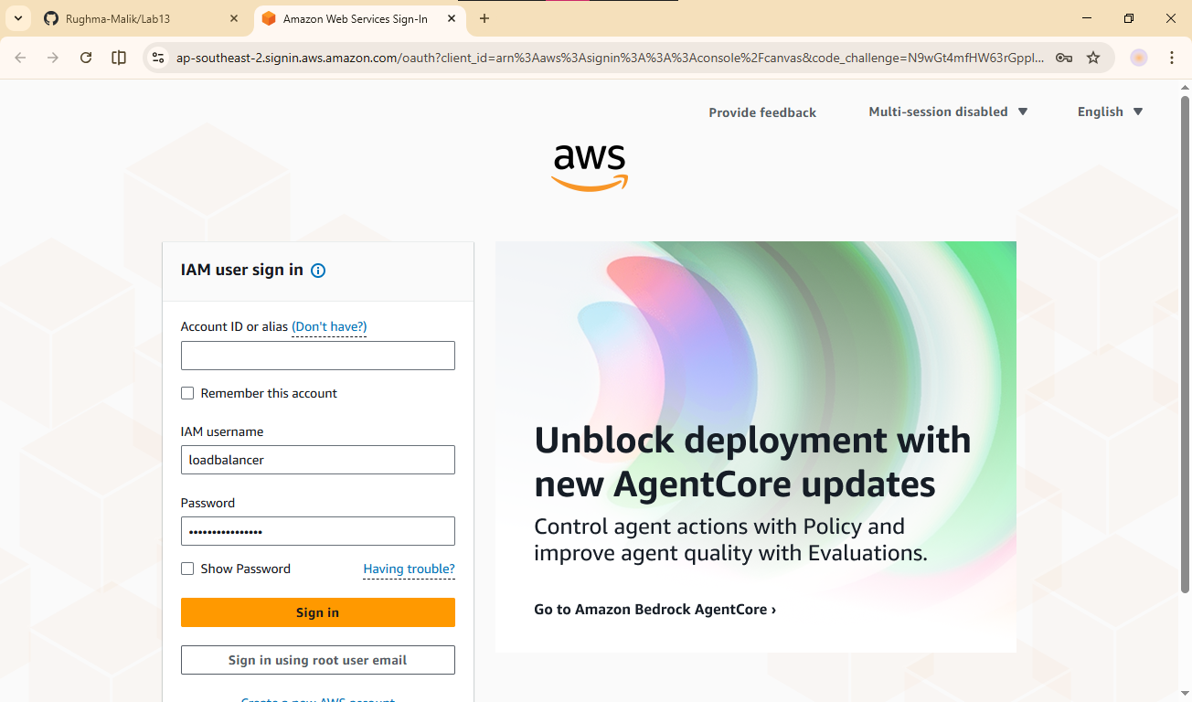
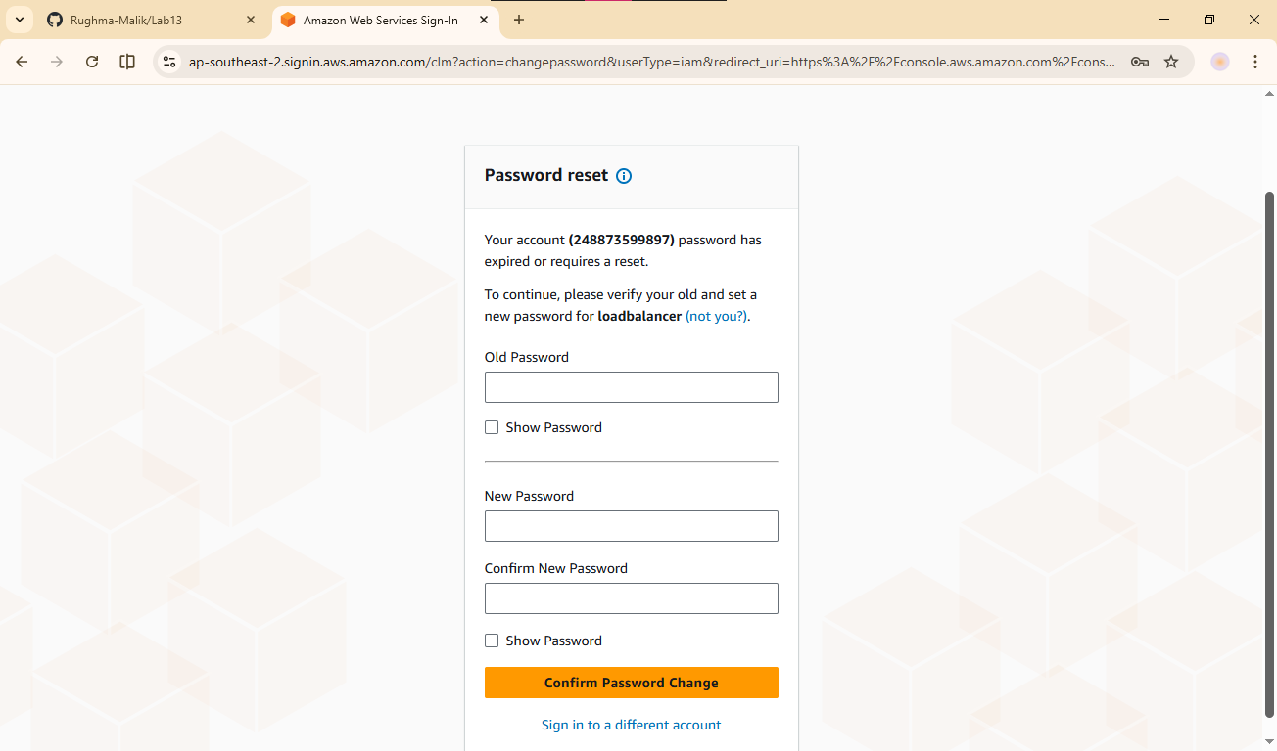

Task 5 — Generate Access Keys for IAM User
In this task, you will create access keys for the loadbalancer user and view them in terraform state.
- Update main.tf to add access key resource and outputs:
Add these resources:
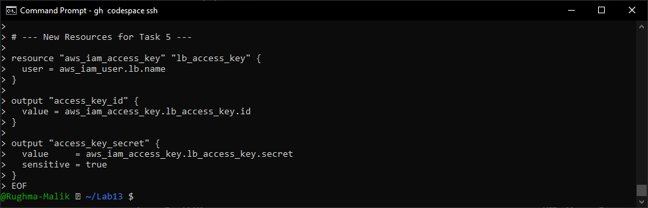
- Apply the configuration:
terraform apply -auto-approve -var="iam_password=MySecurePass123!"
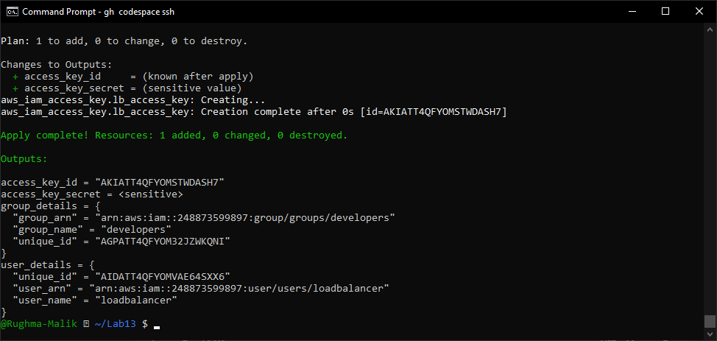
- Display outputs:
terraform output
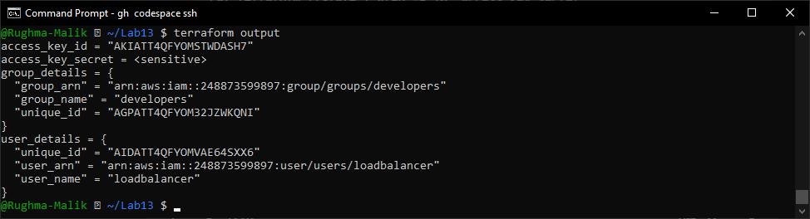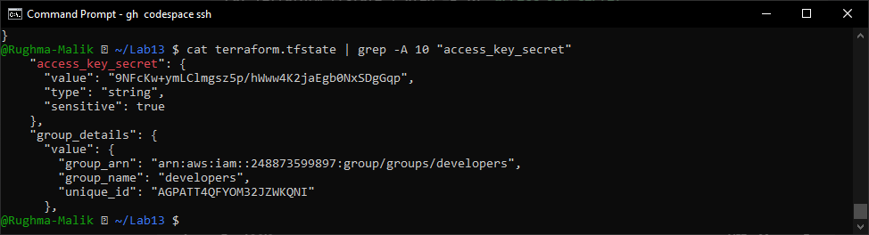
- View the secret in terraform state:
cat terraform.tfstate | grep -A 10 "access_key_secret"
- Verify access key in AWS Console:
- Navigate to IAM → Users → loadbalancer → Security credentials
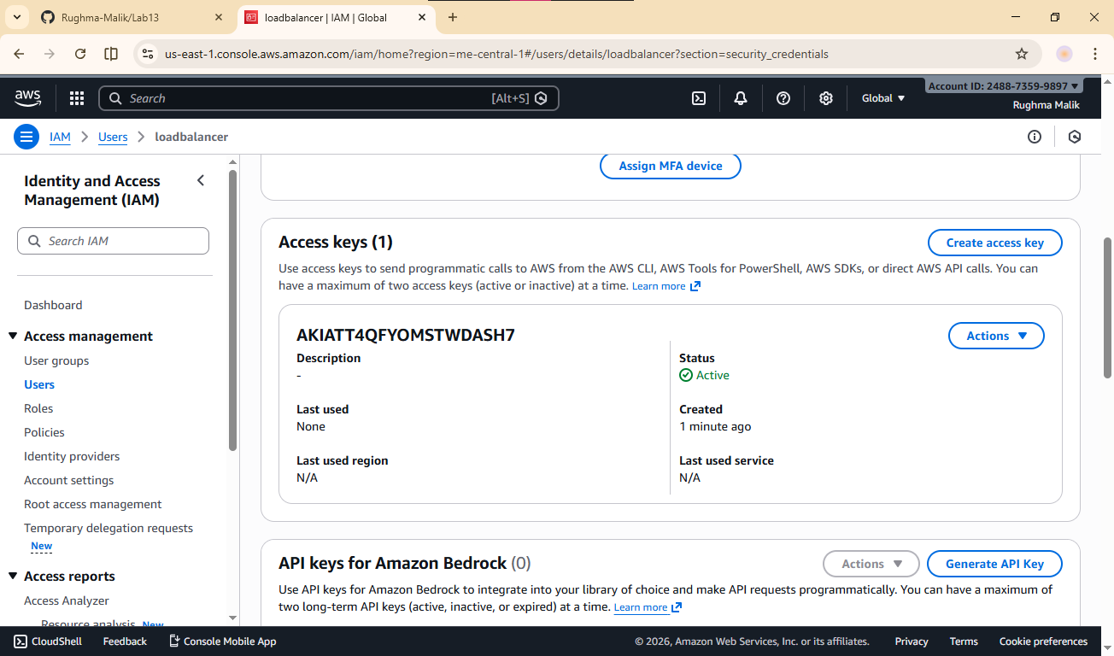

Task 6 — Implement Terraform Remote State with S3
In this task, you will configure Terraform to use S3 backend for remote state storage.
- Create S3 bucket in AWS Console:
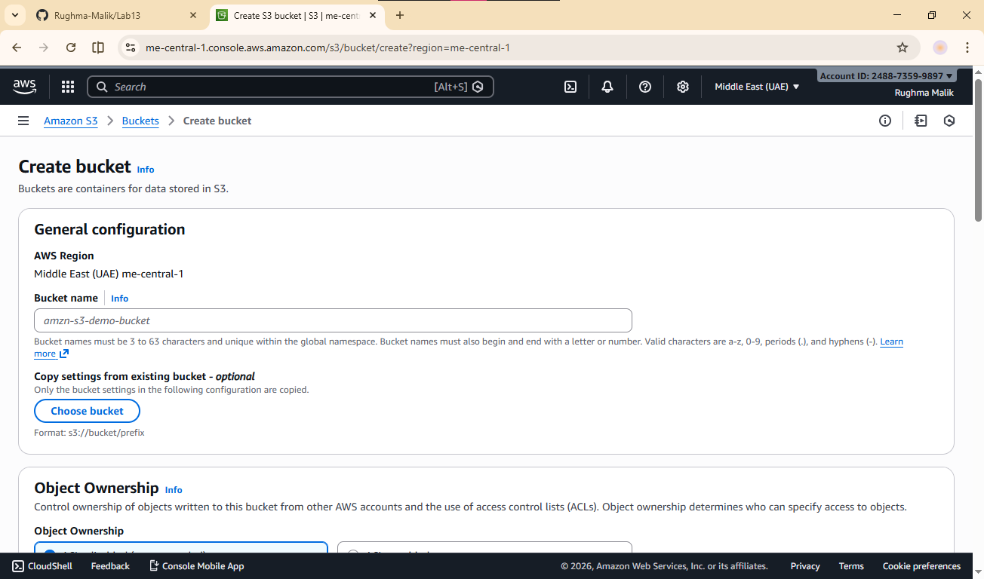
- Click "Create bucket"
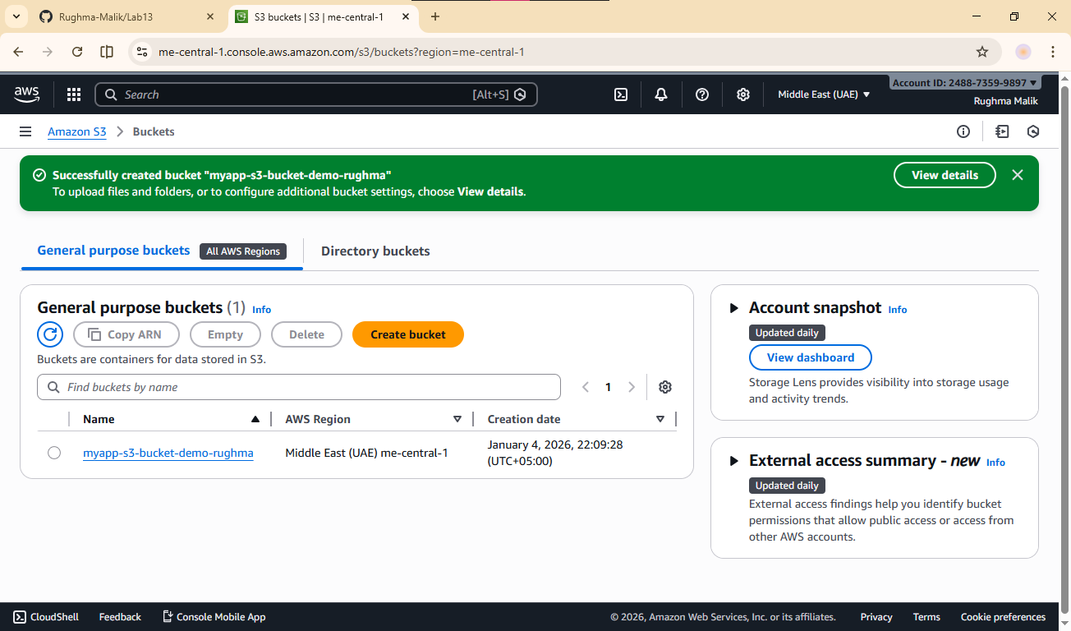
- Update main.tf to add S3 backend configuration:
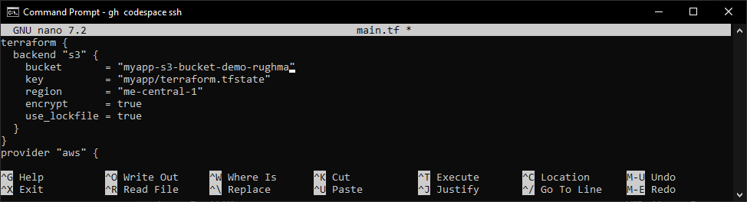
- Reinitialize Terraform with the backend:
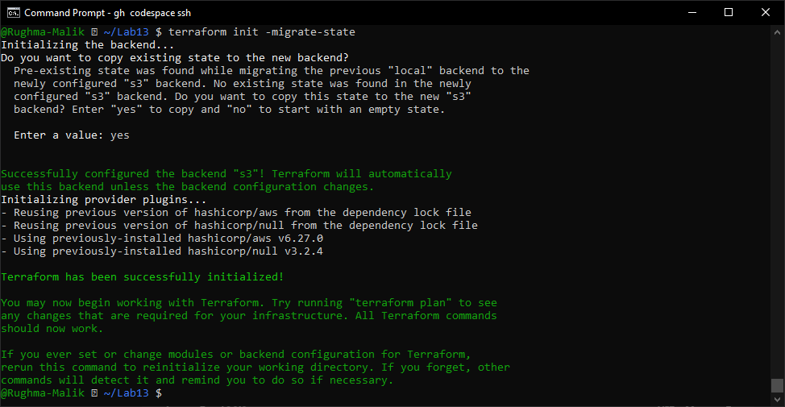
- Apply the configuration:
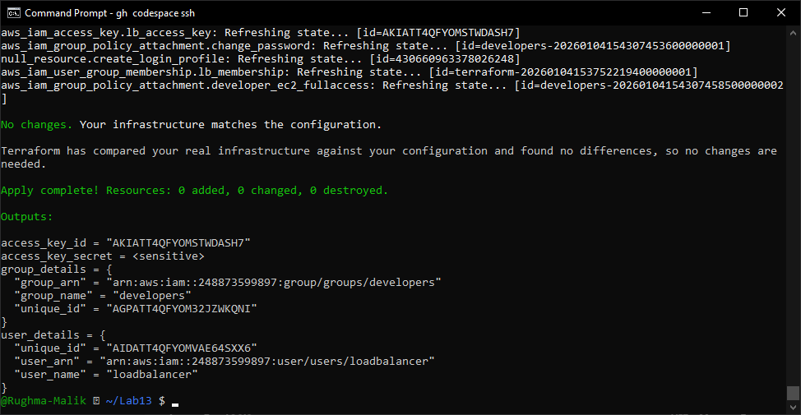
- Verify state file in S3:
- Navigate to S3 → myapp-s3-bucket-demo → myapp/
- You should see terraform.tfstate file
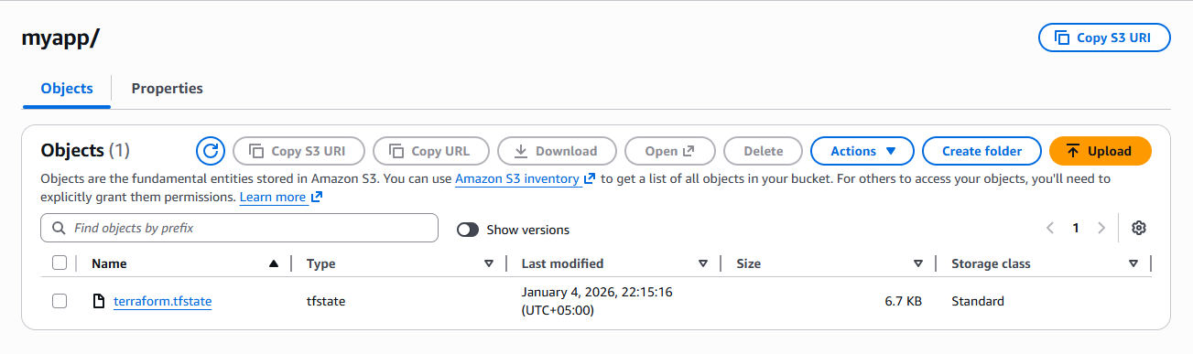
- Check local state file:
ls -la terraform.tfstate*
- Destroy resources and verify state change:
terraform destroy -auto-approve
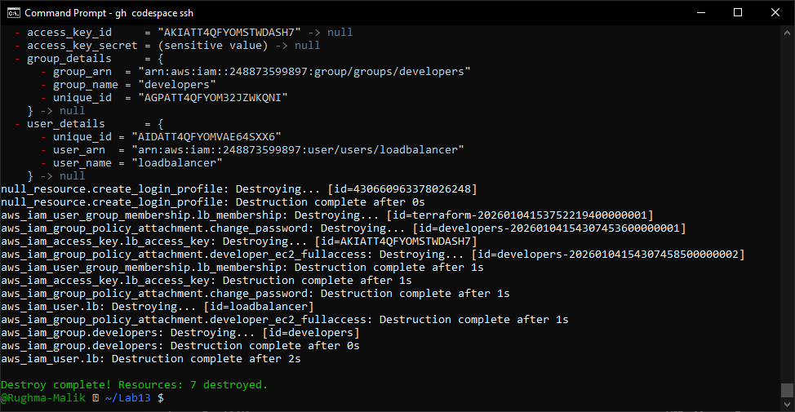

- Verify updated state in S3:
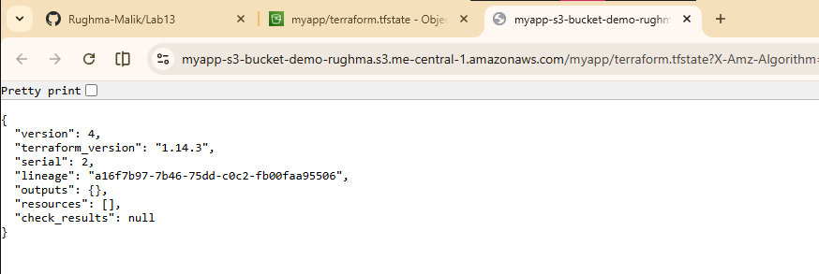

Task 7 — Create Multiple Users from CSV File
In this task, you will create multiple IAM users dynamically from a CSV file.
- Create locals.tf file:
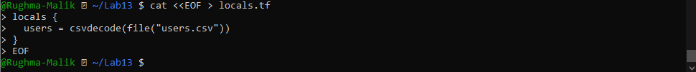
- Create users.csv file:
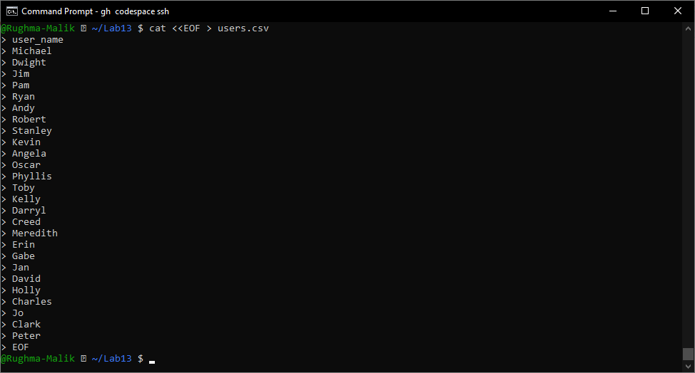
- Update main.tf to create multiple users:
Replace the single user resources with:
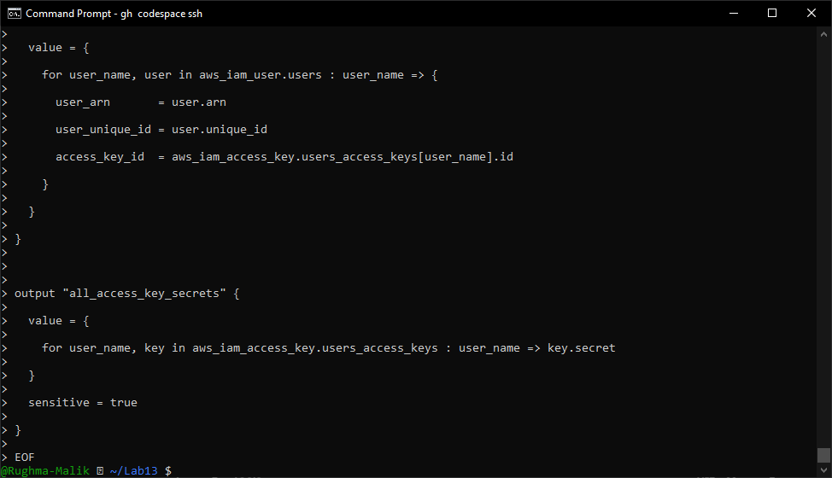
- Reinitialize Terraform (since we changed the configuration significantly):
terraform init
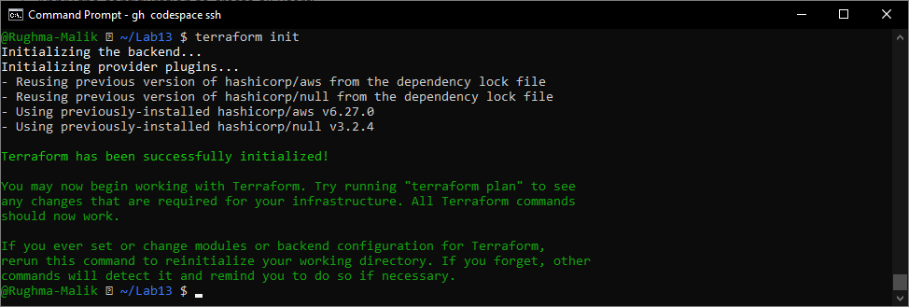
- Apply the configuration to create all users:
terraform apply -auto-approve -var="iam_password=MySecurePass123!"
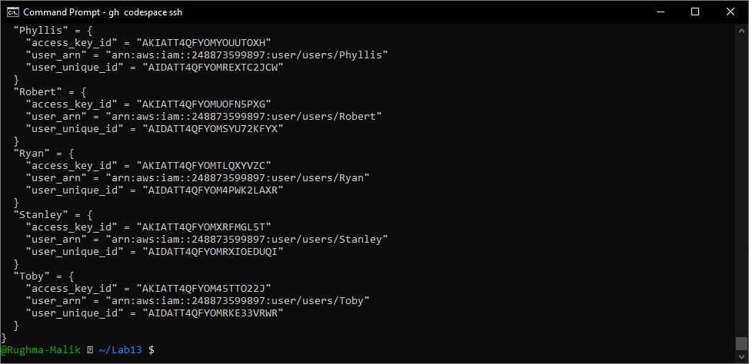
- Display the outputs:
terraform output
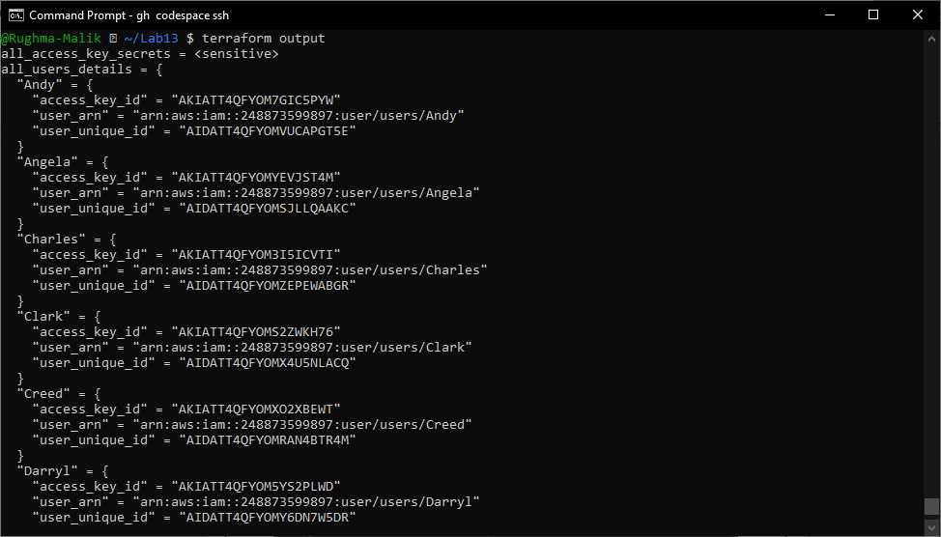
- View secrets in terraform. tfstate:
cat terraform.tfstate | grep -A 5 "all_access_key_secrets"
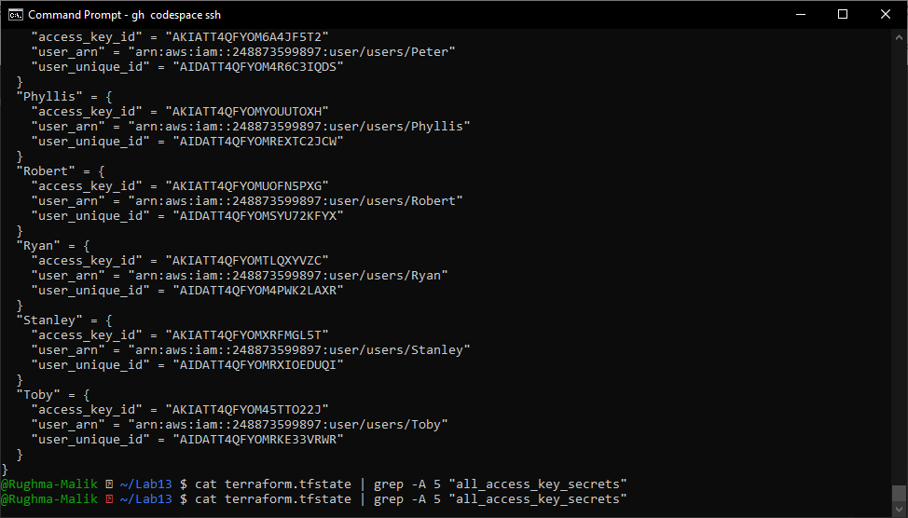
- Verify all users in AWS Console:
- Navigate to IAM → Users
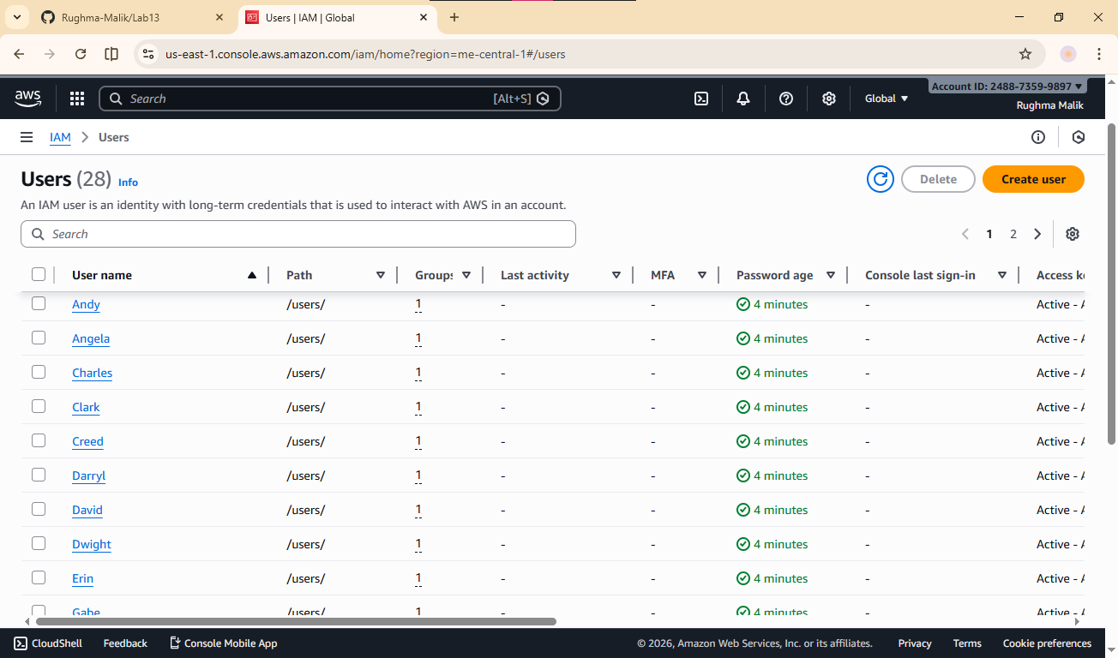

- Verify group membership:
- Navigate to IAM → Groups → developers → Users tab
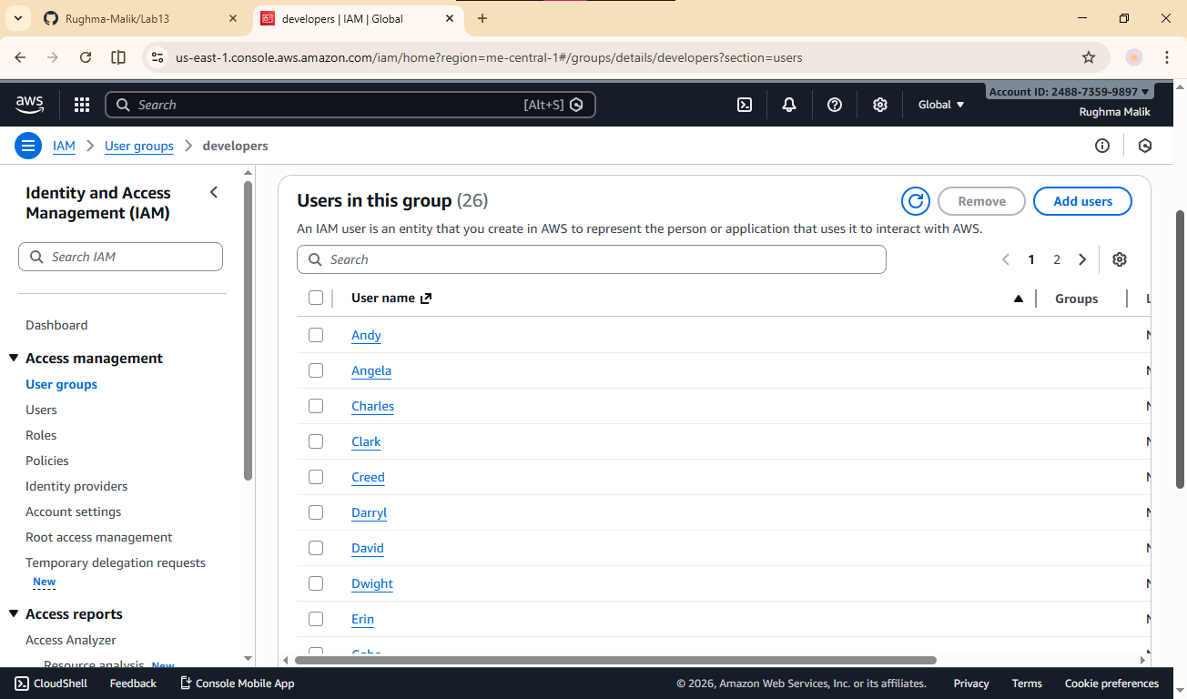
- Verify one user's access keys:
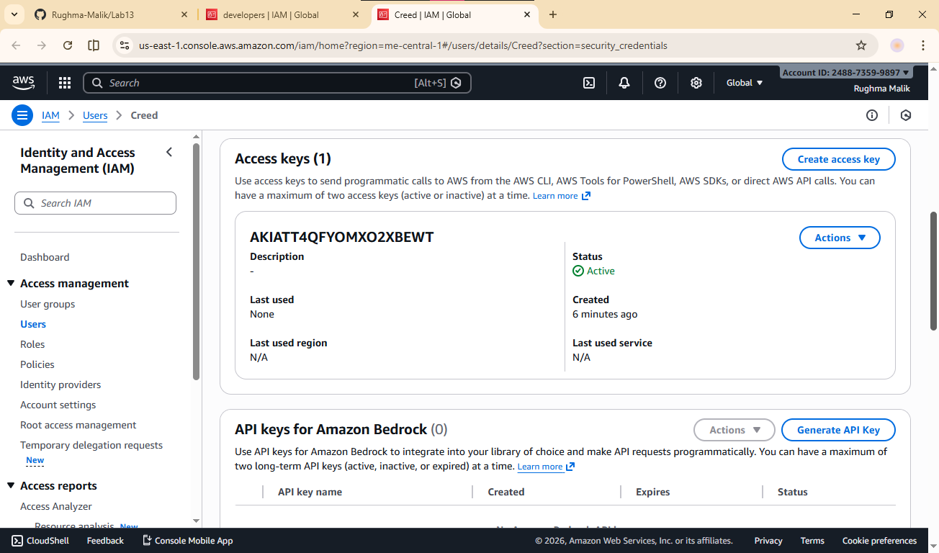
- Check terraform state in S3:
- Navigate to S3 bucket and view the state file
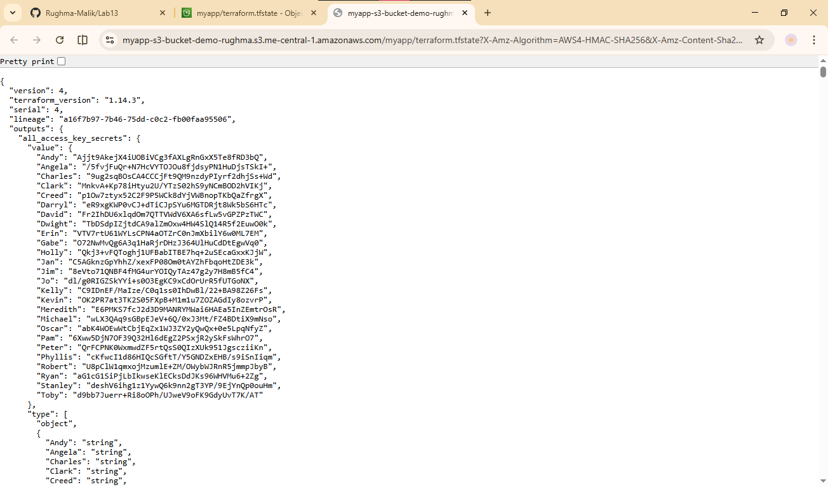

Cleanup
- Destroy all resources:
terraform destroy -auto-approve
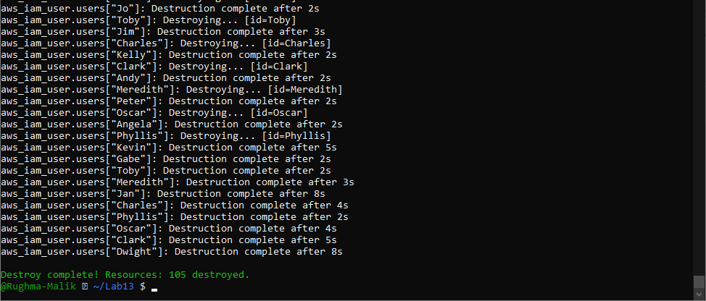
- Verify users deleted in AWS Console:
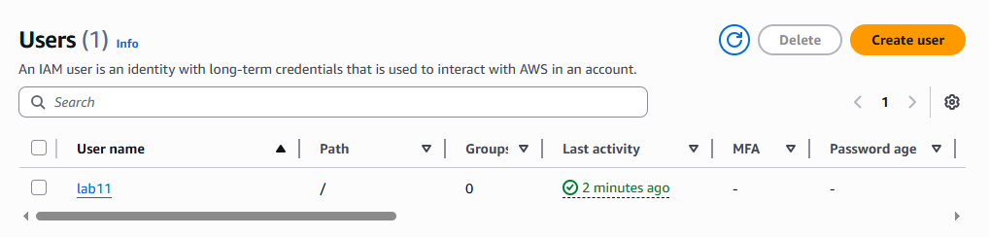
- Verify group deleted in AWS Console:
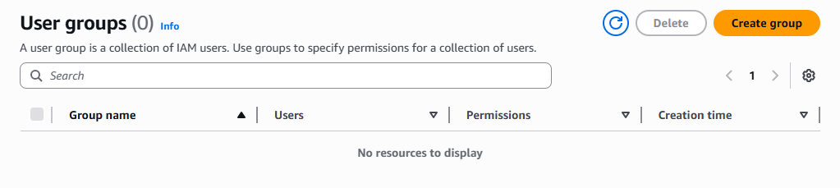
- Check S3 state file:
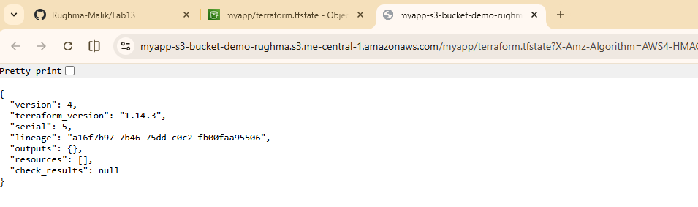
- List all project files:
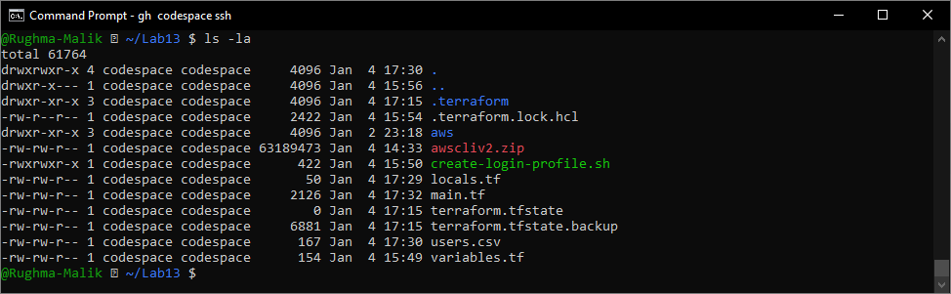
- (Optional) Delete S3 bucket:
- If you want to clean up completely, delete the S3 bucket from AWS Console
