**Name:** Rughma Malik

**Reg no:** 2023-BSE-54

**Course:** Cloud Computing Lab

**Section:** V-B

**LAB 1**

**VMWARE INSTALLATION**

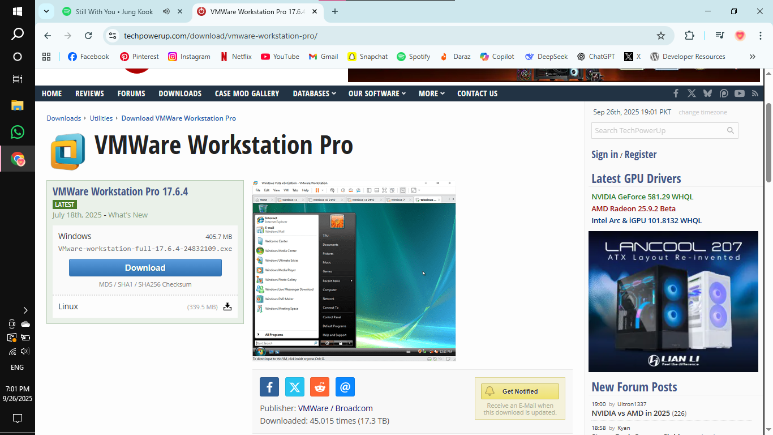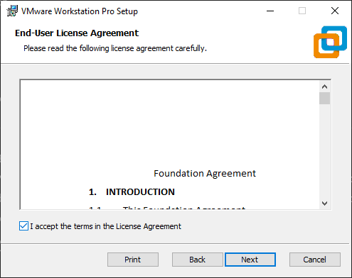

**UBUNTU SERVER INSTALLATION:**

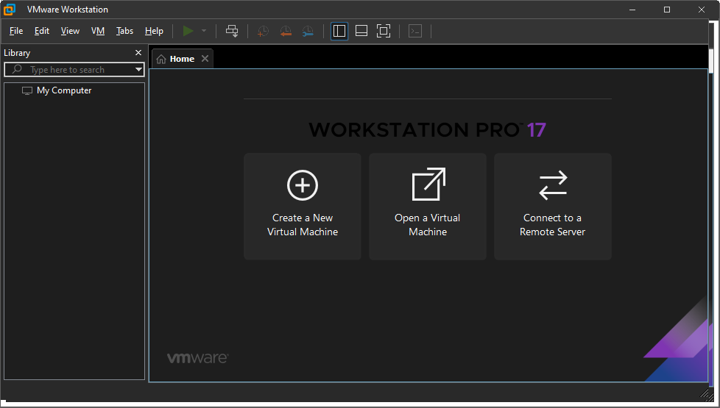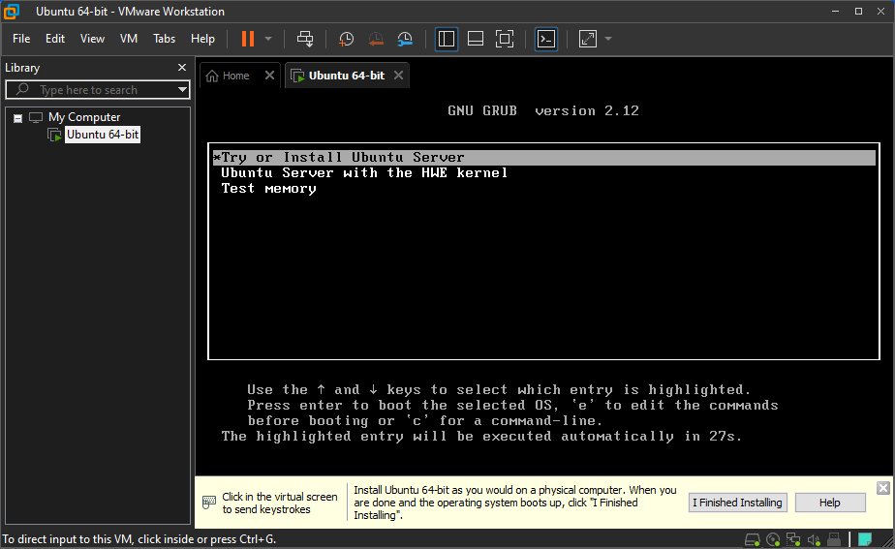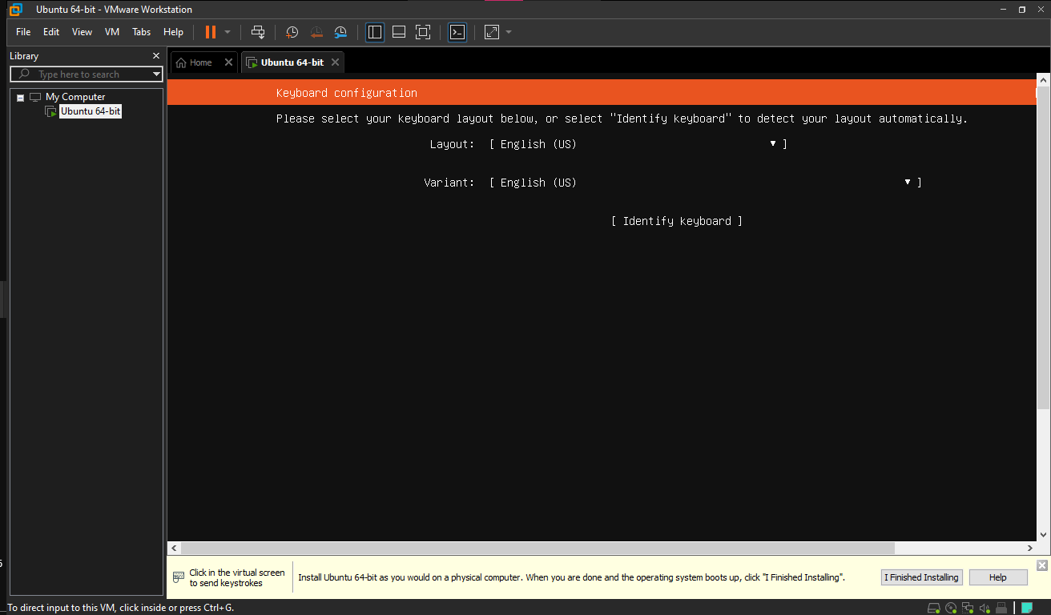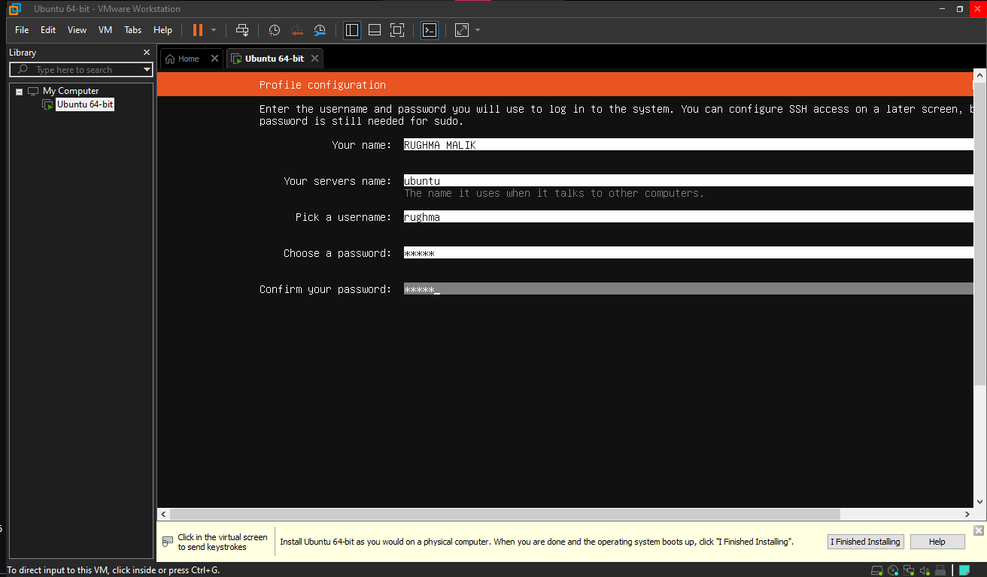

**Accessing your Ubuntu Server from Windows**

