

**FATIMA JINNAH WOMEN UNIVERSITY**

**Department of Software Engineering**

**ASSIGNMENT # 1**

Git, Gitea, GitHub, LFS, and GitHub Pages

**Course Title:**

Cloud Computing

**Submitted to:**

Engr. Waqas Salim

**Submitted by:**

Rughma Malik

2023-BSE-054

V-B

**ASSIGNMENT-1**

* **Screenshot of your Gitea repository (showing README listing names & roll num)**

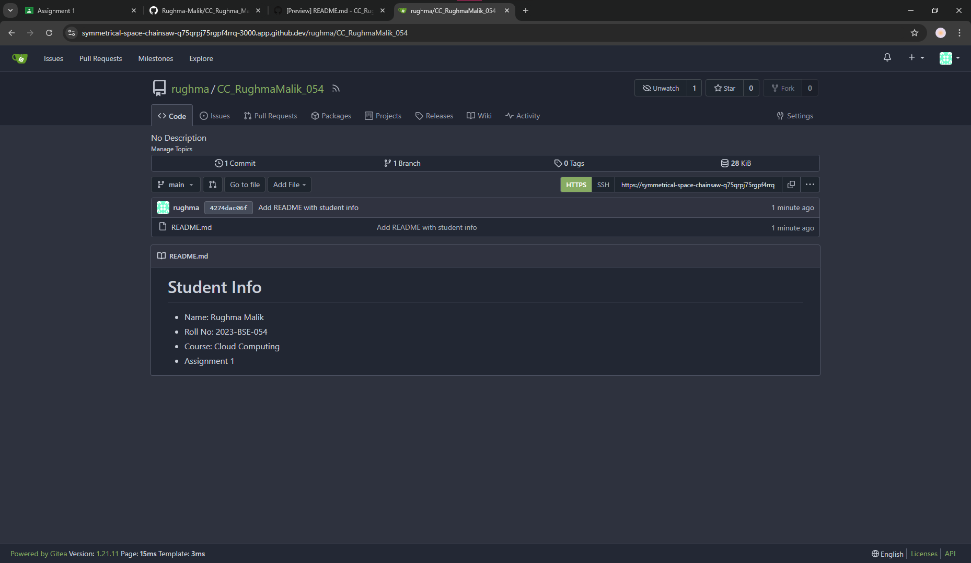

The **Gitea repository screenshot** shows the initial repo with the README file containing my name and roll number.

* **GitHub assignment 1 repo link (with README and large files)**

<https://github.com/Rughma-Malik/assignment-1>

The **GitHub assignment 1 link** shows the mirrored repository with all files, including large files added using Git LFS.

* **Screenshot or output of git remote -v showing both remotes**

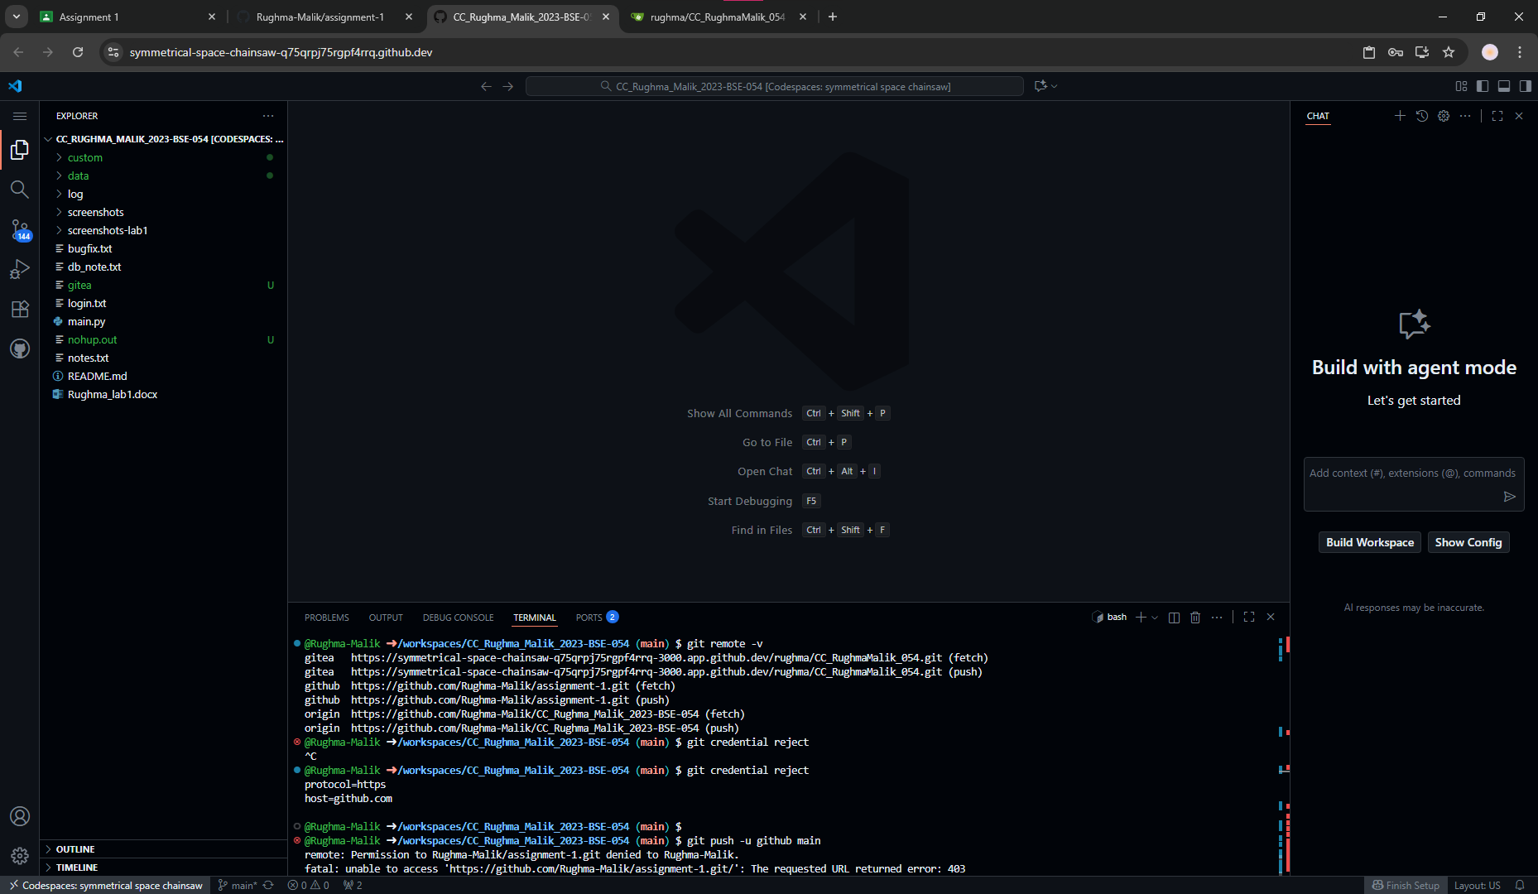

The **git remote -v screenshot** confirms that both Gitea and GitHub remotes were correctly added and linked.

* **GitHub Pages link to your CV/portfolio**

<https://rughma-malik.github.io/>

The **GitHub Pages link** displays my personal CV/portfolio website hosted online.

