TITLE OF THE PAPER

Name and Surname, Name and Surname, Name and Surname,
Name and Surname

Abstract

In this paper, the instructions for preparing a camera-ready paper for the XII International Conference on Economy, Business & Society in Digitalized Environment (EBSiDE 2022) are given. The various components of your paper (title, text, heads, etc.) are already defined on the style sheet, as illustrated by the portions given in this document. The recommended text processor is Microsoft Word. The title of the paper should be centered and written with capital letters in font Times New Roman, 14pt, bold, and should not exceed three lines of text. Authors of the manuscript should be written centered, in Times New Roman, 12pt, regular, separated by commas. Next to the surname of the author, add a footnote with the affiliation details of each author (institution name, address of the institution, city, country, and e-mail address of the author). Please do not write telephone or fax numbers. Abstract content should be fully justified and written with font Times New Roman 12pt, italic. The abstract should contain between 150 words and 300 words. It should summarize the paper and present the objectives and results of the research. Do not cite references in the abstract. Keywords should be aligned left and written with font Times New Roman 12pt, regular. They should capture the essence of the full paper. It is recommended to use up to five keywords, but at least three. Keywords should be listed in decreasing order of importance from left to right.

Keywords: EBSiDE Conference, Research, Faculty of Economics, Prilep, North Macedonia.

1. Introduction

This template, modified in MS Word for Windows, provides authors with most of the formatting specifications needed for preparing electronic versions of camera-ready papers for the XII International Conference on Economy, Business & Society in Digitalized Environment (EBSiDE 2022).

The paper should consist of a title, author's name(s), affiliation, abstract, introduction, main text with section titles and subheadings (if any), conclusion, acknowledgment (if any), references, and optional appendices. The total length of the paper is limited to 10 pages including illustrations, having minded that an even number of pages is preferred.

All standard paper components have been specified for two reasons: (1) ease of use when formatting individual papers, and (2) conformity of style throughout conference proceedings. Each paper should be submitted to the Conference via the official conference e-mail address ebside@uklo.edu.mk in MS Word format before the specified deadline.

2. Instructions for the authors

This template is used to format your paper and style the text. All margins, column widths, line spaces, and text fonts are prescribed; please do not alter them.
Prepare your camera-ready paper on the A4 paper size (210 mm × 297 mm). You are not allowed to use US letter-sized paper. Page margins are mirrored: top margin = 3 cm; bottom margin = 2 cm; inside margin = 4 cm; outside margin = 3 cm.
The paper should begin on the second page. Paper content should be fully justified, single-spaced, with a paragraphs’ first-line indentation of 1.27cm, and written using the font Times New Roman, 12pt, and regular. It may be divided into several sections. Paper subtitles, i.e. section names, except Acknowledgment and References sections), should be numbered with Arabic numerals (e.g. 1., 2., etc.), centered, bolded, and written with font Times New Roman, 12pt. If needed, an additional level of sub-subtitles can be introduced (e.g. 1.1, 1.2, etc.), using font Times New Roman, 12pt, centered, bolded, and italicized. Please note that there should be two blank lines before any main subtitle, and a single blank line before any sub-subtitle. Also note that there is a single blank line after any main subtitle and no blank line after sub-subtitles.

2.1 Abbreviations and acronyms
Define abbreviations and acronyms the first time they are used in the text, even after they have been defined in the abstract. Do not use abbreviations in the title or heads unless they are unavoidable.

2.2 Units
The usage of SI units is encouraged as primary units. Anglo-Saxon units may be used as secondary units (in parentheses). An exception would be the use of such units as identifiers in trade, such as “3.5-inch disk drive”. Avoid combining SI and other units. This often leads to confusion because equations do not balance dimensionally. If you must use mixed units, clearly state the units for each quantity that you use in an equation. Do not mix complete spellings and abbreviations of units: use “Wb/m²” or “webers per square meter”, not “webers/m²”. Spell out units when they appear in text: “…a few henries”, not “…a few H”. Use a zero before decimal points: use “0.25”, not “.25”. Use “cm³”, not “cc”.

2.3 Tables and figures
Tables and figures should be centered, and labeled appropriately with a number, in the order of their appearance (Table 1, Table2, etc., Figure 1, Figure 2, etc.), followed by a caption that describes them. Table captions should be placed above the tables and centered (Table 1), whilst figure captions should be placed below the figures and centered (Figure 1). All the texts within tables and figures should be written using font Times New Roman, 10pt. All tables and figures have to be mentioned in the text before they are inserted. Use the abbreviation “Fig. 1”, even at the beginning of a sentence.

Table 1. Caption of the table
Variable | Visual |  | Infrared |  | F | η
Variable | M | SD | M | SD | F | η
Row 1 | 3.6 | 0.49 | 9.2 | 1.02 | 69.9* | 0.12
Row 2 | 2.4 | 0.67 | 10.1 | 0.08 | 42.7* | 0.23
Row 3 | 1.2 | 0.78 | 3.6 | 0.46 | 53.9* | 0.34
Row 4 | 0.8 | 0.93 | 4.7 | 0.71 | 21.1* | 0.45
* p < 0.01

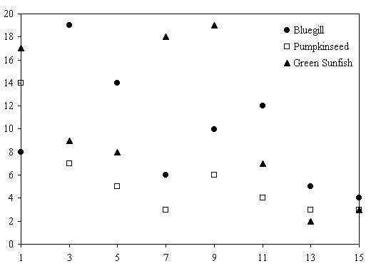
Figure 1. Caption of the figure

Use letters for table footnotes, if any.
We suggest you to use a text box to insert a graphic (which is ideally a 300 dpi JPEG, TIFF or EPS file, with all fonts embedded) because, in an MS Word document, this method is somewhat more stable than directly inserting a picture.

2.4 Equations
Number the equations consecutively. Equation numbers, stated within parentheses, should be positioned right-aligned, as in Eq. (1). Equations should be centered. The example of equations is Eq. (1):

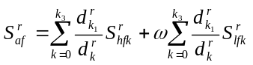 | (1)

Larger equations should be split into multiple lines, as shown in the example of Eq. (2):

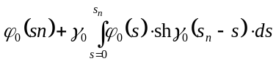  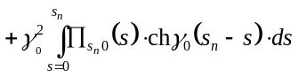  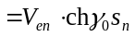 | (2)

To make your equations more compact, you may use the solidus ( / ), the exp function, or appropriate exponents. Italicize Roman symbols for variables, but not Greek symbols. Use a long dash (−) rather than a hyphen (-) for a minus sign. Punctuate equations with commas or periods when they are part of a sentence. Use “Eq. (1)”, not “(1)” or “equation (1)”, except at the beginning of a sentence: “Equation (1) is…”.

2.5 Some common mistakes to avoid
- The word “data” is plural, not singular;
- If the subscript for common scientific constants is zero, then the subscript formatting should be used, not a lowercase letter “o”;
- In American English, commas, semi-/colons, periods, question and exclamation marks are located within quotation marks only when a complete thought or name is cited, such as a title or full quotation. When quotation marks are used, instead of a bold or italic typeface, to highlight a word or phrase, punctuation should appear outside of the quotation marks. A parenthetical phrase or statement at the end of a sentence is punctuated outside of the closing parenthesis (like this). (A parenthetical sentence is punctuated within the parentheses.);
- A graph within a graph is an “inset”, not an “insert”. The word alternatively is preferred to the word “alternately” (unless you really mean something that alternates);
- Do not use the word “essentially” to mean “approximately” or “effectively”;
- In your paper title, if the words “that uses” can accurately replace the word “using”, capitalize the “u”; if not, keep using lower-cased;
- Be aware of the different meanings of the homophones “affect” and “effect”, “complement” and “compliment”, “discreet” and “discrete”, “principal” and “principle”;
- Do not confuse “imply” and “infer”;
- The prefix “non” is not a word; it should be joined to the word it modifies, usually without a hyphen (-);
- There is no period after the “et” in the Latin abbreviation “et al.”;
- The abbreviation “i.e.” means “that is”, and the abbreviation “e.g.” means “for example”.

2.6 Referring
When you refer to an equation, a figure, a table, or a section in the text of the manuscript, please use the following expressions: Eq. (1), Eqs. (1) and (2), Fig. 1, Figs. 1 and 2, Table 1, Tables 1 and 2, Section 1, Sections 1.1 and 1.5.

2.7 Referencing
Examples for referencing a journal paper, a conference paper, and a book are given in the References section.

3. Conclusion

In this paper, the instructions for preparing a camera-ready paper for the XII International Conference on Economy, Business & Society in Digitalized Environment (EBSiDE 2022) are given. Be brief and give most important conclusions from your paper. In this section do not use equations, tables, references, and figures.

Acknowledgment

If any, use the unnumbered section layout for the acknowledgment. The preferred spelling of the word “acknowledgment” in America is without an “e” after the “g”. Avoid the stilted expression, such as “One of us (R. B. G.) thanks…”. Instead, try “R. B. G. thanks…”.

References

The reference list should contain all the used sources, sorted in alphabetical order according to the APA referencing style. The reference list should be left-aligned and written with font Times New Roman, 12pt. Do not put footnotes in the reference list. Book and journal titles should be italicized. The second line of each reference should be indented by 1.25 cm (special, hanging). Online sources should be listed with complete details, including the date of visiting the website.

Examples of references in the text of the paper:
(Sparkes et al., 2002) (McWilliams & Siegel, 2000, pp. 603−609)
(Keinert, 2008, p. 184) (Davis, 2009)

Examples of book references:
Sparkes, R. (2002). Social responsible Investment: a Global Revolution. Hoboken. New York: John Wiley & Sons
Donaldson, W. (2008). Ethical Issues in Business: A Philosophical Approach. 8th Edition. Prentice-Hall. New York. USA

Examples of articles references (from journals):
Jenkins H.M. (2004). Corporate Social Responsibility - Engaging SMEs in the Debate. New Academy Review. 3(3), pp. 76−95

Examples of articles references (from an online database):
Baue, W. (2003). Morgan Stanley Study: Correlates Sustainability with Financial Outperformance. SRI Articles. http://www.socialfunds.com/news/ article.cgi/1289.html (accessed 20.08.2022)

Institution name of the first author, Address, City, Country, e-Mail address
Institution name of the second author, Address, City, Country, e-Mail address
Institution name of the third author, Address, City, Country, e-Mail address
Institution name of the fourth author, Address, City, Country, e-Mail address

