THE UNIVERSITY OF SYDNEY
PROJECT 02

Classifying HEp-2 Cell Images
Using Pretrained CNN Models
A controlled comparison of AlexNet and ResNet34 under partial and full fine-tuning
ELEC5622 • Signals, Software and Health
SUBMISSION DETAILS
Report type | Individual technical report
Student name / SID | [INSERT YOUR NAME] / [INSERT STUDENT ID]
Team membership | [CONFIRM TEAM MEMBERS AND CONTRIBUTIONS IN SECTION 2]
Submission deadline | 8 November 2026, 11:59 pm (Canvas)
Software / device | PyTorch 2.15.0; Apple M1 GPU (MPS); 8 GB unified memory

EXPERIMENTAL RESULT AT A GLANCE
ResNet34 with full fine-tuning achieved 97.17% test accuracy (2,643/2,720 images) and a macro F1 score of 96.91%. Its improvement over shallower or partially fine-tuned alternatives came at higher training cost.

Abstract
This project evaluates the effect of convolutional neural network architecture and fine-tuning depth on six-class classification of HEp-2 indirect immunofluorescence cell images. Using fixed tutor-provided training (8,701), validation (2,175), and test (2,720) partitions, ImageNet-pretrained AlexNet and ResNet34 were each trained under partial and full fine-tuning. Images were resized, adapted to three channels, normalized, and augmented using rotations and reflections during training. Four checkpoint-selected models were evaluated on the untouched test set. ResNet34 with full fine-tuning achieved the highest test accuracy (97.17%) and macro F1 (96.91%), although its cumulative training time (69.6 minutes, excluding validation) exceeded the alternatives. Class-level analysis showed that the minority Golgi category remained challenging, indicating the need for balanced evaluation and external validation before clinical application.
Keywords: HEp-2; indirect immunofluorescence; transfer learning; AlexNet; ResNet34; fine-tuning; medical image classification

1. Aims and Background

1.1 Problem definition and clinical motivation
Indirect immunofluorescence assays using human epithelial type 2 (HEp-2) cells reveal distinct staining patterns that support the laboratory investigation of autoimmune conditions. Manual classification depends on expert interpretation and can be time-consuming and variable between readers or laboratories. Automated analysis offers a potential route to more consistent cell-level screening, although an image classifier is not itself a diagnostic system [1, 5].
The present task is to identify one of six staining patterns from a supplied grayscale cell image: Centromere, Golgi, Homogeneous, Nuclear Membrane (NuMem), Nucleolar, or Speckled. Fine-grained differences, low image resolution, class imbalance and acquisition variability make this more demanding than conventional large-object recognition [1, 5].

1.2 Why transfer learning and these architectures?
AlexNet introduced large-scale deep convolutional image classification, using convolutional feature extraction followed by a high-capacity fully connected classifier [2]. ResNet introduced residual connections that facilitate optimization of deeper architectures [3]. In both cases, ImageNet pretraining supplies reusable visual representations; fine-tuning adapts them to fluorescence images. Whether early visual filters should remain frozen or the entire network should be updated is an empirical question, particularly because natural images and microscopic images differ substantially [4].

1.3 Research question and aims
Research question: How do architecture (AlexNet versus ResNet34) and fine-tuning depth (partial versus full) affect HEp-2 classification accuracy, per-class performance and computational cost under the same data split and training settings?
- Implement four six-class classifiers initialized from official ImageNet-pretrained weights.
- Apply consistent preprocessing, training-only augmentation and checkpoint selection using the validation partition.
- Compare held-out test accuracy, macro F1, trainable parameter counts and cumulative training time.
- Analyze class-level errors and relate the observed behavior to established and recent research, including practical limitations.

1.4 Positioning relative to prior work
Gao et al. [1] demonstrate the value of deep CNNs and rotation augmentation for HEp-2 staining-pattern classification. Their study also highlights Golgi/Nucleolar confusions. Rahman et al. [5] distinguish cell-level from specimen-level classification and synthesize the evolving HEp-2 deep-learning literature. Rather than replicate Gao et al.'s custom CNN or their test-time augmentation, this project follows the assignment brief and compares transfer learning with two standard pretrained architectures. More recently, Mencattini et al. [7] emphasize explainability and multi-hospital robustness for specimen-level workflows, reinforcing why our benchmark accuracy should not be treated as clinical validation.

2. Contributions of Team Members
This is an individual report. To satisfy the submission requirement, the following contributions must be checked against the actual team arrangement before submission. No teammates or work allocations have been assumed.
Member | Contributions to this project
[REPORT AUTHOR: NAME / SID] | [VERIFY/EDIT] Local environment and PyTorch setup; dataset-label integrity checks; CNN configuration and fine-tuning; execution of four experiments; test evaluation, figures and report analysis.
[OTHER TEAM MEMBERS OR “NONE”] | [INSERT VERIFIED NAMES AND DISTINCT TASKS, OR STATE “No other team members.”]

All reported experimental values are taken from the exported training histories, model metadata and test-evaluation CSVs. Contributions should accurately reflect who performed each component; the notebook execution evidence alone does not establish another member's involvement.

3. Methodology

3.1 Dataset and integrity verification
The assignment provides 13,596 HEp-2 cell images from the ICPR 2014 challenge, already separated into 8,701 training, 2,175 validation and 2,720 test images. A companion CSV maps each image ID to one of six classes. The code checked the expected counts, required label columns, label uniqueness and non-overlapping image IDs across all three partitions. This establishes ID-level separation; the available files did not establish independence at specimen or acquisition-session level.
Class | Training | Validation | Test | Total
Centromere | 1,791 | 463 | 487 | 2,741
Golgi | 449 | 110 | 165 | 724
Homogeneous | 1,556 | 415 | 523 | 2,494
NuMem | 1,430 | 337 | 441 | 2,208
Nucleolar | 1,675 | 394 | 529 | 2,598
Speckled | 1,800 | 456 | 575 | 2,831

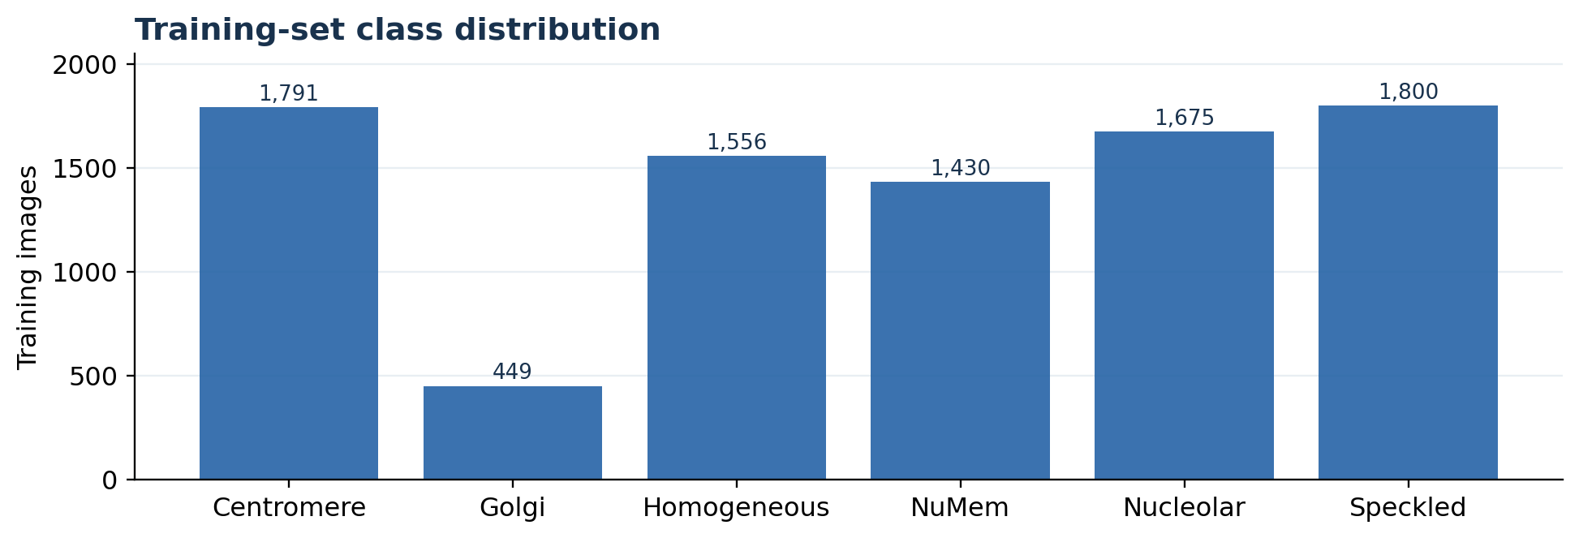
Figure 1. Training image counts by HEp-2 category. Golgi is the smallest training class (449/8,701, 5.16%).

3.2 Input preparation and augmentation
The supplied images are 78 × 78 grayscale PNGs. They were converted to three identical RGB channels, resized to 224 × 224 pixels, transformed into tensors and normalized with ImageNet channel statistics (mean: 0.485, 0.456, 0.406; standard deviation: 0.229, 0.224, 0.225). These transformations allow use of the official ImageNet-weighted torchvision models without changing their input interface.
Training-only augmentation consisted of a random in-plane rotation from −180° to +180° with bilinear interpolation and black fill, independent horizontal and vertical flips (probability 0.5 each), followed by normalization. Validation and test images were resized and normalized without random augmentation. Rotation was motivated by the orientation-insensitive nature of many HEp-2 staining patterns and the benefit documented by Gao et al. [1], though our stochastic augmentation differs from their fixed-angle augmentation strategy. No per-image min–max intensity normalization or test-time ensemble was used.
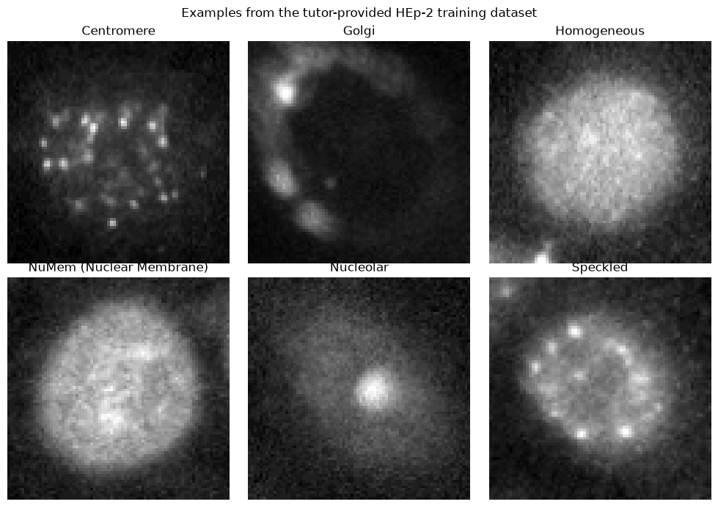
Figure 2. One example per class, reproduced from the executed notebook’s visualization of the supplied training images.

3.3 Model design and fine-tuning protocol
Both models were loaded with torchvision ImageNet-1K V1 pretrained weights and their final classification layers were replaced to output six logits. AlexNet consists of convolutional features plus a large fully connected classifier; ResNet34 contains residual blocks and a final fully connected layer. Two strategies were applied to each:
- Partial AlexNet: freeze the convolutional feature extractor; train the three fully connected classifier stages (FC6–FC8).
- Full AlexNet: train all network weights.
- Partial ResNet34: freeze earlier layers; train layer4 and the final fully connected layer. Frozen BatchNorm statistics were kept in evaluation mode.
- Full ResNet34: train all network weights.
Configuration | Total parameters | Trainable | Trainable share
AlexNet / partial | 57,028,422 | 54,558,726 | 95.7%
AlexNet / full | 57,028,422 | 57,028,422 | 100.0%
ResNet34 / partial | 21,287,750 | 13,117,446 | 61.6%
ResNet34 / full | 21,287,750 | 21,287,750 | 100.0%

3.4 Training, checkpoint selection and environment
Setting | Implementation
Loss function | Multiclass cross-entropy
Optimizer / learning rate | AdamW, 1 × 10⁻⁴
Weight decay | 1 × 10⁻⁴
Batch size / input | 8 images; 3 × 224 × 224
Training budget | Maximum 15 epochs; early stopping patience = 4
Model selection | Highest validation accuracy; earlier epoch kept on ties
Seed | 5622 (Python, NumPy and PyTorch)
Hardware | Apple M1, 8 GB unified memory; PyTorch MPS accelerator

The same hyperparameters, data partitions and evaluation protocol were used for all four configurations. Validation accuracy determined the checkpoint saved for testing. The test set was not used for training, early stopping or hyperparameter selection. Training durations were recorded as cumulative training-epoch time and exclude validation, figure generation, model initialization and checkpoint-writing overhead; this distinction matters when interpreting runtime.

3.5 Evaluation measures
Overall accuracy was computed as the number of correctly predicted test images divided by 2,720. For each class, precision = TP/(TP+FP), recall = TP/(TP+FN), and F1 = 2 × precision × recall/(precision+recall). Macro F1 is the unweighted mean of the six class-level F1 scores; unlike overall accuracy, it does not weight classes by prevalence. Confusion matrices were recorded with true classes as rows and predicted classes as columns.

4. Results

4.1 Training dynamics and checkpoint selection
All four experiments completed successfully on the Apple M1 GPU. AlexNet partial stopped after 14 epochs and AlexNet full after 13 epochs under the four-epoch patience rule. Both ResNet34 configurations completed the 15-epoch budget. Training accuracy generally increased across runs, while validation accuracy fluctuated, so the highest-accuracy validation checkpoint rather than the final epoch was used for testing.
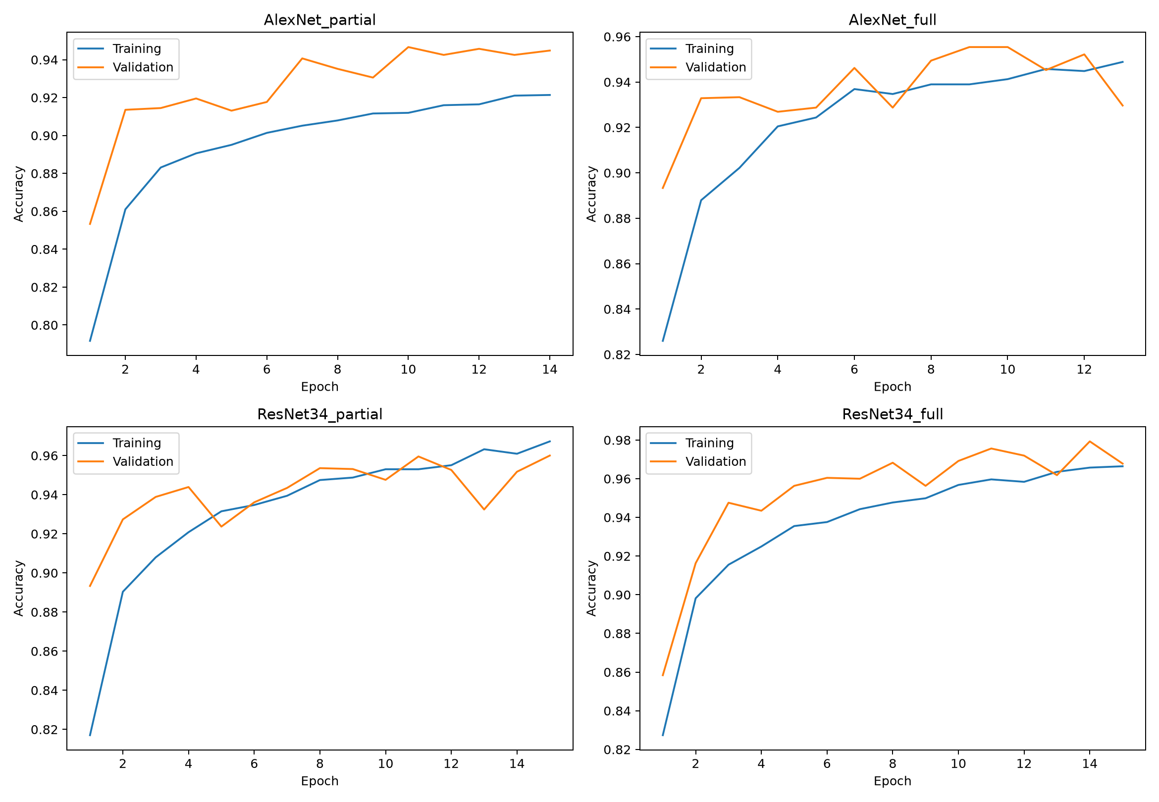
Figure 3. Training (blue) and validation (orange) accuracy by epoch for each architecture/strategy combination. Curves are from the recorded experiment histories.

4.2 Validation and held-out test comparison
Architecture / strategy | Best val. | Test acc. | Macro F1 | Correct / 2,720
AlexNet / partial | 94.67% | 93.12% | 93.09% | 2,533
AlexNet / full | 95.54% | 95.00% | 95.09% | 2,584
ResNet34 / partial | 96.00% | 95.22% | 95.27% | 2,590
ResNet34 / full | 97.93% | 97.17% | 96.91% | 2,643

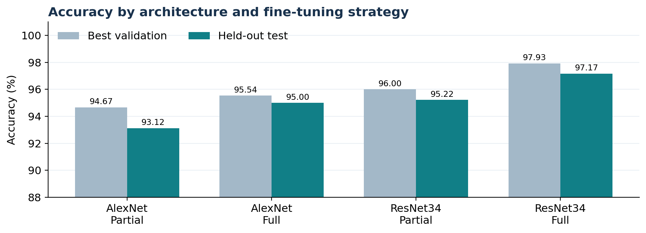
Figure 4. Best validation and held-out test accuracy. Checkpoints were selected using validation accuracy; test scores were calculated afterward.
ResNet34 Full attained the highest test accuracy (97.17%, 2,643 correct predictions) and macro F1 (96.91%). It exceeded ResNet34 Partial by 1.95 percentage points in test accuracy and AlexNet Full by 2.17 percentage points. All four models exceeded 93% test accuracy, demonstrating that both pretrained architectures could adapt to the supplied cell images under the selected protocol.

4.3 Parameter counts and computation
Configuration | Best epoch | Epochs run | Trainable params. | Train time*
AlexNet / partial | 10 | 14 | 54.56 M | 32.3 min
AlexNet / full | 9 | 13 | 57.03 M | 38.8 min
ResNet34 / partial | 15 | 15 | 13.12 M | 29.7 min
ResNet34 / full | 14 | 15 | 21.29 M | 69.6 min

* Sum of training-step durations recorded in the notebook; excludes validation and other overhead. Wall-clock cell runtimes can therefore be longer.
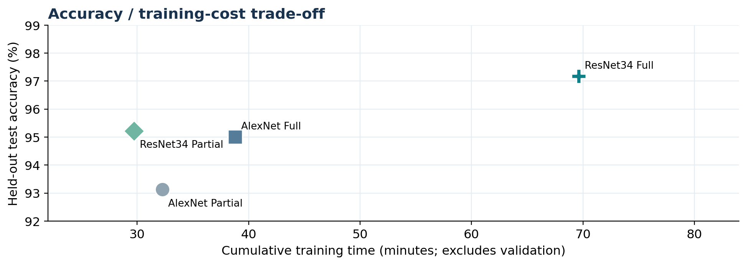
Figure 5. Test accuracy versus cumulative training time, illustrating the performance–cost trade-off. Times use the training-only timer for comparability.
Full ResNet34 training required 69.6 minutes compared with 29.7 minutes for ResNet34 Partial (2.34× as long). Despite having fewer trainable parameters than AlexNet Full (21.29 M versus 57.03 M), full ResNet34 ran longer, showing that parameter count alone does not determine convolutional training cost. Interestingly, AlexNet partial tuning still updated 95.7% of AlexNet parameters because the large fully connected classifier dominates its parameter budget.

4.4 Per-class performance of the best model
True class | Test images | Precision | Recall | F1
Centromere | 487 | 98.96% | 97.54% | 98.24%
Golgi | 165 | 98.68% | 90.30% | 94.30%
Homogeneous | 523 | 96.29% | 99.24% | 97.74%
NuMem | 441 | 98.86% | 98.64% | 98.75%
Nucleolar | 529 | 94.54% | 98.11% | 96.29%
Speckled | 575 | 97.33% | 94.96% | 96.13%

The best model correctly classified 149/165 Golgi test images (90.30% recall), its weakest class-level recall. Thirteen Golgi images were classified as Nucleolar. This single confusion accounts for 16.9% (13/77) of all errors made by ResNet34 Full. Conversely, Homogeneous achieved 99.24% recall (519/523). Class-wise improvements were not uniform: AlexNet Partial had higher Golgi recall (95.15%) despite lower overall test accuracy (93.13%).
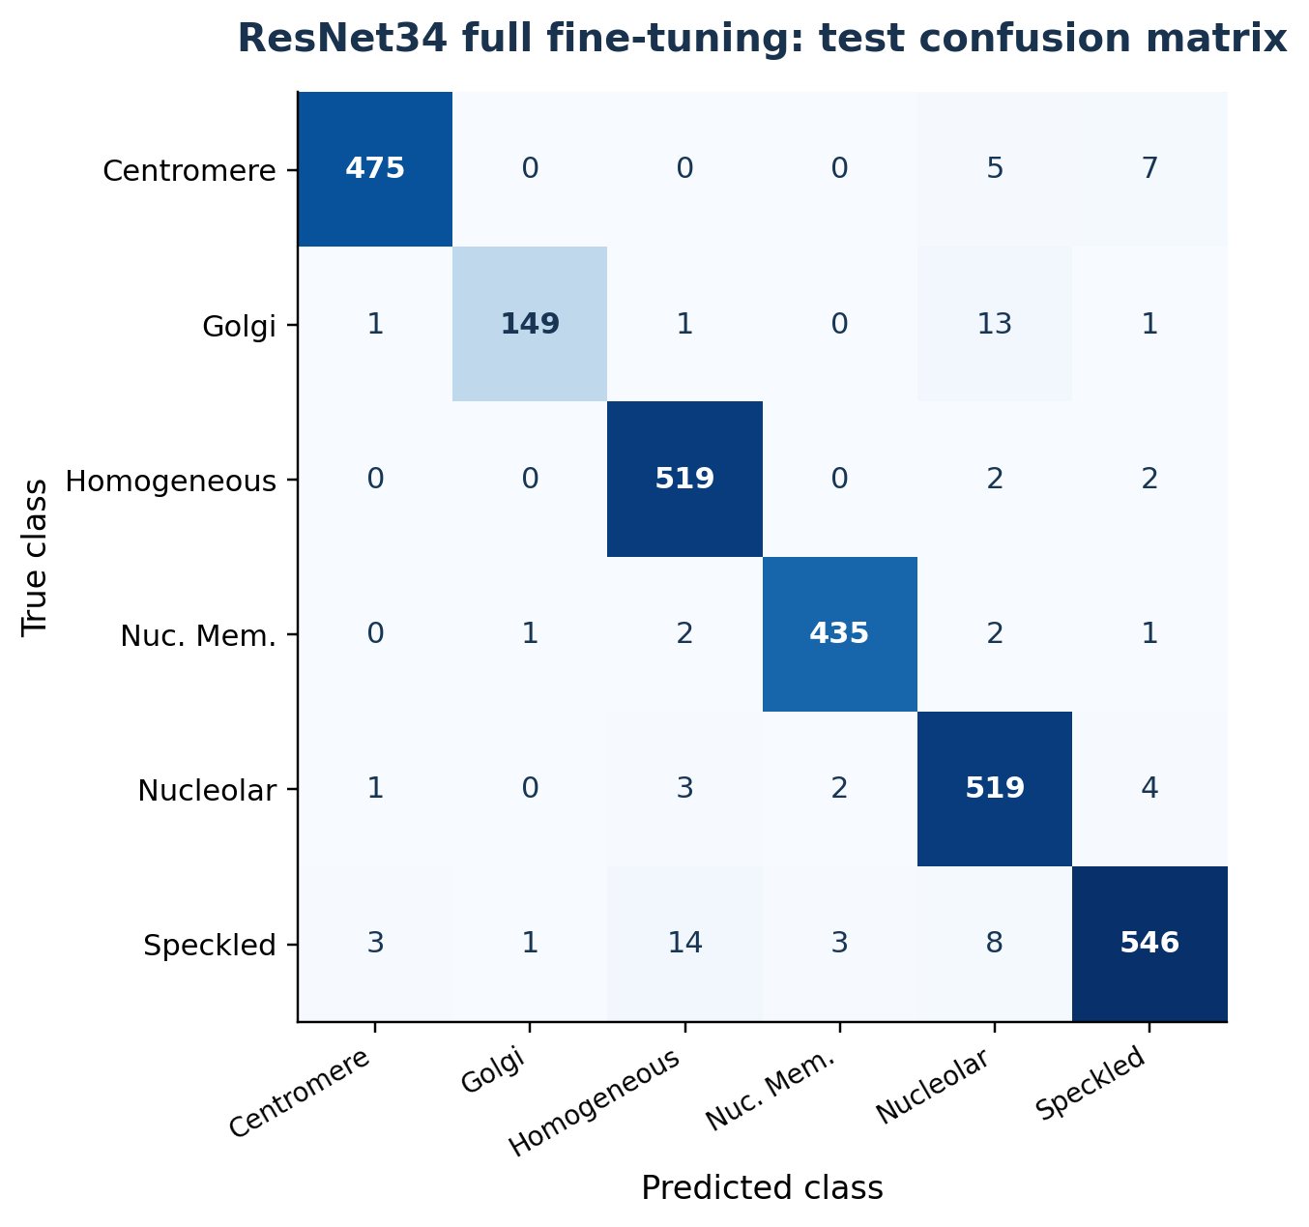
Figure 6. Held-out test confusion matrix for ResNet34 Full. Rows represent ground truth and columns represent predictions (counts, not percentages).

4.5 Error patterns across alternative configurations
The remaining test confusion matrices are provided in Figure 7. They help distinguish improvements in aggregate accuracy from shifts in the pattern of mistakes. In particular, partial ResNet34 had lower Homogeneous recall (89.87%) than full ResNet34 (99.24%), whereas Golgi recall dropped from 93.94% to 90.30% when ResNet34 was fully fine-tuned. These trade-offs are clinically relevant because missing a rare or subtle pattern may matter even when average accuracy rises.
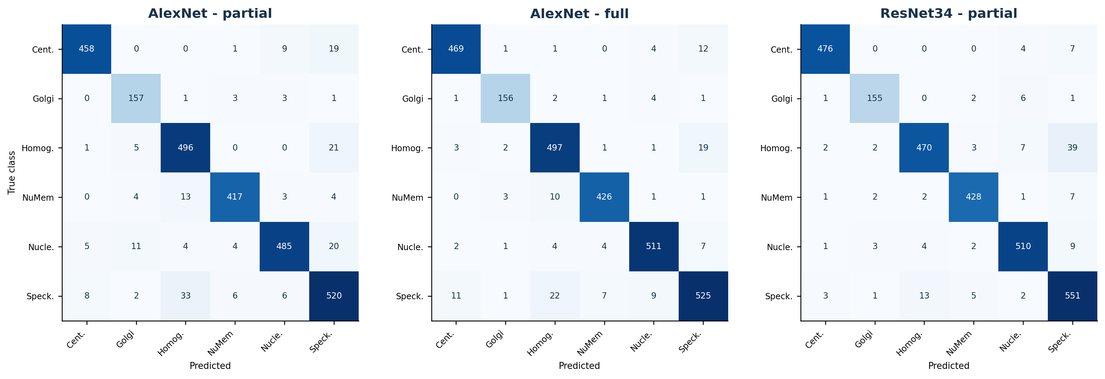
Figure 7. Test confusion matrices for AlexNet Partial, AlexNet Full and ResNet34 Partial. Their performance must be interpreted jointly with class support and macro F1.

5. Discussion and Conclusion

5.1 What explains the architecture and fine-tuning effects?
Across both model families, updating all layers improved test accuracy: AlexNet increased from 93.13% to 95.00% (+1.88 percentage points), and ResNet34 increased from 95.22% to 97.17% (+1.95 points). This is consistent with the possibility that adapting low-level and intermediate filters to fluorescence morphology is helpful, rather than assuming the representations learned from natural images are already optimal. Nevertheless, a four-run comparison cannot establish the isolated causal contribution of residual connections, depth or pretraining; random initialization of the new classifiers and other architecture differences are also present.
ResNet34 Full achieved the strongest overall performance, which is compatible with the optimization benefits of residual learning described by He et al. [3]. The transfer-learning literature also warns that the optimal fine-tuning depth depends on task and data properties [4]; therefore the observed advantage should be interpreted as specific to this dataset, these settings and this training run. The additional 39.9 minutes of training over partial ResNet34 bought 1.95 percentage points of test accuracy, which may be worthwhile for research but represents a tangible computational trade-off.

5.2 Class imbalance, characteristic errors and literature synthesis
Golgi represented only 5.16% of training images (449/8,701) and had the lowest recall under the highest-accuracy model. Its predominant confusion with Nucleolar is biologically plausible because both patterns can contain bright punctate structures. Gao et al. [1] also identified Golgi/Nucleolar confusion in a different CNN-based HEp-2 framework; the agreement supports a morphology-driven interpretation, although this project did not directly visualize the misclassified cells or test that explanation. The fact that AlexNet Partial recalled a larger fraction of Golgi cases shows why aggregate accuracy should be accompanied by per-class recall and a confusion matrix.
The supplied paper [1] strongly motivates rotation-based augmentation, but its published accuracy values are not directly comparable with ours: the architecture, preprocessing, augmentation schedules, ensembling procedures and evaluation protocols differ. Rahman et al. [5] further distinguish cell-level accuracy from specimen-level performance. Our results address only cell-image classification, not specimen aggregation, antibody titers or clinical diagnosis. More recent work [7] has evaluated explainability and cross-hospital behavior, highlighting requirements beyond a single held-out split.

5.3 Reliability and limitations
- Single trial per condition: only one random seed was evaluated; the observed percentage-point differences lack repeated-run uncertainty estimates or paired significance testing.
- Data independence: image IDs were disjoint across partitions, but specimen-, subject- and acquisition-level grouping could not be verified from the available metadata. Related images could therefore affect apparent generalization.
- Internal-only testing: evaluation used the supplied challenge split rather than unseen hospitals, microscopes or laboratory protocols. Domain shifts can degrade medical image performance [6].
- Preprocessing and optimization constraints: low-resolution source images were upsampled to 224 × 224; only one shared optimizer/learning-rate setting, one augmentation scheme and a 15-epoch cap were evaluated.
- Clinical interpretation: predictions were not assessed for confidence calibration, rejection of uncertain cases, interpretability or consequences of class-specific errors. No claims of diagnostic readiness are justified.

5.4 Priorities for further work
The most informative next steps would be (i) repeated seeds and specimen-grouped or external-site validation; (ii) explicit balancing strategies, such as class-weighted losses or targeted Golgi augmentation, evaluated without test-set tuning; (iii) domain-shift tests across laboratories and acquisition conditions; and (iv) calibrated uncertainty and explainability assessments before consideration of a clinician-facing tool [6, 7]. These extensions directly address weaknesses exposed by the current confusion matrices and protocol.

5.5 Conclusion
Under a controlled comparison of four ImageNet-pretrained CNN configurations on 13,596 HEp-2 images, ResNet34 with full fine-tuning delivered the best held-out performance: 97.17% accuracy and 96.91% macro F1. Full fine-tuning improved results within both architectures but increased compute requirements, especially for ResNet34. The most important qualification is that strong aggregate test performance coexisted with a weaker Golgi recall and potential generalization limitations. Thus the project demonstrates the value of task-specific feature adaptation while showing why responsible medical-image evaluation must consider class balance, data independence and deployment conditions, not just a single accuracy number.

References
[1] Z. Gao, L. Wang, L. Zhou and J. Zhang, “HEp-2 Cell Image Classification With Deep Convolutional Neural Networks,” IEEE Journal of Biomedical and Health Informatics, vol. 21, no. 2, pp. 416–428, 2017. doi:10.1109/JBHI.2016.2526603. (Tutor-supplied paper; 2015 arXiv manuscript.)
[2] A. Krizhevsky, I. Sutskever and G. E. Hinton, “ImageNet Classification with Deep Convolutional Neural Networks,” Advances in Neural Information Processing Systems, vol. 25, 2012.
[3] K. He, X. Zhang, S. Ren and J. Sun, “Deep Residual Learning for Image Recognition,” Proceedings of CVPR, pp. 770–778, 2016. doi:10.1109/CVPR.2016.90.
[4] N. Tajbakhsh et al., “Convolutional Neural Networks for Medical Image Analysis: Full Training or Fine Tuning?” IEEE Transactions on Medical Imaging, vol. 35, no. 5, pp. 1299–1312, 2016. doi:10.1109/TMI.2016.2535302.
[5] S. Rahman, L. Wang, C. Sun and L. Zhou, “Deep learning based HEp-2 image classification: A comprehensive review,” Medical Image Analysis, vol. 65, art. 101764, 2020. doi:10.1016/j.media.2020.101764.
[6] S. Matta et al., “A systematic review of generalization research in medical image classification,” Computers in Biology and Medicine, vol. 183, art. 109256, 2024. doi:10.1016/j.compbiomed.2024.109256.
[7] A. Mencattini et al., “Automatic classification of HEp-2 specimens by explainable deep learning and Jensen-Shannon reliability index,” Artificial Intelligence in Medicine, vol. 160, art. 103030, 2025. doi:10.1016/j.artmed.2024.103030.

Reproducibility and supporting files
Experimental evidence: ELEC5622_Project2_VSCode.ipynb; project2_experiment_results.zip (training histories, model metadata, final_comparison.csv, per-class reports and confusion matrices). Source dataset: provided separately by the teaching staff and excluded from the code submission archive. The notebook sets the seed to 5622; exact GPU-level determinism was not enforced.

