Cyberion ThreatShield
Setup, Verification and Dashboard Guide
A clean-device procedure for Windows, Linux and macOS
Version 1.0 | 1 November 2026
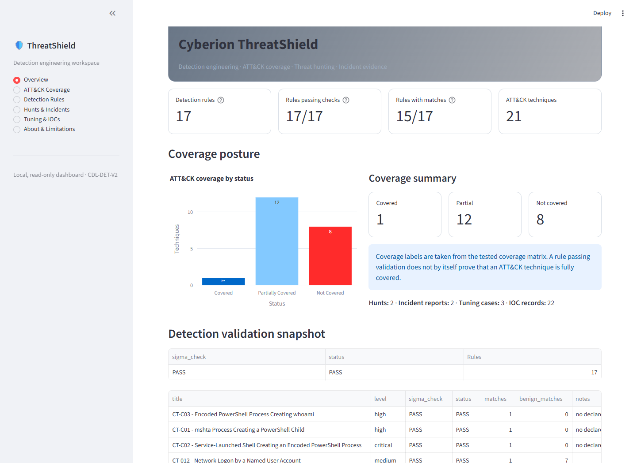
Figure 1. Local read-only dashboard after a successful validation run.
Prepared by Rigved Londhe

1. Purpose and verified baseline
This guide reproduces Cyberion ThreatShield on a different computer, validates its recorded detection evidence and starts the local Streamlit dashboard. The repository excludes raw telemetry and secrets; two pinned public research archives are downloaded only when the user runs the bootstrap step.
Control | Verified result
Sigma validation | 17 of 17 rules PASS
ATT&CK assessment | 21 techniques across 11 tactics
Coverage posture | 1 Covered, 12 Partial, 8 Not Covered
Investigation outputs | 2 hunts, 2 incident cases, 4 playbooks
Requirements | 85/85 mandatory and 3/3 optional PASS
Repository controls | 9/9 security controls PASS

What the project is—and is not
• A reproducible detection-engineering and threat-hunting research project.
• A Sigma validation workflow that retains positive, benign and negative findings.
• Not a live SIEM, endpoint agent, blocking product or guarantee of production detection.
• Intended only for defensive, authorized research data.

2. Prerequisites
Requirement | Recommended | Check
Operating system | Windows 10/11; Linux/macOS supported | Current updates installed
Python | CPython 3.12, 64-bit | py -3.12 --version
Git | Current Git client | git --version
Disk space | At least 3 GB free | Environment and generated data
Memory | 4 GB minimum; 8 GB recommended | Analysis runs locally
Network | HTTPS during initial setup | GitHub, PyPI, raw.githubusercontent.com
The project does not require API keys, passwords or cloud credentials. Corporate networks may require approved Python and Git proxy configuration.

3. Obtain and inspect the repository
Open PowerShell in the directory where you keep projects, then run:
git clone https://github.com/Rugved-24/Cyberion-ThreatShield.git
Set-Location Cyberion-ThreatShield
git status --short
Expected: Git reports no local changes. If a ZIP was supplied, use Extract All, open the extracted Cyberion-ThreatShield folder and run the remaining commands there.

Initial safety check
• Confirm there is no .env, private key, credentials.json or secrets.json in the root.
• Confirm data/raw and data/processed are absent or empty before acquisition.
• Review THIRD_PARTY_NOTICES.md and SECURITY.md before using external data.

4. Create the isolated Python environment
py -3.12 -m venv .venv
.\.venv\Scripts\python.exe -m pip install --upgrade pip
.\.venv\Scripts\python.exe -m pip install --require-hashes -r requirements.lock.txt
The hash-locked install prevents unexpected package artifacts from being accepted. Use the project interpreter directly; activation and execution-policy changes are not required.

Linux or macOS equivalent
python3.12 -m venv .venv
.venv/bin/python -m pip install --upgrade pip
.venv/bin/python -m pip install --require-hashes -r requirements.lock.txt
The lock was validated on Windows. If a platform-specific wheel is unavailable, use the fully pinned requirements.txt in a fresh environment and record the platform difference; do not silently edit the lock.

5. Acquire the pinned telemetry
The bootstrap downloads two public OTRF archives from a pinned commit. It allowlists one host, rejects redirects, caps size, and verifies byte counts and SHA-256 before writing files.
.\.venv\Scripts\python.exe scripts\bootstrap_datasets.py
Expected: one verified SHA-256 line for DS001 and one for DS002.
.\.venv\Scripts\python.exe scripts\inventory_dataset.py DS001 cmd_mshta_vbscript_execute_psh_2020-10-2202580804.json
.\.venv\Scripts\python.exe scripts\inventory_dataset.py DS002 empire_psexec_dcerpc_tcp_svcctl_2020-09-20121608.json
Each command verifies its archive again, safely extracts one expected flat member and records its digest, byte count, event count and channel distribution.

6. Build the normalized evidence
.\.venv\Scripts\python.exe scripts\check_capture.py
.\.venv\Scripts\python.exe scripts\normalize_dataset.py DS001 DS002
• check_capture.py verifies the extracted-file digest before profiling event-time fields.
• normalize_dataset.py writes traceable JSONL under data/processed and stops on rejected, duplicate or mismatched records.
• Timestamps without a proven timezone remain unresolved; the pipeline does not invent one.

7. Run the verification suite
.\.venv\Scripts\python.exe scripts\test_all.py
.\.venv\Scripts\python.exe scripts\prd_compliance.py
.\.venv\Scripts\python.exe scripts\security_review.py
Command | Expected | Meaning
test_all.py | 17 rules PASS; sigma_check=PASS | Attack, benign and correlation cases behaved as recorded
prd_compliance.py | 85/85 mandatory; 3/3 optional | Required deliverables and acceptance checks are present
security_review.py | C1–C9 PASS | The nine stated repository controls held during the run
A PASS is scoped evidence, not proof that a rule detects every variant or that the repository is vulnerability-free. Review coverage/matrix-v2.md for the conservative decision.
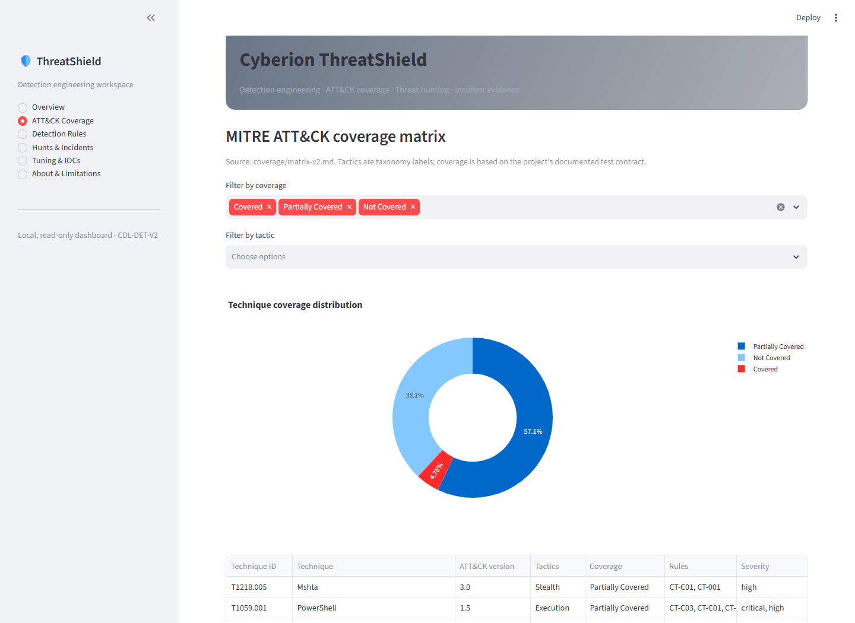
Figure 2. Coverage remains explicit: Covered, Partially Covered or Not Covered.

8. Start the dashboard
.\.venv\Scripts\python.exe -m streamlit run dashboard\app.py
- Wait for Streamlit to print the Local URL, normally http://localhost:8501.
- Open that address if the browser does not open automatically.
- Review coverage, rule tests, hunts, incidents, tuning and IOC summaries.
- Press Ctrl+C in PowerShell to stop the dashboard.
The dashboard is local and read-only. It summarizes generated artifacts; it does not ingest live telemetry, execute detections, contain endpoints or block indicators.
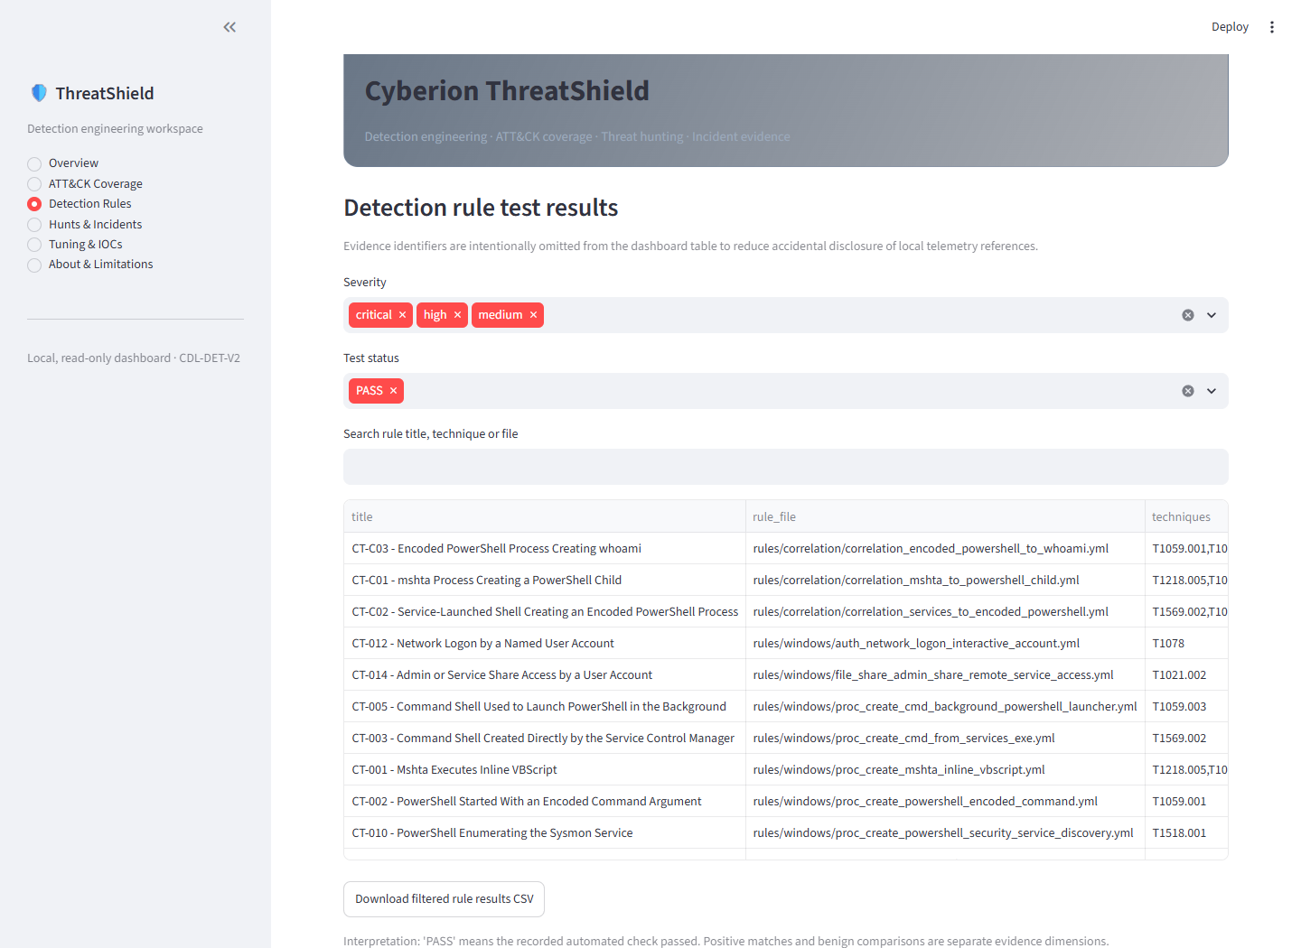
Figure 3. Rule results omit event-level identifiers from the dashboard view.

9. Evidence and reporting map
Question | Open
What should an executive know? | reports/executive-summary.md
How were conclusions reached? | reports/final-technical-report.md
What is and is not covered? | coverage/matrix-v2.md
Which detections passed? | detections/test-results.csv
What was tuned? | detections/tuning-results.csv and evidence/tuning/
What did the hunts find? | hunts/HUNT-001.md and hunts/HUNT-002.md
How should an analyst respond? | playbooks/PB-01 through PB-04
How is data traced? | docs/DS001-*.json, docs/DS002-*.json, docs/methodology.md

10. Troubleshooting

Python 3.12 is not found
Install 64-bit CPython 3.12, enable the Python launcher, reopen PowerShell, and run py -0p.

Hash-locked install fails
Confirm Python 3.12 and OS architecture. Remove only the project-local .venv, recreate it and retry. Do not bypass hashes.

Dataset download is blocked
Check approved HTTPS access to raw.githubusercontent.com and proxy policy. Do not substitute a mirror.

Archive digest mismatch
Delete only the affected file inside data/raw, then rerun bootstrap_datasets.py. Never edit a digest to make an unknown file pass.

Sigma cannot refresh reference data
Allow outbound HTTPS for the first run and ensure the user-profile cache is writable.

A verification command returns non-zero
Stop and read the first error. Later output is not trustworthy until the earlier integrity or evidence check passes.

Port 8501 is already in use
.\.venv\Scripts\python.exe -m streamlit run dashboard\app.py --server.port 8502

11. Safe sharing and cleanup
• Share the Git repository, not .venv, data/raw, data/processed or local caches.
• Never include .env files, private keys, passwords, tokens, browser profiles or cloud credentials.
• Review reports before publication because research telemetry contains public lab identifiers and adversary tradecraft.
• To remove downloaded telemetry, delete only data/raw and data/processed inside this clone; both can be rebuilt.
The repository is intentionally small because dependencies and raw research data are reproducibly acquired rather than embedded. Source, rules, evidence summaries, reports, screenshots, notebooks, playbooks and this guide remain included.

12. Completion checklist
[ ] Repository obtained and git status clean
[ ] Python 3.12 environment created
[ ] Hash-locked dependencies installed
[ ] DS001 and DS002 downloaded and SHA-256 verified
[ ] Inventories and normalized data generated
[ ] 17/17 detection tests passed
[ ] 85/85 mandatory and 3/3 optional requirements passed
[ ] C1–C9 security review passed
[ ] Dashboard opened and reviewed
[ ] No secrets or raw telemetry added to Git

