1. XAMPP Server:-

**Installing XAMPP**

Our XAMPP tutorial will take you through the installation process for the software package on Windows. If you’re using Linux or Mac OS X, then the steps listed below for the installation process may differ.

**Step 1: Download**

XAMPP is a release made available by the non-profit project Apache Friends. Versions with PHP 5.5, 5.6, or 7 are available for download on the [Apache Friends](http://www.apachefriends.org/de/download.html) website.

**Step 2: Run .exe file**

Once the software bundle has been downloaded, you can start the installation by double clicking on the file with the ending [.exe](https://www.ionos.com/digitalguide/server/know-how/exe-file/).

**Step 3: Deactivate any antivirus software**

Since an active antivirus program can negatively affect the installation process, it’s recommended to temporarily pause any antivirus software until all XAMPP components have successfully been installed.

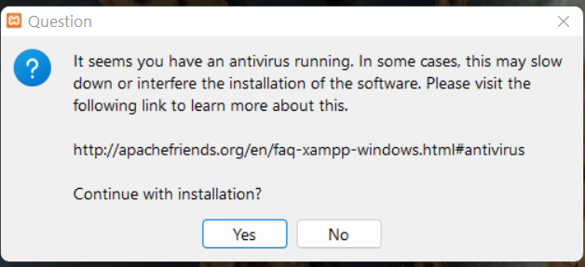

Before installing XAMPP, it is advisable to disable the anti-virus program temporarily

**Step 4: Deactivate UAC**

User Account Control (UAC) can interfere with the XAMPP installation because it limits writing access to the C: drive, so we recommend you deactivate this too for the duration of the installation process. To find out how to turn off your UAC, head to the [Microsoft Windows support pages](https://support.microsoft.com/en-us/help/17228/windows-protect-my-pc-from-viruses).

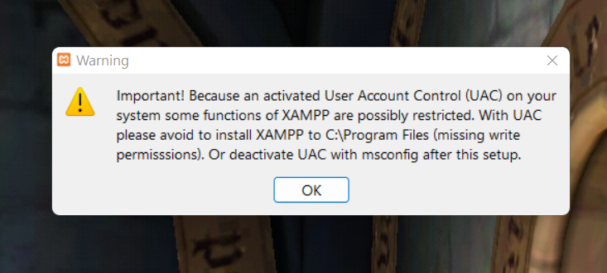

User account control can affect the installation of XAMPP

**Step 5: Start the setup wizard**

After you’ve opened the .exe file (after deactivating your antivirus program(s) and taken note of the User Account Control, the start screen of the XAMPP setup wizard should appear automatically. Click on ‘Next’ to configure the installation settings.

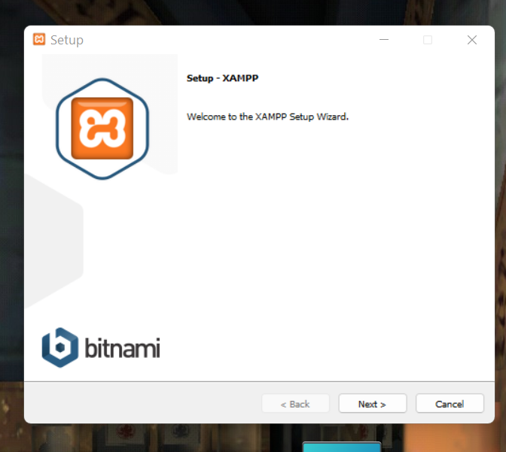

You can start the setup on the start-up screen

**Step 6: Choose software components**

Under ‘Select Components’, you have the option to exclude individual components of the XAMPP software bundle from the installation. But for a full local test server, we recommend you install using the standard setup and all available components. After making your choice, click ‘Next’.

In the dialog window entitled 'select components', you can choose the software components before installation

**Step 7: Choose the installation directory**

In this next step, you have the chance to choose where you’d like the XAMPP software packet to be installed. If you opt for the standard setup, then a folder with the name XAMPP will be created under C:\ for you. After you’ve chosen a location, click ‘Next’.

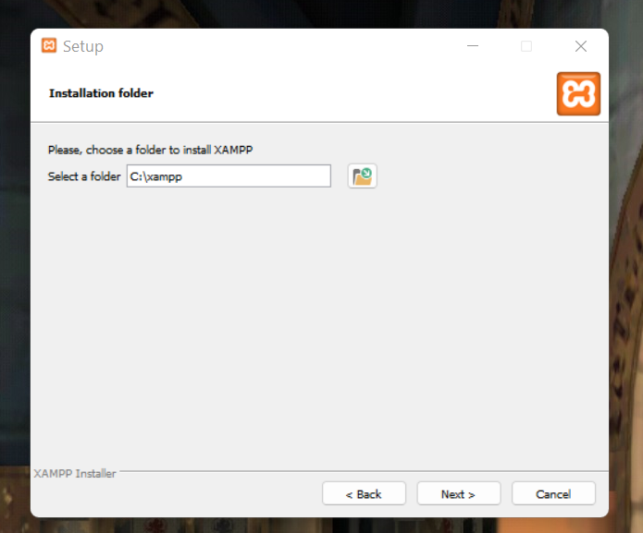

For the next step, you need to select the directory where XAMPP should be installed

**Step 8: Start the installation process**

Once all the preferences have been decided, click to start the installation. The setup wizard will unpack and install the selected components and save them to the designated directory. This process can take several minutes in total. You can follow the progress of this installation by keeping an eye on the green loading bar in the middle of the screen.

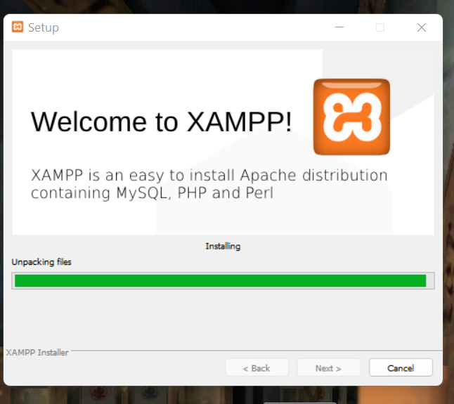

According to the default settings, the selected software components are unpacked and installed in the target folder

**Step 9: Windows Firewall blocking**

Your Firewall may interrupt the installation process to block some components of the XAMPP. Use the corresponding check box to enable communication between the Apache server and your private network or work network. Remember that making your XAMPP server available for public networks isn’t recommended.

**Step 10: Complete installation**

Once all the components are unpacked and installed, you can close the setup wizard by clicking on ‘Finish’. Click to tick the corresponding check box and open the XAMPP Control Panel once the installation process is finished.

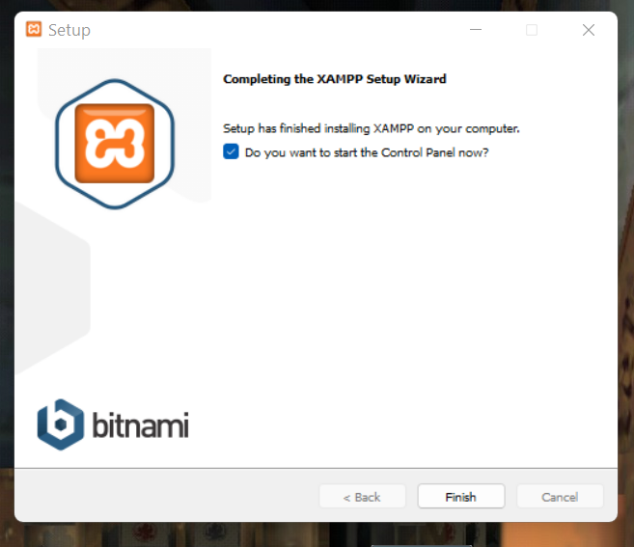

By clicking on 'finish', the XAMPP Setup Wizard is completed.

**The XAMPP Control Panel**

Controls for the individual components of your test server can be reached through the XAMPP Control Panel. **The clear user interface** logs all actions and allows you to start or stop individual modules with a single. The XAMPP Control Panel also offers you various other buttons, including:

* **Config:** allows you to configure the XAMPP as well as the individual components
* [Netstat](https://www.ionos.com/digitalguide/server/tools/introduction-to-netstat/)**:** shows all running processes on the local computer
* **Shell:** opens a UNIX shell
* **Explorer:** opens the XAMPP folder in Windows Explorer
* **Services:** shows all services currently running in the background
* **Help:** offers links to user forums
* **Quit:** closes the XAMPP Control Panel

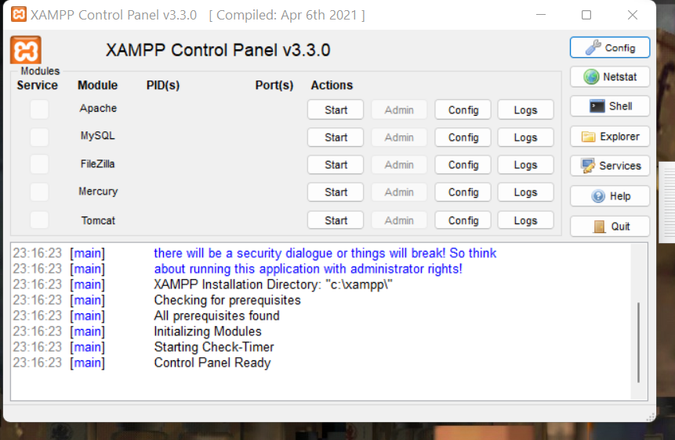In the Control Panel, you can start and stop individual modules

--------------------------------------------------------------------------------------------------------------------------------------

1. VS Code:-

1] Download the [Visual Studio Code installer](https://go.microsoft.com/fwlink/?LinkID=534107) for Windows.

2] Once it is downloaded, run the installer (VSCodeUserSetup-{version}.exe). This will only take a minute.

3] By default, VS Code is installed under C:\users\{username}\AppData\Local\Programs\Microsoft VS Code.

Alternatively, you can also download a [Zip archive](https://code.visualstudio.com/docs/?dv=winzip), extract it and run Code from there.

**Note:** .NET Framework 4.5.2 or higher is required for VS Code. If you are using Windows 7, make sure you have at least [.NET Framework 4.5.2](https://www.microsoft.com/download/details.aspx?id=42643) installed. You can check your version of .NET Framework using this command, reg query "HKEY_LOCAL_MACHINE\SOFTWARE\Microsoft\NET Framework Setup\NDP\v4\full" /v version from a command prompt.

**Tip:** Setup will add Visual Studio Code to your %PATH%, so from the console you can type 'code .' to open VS Code on that folder. You will need to restart your console after the installation for the change to the %PATH% environmental variable to take effect.

----------------------------------------------------------------------------------------------------------------