**WEB TECHNOLOGY LAB ASSIGNMENT-7**

**File Handling.php**

<?php

    $myfile=fopen("webtech.txt","r") or die("Error file cannot be open");

    echo fread($myfile,filesize("webtech.txt"));

    fclose($myfile);

?>

**webtech.txt**

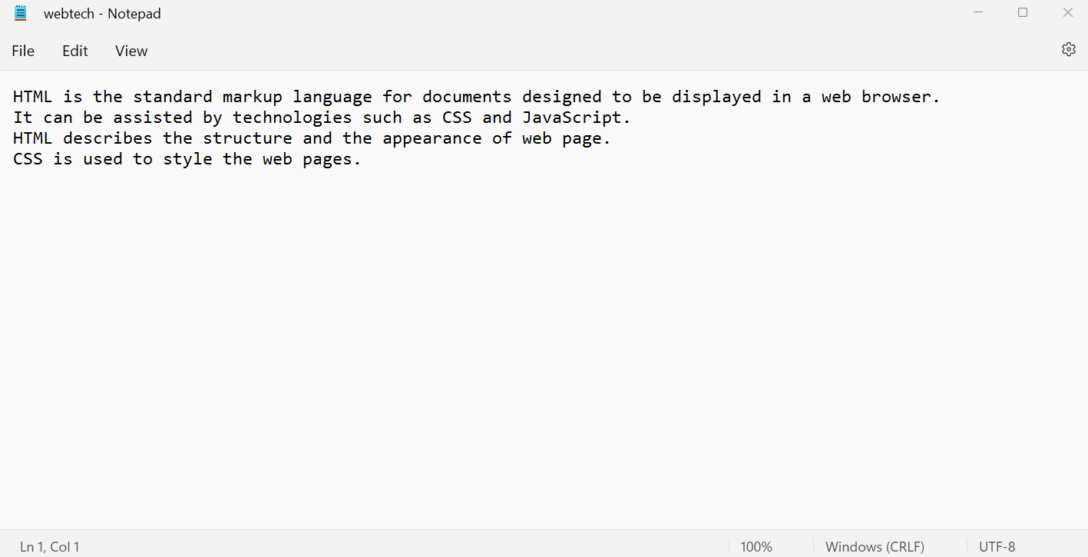

**OUTPUT: -**

