📘 BANK DEPOSIT ANALYSIS — DATA SCIENCE PROJECT REPORT

BANK DEPOSIT ANALYSIS DASHBOARD
Data Science Project Report
Prepared By: Rugwed Yawalkar
PRN: 22070521010

Table of Contents
- Project Overview
- Data Engineering Workflow
- Exploratory Data Analysis (EDA)
- Statistical & Business Insights
- Machine Learning Readiness
- Visualization Strategy
- Screenshots
- Conclusion

1. Project Overview
The Bank Deposit Analysis Dashboard is a data-driven analytical system designed to extract insights from bank deposit data across Indian states, districts, regions, and population groups. The goal is to apply standard data science methodology—data engineering, EDA, statistical analysis, segmentation, visualization, and machine-learning readiness—to understand structural deposit behavior.
The application leverages Streamlit, Pandas, and Plotly to convert raw CSV files into an interactive financial intelligence dashboard. It enables analysts, policymakers, and financial institutions to explore deposit distribution patterns, account structures, branch penetration, demographic differences, and regional disparities.

2. Data Engineering Workflow
The dataset (populationgroup-wise-deposits.csv) undergoes structured preprocessing, implemented in the Streamlit application.

2.1 Data Cleaning Steps
- Removal of uninformative identifier columns (id, state_code, district_code)
- Conversion of year into categorical format
- Removal of invalid or empty entries (rows where deposits, accounts, and offices are all zero)
- Normalization of numeric fields for consistency
- Categorization of attributes into numeric vs. categorical groups

2.2 Final Dataset Structure
Numerical Columns
- no_of_offices
- no_of_accounts
- deposit_amount
Categorical Columns
- state_name
- district_name
- region
- population_group
- year

2.3 Data Pipeline Diagram
[Raw Data] → [Cleaning & Preprocessing] → [Validated & Structured Dataset]
Where:
- Raw Data: Original CSV input
- Cleaning: Removing duplicates, filtering zero rows, fixing dtypes
- Prepared Dataset: Final dataset used for analysis

3. Exploratory Data Analysis (EDA)
EDA was performed using descriptive statistics, distribution exploration, segmentation, and comparative charts.

3.1 Descriptive Statistics
- Mean, median, min–max of deposits and account counts
- Distribution of branches across districts
- Skewness and spread of deposit values

3.2 Categorical Exploration
- State count distribution
- Region count distribution (North, South, East, West, Central)
- Population group distribution (Urban, Semi-Urban, Rural, Metro)
- Year-wise frequency

3.3 Business KPIs
Displayed on the dashboard:
- Total deposits
- Total number of accounts
- Total number of bank offices

3.4 Sample Data Inspection
Random sampling (df.sample(10)) used to inspect variety and anomalies.

4. Statistical & Business Insights

4.1 Deposit Concentration
Deposits are unevenly distributed with certain high-performing states contributing a majority share.

4.2 Accounts vs Deposit Correlation
A positive relationship is visible between number of accounts and deposit amount.
(Core analytical direction for ML regression.)

4.3 Demographic Penetration
Population groups exhibit clear financial behavior differences:
- Metro & urban areas → high deposits and account density
- Rural & semi-urban → lower deposit values but more offices

4.4 Regional Disparities
Regional aggregation shows disparities that support targeted financial inclusion initiatives.

4.5 State-Level Ranking Insight
A bar chart ranks the top 20 states by total deposit amount, offering a macroeconomic view of deposit distribution.

5. Machine Learning Readiness
The dataset is designed to support multiple ML applications after feature engineering.

5.1 ML Tasks Supported
1. Regression
- Predict deposit amount
- Estimate district performance
2. Classification
- Label regions by performance tier (High/Med/Low)
3. Clustering
- Unsupervised grouping of districts based on deposit density & population group
4. Time Series Forecasting
- Year-wise deposit trend modeling
- Forecasting financial growth

5.2 ML-Ready Properties
- Clean numeric fields
- Categorized demographic fields
- Segmentation (region + population group + state)
- Outputs suitable for supervised & unsupervised ML

5.3 Feature Engineering Ideas
- Deposit per office
- Deposit per account
- Account-to-office ratio
- Year-over-year percentage changes
- Regional embeddings

6. Visualization Strategy
Visual storytelling is achieved through Plotly Interactive Charts, enabling:
- State-wise ranking
- Temporal comparisons
- Regional segmentation
- Financial distribution mapping

6.1 Chart Types Used
- Bar charts
- Frequency tables
- Summary statistics tables

6.2 Chart Expansion Possibilities
- Line charts for year trends
- Heatmaps (correlation)
- Clustering scatter plots
- Geographic heatmaps (state shading)

6.3 Design Principles
- Clean color themes
- Business-focused readability
- High information density
- Interactive tooltips

7. Screenshots

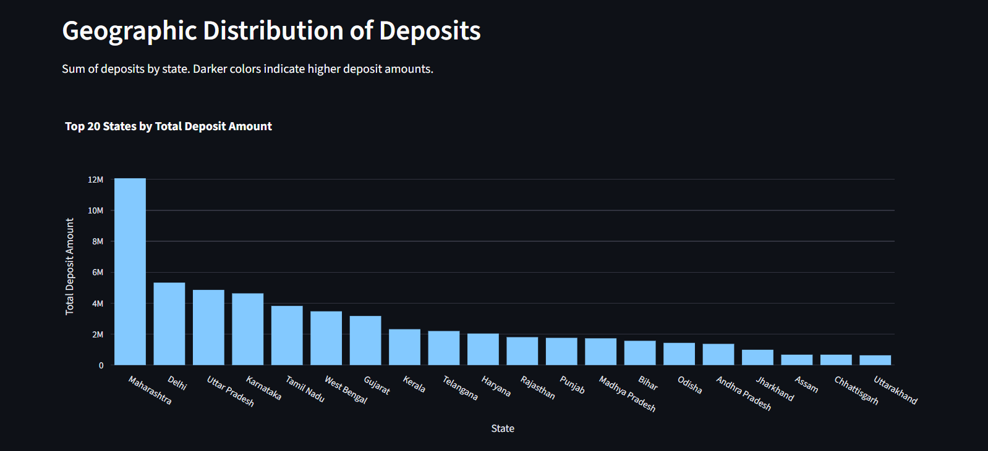

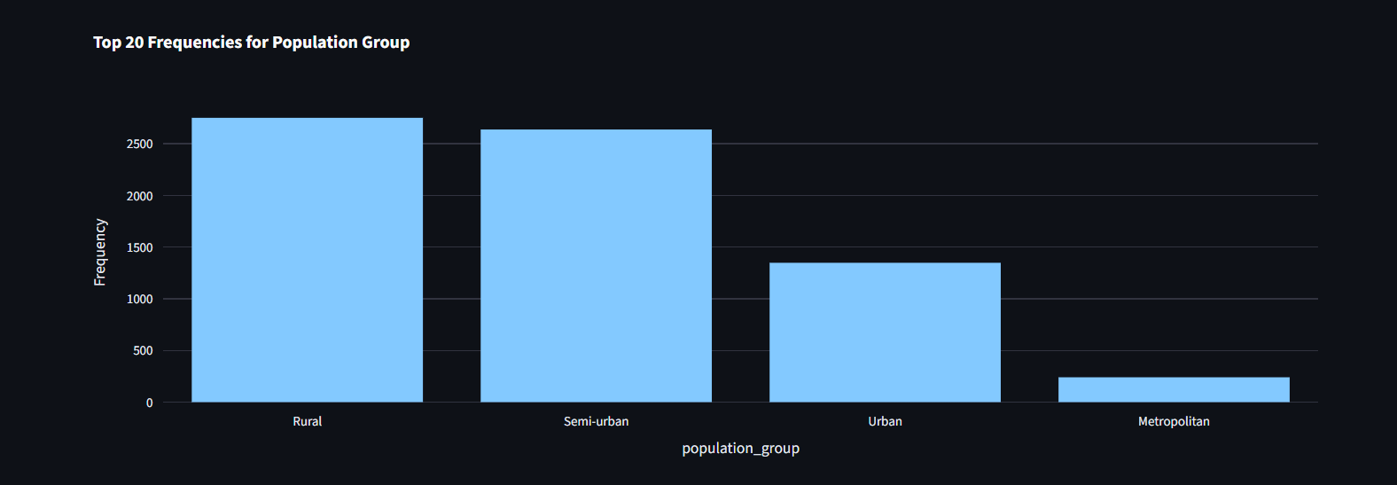

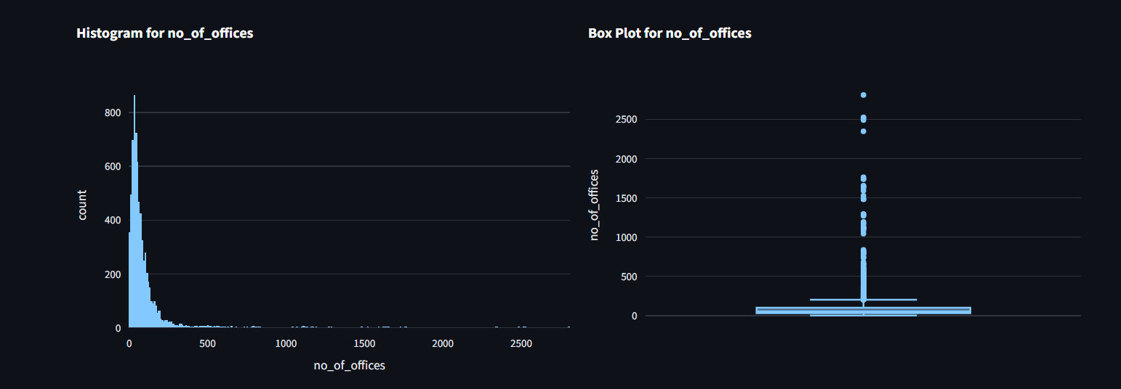

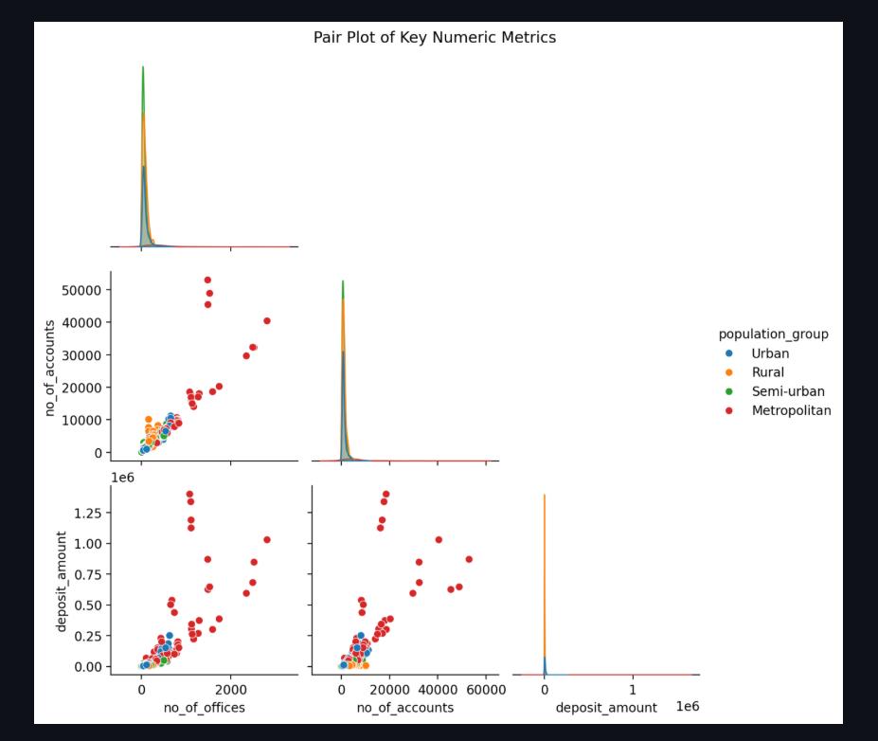

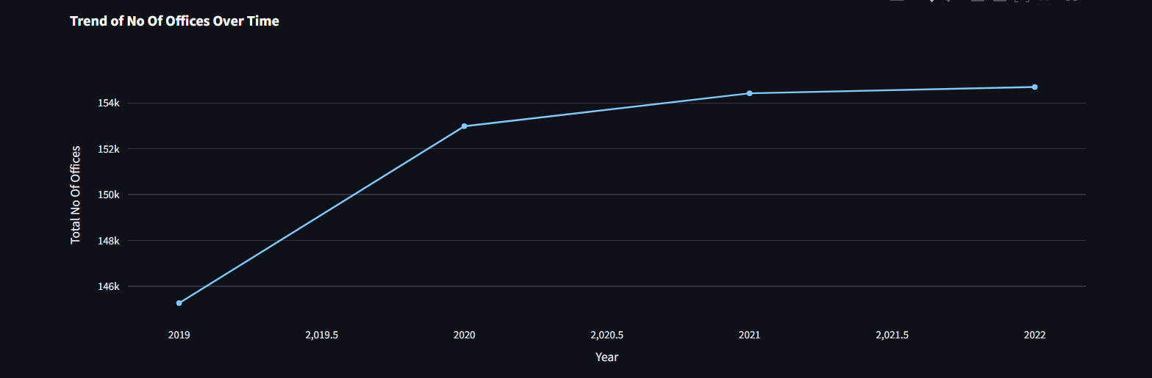

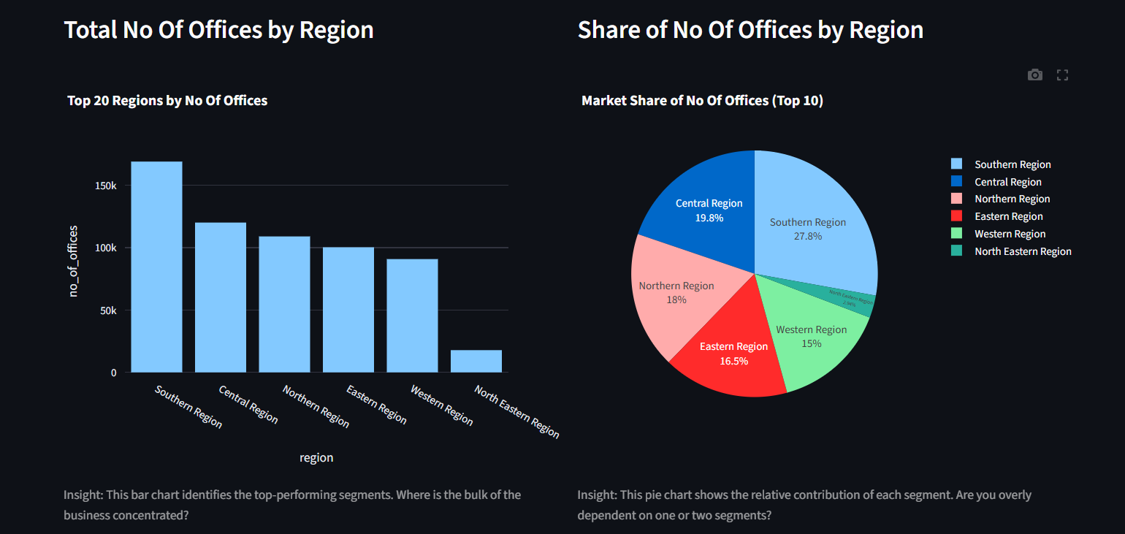

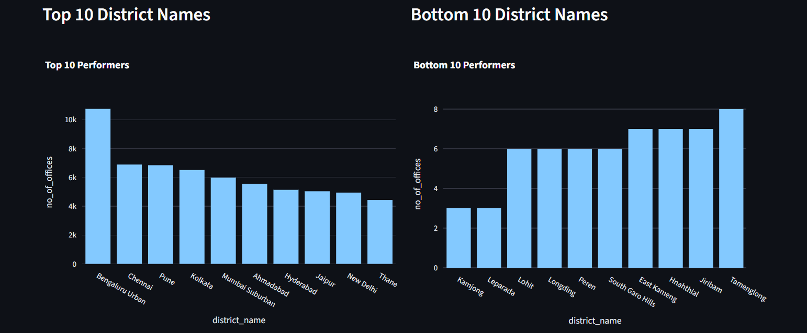

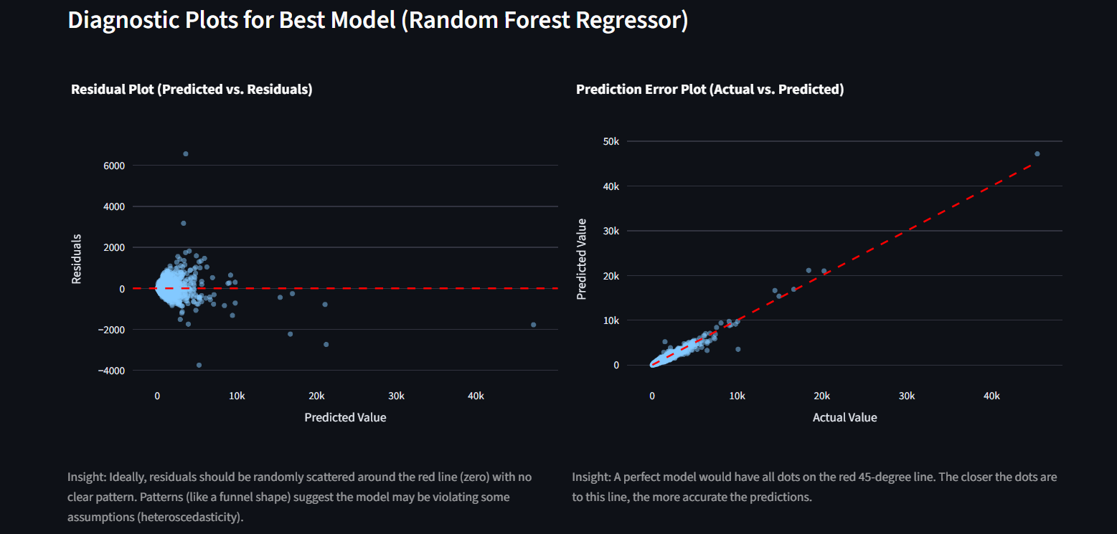

8. Conclusion
This project establishes a complete, scalable data science framework for analyzing India's banking deposit ecosystem. It integrates robust data engineering, descriptive analytics, segmentation, visualization, and ML-ready architecture.
The system can easily grow into:
- A predictive deposit forecasting engine
- A financial risk assessment tool
- A performance benchmarking dashboard
- A prescriptive analytics platform for policy planning
The methodology and structure follow industry-standard practices in data science, making the project suitable for academic, research, enterprise analytics, and advanced ML deployment.

