**Skymon Hardware Upgrade Recommendations**

**The Skymon signal tracker was successfully able to capture and transform GPS signal data into something meaningful in the Cloud. Now that the proof of concept has been completed, we begin to find ways we can overcome the major issues and problems we encountered while testing this project.**

**--------------------------------------------------------**

**The first issue that we wish to address in the Skymon 2.0 release is the terrible portability of the program. We could not power on or seeour machine outdoors without going through many loopholes. Which if this project is going to be useful in a security and business environment, the Skymon device will need to be able to run off a portable power source while not needing a screen to become a practical device.**

**The second major issue discussed quite frequently was the weak signal of the receiver. The reason it was hard to even test the Skymon at first was the fact that the receiver needed to be outside under clear skies. Without device portability as aforementioned, we cannot even get a good enough signal unless we boost it.**

**One last issue we aim to resolve with hardware is the issue of precise data. The Skymon cloud architecture only leverages the data from a GPS signal. While that data can be used to measure speed and such, it can be unreliable and can pose risk to data availability and integrity. Adding an accelerometer and/or a gyroscope will enable Skymon to be able to create much more detailed information on speed and where the device may be heading. Combine that data with geolocation data from satellites and we can leverage A.I to give more detailed and accurate information than any IoT tracking solution that exists in the market.**

**--------------------------------------------------------**

**Raspberry Pi Pico and Pico W**

This new hardware feature allows the satellite tracker to run on a much smaller device rather than a larger Raspberry Pi3 model.

Documentation: <https://www.raspberrypi.com/documentation/microcontrollers/raspberry-pi-pico.html>

**FORIOT 9-12V Radio Frequency Wideband Amplifier LNA**

This new hardware feature aims to address the issues with the weak strength of the satellite receiver. This will amplify the receiver signal’s strength, hopefully to allow device use and connectivity in buildings.

FORIOT 9-12V Radio Frequency Wideband Amplifier Low Noise Amplifier LNA 0.1-2000MHz Gain 32dB

Where to buy: <https://www.amazon.com/FORIOT-Frequency-Wideband-Amplifier-0-1-2000MHz/dp/B0CFLB7QLF/ref=sr_1_2?crid=3REKT1Q7B5EID&dib=eyJ2IjoiMSJ9.PSmkzlLk9EybaaRYhn-tLvvsvQINkeYbZJGl6u44EtEaLD66N4CKL4dC2xHR9fNVtCt1tJ0iAYP_3dgxoDPzxwtR9k-B_hJX5gWFEMTROuCOLC3VTZ1LoAV28dFJI1ufoFVlft7R9mATqU3H8AvsWsyDdd3JzTQ46x2U18ZWnKIqPUGOpz6WCxVmbVGa_B_eFA0nB4vXChJ-hZgwMWuCQWMv2H-WYV05u31Etv7WgnJqdtrq54X_rjnKiXcjxQIcGgkqz8_8QiqAyhOfVnD2PT4xNfTfq7IGlQmHHOx5CRY.vCeJ8eXy8Zl0QJym2rSEVPf2liTnLEWj9Vo63t8IbBs&dib_tag=se&keywords=Mini+Circuits+ZFL-1000LN%2B+Low+Noise+Amplifier&qid=1715382008&s=electronics&sprefix=mini+circuits+zfl-1000ln%2B+low+noise+amplifier%2Celectronics%2C318&sr=1-2>

**AZDelivery GY-521 MPU-6050 Axis Gyroscope and Accelerometer**

This hardware sensor will enable the Skymon device to gather more information in regards to a target’s speed and direction. This will enable the Skymon tracker to have more detailed information with proper software and cloud configuration while increasing Skymons overall availability in displaying data.

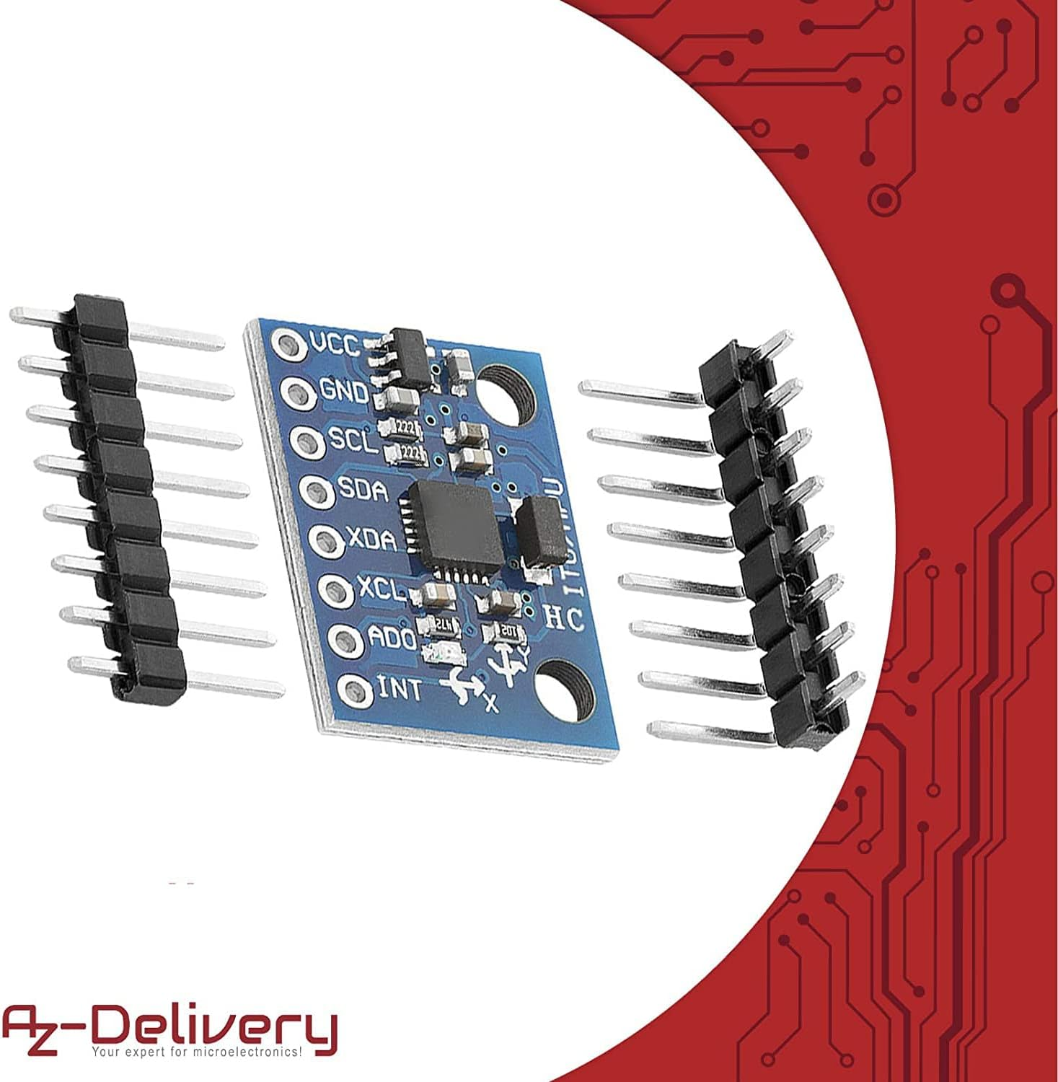

Where to buy: <https://www.amazon.com/AZDelivery-MPU-6050-Gyroscope-Accelerometer-Compatible/dp/B07N2ZL34Z/ref=sr_1_3?crid=18LKRS86O9UFH&dib=eyJ2IjoiMSJ9.TTrFHQyU2uZ9UEufftT6Qo7ZxjtnDXyH9Qps0OmM_HnGjHj071QN20LucGBJIEps.LGKzi787NKACdKct6-wjeULX2HX5O4Lym92Su5sDF-c&dib_tag=se&keywords=MPU-9250&qid=1715384548&s=electronics&sprefix=mpu-9250%2Celectronics%2C167&sr=1-3&th=1>

**GeeekPi UPS Power Supply Uninterruptible UPS HAT for Raspberry Pi Pico/Pico W**

This new hardware feature will allow our computer to be powered on in a portable fashion. It requires power connection soldering and a lithium ion battery we can use to hold battery but we can keep recharging and using the entire device as long as the battery is functional.

Where to buy: <https://www.amazon.com/AITRIP-Lithium-Charging-Protection-Functions/dp/B08DNK398S/ref=sr_1_2?crid=15CLIWVP9V27H&dib=eyJ2IjoiMSJ9.H8AgfCUXM6j6jneotXvgp9PglghwvDQAL0fq8xs9dIHHOSBxMdjG2aD-PbGCKHOGheHsyGcvlVSU7zFIOKmexVxH_iEfegD_ggKL9EigbEwq8BVe5ylIEJvCJJXCz7QTbJWH5ZU7gnuG_NyAnFCXpNikVKV17B9onZTDDTgHjPzsz9iL71dqnQxxp9_CSxk59mc5OIZeRS1CEDv8dEg-2XaOSB0I4z3adhM2RfADM1-CEPTOCDXea0m2HPdknBp6HDP_50QpKDU4qfnqsHBYIJfY0lz81nUQE0agdrau9Qw.BSPIWvV60tAIQXVmOpYokzAxxETt-htzZAHLe6GsWgY&dib_tag=se&keywords=USB%2BLiPo%2Bbattery%2Bcharger%2Bmodule%2Bfor%2Bpi%2Bpico&qid=1715380397&s=electronics&sprefix=usb%2Blipo%2Bbattery%2Bcharger%2Bmodule%2Bfor%2Bpi%2Bpico%2Celectronics%2C131&sr=1-2&th=1>