IMPLEMENTATION SCREENSHOTS AND TECHNICAL EXPLANATIONS
Fake Media Detection using NLP, Q-Learning and MultiChain
This section documents the implementation sequence shown in the original screenshots: blockchain setup, Python integration, content hashing, dataset processing, model training, RL-based review, and experimental evaluation. Figure explanations describe observed outputs rather than claimed functionality that was not demonstrated.

1. MultiChain Network Initialization
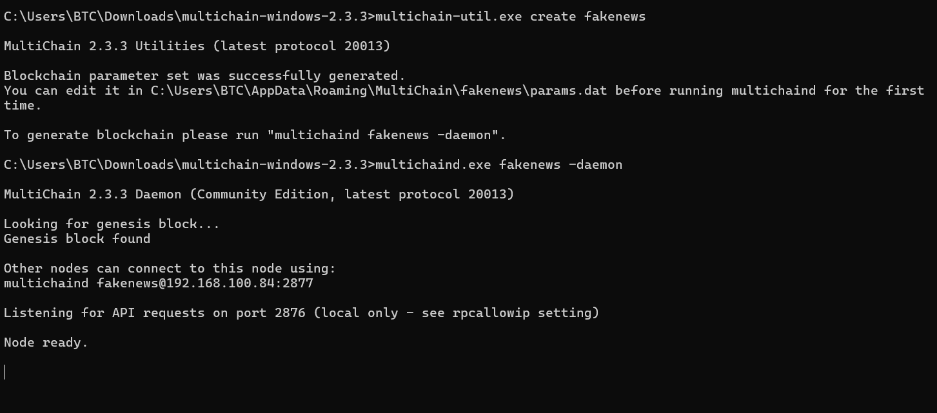
Figure 1. MultiChain blockchain creation and node startup.
Explanation. The commands create a permissioned chain named fakenews and start its local node. The output reports that the genesis block was found and the node is ready to accept requests.
Technical comment. This establishes a running blockchain environment; it does not yet demonstrate a news transaction.
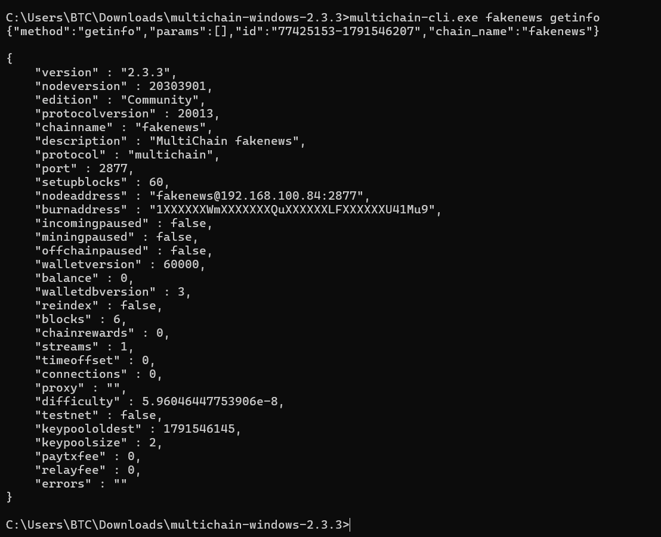
Figure 2. Blockchain configuration verified with getinfo.
Explanation. The getinfo command returns MultiChain version 2.3.3, the fakenews chain name, peer-to-peer port, block height and node state. The empty errors field indicates no reported error in this response.
Technical comment. Zero peer connections are acceptable for this single-node demonstration, but do not establish a distributed deployment.

2. Stream Creation and Blockchain Transactions
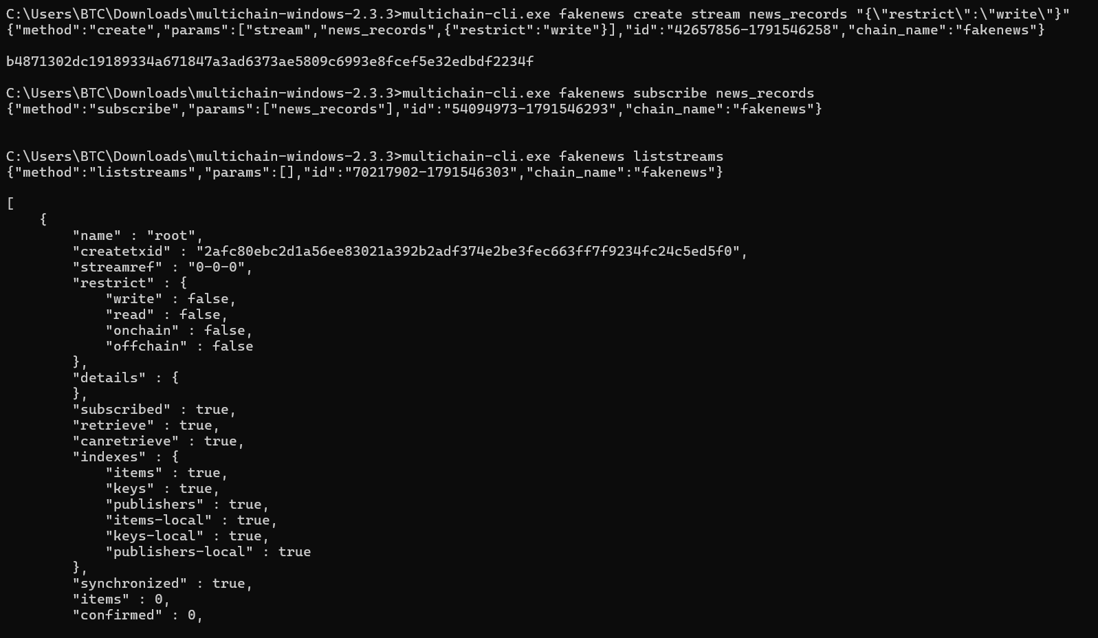
Figure 3. Creation and subscription of the news_records stream.
Explanation. The create stream command defines news_records with restricted write access; subscribe prepares the node to index stream data. The beginning of the liststreams output confirms the chain can query its registered streams.
Technical comment. Write restrictions are configured, but this screenshot does not independently test unauthorized users.
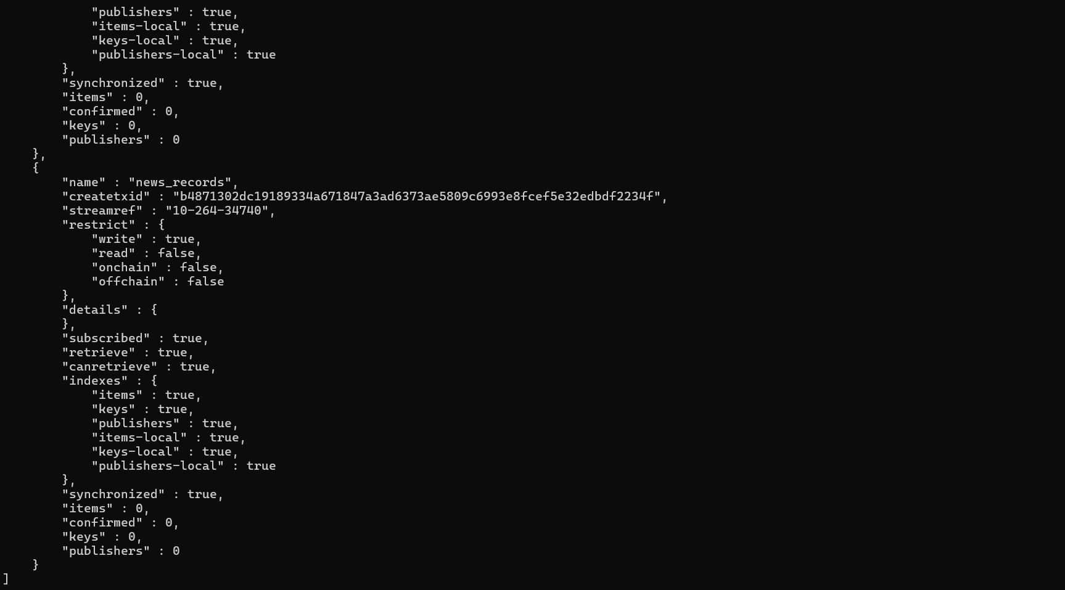
Figure 4. Stream metadata showing restricted writes and subscription.
Explanation. The continuation of liststreams shows the news_records stream with write restriction enabled and subscription/indexing active. At this stage, the stream has no items.
Technical comment. The stream is the audit channel for news identifiers, classification metadata and content hashes.
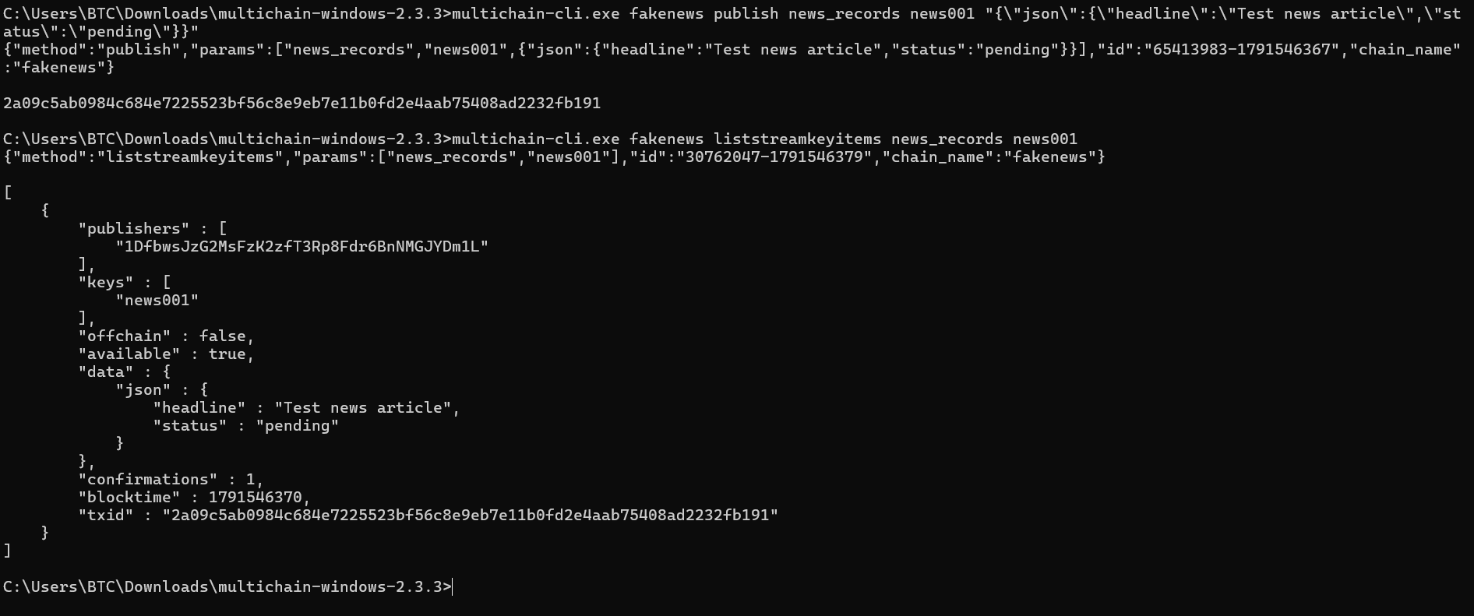
Figure 5. First manual news publication and immediate retrieval.
Explanation. The MultiChain CLI publishes a test JSON item under the key news001 and retrieves it from news_records. The returned fields contain the headline, pending status and a transaction identifier.
Technical comment. This is a storage test; pending is a workflow label, not a validated truth assessment.
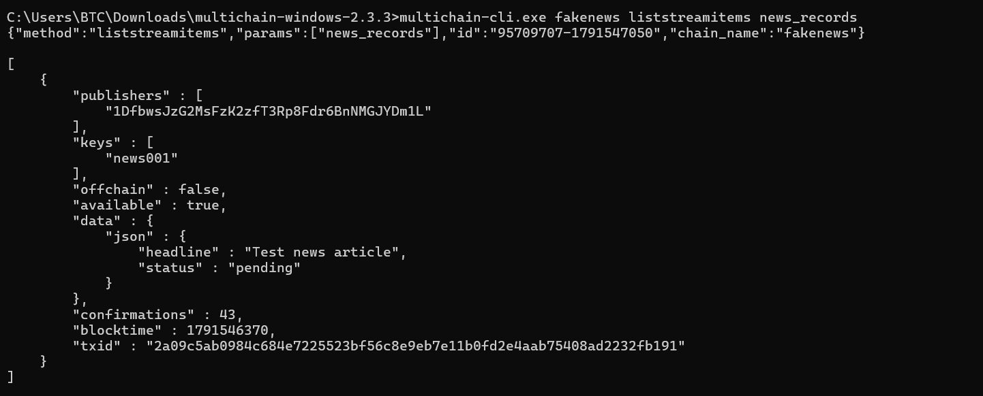
Figure 6. Confirmed blockchain record retrieved from news_records.
Explanation. A later liststreamitems query shows the same news001 item, its publisher address, JSON content, transaction hash, block time and confirmations.
Technical comment. Confirmations indicate inclusion in the blockchain; they do not establish that the news content is factual.

3. Python–MultiChain Integration and Content Integrity
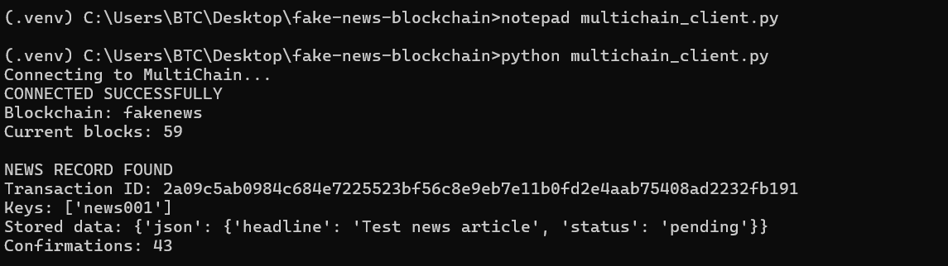
Figure 7. Python connection to MultiChain through JSON-RPC.
Explanation. Running multichain_client.py connects the Python application to the local fakenews node and retrieves news001 with its stored JSON and transaction identifier.
Technical comment. This verifies application-to-blockchain read access without manually re-entering the CLI retrieval command.
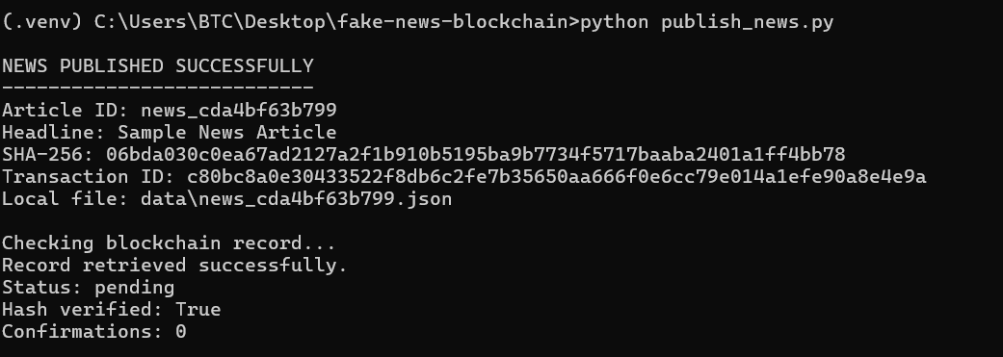
Figure 8. Publishing a SHA-256 news record from Python.
Explanation. The publish_news.py script assigns a unique article ID, saves the news locally, computes a SHA-256 content fingerprint and publishes the fingerprint and metadata into news_records.
Technical comment. The initial zero confirmations reflect an unconfirmed transaction at query time; confirmation must be checked afterward.
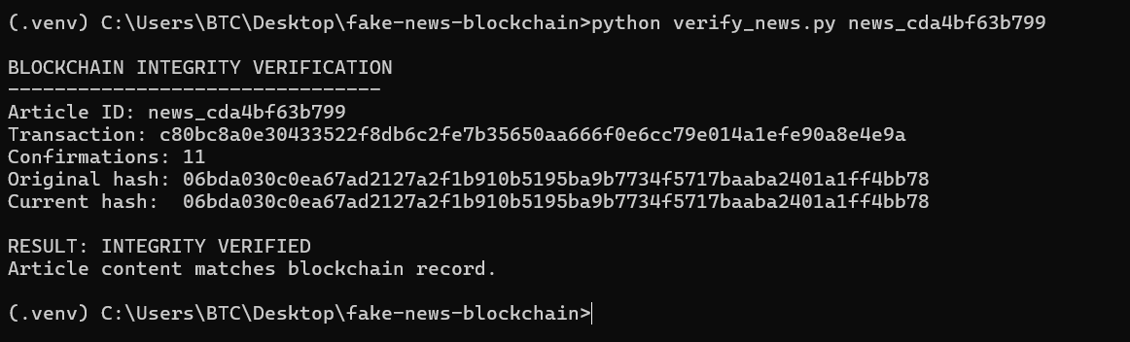
Figure 9. Integrity verification for the original local article.
Explanation. The verify_news.py script recomputes SHA-256 over the locally stored article content and compares it with the previously recorded blockchain hash. Both values match, so the content integrity check passes.
Technical comment. Hash equality establishes consistency with the recorded version, not authenticity or factual correctness.
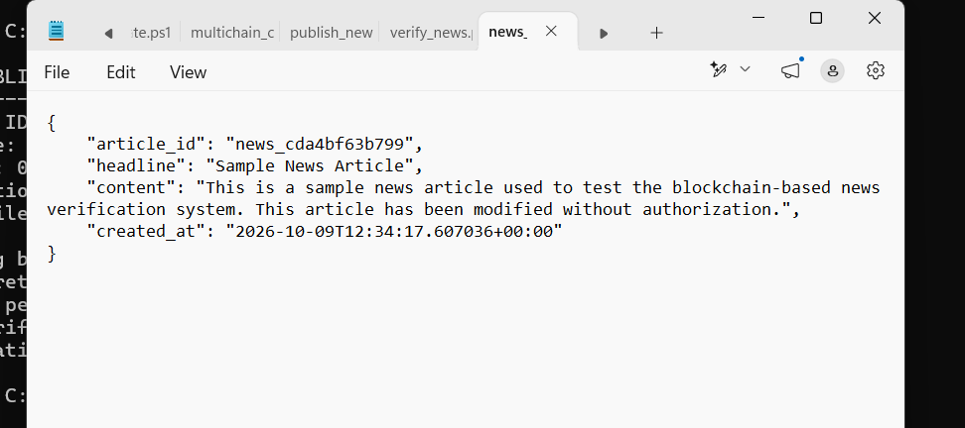
Figure 10. Locally edited news content used in the tampering experiment.
Explanation. This screenshot shows the JSON article file with additional text appended to its content field, representing a controlled modification of the off-chain news record.
Technical comment. The screenshot illustrates the modification step only. A separate mismatch-output screenshot would be needed to demonstrate the failed hash check within this document.

4. Dataset Preparation and NLP Classification
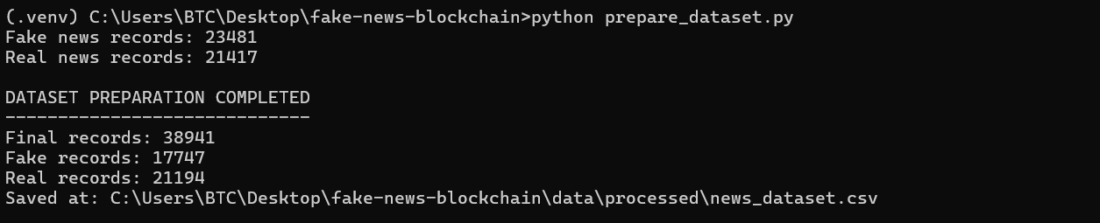
Figure 11. Cleaning and preparation of the ISOT news dataset.
Explanation. The prepare_dataset.py output shows 23,481 fake and 21,417 real input records. After cleaning, filtering and de-duplication, 38,941 records remain: 17,747 fake and 21,194 real.
Technical comment. The larger reduction in fake records is a potential sampling concern that should be acknowledged in the results discussion.
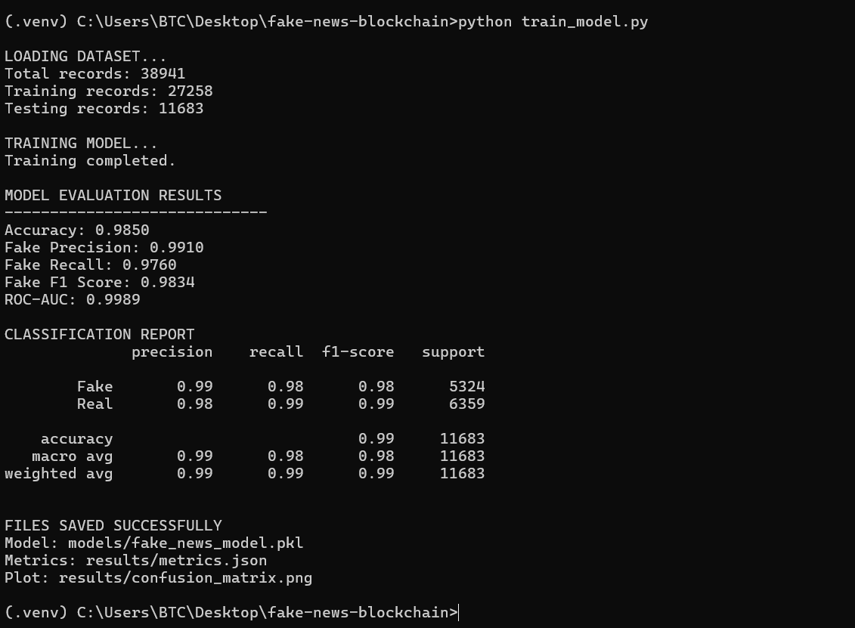
Figure 12. Training and internal evaluation of the NLP classifier.
Explanation. The TF-IDF and Logistic Regression pipeline trains on 27,258 records and evaluates on 11,683 held-out ISOT records. Reported accuracy is 98.50%, fake-class F1 is 0.9834, and ROC-AUC is 0.9989.
Technical comment. These numbers measure in-dataset performance; they do not imply equally strong detection on independent sources.
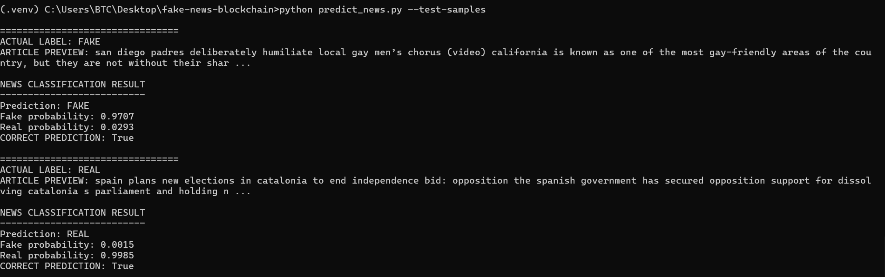
Figure 13. Inference on held-out fake and real news samples.
Explanation. The predict_news.py test classifies one held-out fake article as FAKE with a 0.9707 model score and one real article as REAL with a 0.9985 model score.
Technical comment. Two correct examples verify the inference path but are not an independent performance benchmark.

5. End-to-End NLP and Blockchain Pipeline
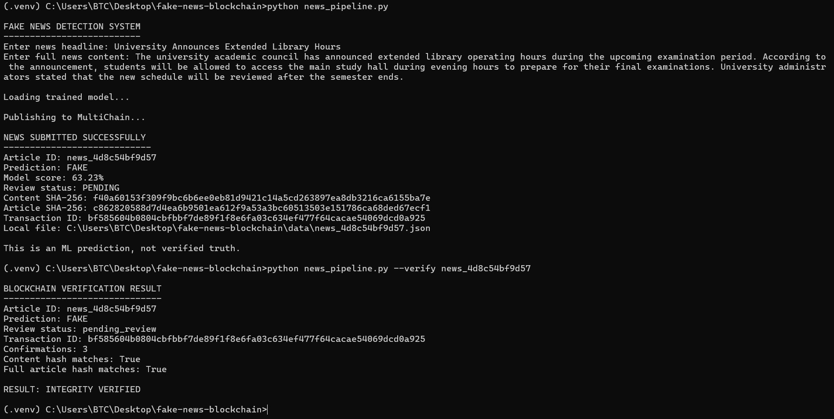
Figure 14. Integrated NLP classification and MultiChain verification.
Explanation. The news_pipeline.py workflow accepts a headline and article, predicts FAKE, stores the hashes with a transaction ID, and later verifies the saved article. Both content and full-article hash comparisons return True.
Technical comment. The review status remains pending_review: an ML label is a prediction, not a human-verified conclusion.
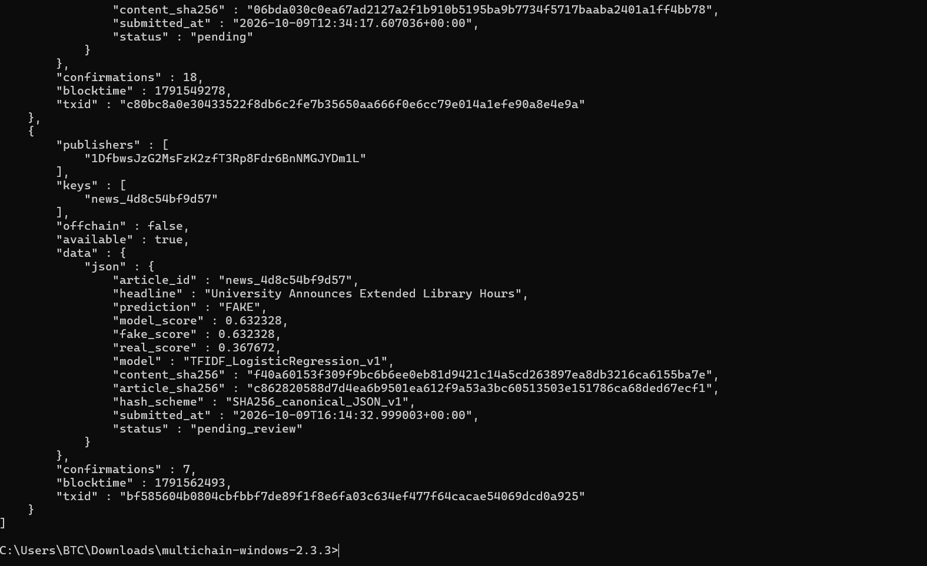
Figure 15. On-chain storage of classification metadata.
Explanation. The MultiChain CLI query shows an on-chain record containing the news identifier, headline, classifier prediction, model score, hashes, timestamp and pending review status.
Technical comment. The ledger records what the application submitted; blockchain immutability does not validate the model prediction.

6. Reinforcement-Learning Policy Evaluation
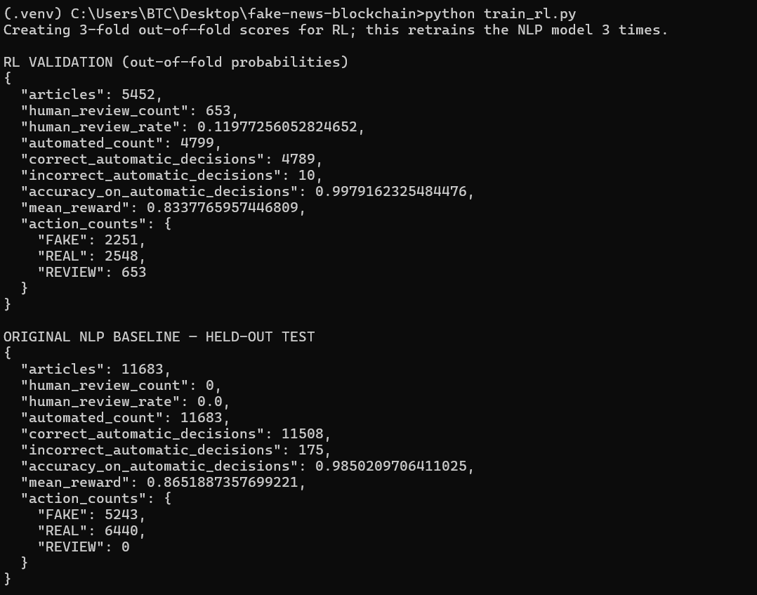
Figure 16. Out-of-fold RL validation and original NLP baseline.
Explanation. The RL training script reports results on 5,452 out-of-fold validation articles and separately displays the original NLP baseline on 11,683 held-out test articles. Baseline automatic accuracy is 98.5021% with 175 incorrect decisions.
Technical comment. The training-only validation partition and final held-out test partition have distinct purposes and should not be conflated.
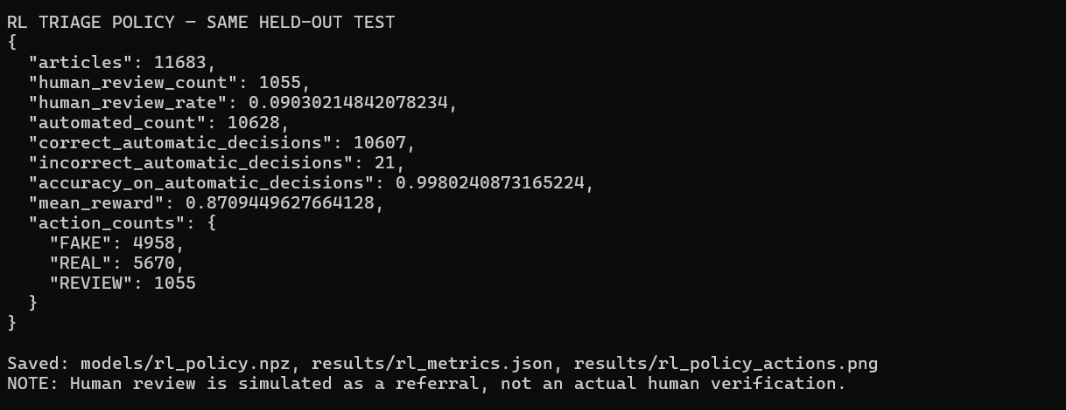
Figure 17. Q-learning triage results on held-out test data.
Explanation. The Q-learning review policy refers 1,055 of the 11,683 test articles for simulated review. Among 10,628 automatic decisions, it makes 21 errors, giving 99.8024% automatic-decision accuracy.
Technical comment. This higher selective accuracy is achieved by abstaining on 9.03% of articles; it is not whole-dataset accuracy.

7. Integrated NLP–RL–MultiChain Application
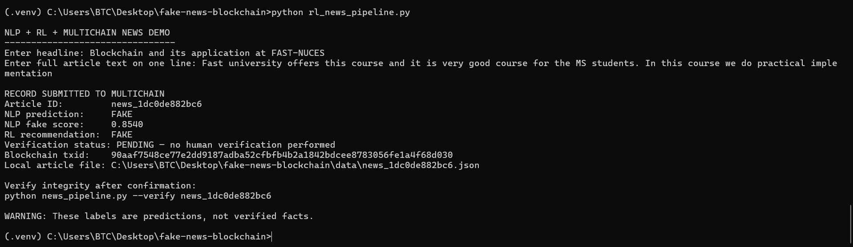
Figure 18. Combined NLP, Q-learning and MultiChain submission.
Explanation. The rl_news_pipeline.py demonstration produces an NLP FAKE score of 0.8540, an RL action of FAKE, a blockchain transaction ID and a local article record.
Technical comment. The script clearly indicates that no human verification was performed. The FAKE label must not be interpreted as a verified fact.
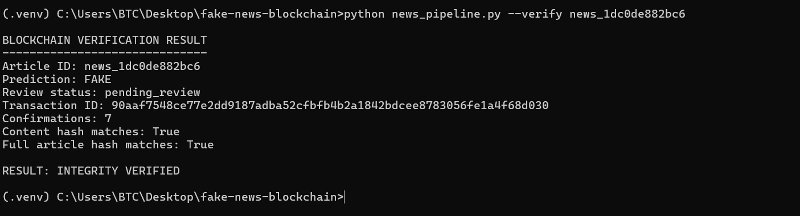
Figure 19. Verification of the RL-submitted article on MultiChain.
Explanation. The application retrieves the RL-submitted article by ID and checks both content and full-article hashes against its confirmed blockchain record. Both comparisons return True.
Technical comment. This validates end-to-end ledger integrity for that item, while the news review status remains pending.

8. Comparative Experiments and External Validation
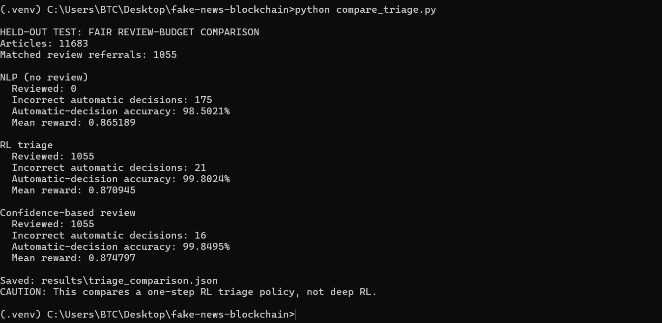
Figure 20. Fair review-budget comparison of decision policies.
Explanation. On 11,683 held-out articles, the original NLP baseline makes 175 automatic errors. With the same 1,055 review referrals, Q-learning makes 21 errors while a simpler confidence-based rule makes only 16.
Technical comment. Because the simpler rule performs better at matched review volume, this experiment does not support claiming that Q-learning outperforms confidence triage.
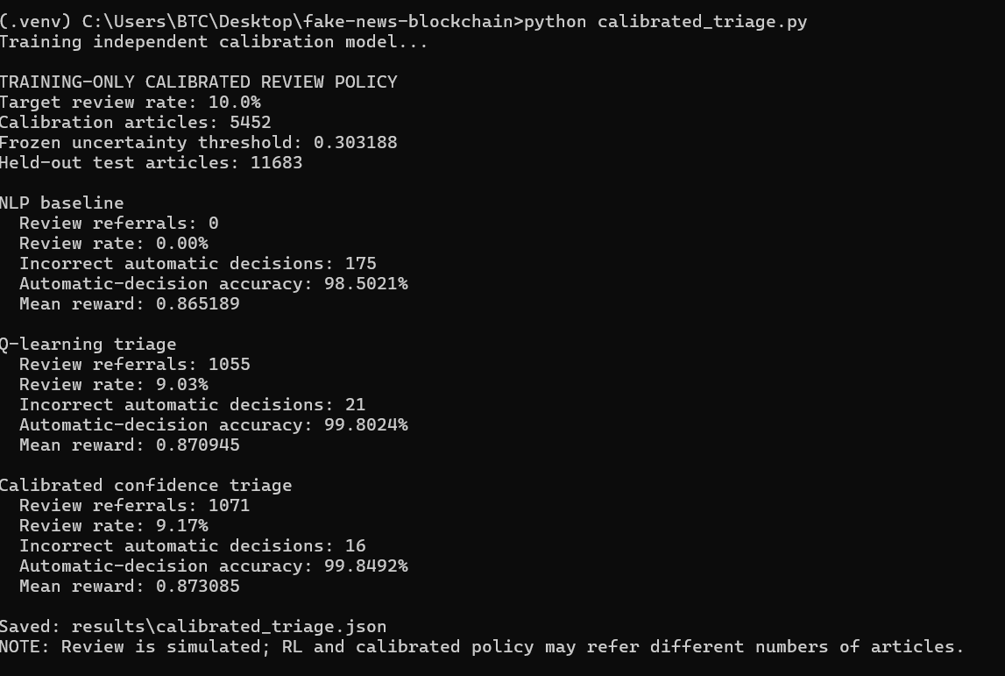
Figure 21. Training-calibrated confidence threshold comparison.
Explanation. A review threshold calibrated using training-side data targets a 10% referral rate and yields 1,071 test referrals (9.17%). It produces 16 automatic errors, compared with 21 for the Q-learning policy.
Technical comment. The reported review workflow is simulated, and the two methods refer slightly different numbers of articles.
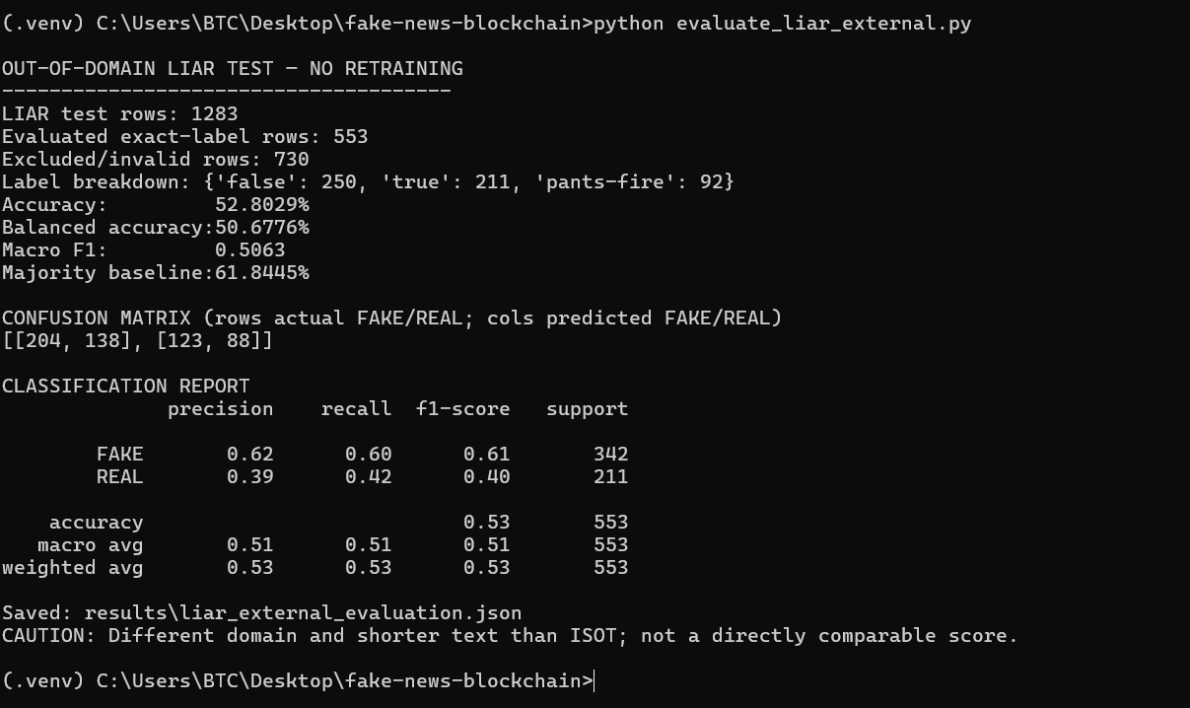
Figure 22. Out-of-domain LIAR dataset generalization test.
Explanation. The ISOT-trained model is evaluated without retraining on 553 LIAR statements with directly mapped true/false labels. Accuracy falls to 52.80%, balanced accuracy to 50.68%, and macro F1 to 0.5063.
Technical comment. The 61.84% majority baseline is higher than model accuracy. LIAR uses short political claims, so this result demonstrates poor transfer under domain shift, not a directly equivalent ISOT benchmark.

