CAPSTONE BACKEND DELIVERABLE

SmartStock Database Design
  - SQLite schema, entity relationships, field definitions, integrity rules, and initialization strategy.
Project | SmartStock Inventory and Sales Management System
Prepared by | Ruhang Liu
Document | Database Design and Table Specification
Date | July 25, 2026

1. Design Overview
SmartStock uses a normalized SQLite database for a small retail inventory and sales workflow. The schema separates authentication, catalog, transactions, operational orders, customers, and workspace configuration. Foreign keys protect the two critical ownership relationships: users to sessions and products to sales.
Database engine | SQLite using Node.js node:sqlite DatabaseSync
Database file | server/database/smartstock.db
Journal mode | WAL
Foreign keys | Enabled with PRAGMA foreign_keys = ON
Initialization | Tables and sample records are created automatically on first start

2. Entity Relationship Diagram
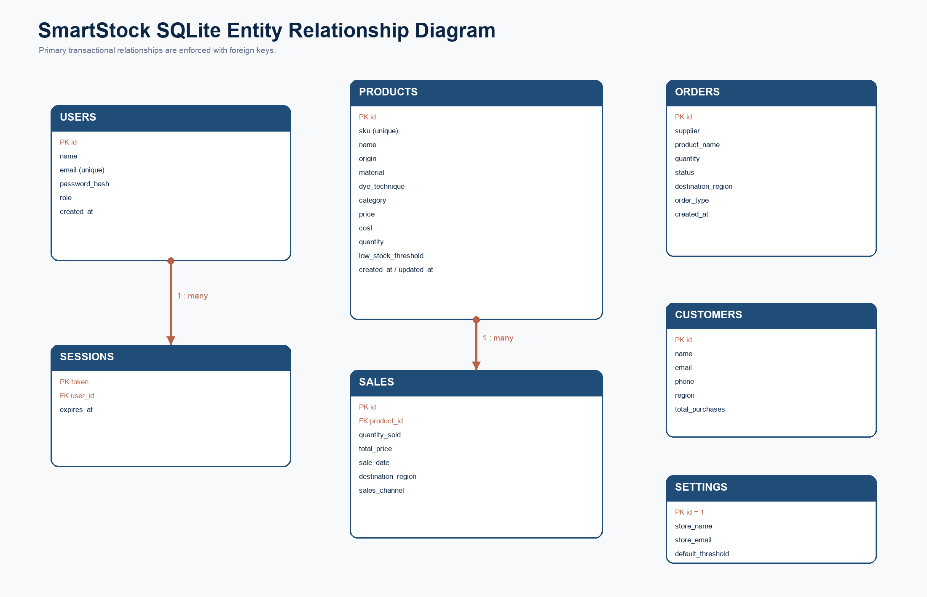
Figure 1. SmartStock database entities and enforced one-to-many relationships.

3. Table Catalog
Table | Purpose | Relationship
users | Authentication identity and role | users.id -> sessions.user_id
sessions | Bearer-token sessions | sessions.user_id -> users.id
products | Catalog and inventory | products.id -> sales.product_id
sales | Sales ledger and regional/channel data | sales.product_id -> products.id
orders | Purchase and international order tracking | Standalone operational record
customers | Customer directory and lifetime value | Standalone directory record
settings | Singleton workspace configuration | Fixed primary key id = 1

4. Detailed Table Definitions

4.1 users
Field | Type | Constraints | Purpose
id | INTEGER | PK, auto increment | Unique user identifier
name | TEXT | NOT NULL | User display name
email | TEXT | NOT NULL, UNIQUE | Login email
password_hash | TEXT | NOT NULL | Salted scrypt password hash
role | TEXT | CHECK admin/employee | Authorization role
created_at | TEXT | NOT NULL | Creation timestamp

4.2 sessions
Field | Type | Constraints | Purpose
token | TEXT | PK | Opaque bearer token
user_id | INTEGER | FK -> users.id | Session owner
expires_at | TEXT | NOT NULL | Session expiration timestamp

4.3 products
Field | Type | Constraints | Purpose
id | INTEGER | PK, auto increment | Product identifier
sku | TEXT | UNIQUE when present | Catalog SKU
name | TEXT | NOT NULL | Product name
origin | TEXT |  | Craft origin
material | TEXT |  | Primary material
dye_technique | TEXT |  | Tie-dye technique
category | TEXT |  | Product category
price | REAL | NOT NULL, default 0 | Retail price
cost | REAL | NOT NULL, default 0 | Unit cost
quantity | INTEGER | NOT NULL, default 0 | Current stock
low_stock_threshold | INTEGER | NOT NULL, default 5 | Alert threshold
created_at | TEXT | NOT NULL | Creation timestamp
updated_at | TEXT | NOT NULL | Last update timestamp

4.4 sales
Field | Type | Constraints | Purpose
id | INTEGER | PK, auto increment | Sale identifier
product_id | INTEGER | FK -> products.id | Sold product
quantity_sold | INTEGER | NOT NULL | Units sold
total_price | REAL | NOT NULL | Server-calculated total
sale_date | TEXT | NOT NULL | Transaction timestamp
destination_region | TEXT | default United States | Customer region
sales_channel | TEXT | default Online Store | Sales channel

4.5 orders
Field | Type | Constraints | Purpose
id | INTEGER | PK, auto increment | Order identifier
supplier | TEXT | NOT NULL | Supplier or sales channel
product_name | TEXT | NOT NULL | Order product
quantity | INTEGER | NOT NULL | Order quantity
status | TEXT | NOT NULL | Operational status
destination_region | TEXT | default United States | Destination
order_type | TEXT | default Purchase | Purchase or International
created_at | TEXT | NOT NULL | Creation timestamp

4.6 customers
Field | Type | Constraints | Purpose
id | INTEGER | PK, auto increment | Customer identifier
name | TEXT | NOT NULL | Customer name
email | TEXT | NOT NULL | Customer email
phone | TEXT |  | Customer phone
region | TEXT | default United States | Customer region
total_purchases | REAL | NOT NULL, default 0 | Lifetime purchase value

4.7 settings
Field | Type | Constraints | Purpose
id | INTEGER | PK, fixed at 1 | Singleton settings record
store_name | TEXT | NOT NULL | Store name
store_email | TEXT | NOT NULL | Store email
default_threshold | INTEGER | NOT NULL | Default alert threshold
admin_name | TEXT | NOT NULL | Administrative contact
currency | TEXT | NOT NULL | Display currency

5. Relationships and Integrity Rules
users 1 -> many sessions | A session belongs to one user. Session rows are deleted when their user is deleted.
products 1 -> many sales | Every sale references one product. Product deletion is blocked when sales history exists.
Unique SKU | A partial unique index prevents duplicate non-null SKU values.
Role constraint | User roles are limited to admin or employee.
Transactional sale | Sale insertion and inventory reduction execute inside one database transaction.
Stock validation | Sales are rejected when the requested quantity is not available.
Singleton settings | The settings table uses a CHECK constraint requiring id = 1.

6. Security and Data Handling
- Passwords are never stored as plaintext; each password uses a random salt and scrypt hash.
- Bearer tokens are generated with cryptographically secure random bytes.
- Sessions have an explicit expiration timestamp and can be revoked through logout.
- SQL statements use prepared parameters rather than string concatenation for user data.
- The automated test suite uses a separate temporary database file and does not modify production demonstration data.

7. Initialization and Migration Strategy
On application startup, the database module creates missing tables, enables foreign keys and WAL mode, and applies additive column migrations for fields introduced after the initial schema. Seed users, tie-dye products, orders, customers, and settings are inserted only when their corresponding tables are empty.
{
"admin_demo": "admin@smartstock.com / admin123",
"employee_demo": "employee@smartstock.com / employee123",
"automatic_database_path": "server/database/smartstock.db",
"test_override": "SMARTSTOCK_DB_PATH=/temporary/path.db"
}

