Output:

Caesar Cipher:

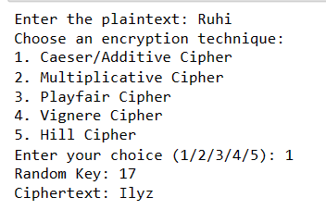

Multiplicative Cipher:

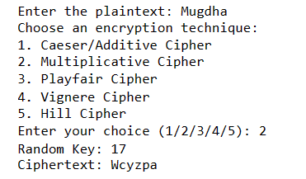

Playfair Cipher:

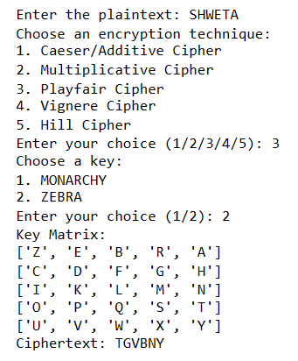

Vigenère Cipher:

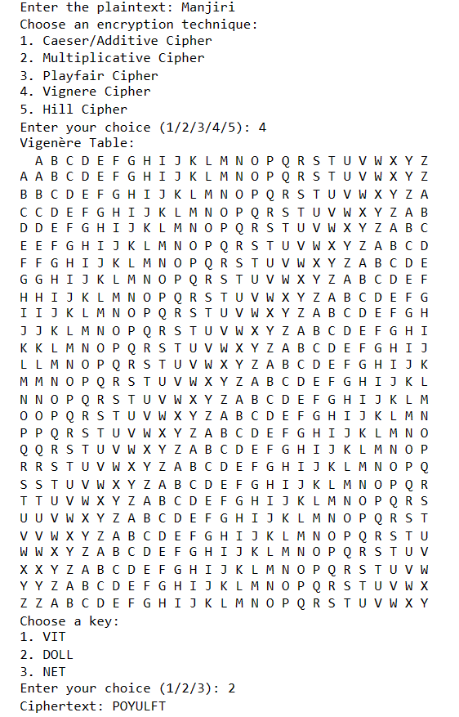

Hill Cipher:

