PROJECT BRIEF
Neuroevolution Cars
Teaching AI to Drive with Zero Rules — Pure Evolution

Stack: Python • Pygame • NumPy • Genetic Algorithm • Feedforward Neural Net

Executive Summary
Neuroevolution Cars is a self-contained simulation that demonstrates how artificial intelligence can learn a complex physical task — driving around a racetrack — without any training data, expert guidance, or predefined rules. The system starts with 30 cars whose neural networks are initialised with completely random weights. Through repeated cycles of simulation, fitness evaluation, and selective breeding, the population progressively discovers effective driving strategies entirely on its own.
This project is both an educational tool and an experimental playground. It makes the abstract concepts of neural networks and evolutionary computation tangible and visible: you watch brains being born, failing, competing, and improving in real time.

Core Premise
No training data — the AI has never seen a car drive before
No reward shaping — fitness is simply: how far did you travel?
No human guidance — three rules replace everything: simulate, score, breed
Emergence — smooth cornering, speed control and lane-keeping arise spontaneously

Concept Overview

What Is Neuroevolution?
Neuroevolution is the combination of two ideas from nature: neural networks (inspired by biological brains) and evolutionary algorithms (inspired by natural selection). Instead of training a neural network using gradient descent and labelled data, we evolve a population of networks by letting the environment do the teaching.
The key insight is that we don't need to know the right answer — we only need a way to measure how good each answer is. That measurement is called the fitness function. Everything else is handled by variation and selection.

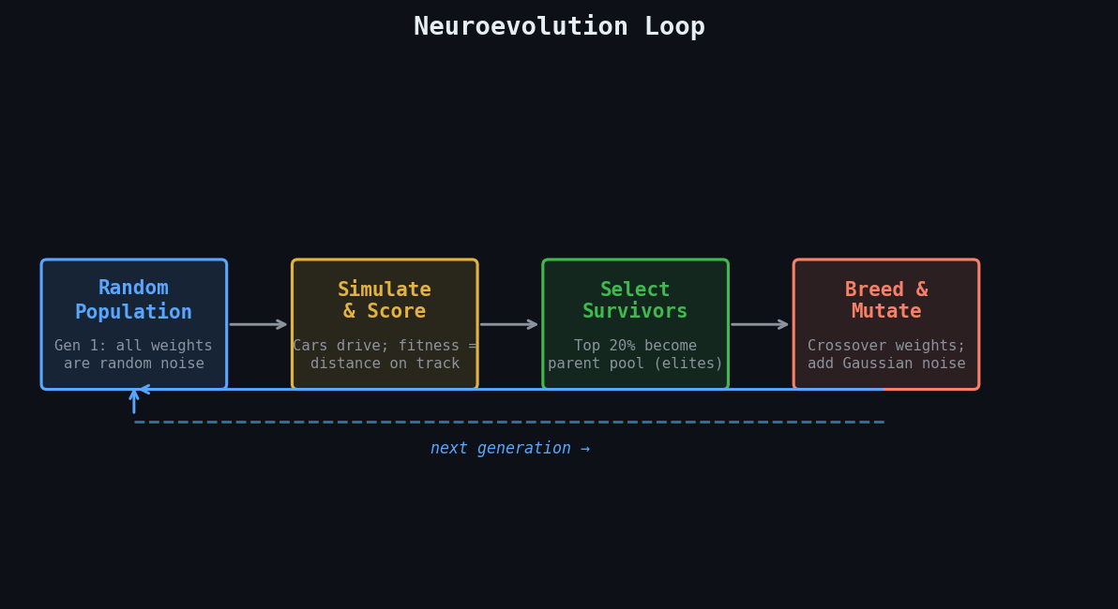
Figure 1 — The four-phase neuroevolution loop that drives all learning

Why No Training Data Is Needed
Traditional supervised learning requires thousands of labelled examples: "in situation X, the correct action is Y". This data is expensive to collect, domain-specific, and often biased by the person who labelled it.
Neuroevolution sidesteps this entirely. The track itself provides the signal. A car that hugs the centre line and maintains speed earns a high fitness score. A car that drives into the wall earns zero. No human ever has to specify what good driving looks like — the geometry of the track does it automatically.

Traditional ML  - Requires labelled training data  - Needs a differentiable loss function  - Sensitive to hyperparameter tuning  - Gradient descent as optimiser  - Requires many examples per scenario | Neuroevolution  - No training data required  - Only needs a fitness score  - Robust to noisy fitness signals  - Evolution as optimiser  - Learns from experience alone

System Architecture

The Neural Network
Each car is controlled by a small feedforward neural network. The network takes the car's 5 sensor readings as input and produces two continuous control values as output. There are no convolutions, no recurrent connections, no attention mechanisms — just a simple three-layer network that is fast to evaluate thousands of times per second.

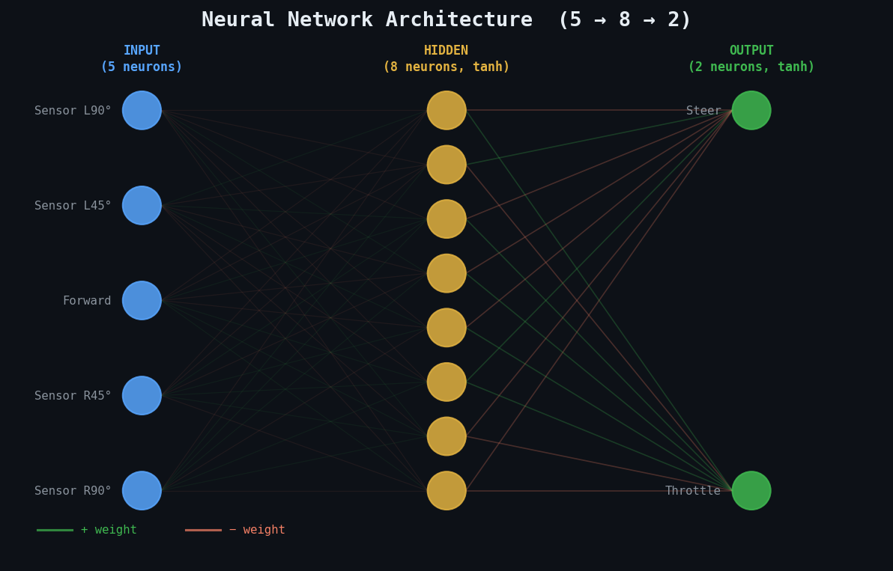
Figure 2 — Network architecture: 5 inputs → 8 hidden neurons → 2 outputs

Inputs — The Five Sensors
Each sensor casts a ray from the car in a specific direction and returns a normalised value between 0.0 (wall is immediately adjacent) and 1.0 (wall is at maximum sensor range or beyond). The five rays fan out at −90°, −45°, 0°, +45°, and +90° relative to the car's current heading.
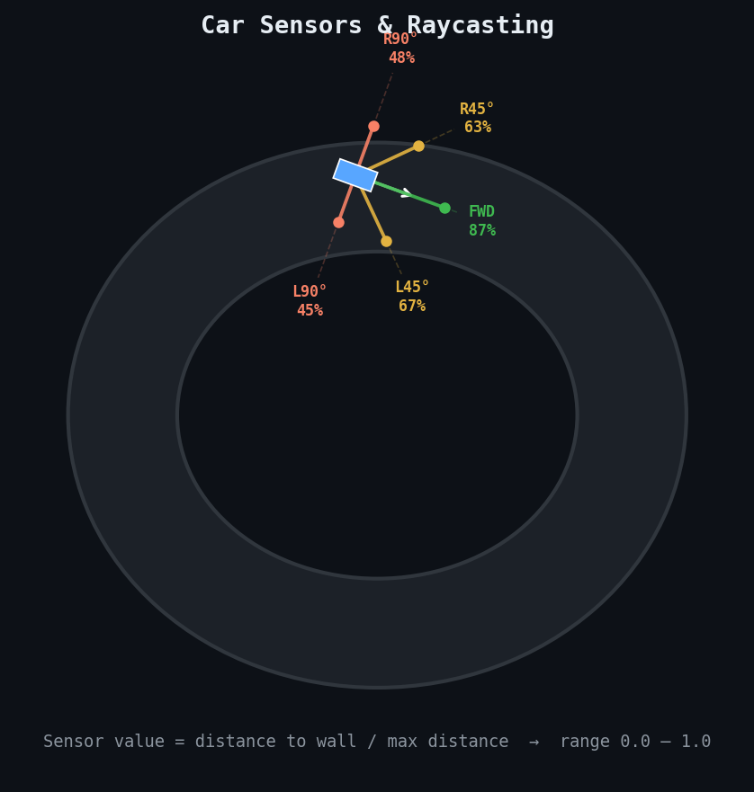
Figure 3 — Sensor raycasting from the car's perspective

Hidden Layer — tanh Activation
The 8 hidden neurons apply the hyperbolic tangent (tanh) function to their weighted sum of inputs. tanh squashes any real number to the range (−1, +1), which prevents activation values from exploding and allows the network to represent both excitation and inhibition — mirroring biological neurons.

Outputs — Steer & Throttle
The two output neurons produce continuous values in (−1, +1). The steer output is mapped to a turning rate (negative = left, positive = right). The throttle output controls acceleration (negative = brake, positive = accelerate). This gives the car fluid, analogue control rather than discrete button presses.

The Genetic Algorithm
The genetic algorithm is the learning engine. It operates on the population of neural networks as if they were organisms in a natural ecosystem — the fit survive, the unfit die, and the survivors reproduce with variation.

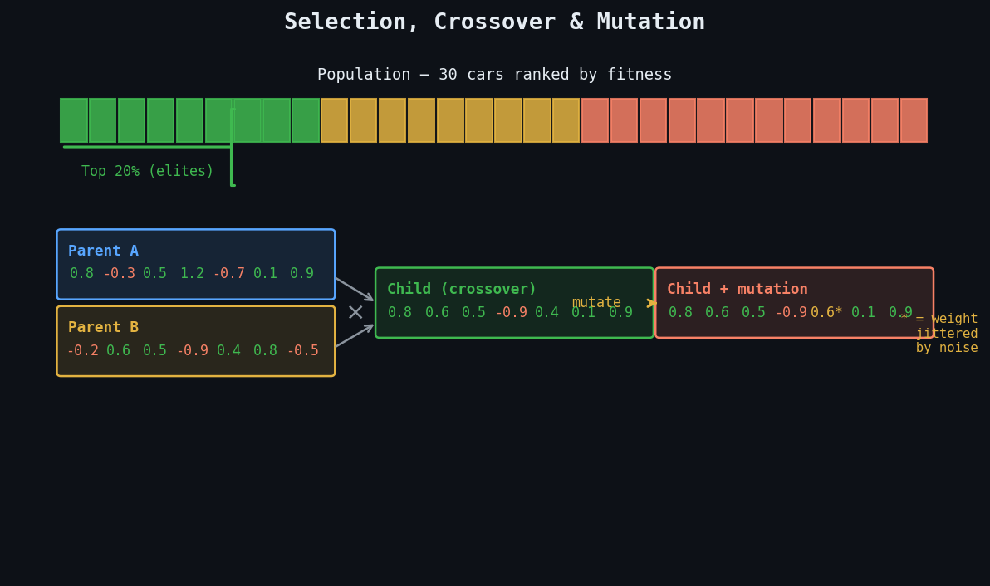
Figure 4 — Selection, crossover, and mutation in one generation cycle

Step 1 — Fitness Evaluation
Every car runs simultaneously on the track until it crashes or the time limit expires. Fitness is measured as the total distance the car travelled along the track centreline. A car that completes a full lap scores more than one that crashes at the first corner, regardless of how the crash happened.
Fitness Function
fitness(car) = Σ progress_along_centreline

Measured in track-units (waypoints passed)
Lap completion gives a large bonus multiplier
Time alive is NOT scored — only distance matters

Step 2 — Selection
After all cars have been evaluated, the population is ranked by fitness. The top 20% (6 cars from a population of 30) are selected as the elite parent pool. The bottom 80% are discarded. The top 2 individuals are always carried forward unchanged into the next generation — this is called elitism, and it prevents the algorithm from accidentally discarding a breakthrough solution.

Step 3 — Crossover
New offspring are created by combining the weights of two randomly chosen parents from the elite pool. We use uniform crossover: for each weight position, we flip a coin and take that weight from either parent A or parent B. This mixes strategies from both parents and is analogous to sexual reproduction in biology.

Step 4 — Mutation
After crossover, each weight in the child network has a small probability of being perturbed by Gaussian noise. Mutation introduces new genetic material that crossover alone cannot produce. Without mutation the population would converge to a local optimum and stop improving. The mutation rate and sigma are the primary dials for controlling the balance between exploration and exploitation.

Key Parameters (config.py)
POPULATION_SIZE = 30 — cars per generation
ELITE_FRACTION = 0.20 — top 20% survive to breed
MUTATION_RATE = 0.12 — probability of mutating each weight
MUTATION_SIGMA = 0.3 — std deviation of Gaussian noise
MAX_GEN_FRAMES = 600 — frames before forcing next generation

Expected Learning Curve
The simulation follows a characteristic S-curve of improvement. Early generations produce chaotic, random behaviour. As the first capable individuals emerge, crossover and selection amplify their strategies across the population. Eventually the curve flattens as the population converges on a near-optimal solution given the track geometry.

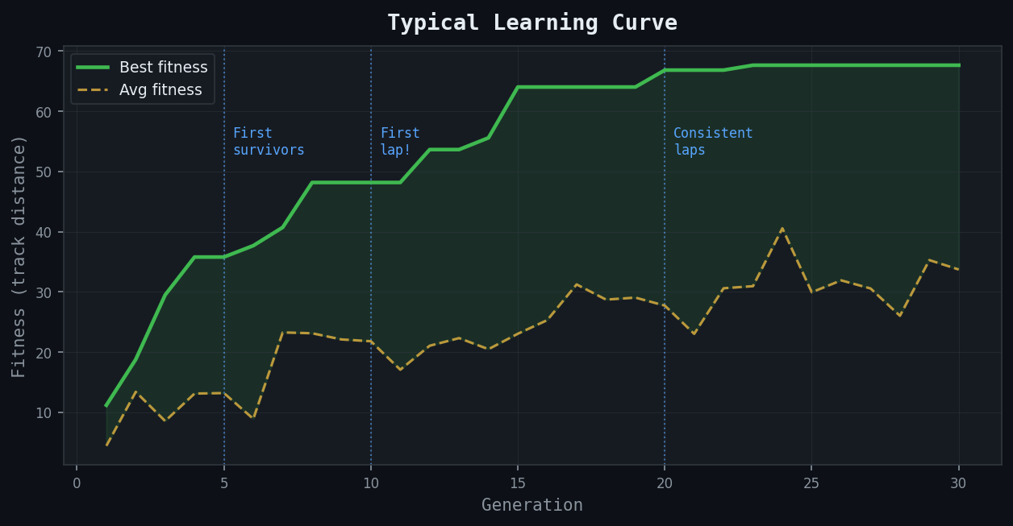
Figure 5 — Typical fitness progression over 30 generations

Generation Milestones
Gen | Milestone | Description
1 | Instant crash | All 30 cars drive straight into the nearest wall within the first second. Weights are random; outputs are noise.
3–5 | First survivors | A handful of cars discover that turning slightly avoids the first corner. These become the new parents.
8–12 | First full lap | One car completes a full circuit. The population rapidly converges on similar strategies.
15–20 | Consistent laps | Multiple cars run clean, reliable laps. Speed and smoothness continue to improve.
25+ | Optimisation | Fine-grained improvements: tighter cornering, higher average speed, overtaking the racing line.

Project Structure
The codebase is organised into single-responsibility modules. Each file has one job, making it easy to swap out components — for example, replacing the genetic algorithm with a different optimiser, or replacing the track with a procedurally generated one.

File Layout
neuroevolution-cars/
├── main.py Game loop, keyboard controls, orchestration
├── car.py Car physics, sensor raycasting, fitness tracking
├── neural_network.py Feedforward NN (NumPy), weight serialisation
├── evolution.py Selection, crossover, mutation, elitism
├── track.py Waypoints, boundary collision, progress metric
├── ui.py HUD, live NN visualiser, fitness history chart
├── config.py All tunable constants with comments
└── README.md Full concept guide and extension ideas

Controls & Interaction

Key | Action
SPACE | Pause or resume the simulation
→ Arrow | Skip immediately to the next generation (end current gen early)
1 / 2 / 3 / 4 / 5 | Set simulation speed to 1×, 2×, 5×, 10×, or 20×
N | Toggle the live neural network visualiser panel
R | Full reset — generation 1, completely random weights

Extension Opportunities
The modular codebase is designed to be extended. Below are a range of directions from straightforward to research-level, ordered roughly by complexity.

Beginner Extensions
- Custom tracks — replace the waypoint list in track.py with any shape
- Adjust population size and mutation rate and observe the effect on convergence speed
- Add a speedometer and lap timer to the HUD
- Record the best car's weight vector to a JSON file and reload it later

Intermediate Extensions
- Add a human-controlled car to race against the AI
- Implement tournament selection instead of top-K selection
- Try different network architectures — more hidden layers, more neurons
- Add noise to sensor readings to produce more robust evolved drivers
- Procedurally generate new tracks each generation to prevent overfitting

Advanced Extensions
- Implement NEAT (NeuroEvolution of Augmenting Topologies) — evolve both weights and network structure
- Multi-objective fitness: balance speed, smoothness, and fuel efficiency
- Co-evolution: evolve track difficulty alongside car capability
- Parallelise simulation across CPU cores using Python multiprocessing
- Replace genetic algorithm with CMA-ES (Covariance Matrix Adaptation) for continuous optimisation

Getting Started

Prerequisites
- Python 3.10 or higher
- pip (Python package manager)
- A terminal / command prompt

Installation
Clone or download the project folder, then install the two dependencies:
pip install pygame numpy
That's it. No other packages are required.

Running the Simulation
cd neuroevolution-cars
python main.py
A window will open showing the track and all 30 cars. Generation 1 will begin immediately. Press N to open the neural network panel. Press 4 or 5 to speed up the simulation and watch several generations evolve quickly.

This project was designed and scoped with Claude (Anthropic). The code is generated by Claude Code.

