After studying this chapter1, you will be able to:

♦ Define economics and distinguish between microeconomics and macroeconomics

♦ Explain the two big questions of economics  
♦ Explain the key ideas that define the economic way of

thinking

♦ Explain how economists go about their work as social scientists and policy advisers

Economics is the social science that studies the choices that individuals, businesses, governments, and entire societies make as they cope with scarcity and the incentives that influence and reconcile those choices.

Microeconomics is the study of choices that individuals and businesses make, the way those choices interact in markets, and the influence of governments.

Two big questions summarize the scope of economics:

▪How do choices end up determining what, how, and for whom goods and servic What, How, and For Whom?  
Goods and services are the objects that people

value and produce to satisfy human wants.

▪When do choices made in the pursuit of self-interest also promote the social interest?

Goods and services are produced by using productive resources that economists call factors of production.

Factors of production are grouped into four categories:

▪ Land  
▪ Labor  
▪ Capital  
▪ Entrepreneurship

The “gifts of nature” that we use to produce goods

and services are land.  
The work time and work effort that people devote

to producing goods and services is labor.

The quality of labor depends on human capital, which is the knowledge and skill that people obtain from education, on-the-job training, and work experience.

The tools, instruments, machines, buildings, and other constructions that businesses use to produce goods and services are capital.

The human resource that organizes land, labor, and capital is entrepreneurship.

For Whom?  
Who gets the goods and services depends on the

incomes that people earn. ▪Land earns rent.

▪Labor earns wages.  
▪Capital earns interest. ▪Entrepreneurship earns profit.

Self-Interest

You make choices that are in your self-interest— choices that you think are best for you.

Social Interest

Choices that are best for society as a whole are said to be in the social interest.

Social interest has two dimensions: ▪ Efficiency

▪ Equity

Efficiency and Social Interest

Resource use is efficient if it is not possible to make someone better off without making someone else worse off.

Equity is fairness, but economists have a variety of views about what is fair.

Fair Shares and Social Interest

The idea that the social interest requires “fair shares” is a deeply held one.

Six key ideas define the economic way of thinking: ▪A choice is a tradeoff.

▪People make rational choices by comparing benefits and costs.

▪Benefit is what you gain from something. ▪Cost is what you must give up to get something.

▪Most choices are “how-much” choices made at the margin.

▪Choices respond to incentives.

The benefit from pursuing an incremental increase in an activity is its marginal benefit.

The opportunity cost of pursuing an incremental increase in an activity is its marginal cost.

Economist as Social Scientist

Economists distinguish between two types of statement:

▪ Positive statements  
▪ Normative statements

A positive statement can be tested by checking it against facts.

A normative statement expresses an opinion and cannot be tested.

Unscrambling Cause and Effect

The task of economic science is to discover positive statements that are consistent with what we observe in the world and that enable us to understand how the economic world works.

Economists create and test economic models.

An economic model is a description of some aspect of the economic world that includes only those features that are needed for the purpose at hand.

Economics: A Social Science and Policy Tool

A model is tested by comparing its predictions with the facts.

But testing an economic model is difficult, so economists also use:

▪Natural experiments ▪Statistical investigations ▪Economic experiments

After studying this section, you will be able to:

♦ Make and interpret a scatter diagram  
♦ Identify linear and nonlinear relationships and relationships

that have a maximum and a minimum  
♦ Define and calculate the slope of a line  
♦ Graph relationships among more than two variables

A graph reveals a relationship.

A graph represents “quantity” as a distance.

A two-variable graph uses two perpendicular scale lines.

The vertical line is the y-axis. The horizontal line is the x-

axis.

The zero point in common to both axes is the origin.

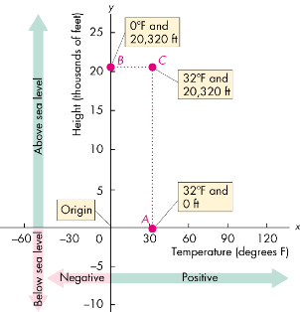

Scatter Diagrams

A scatter diagram plots the value of one variable against the value of another variable for a number of different values of each variable.

Graphs are used in economic models to show the relationship between variables.

The patterns to look for in graphs are the four cases in which

▪Variables move in the same direction. ▪Variables move in opposite directions. ▪Variables have a maximum or a minimum. ▪Variables are unrelated.

Variables That Move in the Same Direction

A relationship between two variables that move in the same direction is called a positive relationship or a direct relationship.

A line that slopes upward shows a positive relationship.

A relationship shown by a straight line is called a linear relationship.

The three graphs on the next slide show positive relationships.

After studying this chapter2, you will be able to:

♦ Define the production possibilities frontier and use it to calculate opportunity cost

♦ Distinguish between production possibilities and preferences and describe an efficient allocation of resources

* ♦ Explain how current production choices expand future production possibilities
* ♦ Explain how specialization and trade expand production possibilities
* ♦ Describe the economic institutions that coordinate decision

Production Possibilities and Opportunity Cost

– The production possibilities frontier (PPF) is the boundary between those combinations of goods and services that c Using Resources Efficiently Preferences and Marginal Benefit

– Preferences are a description of a person’s likes and dislikes.

– To describe preferences, economists use the concepts of marginal benefit and the marginal benefit curve.

– The marginal benefit of a good or service is the benefit received from consuming one more unit of it.

– We measure marginal benefit by the amount that a person is willing to pay for an additional unit of a good or service.

an be produced and those that cannot.

Total Utility

– Total utility is the total benefit a person gets from the consumption of goods.

– Generally, more consumption gives mo Marginal Utility

– Marginal utility from a good is the change in total utility that results from a unit-increase in the quantity of the good consumed.

– As the quantity consumed of a good increases, the marginal utility from it decreases.

– We call this decrease in marginal utility as the quantity of the good consumed increases the principle of diminishing marginal utility.

re total utility.

Allocative Efficiency

– When we cannot produce more of any one good without giving up some other good, we have achieved productive efficiency.

– We are producing at a point on the PPF.

– When we cannot produce more of any one good without giving up some other good that we value more highly, we have achieved allocative efficiency.

– We are producing at the point on the PPF that we prefer above all other points.

A diminishing marginal rate of substitution is the key assumption of consumer theory.

– A diminishing marginal rate of substitution is a general tendency for a person to be willing to give up less of good y to get one more unit of good x, while at the same time remaining indifferent as the quantity of good x increases.

Best Affordable Choice  
– The consumer’s best affordable choice

▪ Is on the budget line.  
▪ Is on the highest attainable indifference curve.

▪ Has marginal rate of substitution equal to relative price.

The expansion of production possibilities—an increase in

the standard of living—is called economic growth. – Two key factors influence economic growth:  
▪ Technological change  
▪ Capital accumulation

– Technological change is the development of new goods and of better ways of producing goods and services.

– Capital accumulation is the growth of capital resources, which includes human capital.

The Cost of Economic Growth

– To use resources in research and development and to produce new capital, we must decrease our production of consumption goods and services.

– So economic growth is not free.

– The opportunity cost of economic growth is less current consumption.

Comparative Advantage and Absolute Advantage

– A person has a comparative advantage in an activity if that person can perform the activity at a lower opportunity cost than anyone else.

– A person has an absolute advantage if that person is more productive than others.

– Absolute advantage involves comparing productivities while comparative advantage involves comparing opportunity costs.

After studying this chapter3, you will be able to:

* ♦ Describe a competitive market and think about a price as an opportunity cost
* ♦ Explain the influences on demand
* ♦ Explain the influences on supply
* ♦ Explain how demand and supply determine prices and quantities bought and sold
* ♦ Use the demand and supply model to make predictions about changes in prices and quantities

Markets and Prices

– A market is any arrangement that enables buyers and sellers to get information and do business with each other.

– A competitive market is a market that has many buyers and many sellers so no single buyer or seller can influence the price.

– The money price of a good is the amount of money needed to buy it.

– The relative price of a good—the ratio of its money price to the money price of the next best alternative good—is its opportunity cost.

Demand

– If you demand something, then you  
– 1. Want it,  
– 2. Can afford it, and  
– 3. Have made a definite plan to buy it.

– Wants are the unlimited desires or wishes people have for goods and services. Demand reflects a decision about which wants to satisfy.

– The quantity demanded of a good or service is the amount that consumers plan to buy during a particular time period, and at a particular price.

– The law of demand states:

– Other things remaining the same, the higher the price of a good, the smaller is the quantity demanded; and ...

– the lower the price of a good, the larger is the quantity demanded.

– Why does a change in the price change the quantity demanded? Two reasons:

▪ Substitution effect ▪ Income effect

– Substitution Effect

– When the relative price (opportunity cost) of a good or service rises, people seek substitutes for it, so the quantity demanded of the good or service decreases.

– Income Effect

– When the price of a good or service rises relative to income, people cannot afford all the things they previously bought, so the quantity demanded of the good or service decreases.

Demand Curve and Demand Schedule

– The term demand refers to the entire relationship between the price of the good and quantity demanded of the good.

– A demand curve shows the relationship between the quantity demanded of a good and its price when all other influences on consumers’ pla A Change in Demand

– When some influence on buying plans other than the price of the good changes, there is a change in demand for that good.

– The quantity of the good that people plan to buy changes at each and every price, so there is a new demand curve.

– When demand increases, the demand curve shifts rightward.

– When demand decreases, the demand curve shifts leftward.

Demand

– Six main factors that change demand are

▪ The prices of related goods  
▪ Expected future prices  
▪ Income

▪ Expected future income and credit ▪ Population  
▪ Preferences

– Prices of Related Goods  
– A substitute is a good that can be used in place of

another good.

– A complement is a good that is used in conjunction with another good.

– When the price of a substitute for an energy bar rises or when the price of a complement of an energy bar falls, the demand for energy bars increases.

. – Expected Future Prices

– If the price of a good is expected to rise in the future, current demand for the good increases and the demand curve shifts rightward.

– Income  
– When income increases, consumers buy more of most

goods and the demand curve shifts rightward.

– A normal good is one for which demand increases as income increases.

– An inferior good is a good for which demand decreases as income increases.

– Expected Future Income and Credit

– When income is expected to increase in the future or when credit is easy to obtain, the demand might increase now.

– Population  
– The larger the population, the greater is the demand

for all goods.

– Preferences

– People with the same income have different demands if they have different preferences.

– Resources and technology determine what it is possible to produce. Supply reflects a decision about which technologically feasible items to produce.

– The quantity supplied of a good or service is the amount that producers plan to sell during a given time period at a particular price.

– The law of supply states:

– Other things remaining the same, the higher the price of a good, the greater is the quantity supplied; and

– the lower the price of a good, the smaller is the quantity supplied.

– The law of supply results from the general tendency for the marginal cost of producing a good or service to increase as the quantity produced increases (Chapter 2, page 35).

– Producers are willing to supply a good only if they can at least cover their marginal cost of production.

The Law of Supply

Supply Supply Curve and Supply Schedule

– The term supply refers to the entire relationship between the quantity supplied and the price of a good.

– The supply curve shows the relationship between the quantity supplied of a good and its price when all other influences on producers’ planned sales remain the same.

A Change in Supply

– When some influence on selling plans other than the price of the good changes, there is a change in supply of that good.

– The quantity of the good that producers plan to sell changes at each and every price, so there is a new supply curve.

– When supply increases, the supply curve shifts rightward. – When supply decreases, the supply curve shifts leftward.

The six main factors that change supply of a good are

▪ The prices of factors of production  
▪ The prices of related goods produced ▪ Expected future prices  
▪ The number of suppliers  
▪ Technology  
▪ State of nature

Supply

– Prices of Factors of Production

– If the price of a factor of production used to produce a good rises, the minimum price that a supplier is willing to accept for producing each quantity of that good rises.

– So a rise in the price of a factor of production decreases supply and shifts the supply curve leftward.

Supply

– Prices of Related Goods Produced  
– A substitute in production for a good is another good

that can be produced using the same resources.

– The supply of a good increases if the price of a substitute in production falls.

– Goods are complements in production if they must be produced together.

– The supply of a good increases if the price of a complement in production rises.

Supply

– Expected Future Prices

– If the price of a good is expected to rise in the future, supply of the good today decreases and the supply curve shifts leftward.

– The Number of Suppliers

– The larger the number of suppliers of a good, the greater is the supply of the good. An increase in the number of suppliers shifts the supply curve rightward.

Supply

– Technology  
– Advances in technology create new products and

lower the cost of producing existing products.

– So advances in technology increase supply and shift the supply curve rightward.

– The State of Nature  
– The state of nature includes all the natural forces that

influence production—for example, the weather.

– A natural disaster decreases supply and shifts the supply curve leftward.

Market Equilibrium

– Equilibrium is a situation in which opposing forces balance each other. Equilibrium in a market occurs when the price balances the plans of buyers and sellers.

– The equilibrium price is the price at which the quantity demanded equals the quantity supplied.

– The equilibrium quantity is the quantity bought and sold at the equilibrium price.

▪ Price regulates buying and selling plans. ▪ Price adjusts when plans don’t match.

After studying this chapter 4, you will be able to:

* ♦ Define, calculate, and explain the factors that influence the price elasticity of demand
* ♦ Define, calculate, and explain the factors that influence the income elasticity of demand and the cross elasticity of demand

♦ Define, calculate, and explain the factors that influence the elasticity of supply

Price Elasticity of Demand

The price elasticity of demand is a units-free measure of the responsiveness of the quantity demanded of a good to a change in its price when all other influences on buying plans remain the same.

Calculating Price Elasticity of Demand

The price elasticity of demand is calculated by using the formula:

age5image4232

© 2016 Pearson Education, Ltd.

Price Elasticity of Demand

To calculate the price elasticity of demand:  
We express the change in price as a percentage of the

average price—the average of the initial and new price, ...

and we express the change in the quantity demanded as a percentage of the average quantity demanded—the average of the initial and new quantity.

Price Elasticity of Demand

Average Price and Quantity

By using the average price and average quantity, we get the same elasticity value regardless of whether the price rises or falls.

Percentages and Proportions

The ratio of two proportionate changes is the same as the ratio of two percentage changes.

%Q / %P = Q / P

age12image4592

© 2016 Pearson Education, Ltd.

Price Elasticity of Demand

A Units-Free Measure

Elasticity is a ratio of percentages, so a change in the units of measurement of price or quantity leaves the elasticity value the same.

Minus Sign and Elasticity

The formula yields a negative value, because price and quantity move in opposite directions.

But it is the magnitude, or absolute value, that reveals how responsive the quantity change has been to a price change.

Price Elasticity of Demand

Inelastic and Elastic Demand

Demand can be inelastic, unit elastic, or elastic, and can range from zero to infinity.

If the quantity demanded doesn’t change when the price changes, the price elasticity of demand is zero and the good has a perfectly inelastic demand.

Price Elasticity of Demand

If the percentage change in the quantity demanded is smaller than the percentage change in price,

▪ the price elasticity of demand is less than 1 and the good has inelastic demand.

If the percentage change in the quantity demanded is greater than the percentage change in price,

▪ the price elasticity of demand is greater than 1 and the good has elastic demand.

Price Elasticity of Demand

The Factors That Influence the Elasticity of Demand

The elasticity of demand for a good depends on: ▪The closeness of substitutes  
▪The proportion of income spent on the good ▪The time elapsed since a price change

Price Elasticity of Demand

Closeness of Substitutes

The closer the substitutes for a good or service, the more elastic is the demand for the good or service.

Necessities, such as food or housing, generally have inelastic demand.

Luxuries, such as exotic vacations, generally have elastic demand.

Price Elasticity of Demand

Proportion of Income Spent on the Good

The greater the proportion of income consumers spend on a good, the larger is the elasticity of demand for that good.

Time Elapsed Since Price Change

The more time consumers have to adjust to a price change, or the longer that a good can be stored without losing its value, the more elastic is the demand for that good.

Price Elasticity of Demand

The change in total revenue due to a change in price depends on the elasticity of demand:

▪ If demand is elastic, a 1 percent price cut increases the quantity sold by more than 1 percent, and total revenue increases.

▪ If demand is inelastic, a 1 percent price cut increases the quantity sold by less than 1 percent, and total revenues decreases.

▪ If demand is unit elastic, a 1 percent price cut increases the quantity sold by 1 percent, and total revenue remains unchanged.

Price Elasticity of Demand

The total revenue test is a method of estimating the price elasticity of demand by observing the change in total revenue that results from a price change (when all other influences on the quantity sold remain the same).

▪If a price cut increases total revenue, demand is elastic.

▪If a price cut decreases total revenue, demand is inelastic.

▪If a price cut leaves total revenue unchanged, demand is unit elastic.

Income Elasticity of Demand

The income elasticity of demand measures how the quantity demanded of a good respond to a change in income, other things remaining the same.

The formula for calculating the income elasticity of demand is

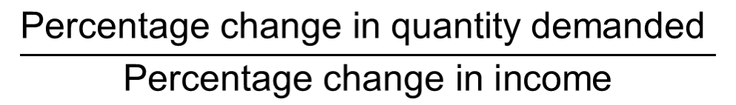

Cross Elasticity of Demand

The cross elasticity of demand is a measure of the responsiveness of demand for a good to a change in the price of a substitute or a complement, other things remaining the same.

The formula for calculating the cross elasticity is:

Percentage change in quantity demanded

Percentage change in price of substitute or complement

More Elasticities of Demand

The cross elasticity of demand for

▪ a substitute is positive.  
▪ a complement is negative.

Elasticity of Supply

The elasticity of supply measures the responsiveness of the quantity supplied to a change in the price of a good, when all other influences on selling plans remain the same.

Calculating the Elasticity of Supply

The elasticity of supply is calculated by using the formula:

Percentage change in quantity supplied

Percentage change in price

Elasticity of Supply

The Factors That Influence the Elasticity of Supply

The elasticity of supply depends on ▪Resource substitution possibilities

▪Time frame for supply decision Resource Substitution Possibilities

The easier it is to substitute among the resources used to produce a good or service, the greater is its elasticity of supply.

Elasticity of Supply

Time Frame for Supply Decision

The more time that passes after a price change, the greater is the elasticity of supply.

Momentary supply is perfectly inelastic. The quantity supplied immediately following a price change is constant.

Short-run supply is somewhat elastic. Long-run supply is the most elastic.

Table 4.1 provides a glossary of all the elasticity measures.

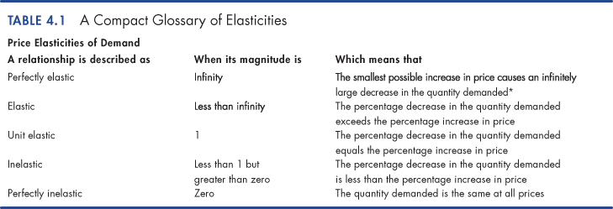

© 2016 Pearson Education, Ltd.

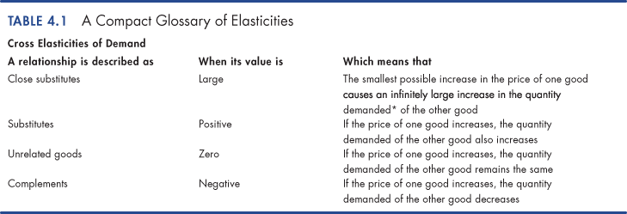

© 2016 Pearson Education, Ltd.

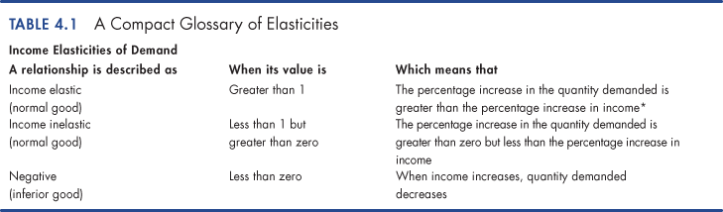

© 2016 Pearson Education, Ltd.

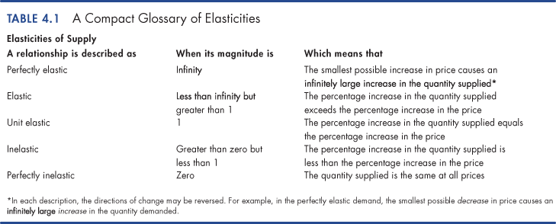

After studying this chapter5, you will be able to:

♦ Describe the alternative methods for allocating scarce resources

* ♦ Explain the connection between demand and marginal benefit and define consumer surplus; and explain the connection between supply and marginal cost and define producer surplus
* ♦ Explain the conditions under which markets are efficient and inefficient
* ♦ Explain the main ideas about fairness and evaluate claims that markets result in unfair outcomes

Resource Allocation Methods

– Scare resources might be allocated by ▪ Market price

▪ Command  
▪ Majority rule  
▪ Contest  
▪ First-come, first-served ▪ Lottery  
▪ Personal characteristics ▪ Force

– How does each method work?

Resource Allocation Methods Market Price

– When a market allocates a scarce resource, the people who get the resource are those who are willing to pay the market price.

– Most of the scarce resources that you supply get allocated by market price.

– You sell your labor services in a market, and you buy most of what you consume in markets.

– For most goods and services, the market turns out to do a good job.

Resource Allocation Methods Command

– Command system allocates resources by the order (command) of someone in authority.

– For example, if you have a job, most likely someone tells you what to do. Your labor time is allocated to specific tasks by command.

– A command system works well in organizations with clear lines of authority but badly in an entire economy.

Resource Allocation Methods Majority Rule

– Majority rule allocates resources in the way the majority of voters choose.

– Societies use majority rule for some of their biggest decisions.

– For example, tax rates that allocate resources between private and public use and tax dollars between competing uses such as defense and health care.

– Majority rule works well when the decision affects lots of people and self-interest must be suppressed to use resources efficiently.

Resource Allocation Methods Contest

– A contest allocates resources to a winner (or group of winners).

– The most obvious contests are sporting events but they occur in other arenas:

– For example, The Oscars are a type of contest.

– A contest works well when the efforts of the “players” are hard to monitor and reward directly.

Resource Allocation Methods First-Come, First-Served

– First-come, first-served allocates resources to those who are first in line.

– Casual restaurants use first-come, first served to allocate tables. Supermarkets also uses first-come, first-served at checkout.

– First-come, first-served works best when scarce resources can serve just one person at a time in a sequence.

Resource Allocation Methods Lottery

– Lotteries allocate resources to those with the winning number, who draw the lucky cards, or who come up lucky on some other gaming system.

– State lotteries and casinos reallocate millions of dollars worth of goods and services each year.

– But lotteries are more widespread. For example, they are used to allocate landing slots at some airports and places in some marathons.

– Lotteries work well when there is no effective way to distinguish among potential users of a scarce resource.

Resource Allocation Methods Personal Characteristics

– Personal characteristics allocate resources to those with the “right” characteristics.

– For example, people choose marriage partners on the basis of personal characteristics.

– But this method gets used in unacceptable ways: allocating the best jobs to white males and discriminating against minorities and women.

Resource Allocation Methods

Force

– Force plays a role in allocating resources.

– For example, war has played an enormous role historically in allocating resources.

– Theft, taking property of others without their consent, also plays a large role.

– But force provides an effective way of allocating resources—for the state to transfer wealth from the rich to the poor and establish the legal framework in which voluntary exchange can take place in markets.

Benefit, Cost, and Surplus

Demand, Willingness to Pay, and Value

– Value is what we get, price is what we pay.

– The value of one more unit of a good or service is its marginal benefit.

– We measure value as the maximum price that a person is willing to pay.

– But willingness to pay determines demand. – A demand curve is a marginal benefit curve.

Benefit, Cost, and Surplus

Individual Demand and Market Demand

The relationship between the price of a good and the quantity demanded by one person is called individual demand.

The relationship between the price of a good and the quantity demanded by all buyers in the market is called market demand.

Benefit, Cost, and Surplus Consumer Surplus

– Consumer surplus is the excess of the benefit received from a good over the amount paid for it.

– We can calculate consumer surplus as the marginal benefit (or value) of a good minus its price, summed over the quantity bought.

– It is measured by the area under the demand curve and above the price paid, up to the quantity bought.

Benefit, Cost, and Surplus

Supply and Marginal Cost

Firms are in business to make a profit.

To make a profit, firms must sell their output for a price that exceeds the cost of production.

Firms distinguish between cost and price.

Benefit, Cost, and Surplus

Supply, Cost, and Minimum Supply-Price

Cost is what the producer gives up, price is what the producer receives.

The cost of one more unit of a good or service is its

marginal cost.  
Marginal cost is the minimum price that a firm is

willing to accept.  
But the minimum supply-price determines supply. A supply curve is a marginal cost curve.

Benefit, Cost, and Surplus

Individual Supply and Market Supply

The relationship between the price of a good and the quantity supplied by one producer is called individual supply.

The relationship between the price of a good and the quantity supplied by all producers in the market is called market supply. 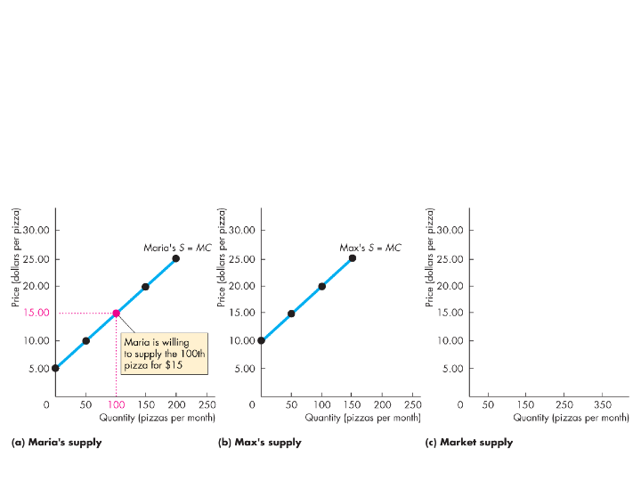

At $15 a pizza, the quantity supplied by Maria is 100 pizzas.

Is the Competitive Market Efficient?

Efficiency of Competitive Equilibrium

Figure 5.5 shows that a competitive market creates an efficient allocation of resources at equilibrium.

In equilibrium, the quantity demanded equals the quantity supplied.

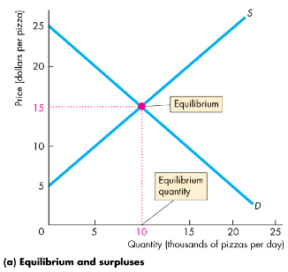

Is the Competitive Market Efficient? When production is ...

▪ less than the equilibrium quantity, MSB > MSC.

▪ greater than the equilibrium quantity, MSC > MSB.

▪ equal to the equilibrium quantity, MSC = MSB.

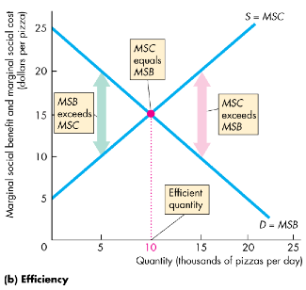

Is the Competitive Market Efficient?

Resources are used efficiently when marginal social benefit equals marginal social cost.

When the efficient quantity is produced, total surplus (the sum of consumer surplus and producer surplus) is maximized.

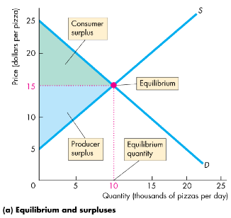

Is the Competitive Market Efficient? The Invisible Hand

– Adam Smith’s “invisible hand” idea in the Wealth of Nations implied that competitive markets send resources to their highest valued use in society.

– Consumers and producers pursue their own self- interest and interact in markets.

– Market transactions generate an efficient—highest valued—use of resources.

Is the Competitive Market Efficient?

Market Failure

– Markets don’t always achieve an efficient outcome.

– Market failure arises when a market delivers an inefficient outcome.

– Market failure can occur because  
▪ Too little of an item is produced (underproduction)

or  
▪ Too much of an item is produced (overproduction).

Is the Competitive Market Efficient?

Underproduction

The efficient quantity is 10,000 pizzas a day.

If production is restricted to 5,000 pizzas a day, there is underproduction and the quantity is inefficient.

A deadweight loss equals the decrease in total surplus—the gray triangle.

This loss is a social loss.

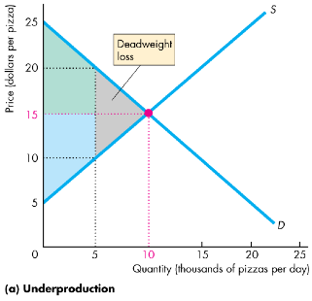

Is the Competitive Market Efficient?

Overproduction

Again, the efficient quantity is 10,000 pizzas a day.

If production is expanded to 15,000 pizzas a day, a deadweight loss arises from overproduction.

This loss is a social loss.

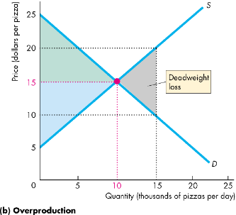

Is the Competitive Market Efficient?

– Sources of Market Failure  
– In competitive markets, underproduction or

overproduction arise when there are ▪Price and quantity regulations

▪Taxes and subsidies  
▪ Externalities  
▪ Public goods and common resources ▪ Monopoly  
▪ High transactions costs

Is the Competitive Market Efficient?

– Price and Quantity Regulations  
– Price regulations sometimes put a block on the price

adjustments and lead to underproduction.

– Quantity regulations that limit the amount that a farm is permitted to produce also lead to underproduction.

Is the Competitive Market Efficient?

– Taxes and Subsidies  
– Taxes increase the prices paid by buyers and lower

the prices received by sellers.

– So taxes decrease the quantity produced and lead to underproduction.

– Subsidies lower the prices paid by buyers and increase the prices received by sellers.

– So subsidies increase the quantity produced and lead to overproduction.

Is the Competitive Market Efficient?

– Externalities  
– An externality is a cost or benefit that affects

someone other than the seller or the buyer of a good.

– An electric utility creates an external cost by burning coal that creates acid rain.

– The utility doesn’t consider this cost when it chooses the quantity of power to produce. Overproduction results.

Is the Competitive Market Efficient? – An apartment owner would provide an external

benefit if she installed an smoke detector.  
– But she doesn’t consider her neighbor’s marginal

benefit and decides not to install a smoke detector. – The result is underproduction.

Is the Competitive Market Efficient?

Efficiency of Competitive Equilibrium

Figure 5.5 shows that a competitive market creates an efficient allocation of resources at equilibrium.

In equilibrium, the quantity demanded equals the quantity supplied.



Is the Competitive Market Efficient? When production is ...

▪ less than the equilibrium quantity, MSB > MSC.

▪ greater than the equilibrium quantity, MSC > MSB.

▪ equal to the equilibrium quantity, MSC = MSB.



Is the Competitive Market Efficient?

Resources are used efficiently when marginal social benefit equals marginal social cost.

When the efficient quantity is produced, total surplus (the sum of consumer surplus and producer surplus) is maximized.



Is the Competitive Market Efficient? The Invisible Hand

– Adam Smith’s “invisible hand” idea in the Wealth of Nations implied that competitive markets send resources to their highest valued use in society.

– Consumers and producers pursue their own self- interest and interact in markets.

– Market transactions generate an efficient—highest valued—use of resources.

Is the Competitive Market Efficient?

Market Failure

– Markets don’t always achieve an efficient outcome.

– Market failure arises when a market delivers an inefficient outcome.

– Market failure can occur because  
▪ Too little of an item is produced (underproduction)

or  
▪ Too much of an item is produced (overproduction).

Is the Competitive Market Efficient?

Underproduction

The efficient quantity is 10,000 pizzas a day.

If production is restricted to 5,000 pizzas a day, there is underproduction and the quantity is inefficient.

A deadweight loss equals the decrease in total surplus—the gray triangle.

This loss is a social loss.



Is the Competitive Market Efficient?

Overproduction

Again, the efficient quantity is 10,000 pizzas a day.

If production is expanded to 15,000 pizzas a day, a deadweight loss arises from overproduction.

This loss is a social loss.



Is the Competitive Market Efficient?

– Sources of Market Failure  
– In competitive markets, underproduction or

overproduction arise when there are ▪Price and quantity regulations

▪Taxes and subsidies  
▪ Externalities  
▪ Public goods and common resources ▪ Monopoly  
▪ High transactions costs

Is the Competitive Market Efficient?

– Price and Quantity Regulations  
– Price regulations sometimes put a block on the price

adjustments and lead to underproduction.

– Quantity regulations that limit the amount that a farm is permitted to produce also lead to underproduction.

Is the Competitive Market Efficient?

– Taxes and Subsidies  
– Taxes increase the prices paid by buyers and lower

the prices received by sellers.

– So taxes decrease the quantity produced and lead to underproduction.

– Subsidies lower the prices paid by buyers and increase the prices received by sellers.

– So subsidies increase the quantity produced and lead to overproduction.

Is the Competitive Market Efficient?

– Externalities  
– An externality is a cost or benefit that affects

someone other than the seller or the buyer of a good.

– An electric utility creates an external cost by burning coal that creates acid rain.

– The utility doesn’t consider this cost when it chooses the quantity of power to produce. Overproduction results.

Is the Competitive Market Efficient? – An apartment owner would provide an external

benefit if she installed an smoke detector.  
– But she doesn’t consider her neighbor’s marginal

benefit and decides not to install a smoke detector. – The result is underproduction.

Is the Competitive Market Efficient?

– Public Goods and Common Resources  
– A public good benefits everyone and no one can be

excluded from its benefits.

– It is in everyone’s self-interest to avoid paying for a public good (called the free-rider problem), which leads to underproduction.

Is the Competitive Market Efficient?

– A common resource is owned by no one but can be used by everyone.

– It is in everyone’s self interest to ignore the costs of their own use of a common resource that fall on others (called tragedy of the commons).

– The tragedy of the commons leads to overproduction.

Is the Competitive Market Efficient?

– Monopoly  
– A monopoly is a firm that is the sole provider of a

good or service.

– The self-interest of a monopoly is to maximize its profit. To do so, a monopoly sets a price to achieve its self-interested goal.

– As a result, a monopoly produces too little and underproduction results.

Is the Competitive Market Efficient?

– High Transactions Costs  
– Transactions costs are the opportunity cost of

making trades in a market.

– To use the market price as the allocator of scarce resources, it must be worth bearing the opportunity cost of establishing a market.

– Some markets are just too costly to operate.

– When transactions costs are high, the market might underproduce.

Is the Competitive Market Efficient? Alternatives to the Market

– When a market is inefficient, can one of the non- market methods of allocation do a better job?

– Often, majority rule might be used.

– But majority rule has its own shortcomings. A group that pursues the self-interest of its members can become the majority.

– Also, with majority rule, votes must be translated into actions by bureaucrats who have their own agendas.

Is the Competitive Market Efficient?

– There is no one efficient mechanism for allocating resources efficiently.

– But supplemented majority rule, bypassed inside firms by command systems, and occasionally using first-come, first-served, markets do an amazingly good job.

Is the Competitive Market Fair?

– Ideas about fairness can be divided into two groups: ▪ It’s not fair if the result isn’t fair.  
▪ It’s not fair if the rules aren’t fair.

Is the Competitive Market Fair? It’s Not Fair if the Result Isn’t Fair

– The idea that only equality brings efficiency is called utilitarianism.

– Utilitarianism is the principle that states that we should strive to achieve “the greatest happiness for the greatest number.”

Is the Competitive Market Fair?

– If everyone gets the same marginal utility from a given amount of income, and

– if the marginal benefit of income decreases as income increases,

– then taking a dollar from a richer person and giving it to a poorer person increases the total benefit.

– Only when income is equally distributed has the greatest happiness been achieved.

Is the Competitive Market Fair?

Figure 5.7 shows how redistribution increases efficiency.

Tom is poor and has a high marginal benefit of income.

Jerry is rich and has a low marginal benefit of income.

Taking dollars from Jerry and giving them to Tom until they have equal incomes increases total benefit.

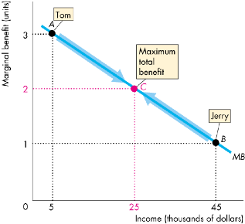

Is the Competitive Market Fair?

– The Big Tradeoff  
– Utilitarianism ignores the cost of making income

transfers.

– Recognizing these costs leads to the big tradeoff between efficiency and fairness.

– Because of the big tradeoff, John Rawls proposed that income should be redistributed to the point at which the poorest person is as well off as possible.

Is the Competitive Market Fair? It’s Not Fair If the Rules Aren’t Fair

– The idea that “it’s not fair if the rules aren’t fair” is based on the symmetry principle.

– The symmetry principle is the requirement that people in similar situations be treated similarly.

Is the Competitive Market Fair? In economics, this principle means equality of

opportunity, not equality of income.  
Robert Nozick suggested that fairness is based on

two rules:

1. The state must create and enforce laws that establish and protect private property.
2. Private property may be transferred from one person to another only by voluntary exchange.

This means that if resources are allocated efficiently, they may also be allocated fairly.

After studying this chapter6, you will be able to:

♦ Explain how rent ceilings create housing shortages ♦ Explain how minimum wage laws create

unemployment

♦ Explain the effects of a tax

♦ Explain the effects of production quotas and subsidies

♦ Explain how markets for illegal goods work

A Housing Market with a Rent Ceiling

– A price ceiling or price cap is a regulation that makes it illegal to charge a price higher than a specified level.

– When a price ceiling is applied to a housing market it is called a rent ceiling.

– If the rent ceiling is set above the equilibrium rent, it has no effect. The market works as if there were no ceiling.

– But a rent ceiling set below the equilibrium rent creates ▪ A housing shortage  
▪ Increased search activity  
▪ A black market