Feature extraction from the high-resolution AggieAir images for leaf water potential and stem water potential estimation in California vineyards
Rui Gao*^{a,b,c}, Alfonso F. Torres-Rua^{a,b}
^{a.}Department of Civil and Environmental Engineering, Utah State University, Old Main Hill, Logan, UT 84322, USA
^{b.}Utah Water Research Laboratory, Utah State University, Logan, UT 84321, USA
^{c.}Department of Civil and Environmental Engineering, University of California, Merced, CA 95340, USA

Abstract: This project aims to use a Python program to generate seventeen features to support the peer-reviewed work, “Integrating sUAS and time-series weather data for leaf and stem water potential assessment via machine learning approach in California vineyards.” Among the seventeen features, six features are extracted directly from the AggieAir images (red-, green-, blue-, near-infrared-band image, digital surface model data, and thermal data), and eleven features are extracted from the vegetation-index image, which is generated based on the spectral images. The feature is generated at a 0.6 m pixel scale. The peer-reviewed work explains the exact algorithm.
“1_Data”, “2_Script”, “3_Results”, and “ReadME.pdf” are folders and documents packaged in this project, and how to use this project is explained below.
Keywords: High-resolution images; sUAS; Vineyards; California; Python

1_Data
“1_Data” contains materials that support running the Python program.
This folder contains three images: (1) “Demo_DSM.tif” is the digital surface model data with 0.15 m resolution in the unit of meter. (2) “Demo_RGBNIR.tif” is the spectral image with red, green, blue, and near-infrared bands at 0.15 m resolution and a value range between 0 and 10,000; and (3) “Demo_TIR.tif” is the thermal image with 0.60 m resolution in the unit of degrees Celsius (Cº).
This folder contains two shapefiles. (1) “Area.shp” is a mask file highlighting the working area. (2) “Points.shp” is a point file, and the distance between each adjacent point is 0.6 m. The coordinates, latitude (Lat) and longitude (Lon), are required to include in this file.

2_Scripts
Two files are saved in this folder.
“Main_HydroShare.ipynb” is the main Python program that tells the main function (called Feature_To_Points) where the materials and call functions from “GR_Functions_Package.py” are located. The meaning of each parameter is explained in the Python program (Fig. 1).
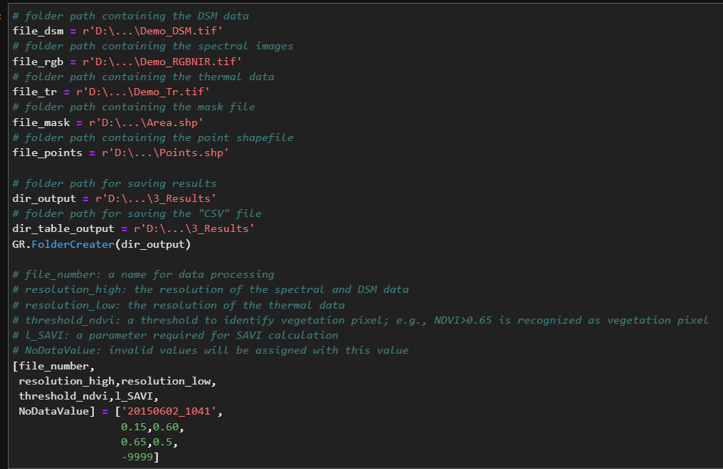
Fig. 1. A screenshot from the main Python program showing the parameters explainations.
“GR_Functions_Package.py” is a function package containing all functions needed by the main Python program.
Results for this project are saved in the “3_Results” folder.

3_Results
Among all the results, the “CSV” file is the final result containing coordinates and the seventeen features. Other images and shapefiles are the intermediate products that can be ignored. “DF20150602_1041.csv” is the final result for this demo project.

Acknowledgment
This study was made possible with financial support from USDA-Agricultural Research Service, E&J Gallo Winery, NASA Applied Sciences Water Resources Grant NNX17AF51G and the Utah Water Research Laboratory Student Fellowship. The authors are also grateful for the extraordinary support from the Utah State University AggieAir sUAS program staff and the E&J Gallo scientific teams for data collection and analysis and the cooperation of the vineyard management staff for logistical support and coordinating field operations with the GRAPEX team. The authors would like to thank Carri Richards for editing the manuscript. Mention of trade names or commercial products in this publication is solely for the purpose of providing specific information and does not imply recommendation or endorsement by the U.S. Department of Agriculture. USDA is an equal opportunity provider and employer.

*Rui.Gao@ usu.edu; ruigao@ucmerced.edu; rui.ray.gao@gmail.com

