Providing Location-privacy in Opportunity Mobile Social Network
by

Rui Huang

A Thesis submitted to the Faculty of Graduate and Postdoctoral Studies
in partial fulfillment of the requirements for the degree of

MASTER OF APPLIED SCIENCE

in Electrical and Computer Engineering

Ottawa-Carleton Institute of Electrical and Computer Engineering
University of Ottawa
Ottawa, Canada

September 3, 2017

© Rui Huang, Ottawa, Canada, 2017

Abstract
Todo

Acknowledgements
Todo

Table of Contents
Abstract i
Acknowledgements ii
Table of Contents iii
List of Figures iv
List of Tables v
Chapter 1 Introduction 1
Chapter 2 Background and Related Work 1
Chapter 3 Multi-Hop Location-Privacy Protection 1
Chapter 4 Appointment Card Protocol 2
4.1. System Model 2
4.2. Appointment Card Protocol Overview 2
4.3. Appointment Card 3
4.4. AC life cycle 6
4.5. Exchange sending process 6
4.5.1. Generate new ACs 7
4.5.2. Pick dispensed ACs 8
4.5.3. Pick ready ACs 8
4.5.4. Send ACs 8
4.5.4.1. Get the number of ACs 9
4.5.4.2. Check duplicated appointment numbers 9
4.6. Exchange receiving process 10
4.7. Sending queries 10
4.8. Transmit replies 11
REFERENCES: 12

List of Figures
Figure 4.1 AC exchange process (send) 9
Figure 4.2 AC exchange process (receive) 10
Figure 4.3 Transmit reply 11

List of Tables
Table 1 Appointment Card 3
Table 2 AC system parameters 4
Table 3 AC states 5
Table 4 friend-encounter list 5
Table 5 query-send list 6
Table 6 coordinate-query-send list 7
Table 5 AC storages 8

Introduction

Background and Related Work

Multi-Hop Location-Privacy Protection

Appointment Card Protocol

System Model
The network architecture consists of two main entities: Users and Location-Based Service Providers (LBSPs). Users are mobile and communicate with others in a certain range, e.g., the communication range of their portable devices. For a user, other ones in the social network are either strangers or his friends whom he can detect when they are in his communication range. Let RS_{i,j} denotes the relationship strength between user i and j, if RS_{i,j} is larger than a specific friend threshold FT_{min}, user i and j (U_{i} and U_{j}) are friends. LBSPs are fixed and not connected in a social network, which provides Location-Based Services (LBSs) for users. We assume that the only information which is necessary for the LBS is the location of the original requester (U₀), but he should still give an identity to the LBSP so that the LBSP can reply to that identity.
Attackers can access the database of LBSPs, so that they can learn everything recorded in LBSPs, including users’ identities and locations. If U₀ sends queries with his own identity and accurate location, his will be located by attackers easily, so the key is to hide his identity and location. We propose Appointment Card Protocol (ACP) to protect the identity and location-privacy of the original requester by providing a fake identity which disenable attackers to locate the original requester with records in the LBSP database.

Appointment Card Protocol Overview
We propose an Appointment Card Protocol (ACP) to protect original requesters when they are served by LBSPs. A user (Agc₁) generates his own Appointment Cards (ACs) containing his identity, a unique Appointment Number (AN) and a location which are be exchanged when he encounters a friend. When U₀ sends a query, he chooses an AC and sends the query with the identity (Agc₁), AN and location in the AC. A LBSP replies to Agc₀ when it receives the query. Since Agc₁ is actually the one who generates the AC, he re-transmits it to the user (Agc₂) whom he exchanged the AC to, and so do the following users until the reply reach U₀.
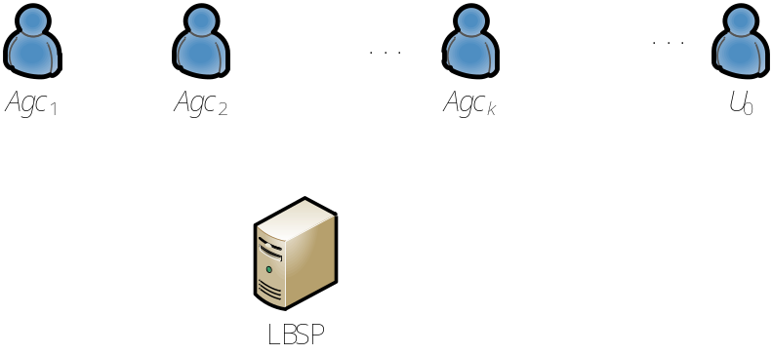
AC
AC
AC
Reply
Query
Reply
Reply
Reply
Figure 4.1 Process example

Appointment Card
Any user in the network can generate his own Appointment Cards (ACs) and he is called the creator of those ACs. The creator should write down his identity (Cid), a unique Creator Appointment Number (Capt) and his current location (Clct) on his AC. Entries of AC are shown in Table 1.
The (ready) AC is an authorization that anyone holds it can send a query to LBSPs using its creator’s identity (Cid) and location (Clct). When LBSPs receives the query, it replies to the creator (Cid) and attaches the Capt in reply, which enable the creator to determine who is the next one to transmit the reply.
Table 1 Appointment Card
entry | explanation
Cid | The identity of the creator who generates the AC.
Capt | A unique number that distinguishes an AC from other ones generated by the same creator.
Clct | The location where the creator generates the AC.
Aid | The identity of an agency who gives the AC to the recent holder. (The previous hop of the AC)
Aapt | A unique number that distinguishes an AC from other ones transmitted by the same agency.
time-out | The time when the AC expires.
EQ | A queue (Exchange Queue) which records users who exchange the AC in order. Its length is EQL.
dc | A counter which is used to distribute ACs of the same creator to various users.
Psd | A pseudonym or a fake identity for the original requester receiving a reply.

To guarantee the security, the distance between the original requester and the AC creator should be far enough, an AC must be exchanged for a specific k (see Error: Reference source not found) times before it can be used for a requester to send a query. The value of k should neither be too small nor too large. If k is small, e.g. k = 1, attackers can infer the original requester from the records of his friends in the database easily. If k is large, replies from LBSPs can hardly reach the original requester, because replies must go through all users in their EQs.
Both Capt and Aapt are appointment numbers, which are unique random integers. When we mention “unique”, it means that there are not an identical (same value and type) existing appointment number generated by the same user in the network. Existing means that the CA which is relevant to the appointment number does not expires. For example, if a user (U_{i}) generates a Aapt “123456” and it does not expire, he cannot generate another Aapt “123456”, but a Capt “123456” is acceptable. He may also generate another Aapt “123456” after the previous one expires. It would not prevent another user (U_{j}, j≠i) generating an Aapt “123456” no matter whether U_{i} generates one or not.
Table 2 AC system parameters
Parameters | explanation
k | The minimum length of the exchange record for an AC eligible to be used in a query.
Seg | 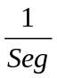 dispensed ACs are exchanged when two friends encounter each other.
DN | The minimum number of ACs that a user hands out in anytime.
SU | The time unit
The parameter k and the EQL also divides ACs into 2 states: dispensed and ready (see Table 3Error: Reference source not found). Ready ACs can be used when their holder sends a query. Users still exchange ready ACs among their friends, but they do not add themselves in ACs’ EQ any more. Dispensed ones are not qualified to be used by current holder. Therefore, in order to make an AC useful, it should be exchanged for k times as fast as possible.
Table 3 AC states
State | Explanation
Dispensed | EQL < k
Ready | EQL = k
In order to manage ACs, each user maintains two lists: the dispense-list and the ready-list. It is obviously that dispense-list contains dispensed ACs and ready-list contains ready ones.
Table 4 AC storages
List Name | Explanation
ready-list | It contains ready ACs.
dispense-list | It contains dispensed ACs.
To avoid ACs generated by a creator simultaneously being dispensed to the same k^{th} user, we employ the parameter Seg and dc. The dc is a counter which is initialized to a random integer in the interval [1, Seg] when a user received an AC. The AC should not be sent to the next friend until dc reaches 0, which enable users to split these ACs into about Seg batches.

AC life cycle
The life cycle of an AC starts when it is generated by its creator. The creator initializes the Cid, Capt and Capt when he generates it. These three entries remain constant in the whole life cycle. In the first k exchanges, the user who is sending it modify its entries Aid to his own identity. The Aapt is also replaced by a new appointment number generated by him. he adds his identity in its EQ before sending it out. When the AC’s ER length reaches k, it is eligible to be used in a query and called a ready AC. A ready AC can be exchanged to other friends either, but senders never modify previous entries, i.e., Aid, Aapt and EQ. Each of ACs can be used for no more than one time. In another word, an AC expires, when reaching its time-out or it is used in a query.
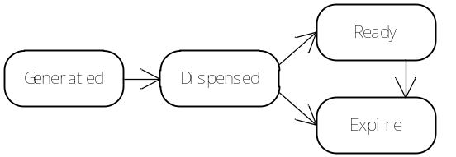
Figure 4.2 AC's life cycle
As shown in the Figure 4.2, an AC starts at a generated state. When it leaves the creator, it switches to a dispensed state. If the length of its ER reaches k, it changes to the ready state. It can be time-out in either the dispensed state or the ready state. If the holder uses it in any queries, it expires, too.

Exchange sending process
Each AC is unique and hold by only one user at one time. When a user exchanges an AC to a friend, he loses the control of that AC and cannot give it to another one. We discuss the process that users exchange ACs with their friends. The process that a user (U_{i}) exchanges ACs to his friend is shown in Figure 4.3 AC exchange process (send). When U_{i} encounters a friend (U_{j}), he would send 3 kinds of ACs to the friend, which include dispensed ACs, ready ACs and new ACs. Even though new ACs must be dispensed ACs, we discuss them separately. During the exchange process, U_{i} generates the specified number of ACs and selects a part of dispensed ACs and ready ACs, then he sends them to his friend. He also remembers whom he sends them to, which enables him to transmit replies to the friend.
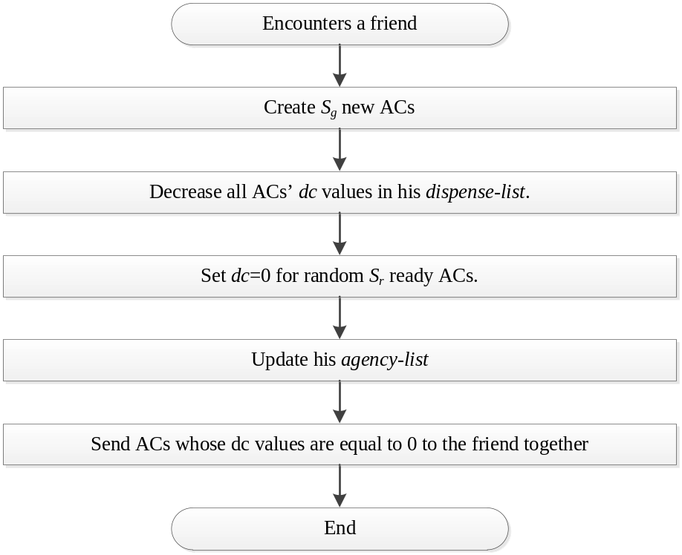
Figure 4.3 AC exchange process (send)

Generate new ACs
Each user (U_{i}) has an obligation to generate proper number of ACs for their friends, so that he guarantees that the number of ACs created by him in the network is larger than DN after he exchanges ACs with a friend (U_{j}). We assume that he must give U_{j} S_{g} new ACs to achieve that goal. U_{i} initializes entries for his new ACs, i.e., Cid (his identity), Capt (a new appointment number), Clct (his current location), Aid (A default value Aid_{default}), Aapt (The same value as the Cid), time-out. The EQ in a new AC is initialized to empty, and dc is 0. We assume that the number of U_{i}’s ACs that are remained in the network is equal to RN_{i}. The method of determining RN_{i} is discussed in . Then 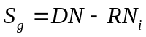.

Pick dispensed ACs
U_{i} decreases dcs of all his dispensed ACs, so that he gets S_{d} ACs whose dc values are equal to zero. They should be sent to his friend. Since the parameter dc is initialed as an integer between 1 and Seg randomly, there are about 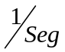 dispensed ACs eligible to be sent to the friend. That enables us to separate ACs which come from a common creator.

Pick ready ACs
There are two ways for a user to provide ready ACs: 1. give his own ready ACs to friends directly; 2. dispensed ACs whose EQL values are equal to k-1. Since ready ACs are precious for every user, the strategy that a user shares ready ACs with his friends should save his own ready ACs. the number of ready ACs which would be sent to the friend is
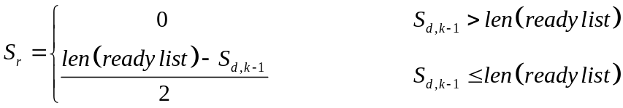
, where S_{d,k-1} denotes the number of dispensed ACs whose EQL values are equal to k-1. We assume that U_{j} has no ACs at all when they encounter. After their exchange, if U_{j} has more ready ACs than U_{i}, U_{i} must have all his old ready ACs with him; if U_{i} loses some of his ready ACs, U_{j} does not have more ready ACs than U_{i}. In another word, U_{i} should do his best to help his friend U_{j}, but U_{i} is not in a dilemma worse than his friends. That strategy makes users who sends more queries than friends supplement their AC consumption quickly, while protecting their friends’ profits. Then U_{i} picks S_{r} ready ACs randomly and sets their dcs to 0.

Send ACs
An AC should be sent to U_{j}, if and only if its dc is equal to 0. Before it is sent to U_{j}, U_{i} adds its identity to the its EQ. Besides, U_{i} replaces its Aid and Aapt with his own identity and a new appointment number. The old Aid is recorded in his agency-list, so do both old and new Aapts. The structure of the agency-list is shown in Table 5. When the AC comes from his dispense-list, he checks its EQL. If it is equal to k and the last entry of EQ is himself, he generates a unique pseudonym for the AC (Psd) and records the pseudonym in the agency-list (Nxt). Otherwise, he records the identity of his friend in Nxt. Since items which is relevant to an expired ACs would be deleted, each item in the agency-list is related to a distinct existing AC. Information in it can be used for statistics showing in the following sections.
Table 5 Agency_list entries
List Name | Explanation
Aid_{old} | The previous agency identity.
Aapt_{old} | The previous agency appointment number
Aapt_{new} | The current agency appointment number
Nxt | The identity of the next friend.
time-out | The time when the AC expires

Get the number of ACs
U_{i} can get the number of existing ACs which is generated by him based on the information in his agency-list. He counts the items in the list whose Aid_{old} value is equal to Aid_{default}, that is the RN_{i}.

Check duplicated appointment numbers
All existing appointment numbers generated by a user are recorded in his agency-list. If Aid_{old} value is equal to Aid_{default}, the Aapt_{old} is a Capt; Otherwise, the Aapt_{new} is a Aapt. When the user generates a new appointment number, he must check the agency-list to guarantee it is unique.

Exchange receiving process
The process that U_{i} receives ACs from his friend is shown in Figure 4.4 AC exchange process (receive). ACs are divided into two groups based on their EQL values, which are dispensed ACs and ready ACs. The dc value of a dispensed AC is assigned to a random integer in the interval [1, Seg], then the AC is moved into his dispense-list. Ready ACs are moved into his ready-list, and their dc values are set to -1.
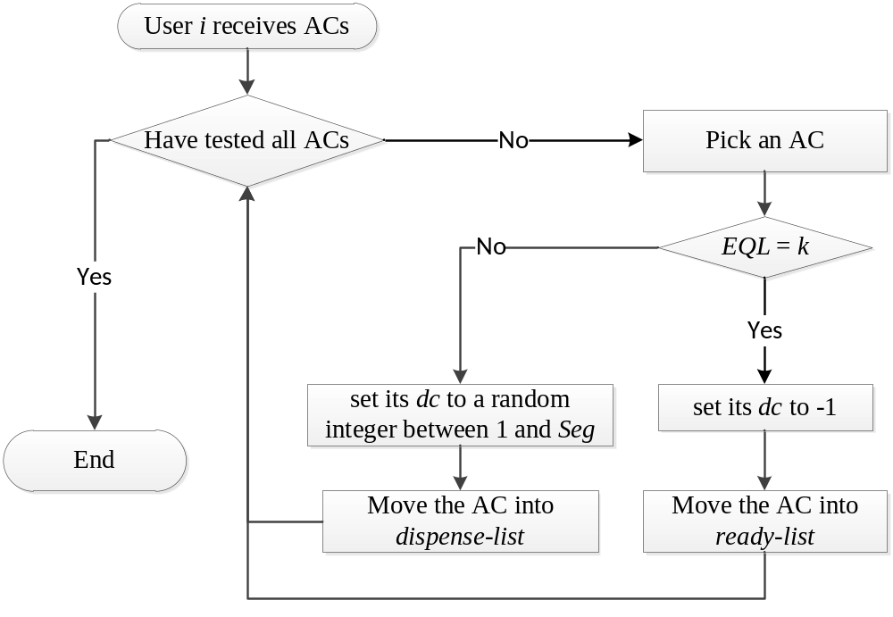
Figure 4.4 AC exchange process (receive)

Sending queries
When a user wants to send a query, he picks an AC from his ready-list. He gives preference to the AC that has the earliest time-out. As a result, he sorts ACs in the ready-list in ascending order based on their remaining time and selects the first AC (e.g. ac) to send his query. That means the query is sent under the name of ac’s creator (i.e., Cid), and the location of the query is also ac’ location (i.e., Clct). Besides, ac’ Capt is also included in the query. The query can be transmitted to LBSPs by an arbitrary DTN routing protocol (e.g., Spray and Wait). When a LBSP receives the query, it provides services based on ac’s location and reply to ac’s creator (ac’s Cid). Users can also use a general DTN routing protocol to deliver the reply.

Transmit replies
When a user receives a reply, he checks his agency_list. If the sender identity is the LBSP, he searches for a record in his agency_list, whose Aid_{old} is Aid_{default} and Aapt_{old} is equal to the Aapt in the reply. If the sender identity is a user, he looks up for an item whose Aid_{old} is equal to the sender identity and Aapt_{old} is equal to the Aapt in the reply.
Based on the record he finds, he modifies information in the reply. The sender identity is set to his own identity; the destination is set to the user whose identity is Nxt; Aapt is assigned to Aapt_{new}. The item related to that AC can be deleted after the replacement, then he replies to the next friend (Aid_{new}).
After the original requester sends the query out, he claims himself as the one whose identity is Psd. That identity is equal to the Nxt in the k^{th} user’s agency_list. As a result, nobody knows the identity of the original requester. The process is shown in Figure 4.5.
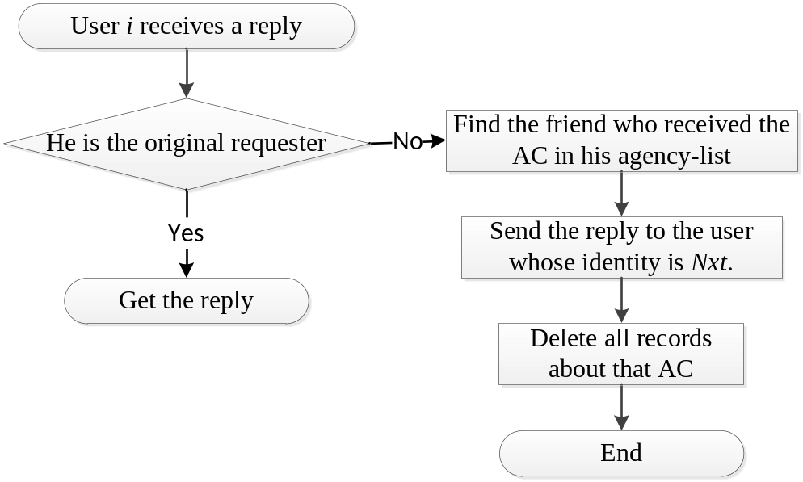
Figure 4.5 Transmit reply

Example
We assume there are four users in our social network: Alice, Bob, Charlie and David and there are 3 pairs of friends (i.e. Alice and Bob, Bob and Charlie, Charlie and David) in our example. We assign the system parameter k to 3, so that each Appointment Card must be exchanged for three times before it can be used. The system parameter DN is equal to 100, so that each user guarantees there are more than 100 ACs generated by him in the network.
When Alice encounters Bob, both of them generate 100 new ACs and give all the new ACs to the other one. Table 6 shows the number of ACs hold by Alice and Bob after the exchange where AC_{Alice,1} denotes the ACs generated by Alice and with EQL equal to 1.
Table 6 Alice and Bob exchange ACs
Users | Alice | Bob
Dispensed ACs | 100 AC_{Bob, 1} | 100 AC_{Alice, 1}

Then Bob encounters a friend Charlie who is a new user. Since Bob has already generated 100 ACs and none of them are used, he generates no AC for Charlie. But, Bob should give half of his dispensed ACs to Charlie while Charlie generates 100 new ACs and give them all to Bob.
Table 7 Bob and Charlie exchange ACs
Users | Bob | Charlie
Dispensed ACs | 100 AC_{Charlie, 1}  50 AC_{Alice, 1} | 50 AC_{Alice, 2}

When Charlie encounters David, Charlie gets 100 new ACs from David. David get 25 ACs which are generated by Alice from Charlie. The 25 ready-ACs hold by David can also be exchanged to other users, as shown in Table 8.
Table 8 Charlie and David exchange ACs
Users | Charlie | David
Dispensed ACs | 100 AC_{David, 1}  25 AC_{Alice, 2}
Ready ACs |  | 25 AC_{Alice, 3}

The route of one of the ready ACs (for example, the AC_{Alice, 3}) after it is received by David is shown as follow. For convenience, we donate it by AC_{x}. David gives a pseudonym (Say p) to AC_{x} before he exchanges it to another user. We assume that David gives it to Elizabeth and Elizabeth gives it to Franklin, and Franklin would use the AC_{x} to send the query. Franklin sends the query pretending he is Alice and receives the reply pretending he is p. More specifically, in the replying phase, LBSP replies to Alice and then the reply would be transmitted by Bob, Charlie and received by David. After that, David broadcast the reply to p, other users would ignore that reply while Franklin realized it is the reply of his query since he uses the AC with pseudonym p.
Table 9 The exchange history of AC_{x}
User name | Cid | Capt | Aid | Aapt | Pseudonym
Alice | Alice | 233 | Alice | 557 | --
Bob | Alice | 233 | Bob | 743 | --
Charlie | Alice | 233 | Charlie | 691 | --
David | Alice | 233 | David | 283 | p
Elizabeth | Alice | 233 | David | 283 | p
Franklin | Alice | 233 | -- | -- | --
When Franklin wants to send a query to a LBSP, he uses Alice’s identity and attaches the Capt (i.e. 233) in the query. Then he uses the pseudonym p as his identity when he receives a reply.
The LBSP replies to Alice, and the Capt (i.e. 233) is included in the message. When Alice receives the message, she checks her agency_list and finds the entry whose Aid_{old} is equal to Aid_{default} and Aapt_{old} is equal to 233. Based on the entry, she attaches the Aapt_{new} (i.e. 557) in the reply and sends it to Nxt (i.e. Bob). We collect entries which are related to the AC_{x} in Table 10. Then Alice remove the item from her agency_list. Also, the number of ACs generated by her decreases to 99 (=100-1), so that she should generate a new AC when she encounters a friend.
When Bob receives the reply from Alice, he also checks his agency_list and learns that the reply is related to the AC_{x} based on the sender identity (i.e. Alice) and the Aapt (i.e. 557). He modifies the Aapt to 743 in the reply message and relays it to Charlie. Charlie also follows the same process. Different from the previous 3 friends, David relays the message to a pseudonym p, because the Nxt value is equal to p in his agency_list. Since Franklin is using the pseudonym p as his identity, he can get the reply message at last.
Table 10 Users' agency_list
User Identity | Aid_{old} | Aapt_{old} | Aapt_{new} | Nxt
Alice | Aid_{default} (LBSP) | 233 | 557 | Bob
Bob | Alice | 557 | 743 | Charlie
Charlie | Bob | 743 | 691 | David
David | Charlie | 691 | 283 | p
Table 11 Important information in the reply messages
Transmit | Sender | Receiver | Aapt
LBSP → Alice | LBSP | Alice | 233
Alice → Bob | Alice | Bob | 557
Bob → Charlie | Bob | Charlie | 743
Charlie → David | Charlie | David | 691
David → p | David | p | 283
In a nutshell, the Aapt in the reply is the key for each user (friend) to relay the reply message to the next one. After a user relays the reply message to the next one, he removes the entry from his agency_list.

REFERENCES:
- A. Lastname1, B. Lastname2, C. Lastname3 and D. Lastname4, “Article name,” in Publication name, vol. 13, issue 2, pp. 223–244, 2017.

