Meeting 5

Rui Li

11/24/2020

# Require packages

# Cleaning Data

# Data Summary

# Ploting data

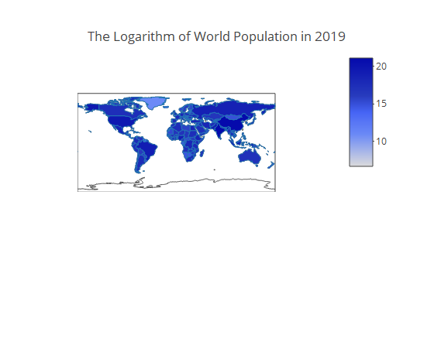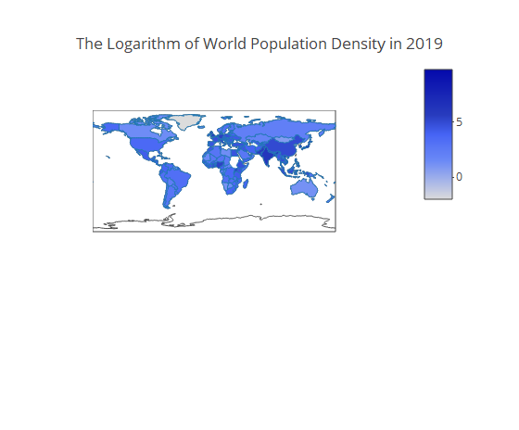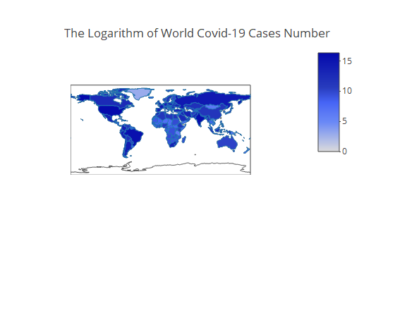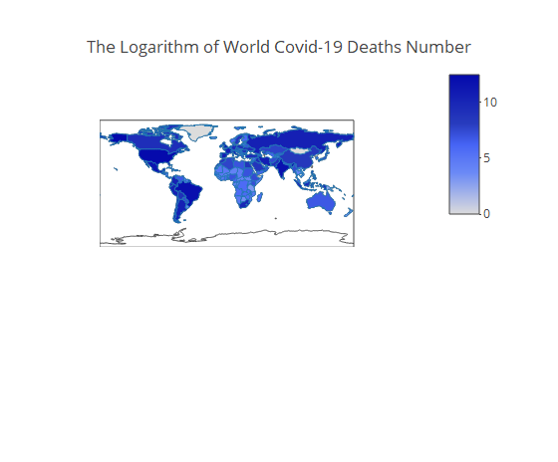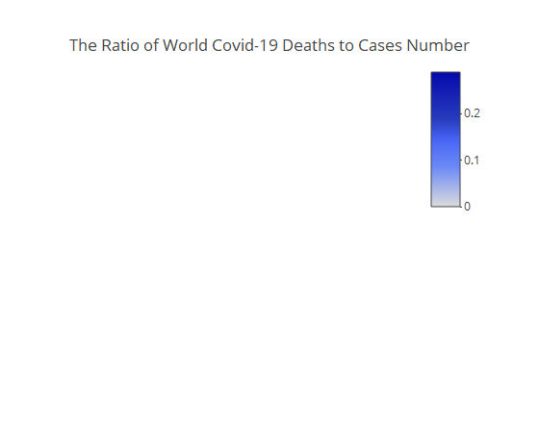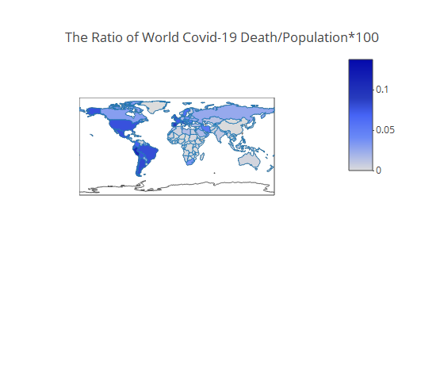

#Modeling

##   
## Call:  
## lm(formula = cases ~ `CASE-1` + `CASE-2` + `CASE-3` + `CASE-4` +   
## `CASE-5` + `CASE-6` + `CASE-7` + `CASE-8` + `CASE-9` + `CASE-10` +   
## `CASE-11` + `CASE-12` + `CASE-13` + `CASE-14`, data = na.omit(data1))  
##   
## Residuals:  
## Min 1Q Median 3Q Max   
## -42444 -14 -5 4 53882   
##   
## Coefficients:  
## Estimate Std. Error t value Pr(>|t|)   
## (Intercept) 5.111539 3.633207 1.407 0.159464   
## `CASE-1` 0.407385 0.004162 97.878 < 2e-16 ***  
## `CASE-2` 0.122695 0.004480 27.389 < 2e-16 ***  
## `CASE-3` 0.143201 0.004448 32.197 < 2e-16 ***  
## `CASE-4` 0.157681 0.004427 35.617 < 2e-16 ***  
## `CASE-5` 0.084409 0.004423 19.086 < 2e-16 ***  
## `CASE-6` 0.137262 0.004328 31.714 < 2e-16 ***  
## `CASE-7` 0.455788 0.004224 107.909 < 2e-16 ***  
## `CASE-8` -0.176051 0.004177 -42.145 < 2e-16 ***  
## `CASE-9` -0.152075 0.004182 -36.364 < 2e-16 ***  
## `CASE-10` -0.109508 0.004185 -26.168 < 2e-16 ***  
## `CASE-11` -0.132647 0.004138 -32.058 < 2e-16 ***  
## `CASE-12` -0.121954 0.004088 -29.833 < 2e-16 ***  
## `CASE-13` -0.015700 0.004076 -3.852 0.000117 ***  
## `CASE-14` 0.175783 0.003772 46.603 < 2e-16 ***  
## ---  
## Signif. codes: 0 '***' 0.001 '**' 0.01 '*' 0.05 '.' 0.1 ' ' 1  
##   
## Residual standard error: 834.5 on 54554 degrees of freedom  
## Multiple R-squared: 0.9743, Adjusted R-squared: 0.9743   
## F-statistic: 1.478e+05 on 14 and 54554 DF, p-value: < 2.2e-16

##   
## Call:  
## lm(formula = cases ~ `DEATH-1` + `DEATH-2` + `DEATH-3` + `DEATH-4` +   
## `DEATH-5` + `DEATH-6` + `DEATH-7` + `DEATH-8` + `DEATH-10` +   
## `DEATH-11` + `DEATH-12` + `DEATH-13` + `DEATH-14`, data = na.omit(data2))  
##   
## Residuals:  
## Min 1Q Median 3Q Max   
## -54653 -70 -66 -37 93780   
##   
## Coefficients:  
## Estimate Std. Error t value Pr(>|t|)   
## (Intercept) 65.6730 14.1060 4.656 3.24e-06 ***  
## `DEATH-1` 3.9189 0.2587 15.148 < 2e-16 ***  
## `DEATH-2` 2.2434 0.2601 8.625 < 2e-16 ***  
## `DEATH-3` 0.5225 0.2643 1.977 0.048022 *   
## `DEATH-4` 1.9138 0.2662 7.190 6.59e-13 ***  
## `DEATH-5` 2.0432 0.2667 7.661 1.88e-14 ***  
## `DEATH-6` 2.2619 0.2656 8.518 < 2e-16 ***  
## `DEATH-7` 3.8777 0.2686 14.435 < 2e-16 ***  
## `DEATH-8` 1.7515 0.2649 6.612 3.82e-11 ***  
## `DEATH-10` 0.9885 0.2600 3.802 0.000144 ***  
## `DEATH-11` 2.5192 0.2609 9.654 < 2e-16 ***  
## `DEATH-12` 2.8053 0.2614 10.731 < 2e-16 ***  
## `DEATH-13` 4.3647 0.2593 16.830 < 2e-16 ***  
## `DEATH-14` 6.0699 0.2535 23.947 < 2e-16 ***  
## ---  
## Signif. codes: 0 '***' 0.001 '**' 0.01 '*' 0.05 '.' 0.1 ' ' 1  
##   
## Residual standard error: 3222 on 54555 degrees of freedom  
## Multiple R-squared: 0.6169, Adjusted R-squared: 0.6168   
## F-statistic: 6757 on 13 and 54555 DF, p-value: < 2.2e-16

##   
## Call:  
## lm(formula = cases ~ `CASE-1` + `CASE-2` + `CASE-3` + `CASE-4` +   
## `CASE-5` + `CASE-6` + `CASE-7` + `CASE-8` + `CASE-9` + `CASE-10` +   
## `CASE-11` + `CASE-12` + `CASE-13` + `CASE-14` + `DEATH-1` +   
## `DEATH-2` + `DEATH-4` + `DEATH-5` + `DEATH-6` + `DEATH-7` +   
## `DEATH-9` + `DEATH-10` + `DEATH-12` + `DEATH-13` + `DEATH-14`,   
## data = na.omit(data3))  
##   
## Residuals:  
## Min 1Q Median 3Q Max   
## -41043 -9 1 9 53947   
##   
## Coefficients:  
## Estimate Std. Error t value Pr(>|t|)   
## (Intercept) -0.671802 3.631182 -0.185 0.85322   
## `CASE-1` 0.399744 0.004221 94.707 < 2e-16 ***  
## `CASE-2` 0.117546 0.004515 26.036 < 2e-16 ***  
## `CASE-3` 0.142202 0.004432 32.085 < 2e-16 ***  
## `CASE-4` 0.155220 0.004475 34.689 < 2e-16 ***  
## `CASE-5` 0.077328 0.004473 17.287 < 2e-16 ***  
## `CASE-6` 0.126897 0.004394 28.882 < 2e-16 ***  
## `CASE-7` 0.448283 0.004268 105.024 < 2e-16 ***  
## `CASE-8` -0.173202 0.004172 -41.516 < 2e-16 ***  
## `CASE-9` -0.140962 0.004243 -33.220 < 2e-16 ***  
## `CASE-10` -0.103582 0.004241 -24.426 < 2e-16 ***  
## `CASE-11` -0.127131 0.004132 -30.765 < 2e-16 ***  
## `CASE-12` -0.117324 0.004133 -28.388 < 2e-16 ***  
## `CASE-13` -0.018707 0.004123 -4.537 5.71e-06 ***  
## `CASE-14` 0.175697 0.003818 46.015 < 2e-16 ***  
## `DEATH-1` -0.108730 0.067223 -1.617 0.10579   
## `DEATH-2` 0.322153 0.068549 4.700 2.61e-06 ***  
## `DEATH-4` 0.152686 0.067921 2.248 0.02458 *   
## `DEATH-5` 0.581602 0.069561 8.361 < 2e-16 ***  
## `DEATH-6` 0.782904 0.070313 11.135 < 2e-16 ***  
## `DEATH-7` 0.636819 0.070498 9.033 < 2e-16 ***  
## `DEATH-9` -0.679943 0.068675 -9.901 < 2e-16 ***  
## `DEATH-10` -0.123822 0.067689 -1.829 0.06736 .   
## `DEATH-12` -0.434272 0.068444 -6.345 2.24e-10 ***  
## `DEATH-13` -0.116116 0.068496 -1.695 0.09004 .   
## `DEATH-14` -0.195638 0.066319 -2.950 0.00318 **   
## ---  
## Signif. codes: 0 '***' 0.001 '**' 0.01 '*' 0.05 '.' 0.1 ' ' 1  
##   
## Residual standard error: 829 on 54543 degrees of freedom  
## Multiple R-squared: 0.9746, Adjusted R-squared: 0.9746   
## F-statistic: 8.388e+04 on 25 and 54543 DF, p-value: < 2.2e-16