Table 3.1: Linear Regression Results of Models 1 & 2 & 3

|  |  |  |  |
| --- | --- | --- | --- |
|  | Dependent variable: | | |
|  |
|  | Cdiff(0) | | |
|  | (Model 1) | (Model 2) | (Model 3) |
|  | | | |
| Cdiff(7) | 0.486*** | 0.462*** | 0.461*** |
|  | (0.005) | (0.005) | (0.005) |
|  |  |  |  |
| Cdiff(14) | 0.114*** | 0.110*** | 0.110*** |
|  | (0.003) | (0.004) | (0.004) |
|  |  |  |  |
| Cdiff(1) | -0.544*** | -0.551*** | -0.552*** |
|  | (0.004) | (0.004) | (0.004) |
|  |  |  |  |
| Cdiff(8) | 0.359*** | 0.337*** | 0.336*** |
|  | (0.005) | (0.005) | (0.005) |
|  |  |  |  |
| Cdiff(2) | -0.435*** | -0.444*** | -0.445*** |
|  | (0.005) | (0.005) | (0.005) |
|  |  |  |  |
| Cdiff(9) | 0.222*** | 0.211*** | 0.210*** |
|  | (0.004) | (0.004) | (0.004) |
|  |  |  |  |
| Cdiff(6) | 0.073*** | 0.055*** | 0.054*** |
|  | (0.005) | (0.005) | (0.005) |
|  |  |  |  |
| Cdiff(3) | -0.276*** | -0.282*** | -0.283*** |
|  | (0.005) | (0.005) | (0.005) |
|  |  |  |  |
| Cdiff(10) | 0.111*** | 0.107*** | 0.107*** |
|  | (0.004) | (0.004) | (0.004) |
|  |  |  |  |
| Cdiff(12) | -0.110*** | -0.109*** | -0.109*** |
|  | (0.003) | (0.004) | (0.004) |
|  |  |  |  |
| Cdiff(13) | -0.111*** | -0.114*** | -0.114*** |
|  | (0.004) | (0.004) | (0.004) |
|  |  |  |  |
| Cdiff(4) | -0.140*** | -0.145*** | -0.146*** |
|  | (0.004) | (0.004) | (0.004) |
|  |  |  |  |
| Cdiff(5) | -0.071*** | -0.081*** | -0.082*** |
|  | (0.005) | (0.005) | (0.005) |
|  |  |  |  |
| Ddiff(8) |  | 2.100*** | 2.098*** |
|  |  | (0.110) | (0.110) |
|  |  |  |  |
| Ddiff(7) |  | 1.908*** | 1.907*** |
|  |  | (0.101) | (0.101) |
|  |  |  |  |
| Ddiff(6) |  | 1.313*** | 1.312*** |
|  |  | (0.090) | (0.090) |
|  |  |  |  |
| Ddiff(5) |  | 0.672*** | 0.671*** |
|  |  | (0.070) | (0.070) |
|  |  |  |  |
| Ddiff(9) |  | 1.565*** | 1.563*** |
|  |  | (0.114) | (0.114) |
|  |  |  |  |
| Ddiff(10) |  | 1.401*** | 1.399*** |
|  |  | (0.112) | (0.112) |
|  |  |  |  |
| Ddiff(11) |  | 1.389*** | 1.386*** |
|  |  | (0.107) | (0.107) |
|  |  |  |  |
| Ddiff(12) |  | 1.048*** | 1.047*** |
|  |  | (0.100) | (0.100) |
|  |  |  |  |
| Ddiff(13) |  | 0.900*** | 0.899*** |
|  |  | (0.089) | (0.089) |
|  |  |  |  |
| Ddiff(14) |  | 0.569*** | 0.569*** |
|  |  | (0.070) | (0.070) |
|  |  |  |  |
| P |  |  | 0.00000*** |
|  |  |  | (0.00000) |
|  |  |  |  |
| Ddiff(2) |  | 0.282*** | 0.282*** |
|  |  | (0.063) | (0.063) |
|  |  |  |  |
| Ddiff(1) |  | 0.182*** | 0.181*** |
|  |  | (0.063) | (0.063) |
|  |  |  |  |
| Constant | 14.180*** | 13.018*** | 9.417** |
|  | (3.778) | (3.761) | (3.892) |
|  |  |  |  |
|  | | | |
| Observations | 52,962 | 52,962 | 52,962 |
| R2 | 0.585 | 0.589 | 0.589 |
| Adjusted R2 | 0.584 | 0.588 | 0.589 |
| Residual Std. Error | 867.294 (df = 52948) | 863.136 (df = 52936) | 863.040 (df = 52935) |
| F Statistic | 5,731.463*** (df = 13; 52948) | 3,030.079*** (df = 25; 52936) | 2,914.683*** (df = 26; 52935) |
|  | | | |
| Note: *p<0.1; **p<0.05; ***p<0.01 | | | |

Table 3.4: Linear Regression Results of Models 3 & 4

|  |  |  |
| --- | --- | --- |
|  | Dependent variable: | |
|  |
|  | Cdiff(0) | |
|  | (Model 3) | (Model 4) |
|  | | |
| Cdiff(7) | 0.461*** | 0.462*** |
|  | (0.005) | (0.005) |
|  |  |  |
| Cdiff(14) | 0.110*** | 0.110*** |
|  | (0.004) | (0.004) |
|  |  |  |
| Cdiff(1) | -0.552*** | -0.551*** |
|  | (0.004) | (0.004) |
|  |  |  |
| Cdiff(8) | 0.336*** | 0.337*** |
|  | (0.005) | (0.005) |
|  |  |  |
| Cdiff(2) | -0.445*** | -0.444*** |
|  | (0.005) | (0.005) |
|  |  |  |
| Cdiff(9) | 0.210*** | 0.211*** |
|  | (0.004) | (0.004) |
|  |  |  |
| Cdiff(6) | 0.054*** | 0.055*** |
|  | (0.005) | (0.005) |
|  |  |  |
| Cdiff(3) | -0.283*** | -0.282*** |
|  | (0.005) | (0.005) |
|  |  |  |
| Cdiff(10) | 0.107*** | 0.107*** |
|  | (0.004) | (0.004) |
|  |  |  |
| Cdiff(12) | -0.109*** | -0.109*** |
|  | (0.004) | (0.004) |
|  |  |  |
| Cdiff(13) | -0.114*** | -0.114*** |
|  | (0.004) | (0.004) |
|  |  |  |
| Cdiff(4) | -0.146*** | -0.145*** |
|  | (0.004) | (0.004) |
|  |  |  |
| Cdiff(5) | -0.082*** | -0.081*** |
|  | (0.005) | (0.005) |
|  |  |  |
| Cdiff(8) | 2.098*** | 2.100*** |
|  | (0.110) | (0.110) |
|  |  |  |
| Cdiff(7) | 1.907*** | 1.908*** |
|  | (0.101) | (0.101) |
|  |  |  |
| Cdiff(6) | 1.312*** | 1.313*** |
|  | (0.090) | (0.090) |
|  |  |  |
| Cdiff(5) | 0.671*** | 0.672*** |
|  | (0.070) | (0.070) |
|  |  |  |
| Cdiff(9) | 1.563*** | 1.565*** |
|  | (0.114) | (0.114) |
|  |  |  |
| Cdiff(10) | 1.399*** | 1.401*** |
|  | (0.112) | (0.112) |
|  |  |  |
| Cdiff(11) | 1.386*** | 1.389*** |
|  | (0.107) | (0.107) |
|  |  |  |
| Cdiff(12) | 1.047*** | 1.048*** |
|  | (0.100) | (0.100) |
|  |  |  |
| Cdiff(13) | 0.899*** | 0.900*** |
|  | (0.089) | (0.089) |
|  |  |  |
| Cdiff(14) | 0.569*** | 0.569*** |
|  | (0.070) | (0.070) |
|  |  |  |
| P | 0.00000*** |  |
|  | (0.00000) |  |
|  |  |  |
| Cdiff(2) | 0.282*** | 0.282*** |
|  | (0.063) | (0.063) |
|  |  |  |
| Cdiff(1) | 0.181*** | 0.182*** |
|  | (0.063) | (0.063) |
|  |  |  |
| Constant | 9.417** | 13.018*** |
|  | (3.892) | (3.761) |
|  |  |  |
|  | | |
| Observations | 52,962 | 52,962 |
| R2 | 0.589 | 0.589 |
| Adjusted R2 | 0.589 | 0.588 |
| Residual Std. Error | 863.040 (df = 52935) | 863.136 (df = 52936) |
| F Statistic | 2,914.683*** (df = 26; 52935) | 3,030.079*** (df = 25; 52936) |
|  | | |
| Note: *p<0.1; **p<0.05; ***p<0.01 | | |

Figure 3.1 Diagnostic Test Results

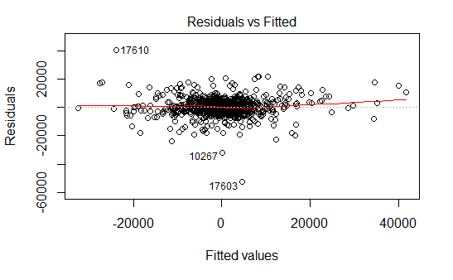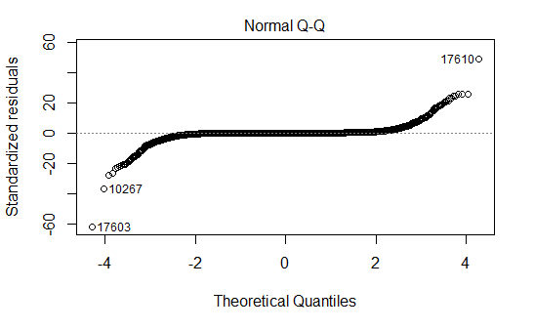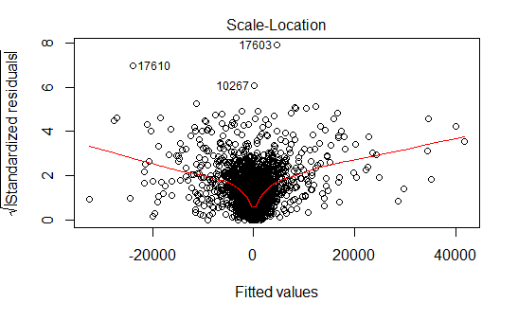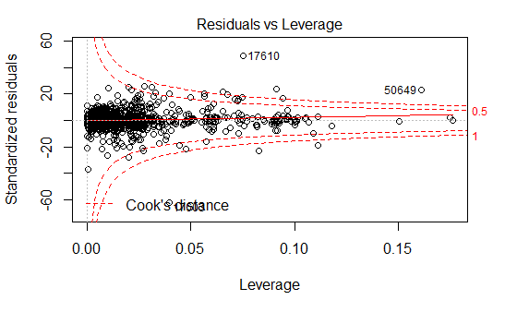

Figure 1.1 The Logarithm of World Covid-19 Case Number Figure 1.2 The Logarithm of World Covid-19 Death Number

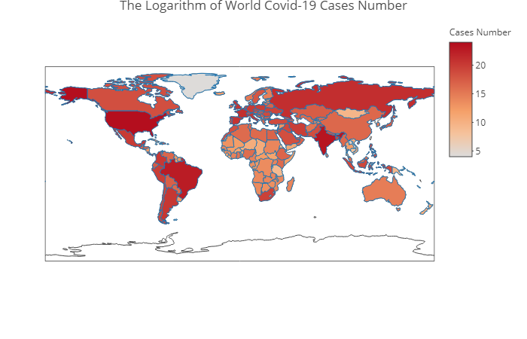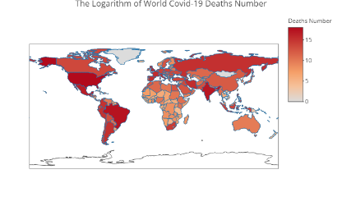

Figure 1.3 The Ratio of World Covid-19 Death to Case Number Figure 1.4 The Ratio of World Covid-19 Death/Pop*100

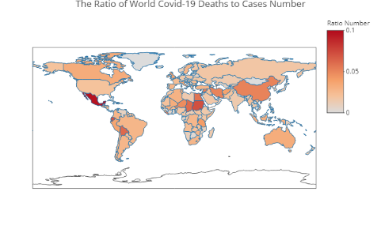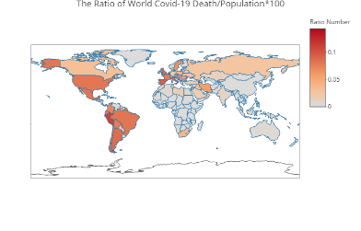

Figure 1.5 The Logarithm of World Population in 2019 Figure 1.6 The Logarithm of World Population Density in 2019

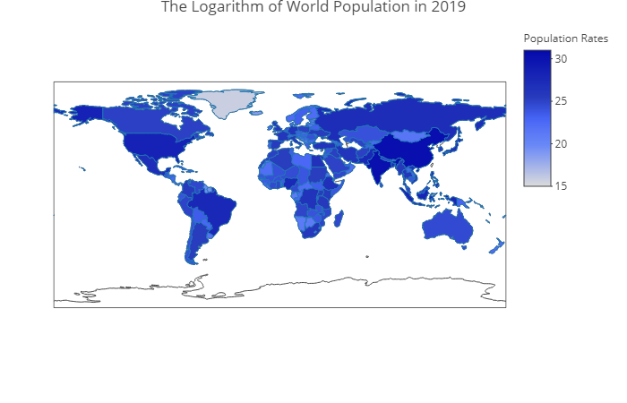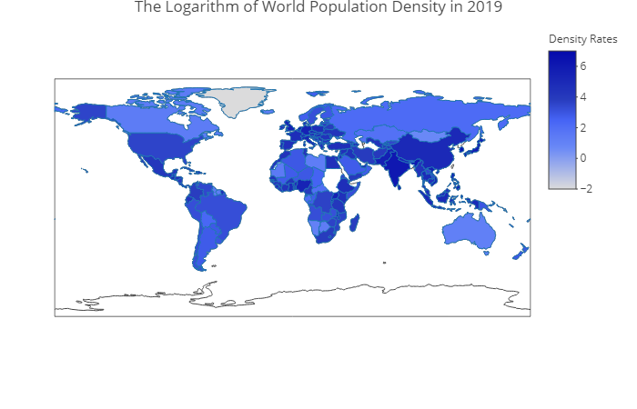

Table 3.2: ANOVA Test Results of Comparing Models 1 & 2

|  |  |  |  |  |  |  |
| --- | --- | --- | --- | --- | --- | --- |
| Model Name | Res.DF | RSS | Df | Sum of Sq | F | Pr(>F) |
| 1 | 52547 | 39.17 |  |  |  |  |
| 2 | 52534 | 38.78 | 13 | 388052910 | 40.438 | <2.2e-16 *** |

Table 3.3: ANOVA Test Results of Comparing Models 2 & 3

|  |  |  |  |  |  |  |
| --- | --- | --- | --- | --- | --- | --- |
| Model Name | Res.DF | RSS | Df | Sum of Sq | F | Pr(>F) |
| 2 | 52534 | 38.78 |  |  |  |  |
| 3 | 52533 | 38.77 | 1 | 11207507 | 15.187 | 9.75e-05 *** |

Table 3.5: ANOVA Test Results of Comparing Models 3 & 4

|  |  |  |  |  |  |  |
| --- | --- | --- | --- | --- | --- | --- |
| Model Name | Res.DF | RSS | Df | Sum of | F | Pr(>F) |
| 3 | 52533 | 38.77 |  |  |  |  |
| 4 | 52534 | 38.78 | -1 | -11207507 | 15.187 | 9.75e-05 *** |