# Task 7.1

**Create project & Register your project with Firebase:**

**Register user via Firebase:**

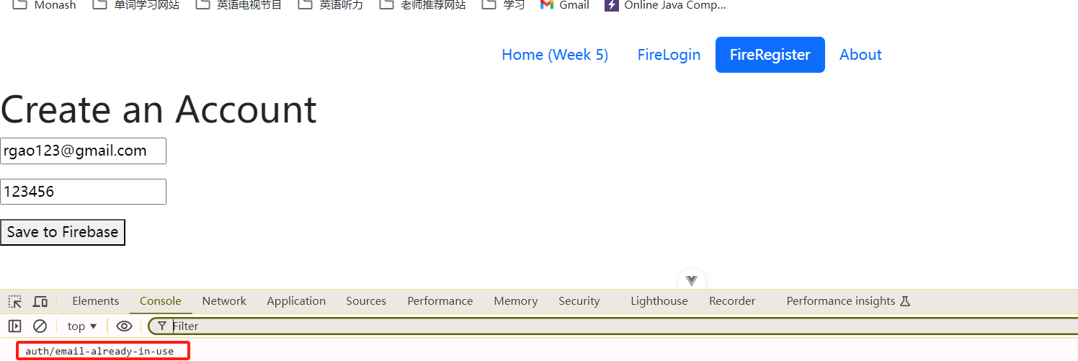

**Singn in via registerd account via Firebase:**

# Task 7.2

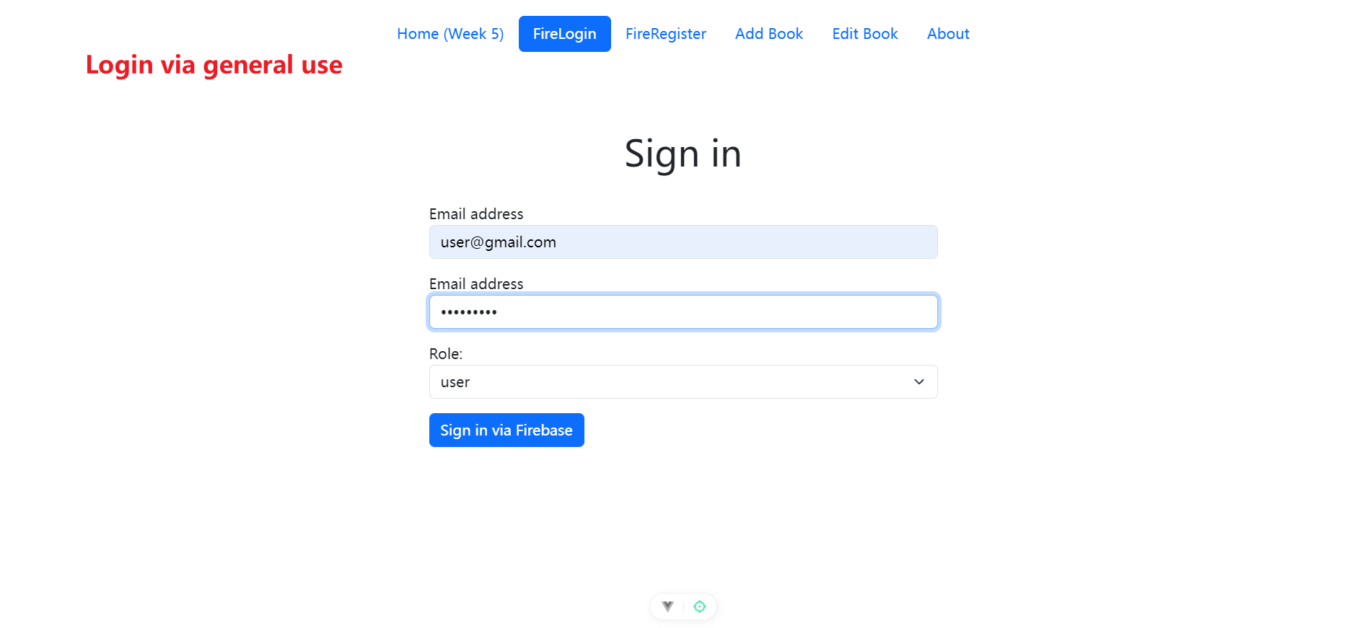

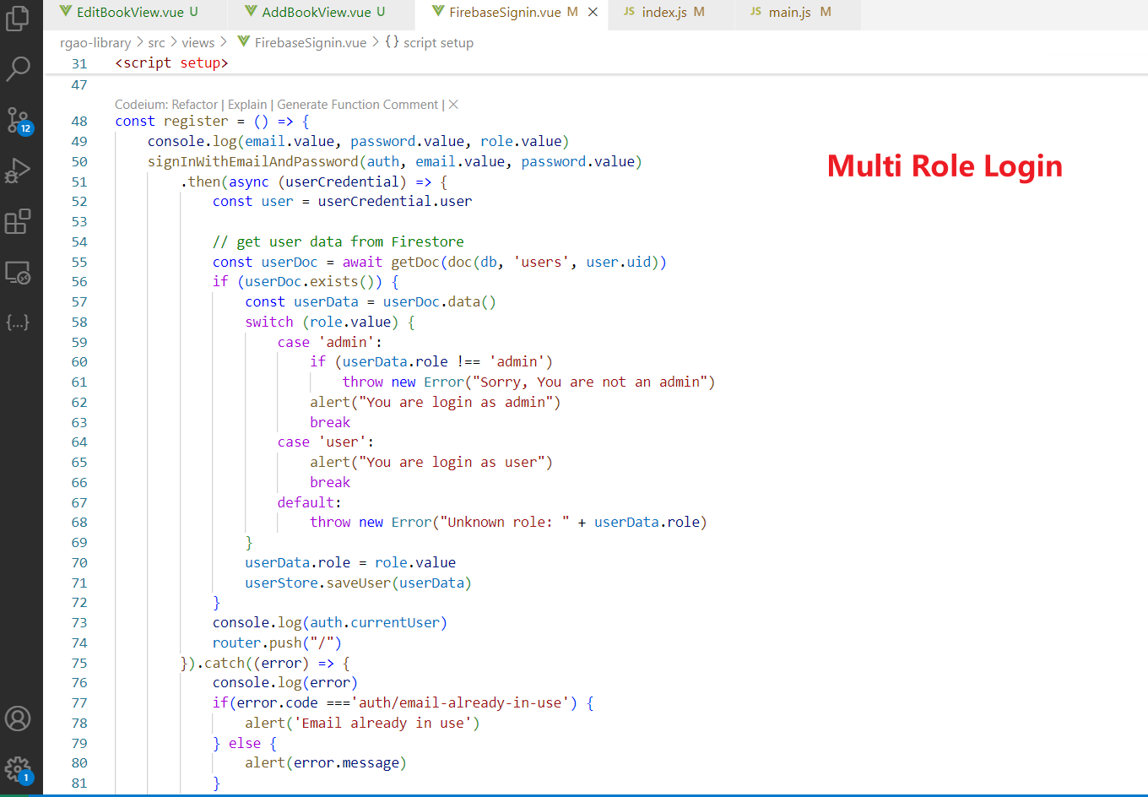

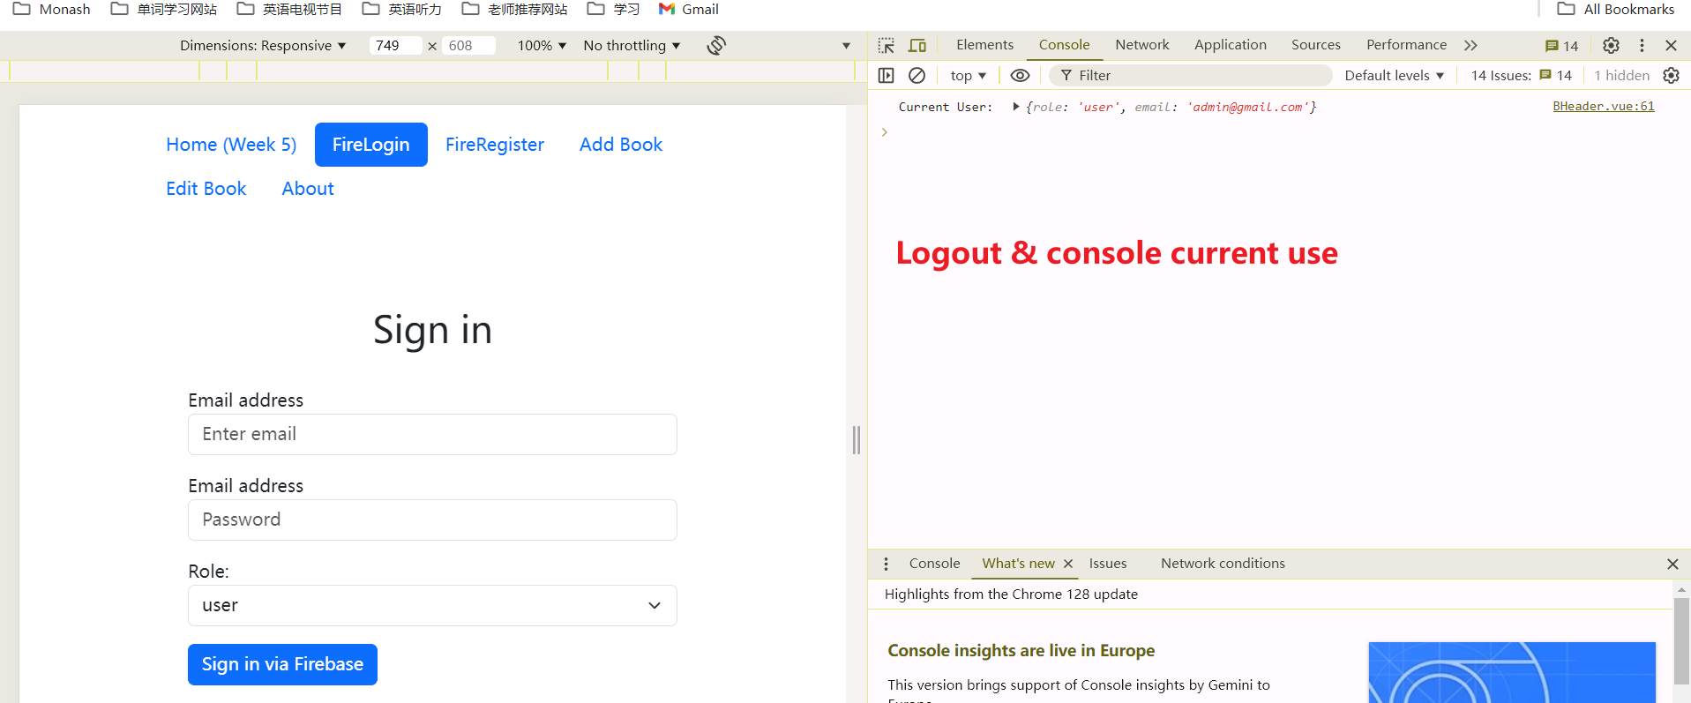

# Task 8.1

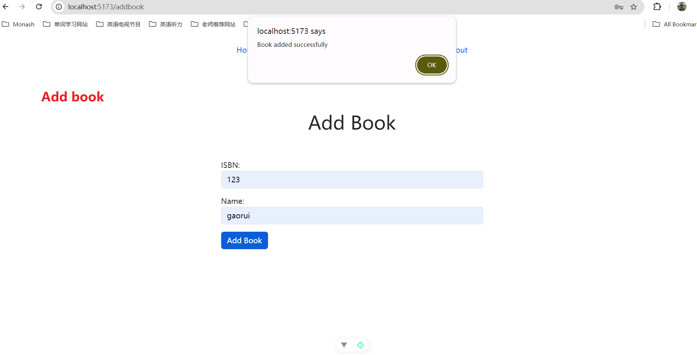

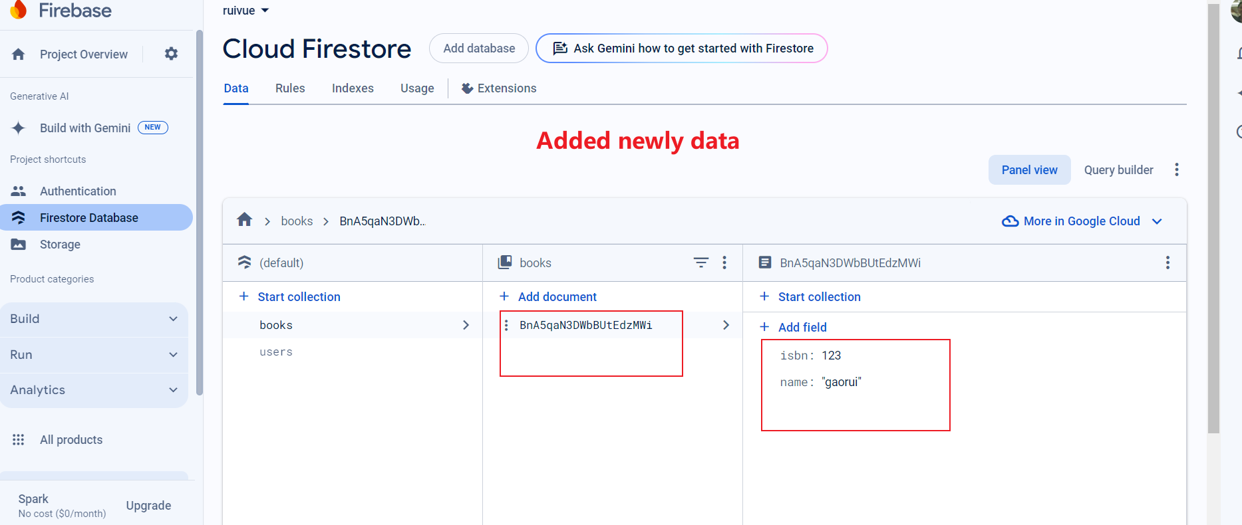

# Task 8.2



