# Task 9.1

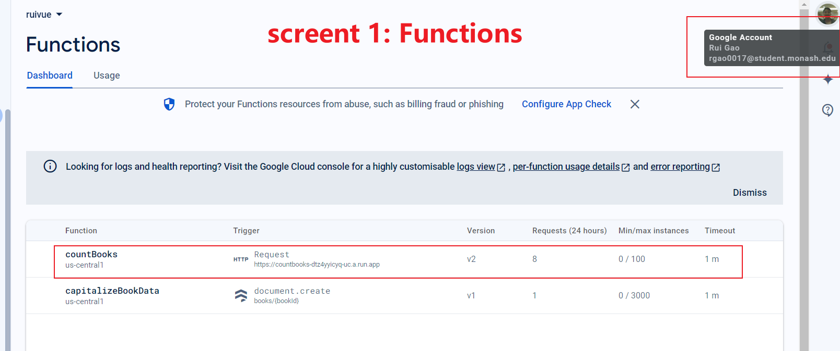

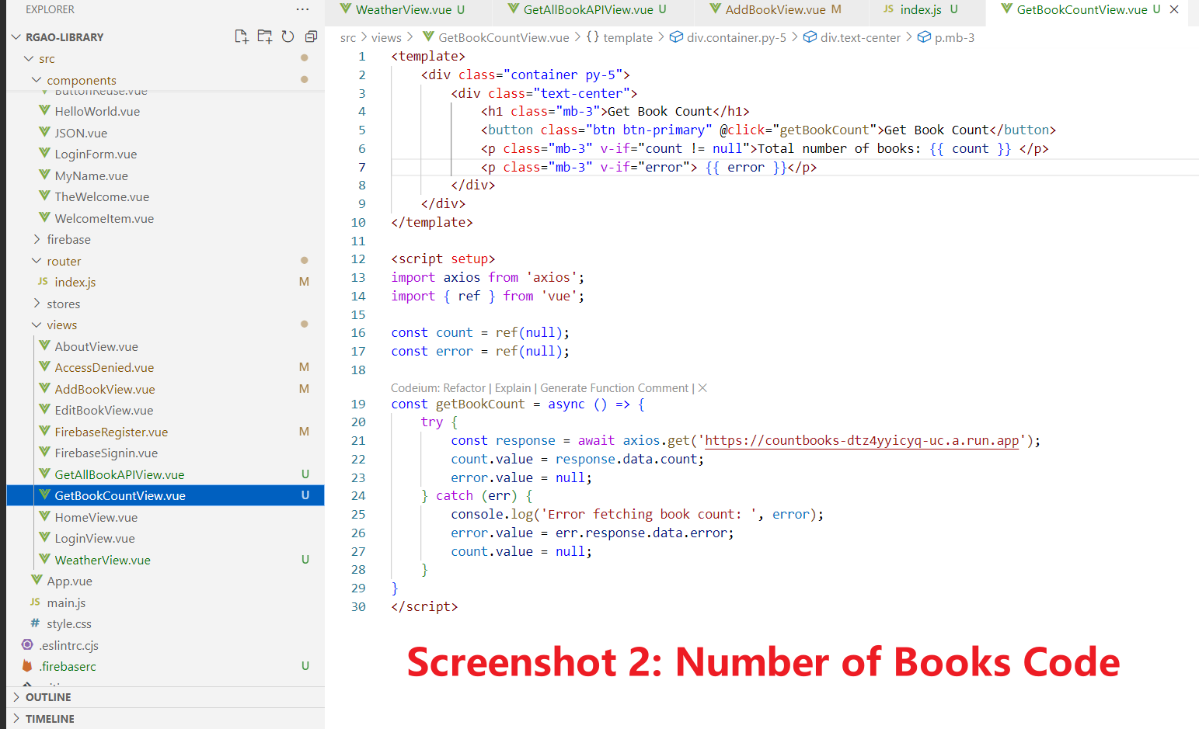

# Task 9.2

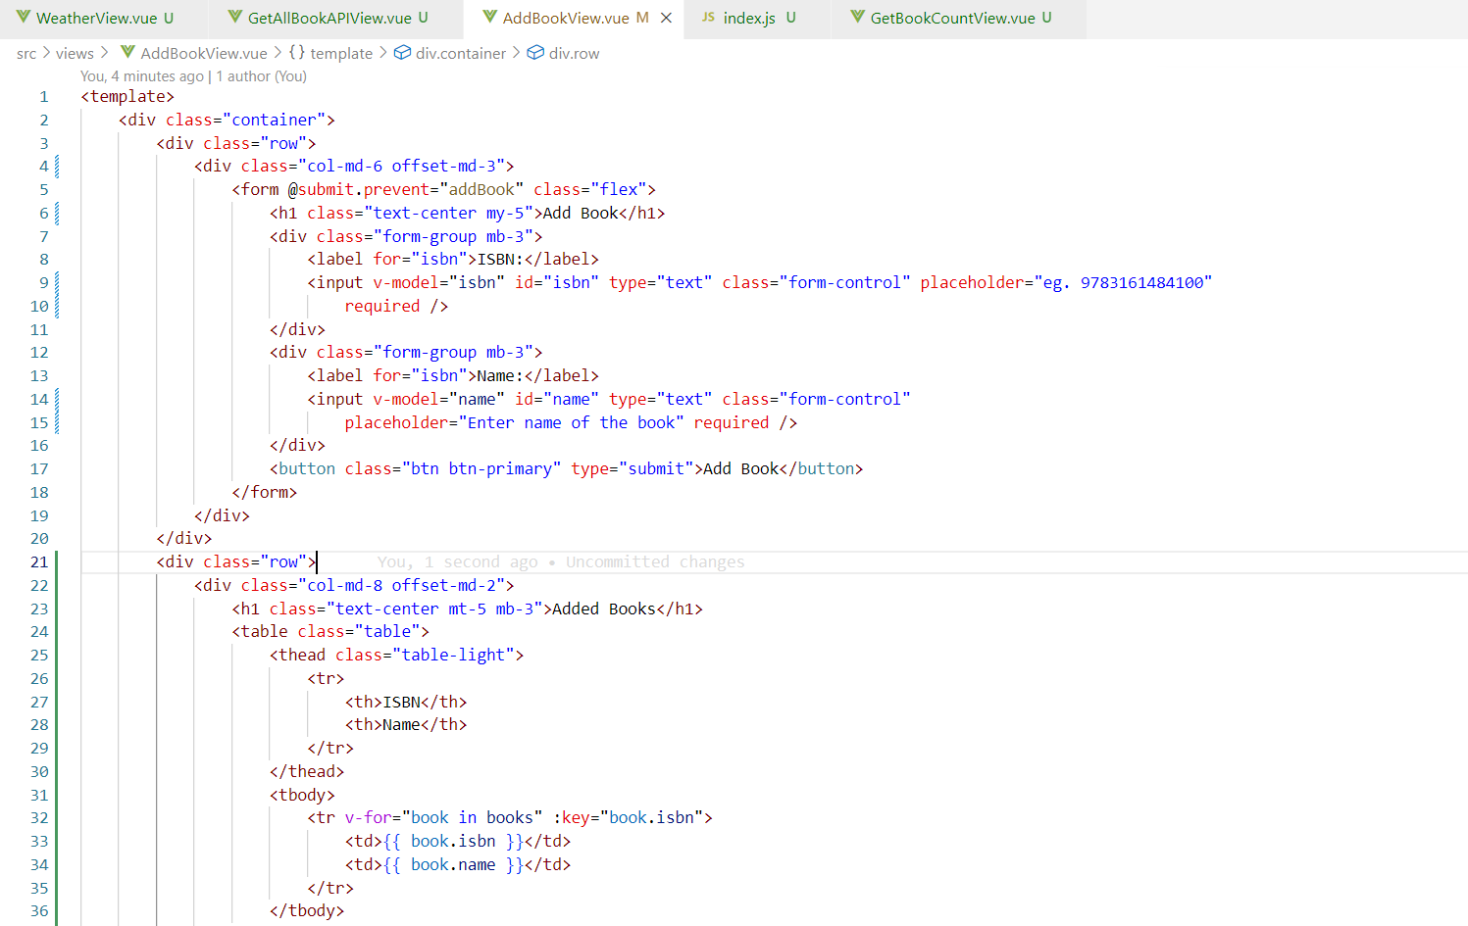

# Task 10.1

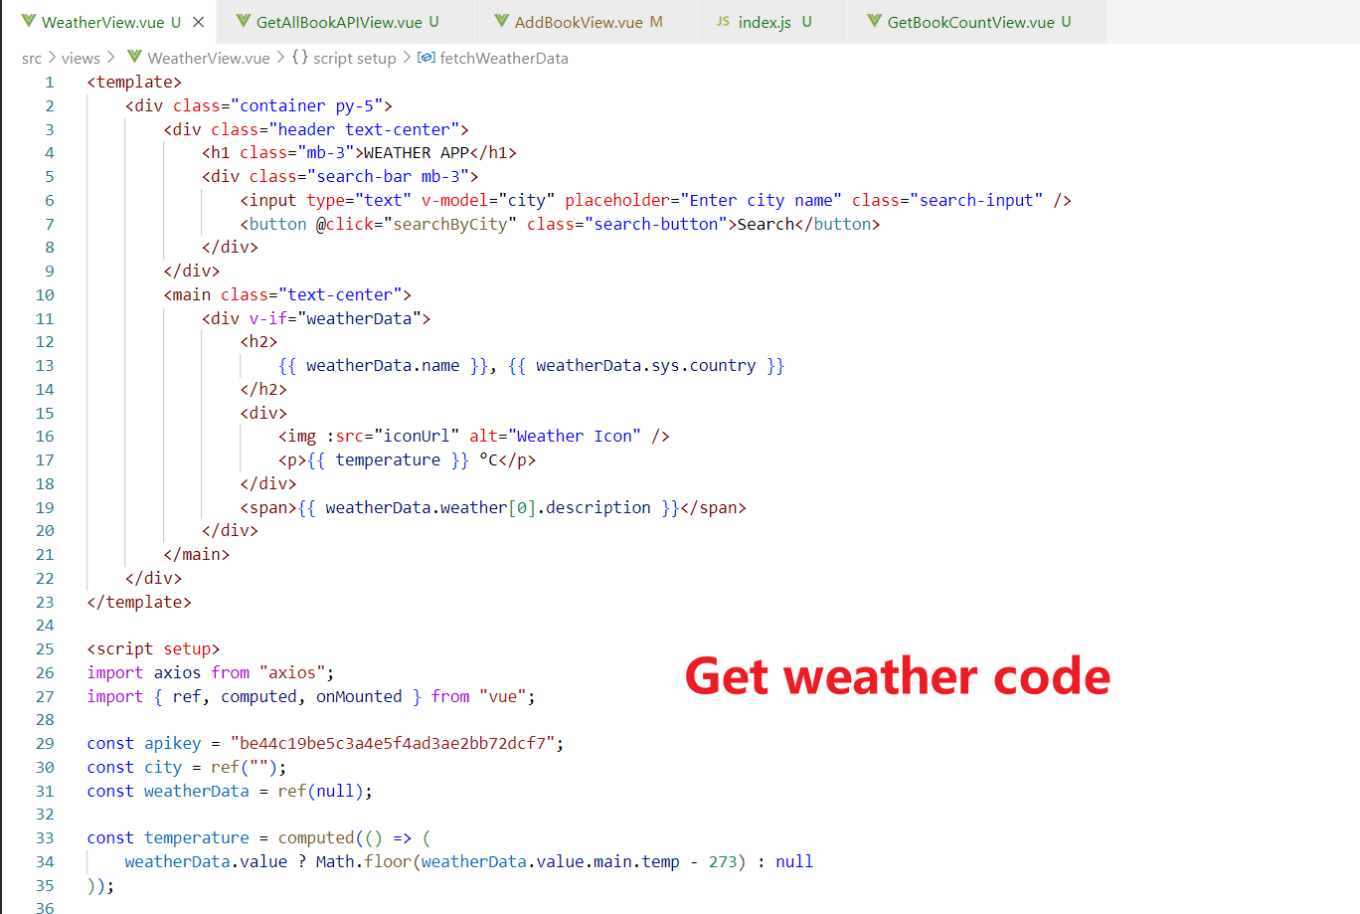

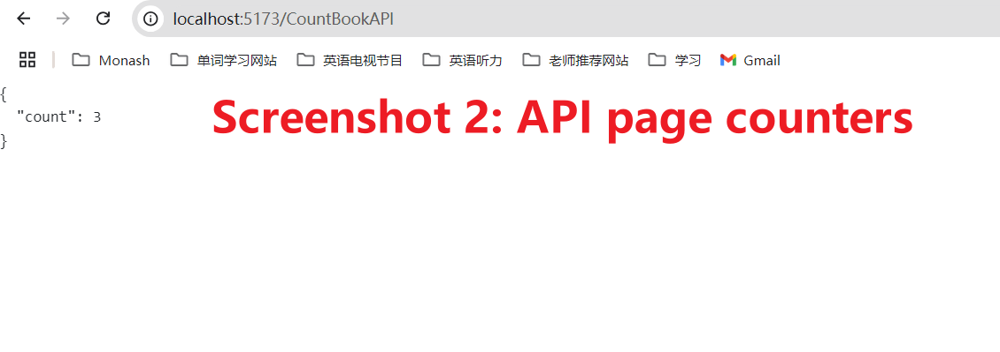

# Task 10.2

