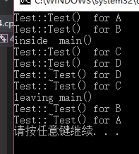

 the sequence of execution of their constructors and destructors are above.

The reason is that the local objects are stored in stack so that they have the order that the latter one to be constructed will the former one to destructed.

And the global objects are stored in the static part and released when the program end.