**Primary Reading**

A family tree is a diagram（表格）of the people in a family. This is the Wilson’s family tree. All the members of the Wilson's family are on the tree.

Betty and Henry are the parents of Sally, Linda, and Tom. Linda is single(单身). Sally is married. Her husband's name is Jack. Sally and Jack are the parents of Jimmy and Sarah. Jimmy is their son, and Sarah is their daughter.

Tom is also married. His wife's name is Patty. Patty and Tom are the parents of Julie and Kevin. Julie is their daughter, and Kevin is their son.

Jimmy, Sarah, Julie, and Kevin are cousins. They are also the grandchildren of Betty and Henry.

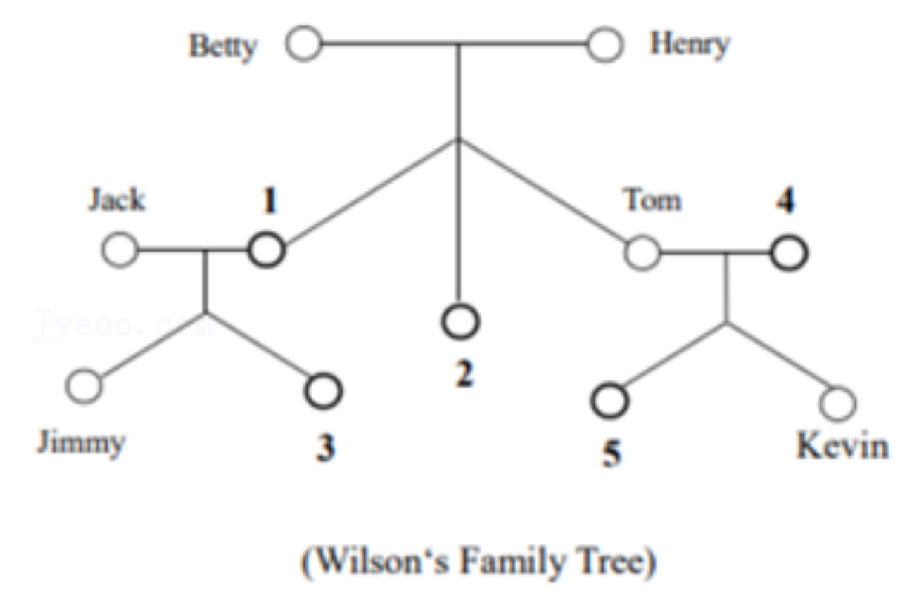

请根据文章内容完成Wilson的家庭图谱

(1)__________

(2)__________

(3)__________

(4)__________

(5)__________

**Intermediate Reading**

**Clothes Donation( 捐赠 ) Box**

　　Have you ever put your old clothes into the donation box in your neighborhood? If not, you can do it right now because clothes donation is becoming a trend( 趋势 ) in Urumqi.

　　“From time to time, my mother clears out the clothes which I no longer wear. You know, we

　　teenagers are growing fast. I think it’s a good way to help others. ” Lin Tao, a junior student says.

　　“I often pick out some of my clothes that are out of style after going shopping. Then I’ll put them into the donation box. ” Miss Li, a pretty young lady says.

　　“That seems like a good idea. Some clothes in the box are quite new. People can either wear them or use them to make things such as handbags and pencil cases.” Mrs. Wang, an old woman says, “Sometimes I also look through the box for some nice clothes.”

　　However, there are some problems along with the popularity of clothes donation. Recently, a UTV reporter from Focus on the City has made a survey. Here are the results:

　　◆ The box is full of clothes in a short time. There is no more room for people to give away clothes.

　　◆ Some people sell the clothes in the donation box for making money instead of wearing them.

　　◆ Some communities set the box in unsuitable places. So there are few clothes in it.

　　◆ Many clothes are too old and shabby( 破烂的 ).

　　“What’s worse,” one of the staff in a community added, “We qutie often see people throw rubbish

　　into the box when they pass by. We’ve tried to stop them several times but failed. It has been the most serious problem since we set the box.”

　　In order to make the donation box work in an efficient( 有 效 的 ) way, our government is taking action. Clothes donation will be better organized and it’ll be more convenient for people in need to take the clothes away.

　　56. Miss Li gives away her clothes because .

　　A. her clothes are out of style B. her mother clears out her clothes

　　C. she is growing too fast D. She wants to make something

　　57. The reporter from UTV has collected.

　　A. 4 problems B. 5 problems C. 6 problems D. 7 problems

　　58. All the problems about the donation box are included EXCEPT .

　　A. there's no more room for people to donate clothes

　　B. people choose unsuitable places to set the box

　　C. sometimes the box is broken by someone

　　D. the clothes in the box are too old and shabby

　　59. The underlined word “them” in Paragraph 4 means .

　　A. the clothes donation boxes B. the old people

　　C. handbags and pencil cases D. some clothes in the box

　　60. We can infer( 推断 ) from the passage that .

　　A. the clothes donation will be better-organized to help donators and people in need

　　B. the clothes donation becomes less popular than before because of serious problems

　　C. the clothes donation can prevent some girls from wearing clothes that are out of style

　　D. the clothes donation gives the traders a good idea to sell old clothes for making money

　　56. A 57. B 58. C 59. D 60. A

**Advanced Reading**

A young girl named Malala, born in 1997 in the northwest of Pakistan, is famous for supporting children and women to get an education.

　　In 2012, she was shot and seriously injured when she returned home on the school bus. Luckily, she was sent to the hospital in time and saved. After that, she went back to school and began to

　　strive( 奋斗 ) for children and women to receive an education.

　　On October 10, 2014, the Nobel Prize for Peace was awarded ( 授 予 ) to Malala. She became the youngest winner in the history of the Nobel Prize. However, Malala missed the most important event of being announced to be the winner of the prize. At that very moment, she was taking chemistry lessons

　　in the classroom! After hearing the news, Malala chose to take her history and physics lessons as usual. She said calmly to the reporter, “I’m proud of getting this prize. Although the unforgettable date itself means something to me, it’s more important to finish the rest lessons today. After all, it’s a normal school day.”

　　One year later, Amy Mainzer, an astronomical scientist of NASA, found a new planet. She named it “Malala”. When Amy Mainzer was interviewed by Times, she explained, “I think Malala has set an example for us. She is fearless and sticks to helping children and women get the right of being educated. Nothing can stop her.”

　　Last year, Malala passed the entrance examination of Oxford University through her hard work.

　　Before she finished her high school, she had written the book I’m Malala. She said, “I hope readers around the world have a chance to read my book. My dream is that more and more people will realize it is extremely difficult for children and women in some areas to get an education. Actually, my story is also the story of 61 million children. Every boy and every girl should have the right to go to school. ”

　　61. How old was Malala when she won the Nobel Prize for Peace?

　　A. 17. B. 16. C. 15. D. 14.

　　62. What’s the meaning of the underlined word “astronomical” in Chinese?

　　A. 航天的 B. 天文的 C. 地理的 D. 生物的

　　63. What’s the name of the new planet?

　　A. Amy Mainzer. B. NASA. C. Oxford. D. Malala.

　　64. What is the correct order of the following events?

　　① Malala became a student of Oxford. ② A planet was named for Malala.

　　③ The Nobel Prize was awarded to Malala. ④ Malala wrote a book called I’Malala. A. ③②①④ B. ②③①④ C. ③②④① D. ②④①③

　　65. Which of the following about Malala is NOT TRUE according to the passage?

　　A. She strives for helping children and women to go to school.

　　B. She is the youngest winner in the history of the Nobel Prize.

　　C. She was taking chemistry lessons when she was awarded.

　　D. She wrote a book about herself and 6.1 million children.

61. A 62. B 63. D 64. C 65. D