Alpha Tracker

## Installation

* before installation, make sure you are in the root of AlphaTracker

**step 1**. create conda enviroment with dependencies:

conda env create -f environment.yml

If the above command line failed, please install the package manually with pip and then run the following command line:

conda activate alphatracker

conda env update --file environment.yml

**step 2**. Install YOLO for training.

cd ./train_yolo/darknet/

make

cd ../../

## Training

**Step 1**. data preparation

labeled data is required to train the model. The code would read RGB images and json files of annotations to train the model.

Figure 1 shows an example of annotation json file. In this example, there only two images. Each image has two mice and each mouse has two keypoint annotated.

Note that point order matters. Point with the same sequence position should be the same keypoint. For example, all the first point represent the nose, all the second points represent the tail and etc.

If the keypoint is not visible, then make the x,y of the keypoint to be -1.

**Step 2**. configure

Before trianing, you need to charge the parameter in ./setting.py (read block in figure 2). The meaning of the parameter can be found in the ./setting.py.

**Step 3**. run code

Use the following command line to train the model:

conda activate alphatracker

python train.py

## Tracking

**Step 1**. configure

Before tracking, you need to charge the parameter in ./setting.py (blue block in figure 2). The meaning of the parameter can be found in the ./setting.py.

**Step 2**. run code

Use the following command line to train the model:

conda activate alphatracker

python track.py

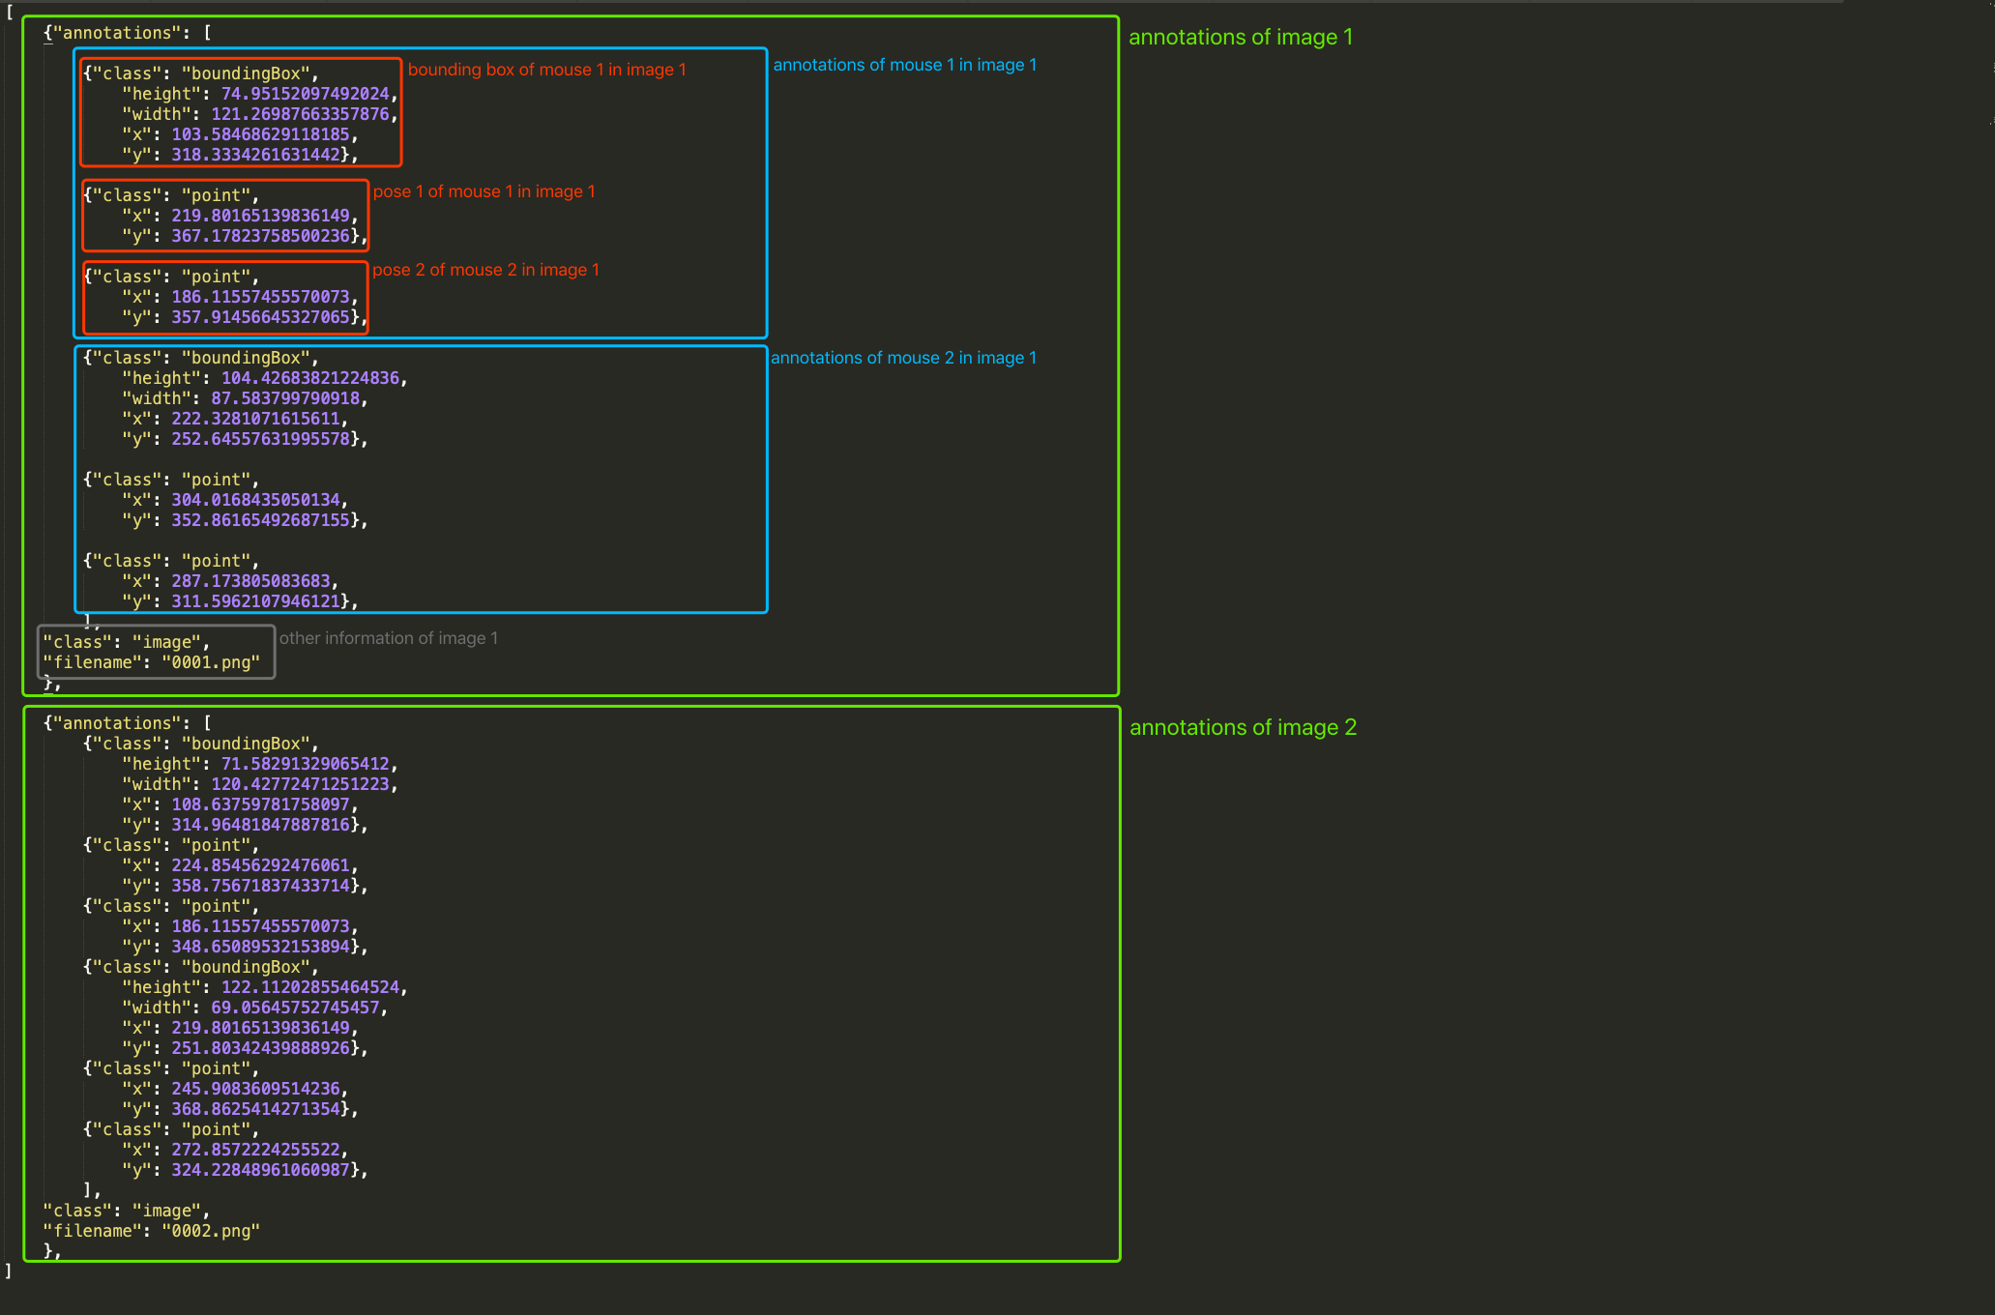

Figure 1. format of the json file

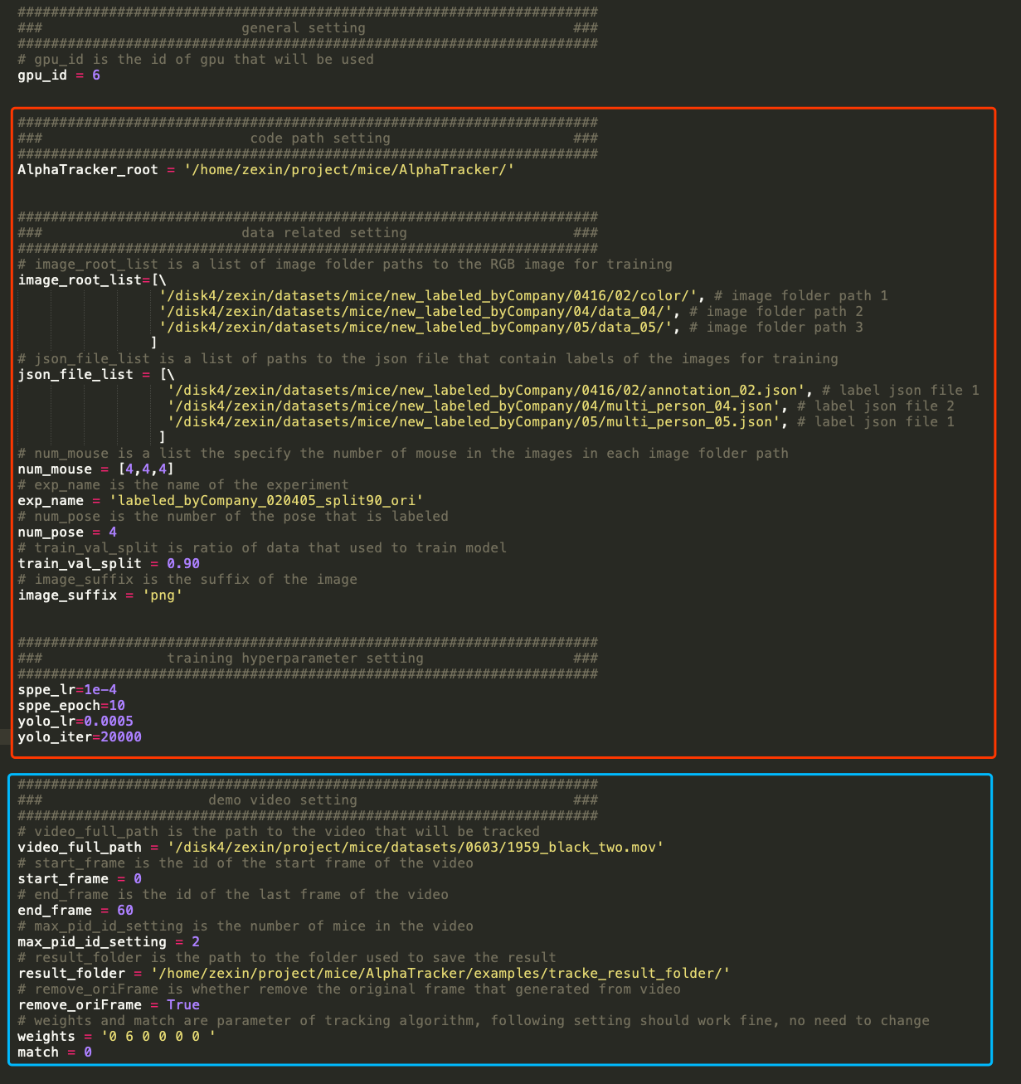

Figure 2. parameter in ./setting.py