HW1

# Ruijie Song

# Feb.4.2021

**Exercise 1: Histogram and Cross-Validation**a)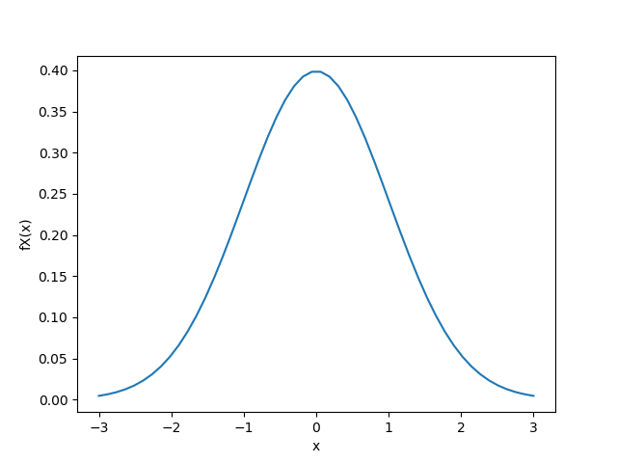

Figure 1. fX

b)

ii)

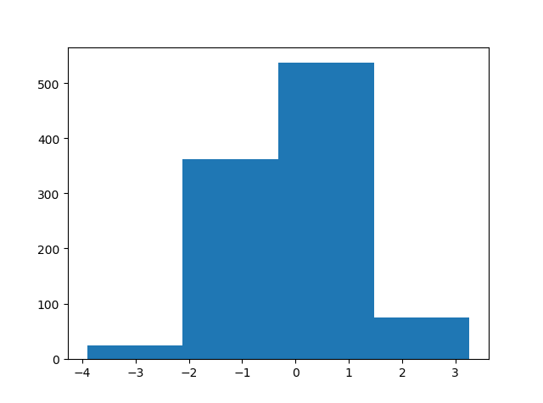

Figure 2. m=4

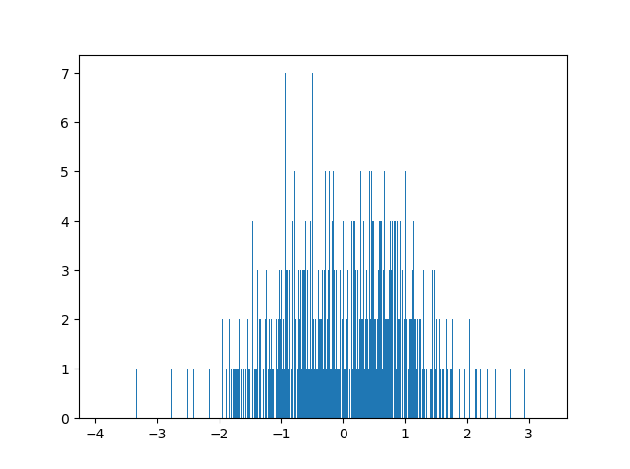

Figure 3. m=1000

iii)

mean = -0.02185824415219112

standard deviation = 1.0469359084378456

iv)

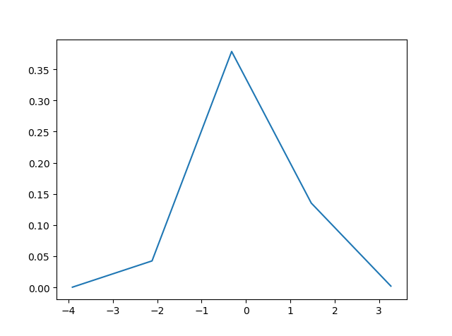

Figure 4. m=4

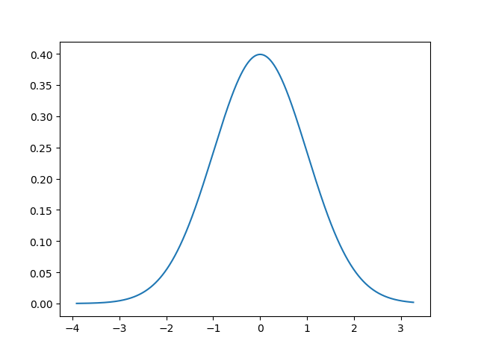

Figure 5. m=1000

c)

i)

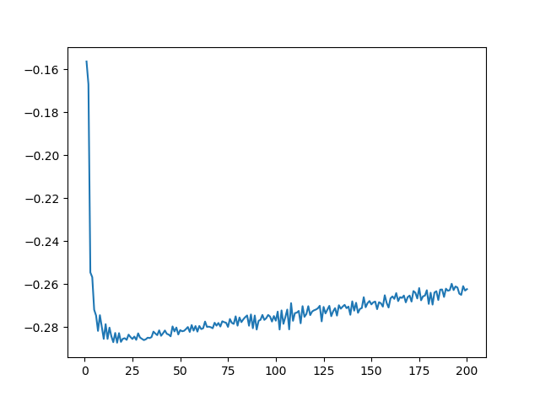

Figure 6. J(h)

ii)

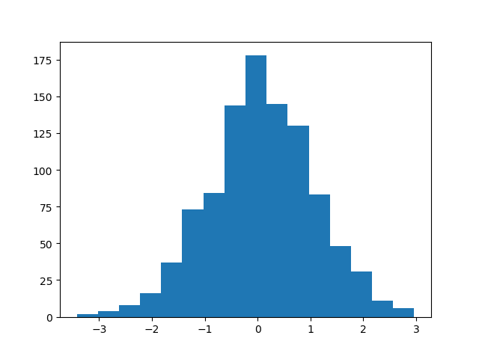

Figure 7. histogram of your data with that m∗

m* = 16

iii)

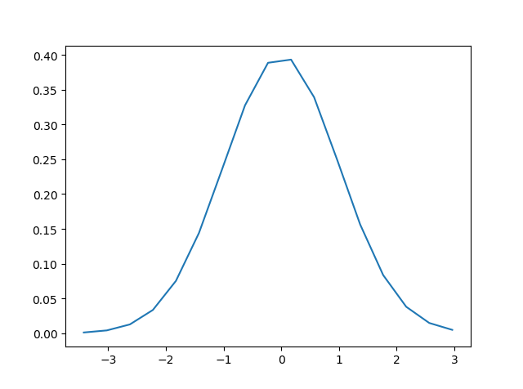

Figure 8. Gaussian curve

Exercise 2: Gaussian Whitening

a)

i)

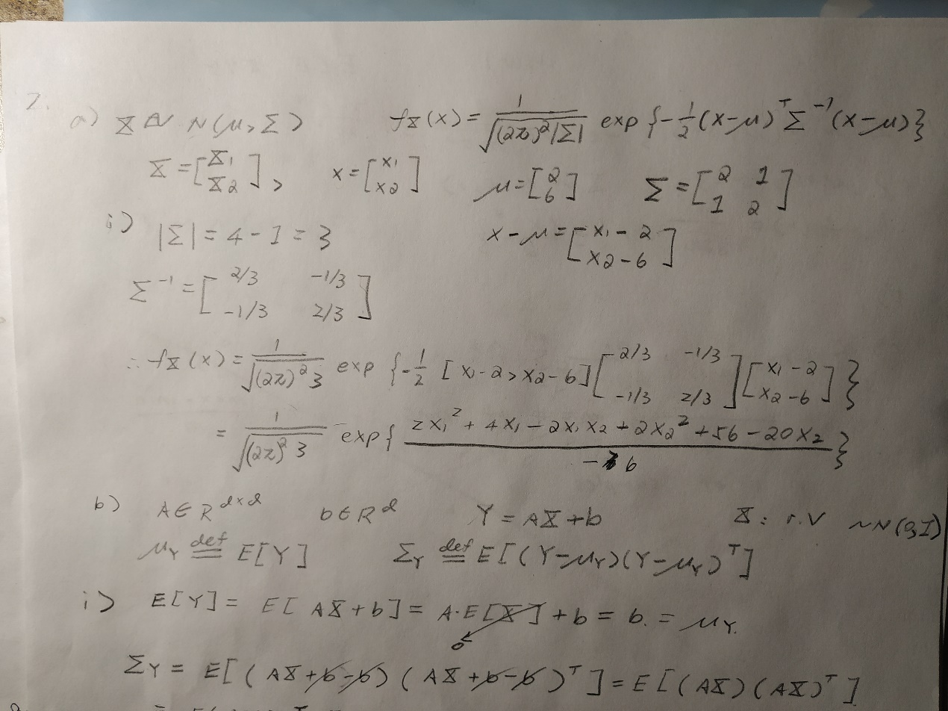

ii)

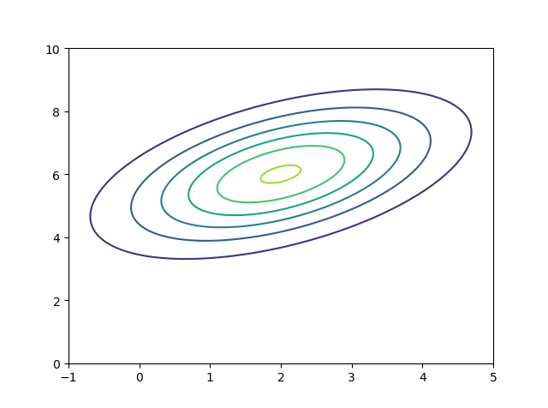

Figure 9. The contour of fX

b)

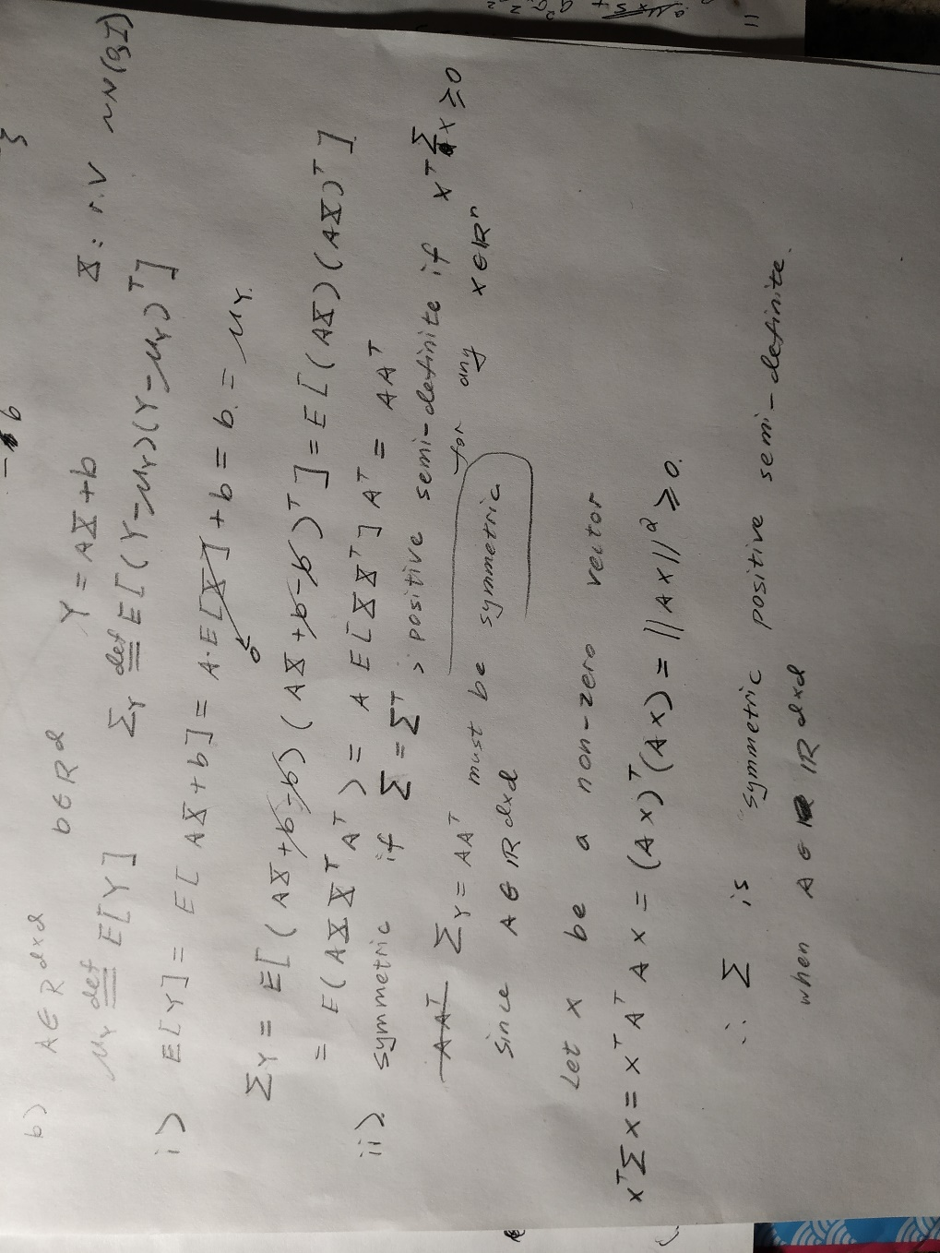

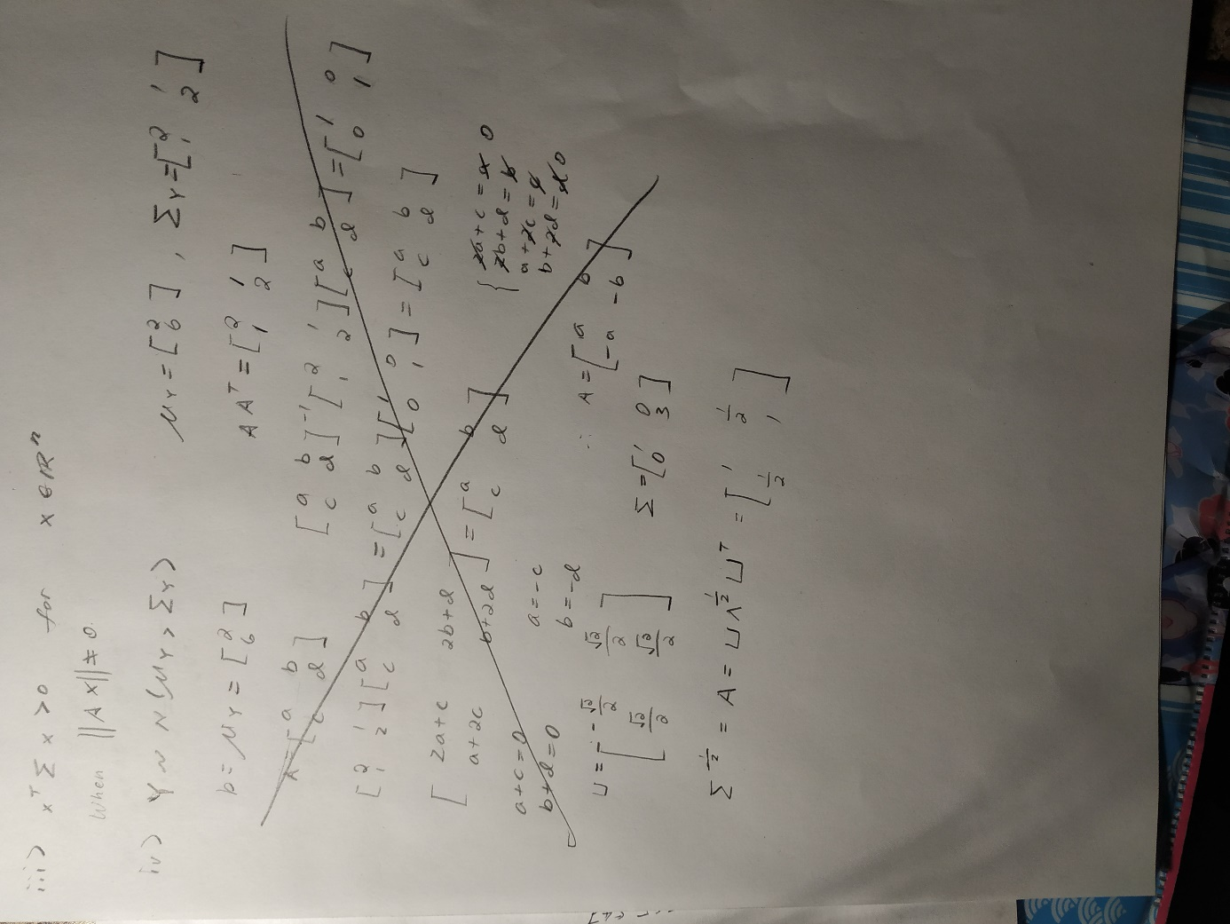

c)

i)

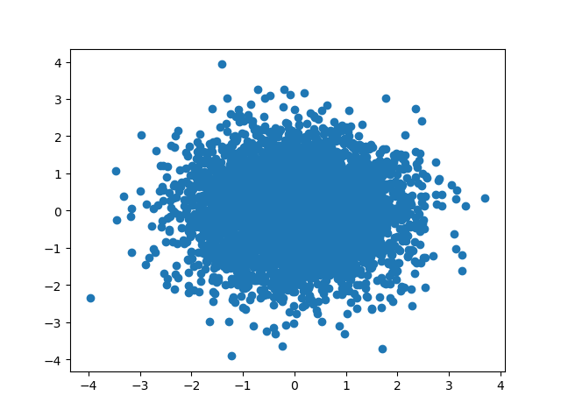

Figure 10. scatter plot

ii)

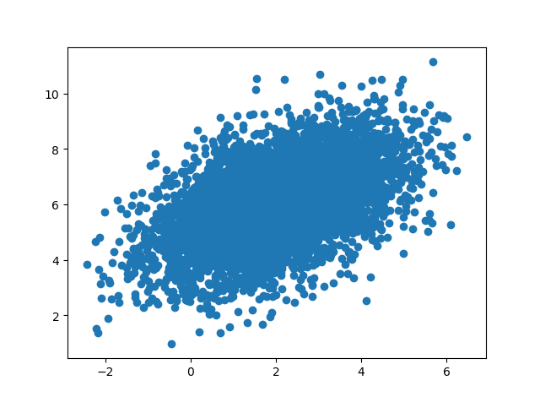

Figure 11. data calculated by numpy.random.multivariate_normal

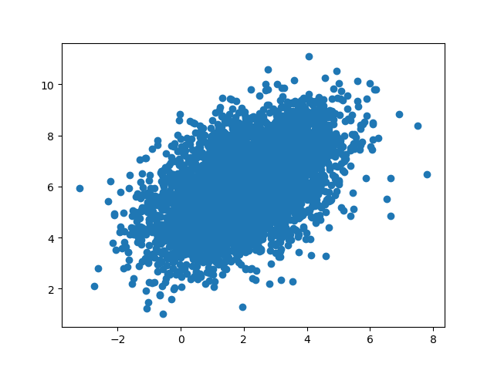

Figure 12. data calculated by affine transformation

Exercise 3: Linear Regression

a & c.

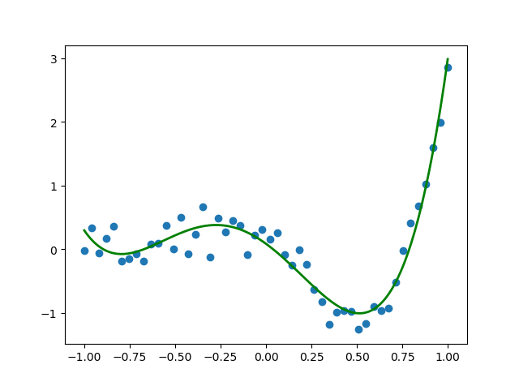

d.

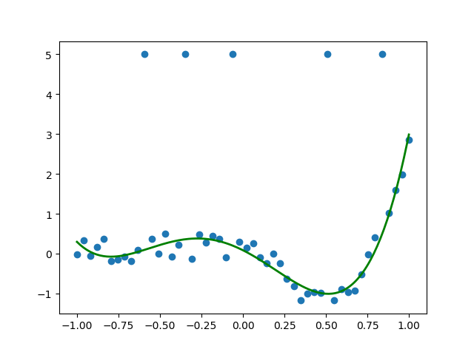

There are a few differences between those 2 plot. However, the outliers do not affect much.

b & e.

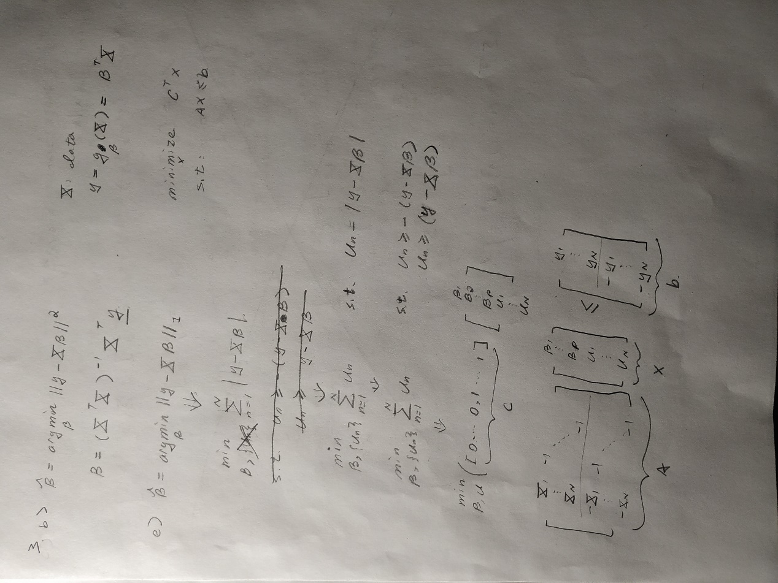

f.

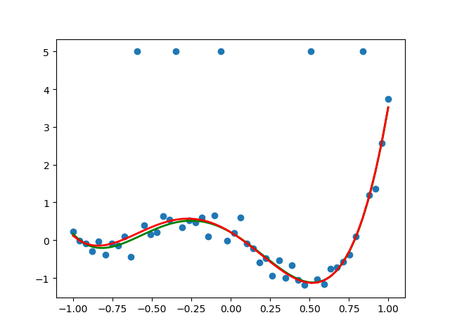

Figure . The green curve is for d, The red curve is for f