# ECE 595 HW2

## Ruijie Song

## Feb.17.2021

Exercise 1: Loading Data via Python

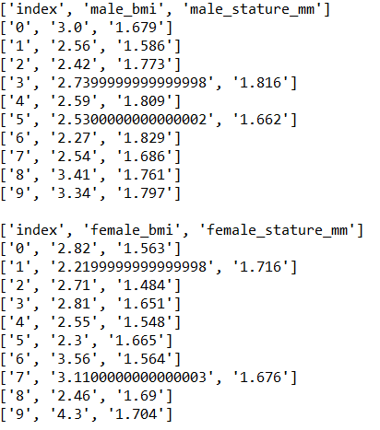

Figure . Exercise 1 result

Exercise 2: Build a Linear Classifier via Optimization

a.

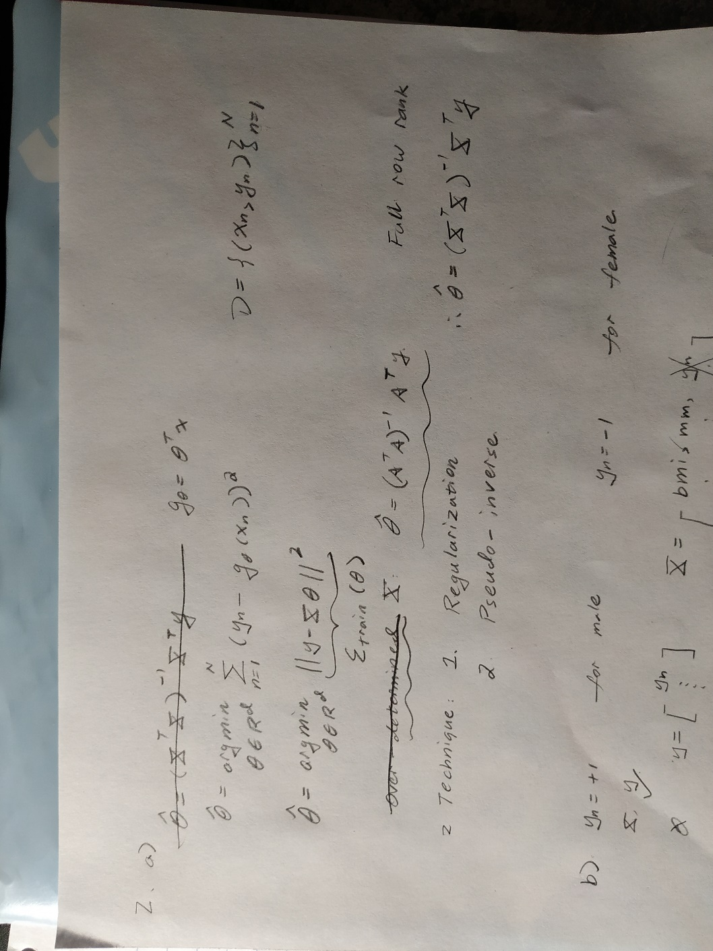

b.

theta = [ -1.070e+01; -1.233e-01; 6.674e+00]

c.

theta = [ -1.070e+01; -1.233e-01; 6.674e+00]

d.

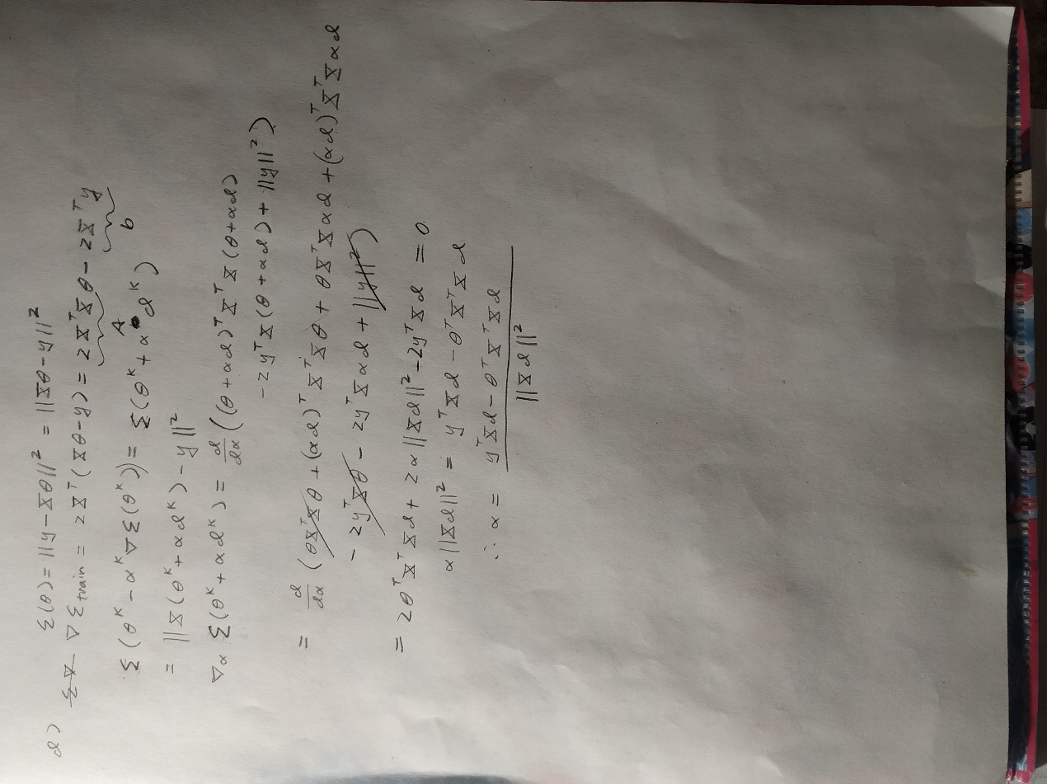

e.

theta = [ -1.070e+01; -1.233e-01; 6.674e+00]

f.

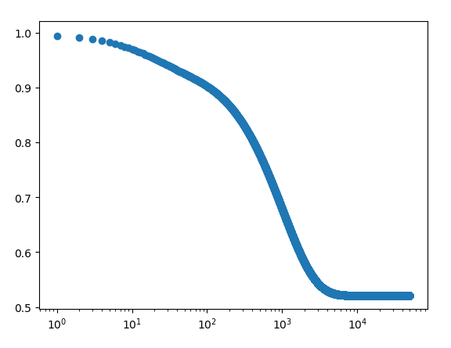

Figure 2. plot of the training loss

g.

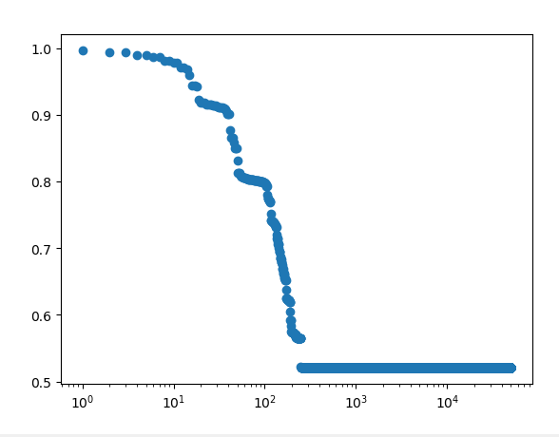

Figure 3. plot of the training loss

Exercise 3: Visualization and Testing

a.

i.

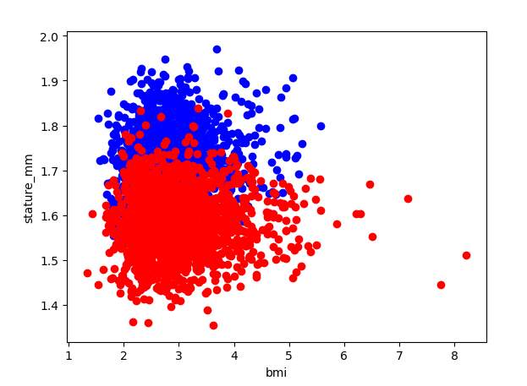

ii.

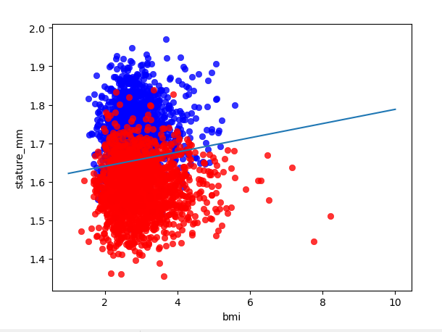

b

False Alarm = 15.02403846153846%

Miss = 18.653846153846154%

Precision = 0.9998804240631164

Recall = 0.9999036898201988

Exercise 4: Regularization

a.

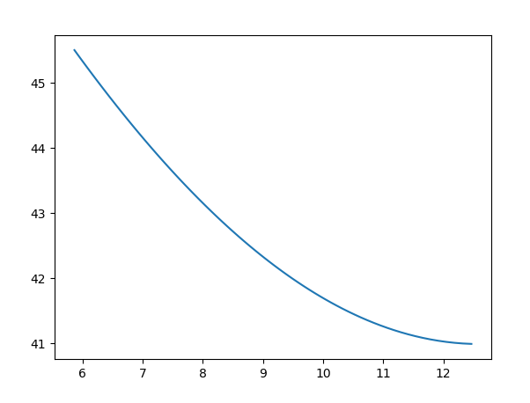

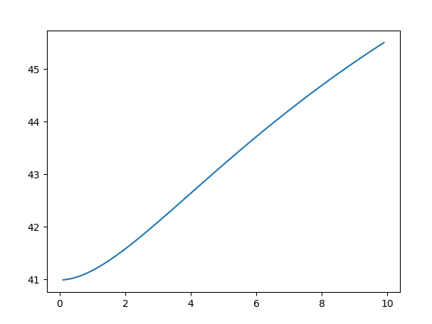

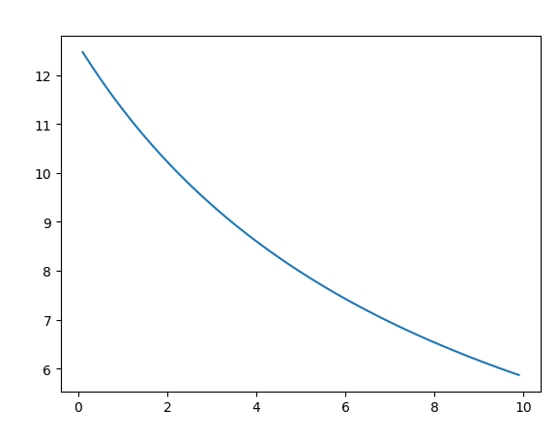

b.

