# ECE595 HW4

## Ruijie Song

## Mar.18.2021

Ex1.

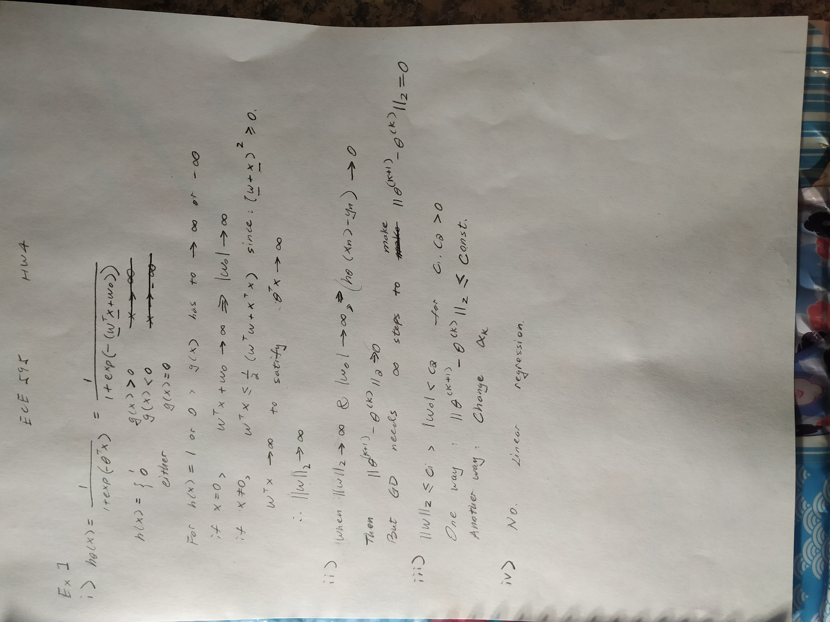

Ex.2

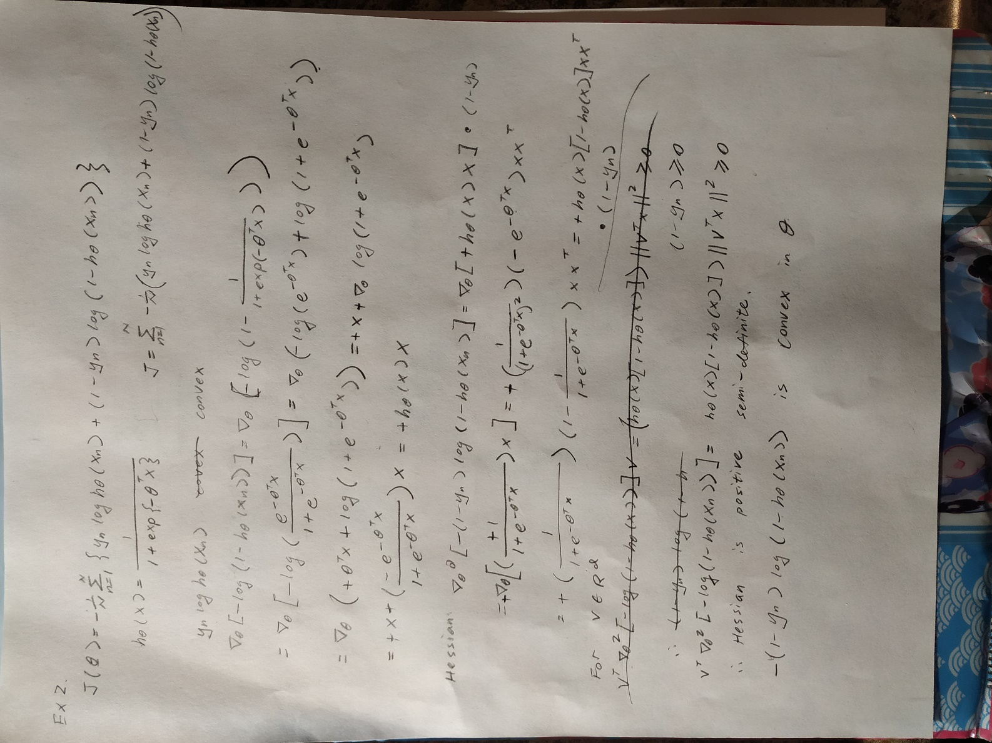

### Ex3.

a.

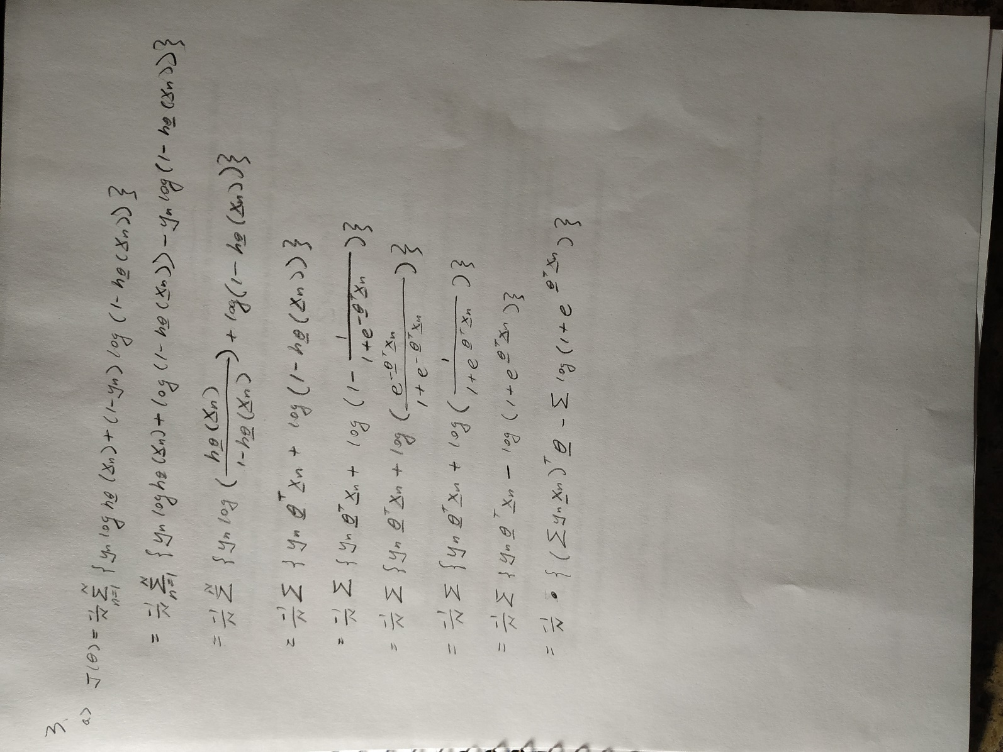

b.

theta = [2.38, 1.50, -10.44]

c.

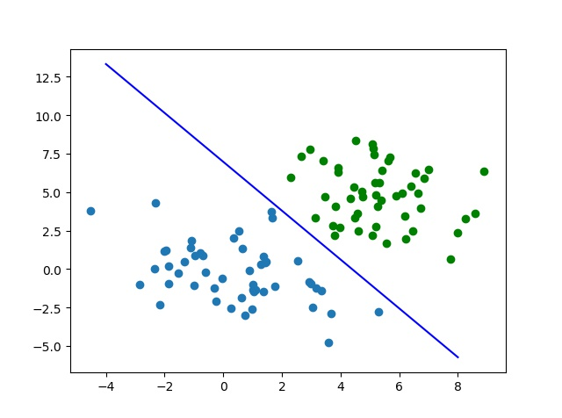

d.

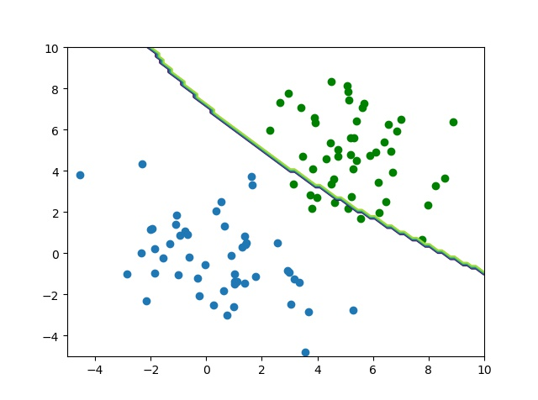

Ex4.

a.

[[1.00000000e+00 5.78667187e-13 6.19586231e-20 7.94511151e-25

4.31787909e-17]

[5.78667187e-13 1.00000000e+00 2.66618165e-12 2.63683326e-31

1.07334027e-11]

[6.19586231e-20 2.66618165e-12 1.00000000e+00 3.36906580e-42

1.49290933e-18]

[7.94511151e-25 2.63683326e-31 3.36906580e-42 1.00000000e+00

1.20563730e-05]

[4.31787909e-17 1.07334027e-11 1.49290933e-18 1.20563730e-05

1.00000000e+00]]

b.

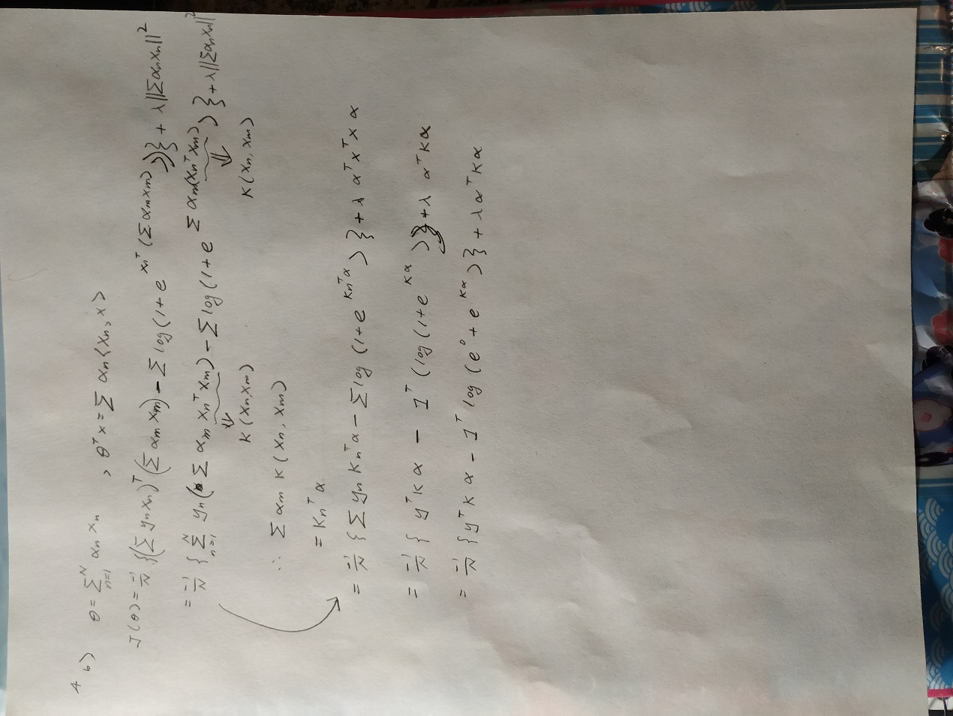

c.

[-0.52, -0.60]

d.