# ECE 595 HW5

## Ruijie Song

## Apr.1.2021

Exercise 1

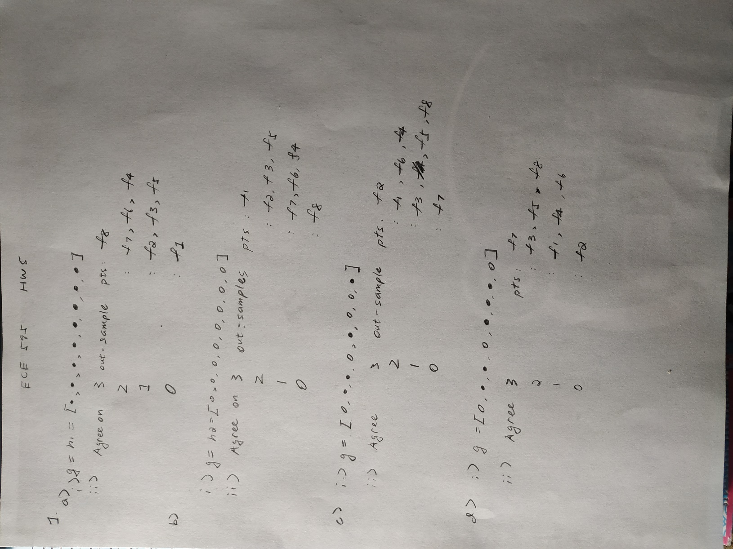

Exercise 2

1. μ1 = μrand = μmin = 0.5

2.

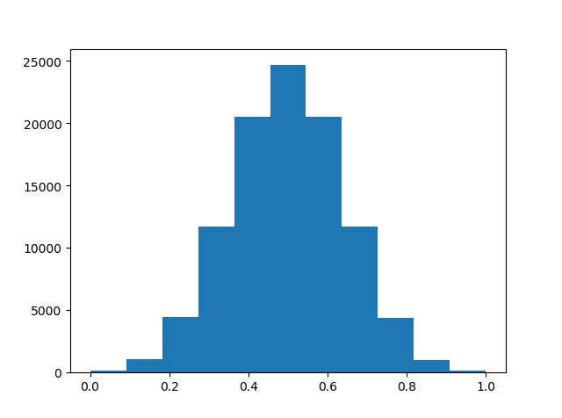

Figure 1. V1

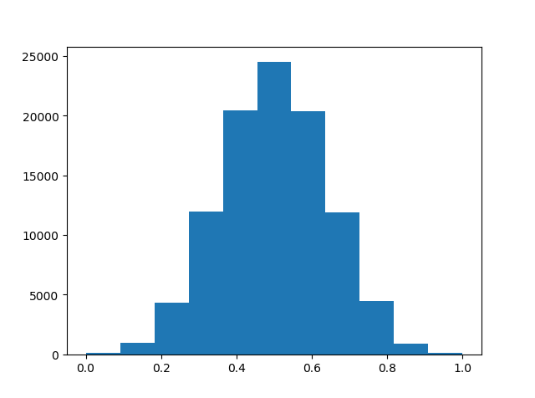

Figure 2. Vrand

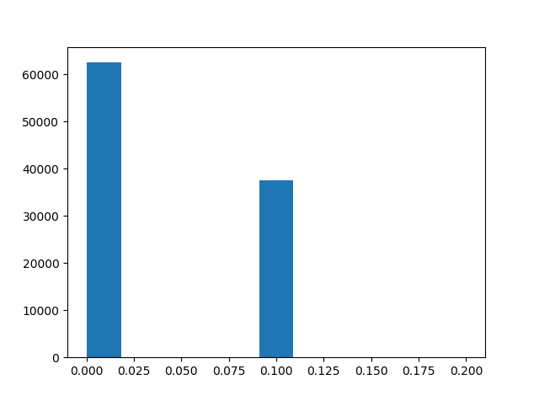

Figure 3. Vmin

3.

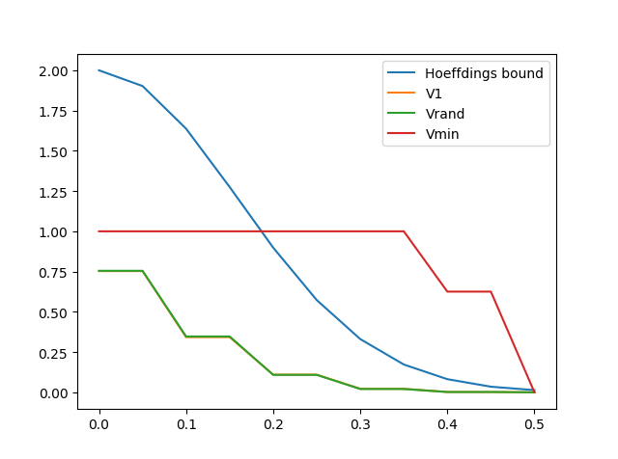

d.

The coin1 and coin_rand obey the Hoeffding’s bound, and coin_min does not. That is because the coin_min is not independent of the samples. E[V1] = E[Vrand] = 0.5.

However, E[Vmin] = 0.04, which is far away from μ.

Exercise 3.

b.

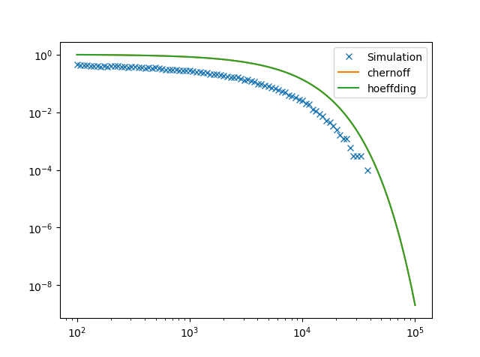

a.

