# Lab 7 Report

## Ruijie Song

## Apr.2.2021

1 Minimum Mean Square Error (MMSE) Linear Filters

1.



Figure . img14bl



Figure . img14g



Figure . img14gn



Figure . img14sp

2.

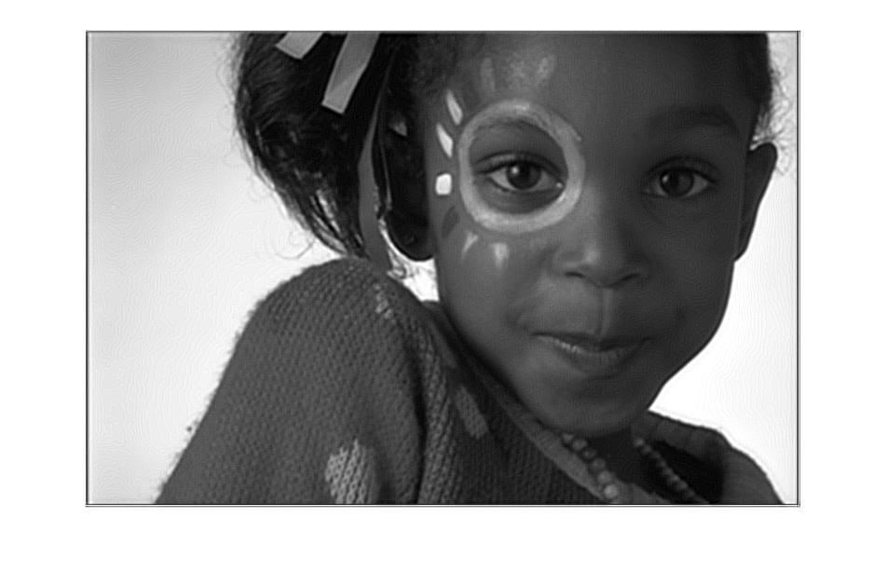

Figure . output for the blurred image

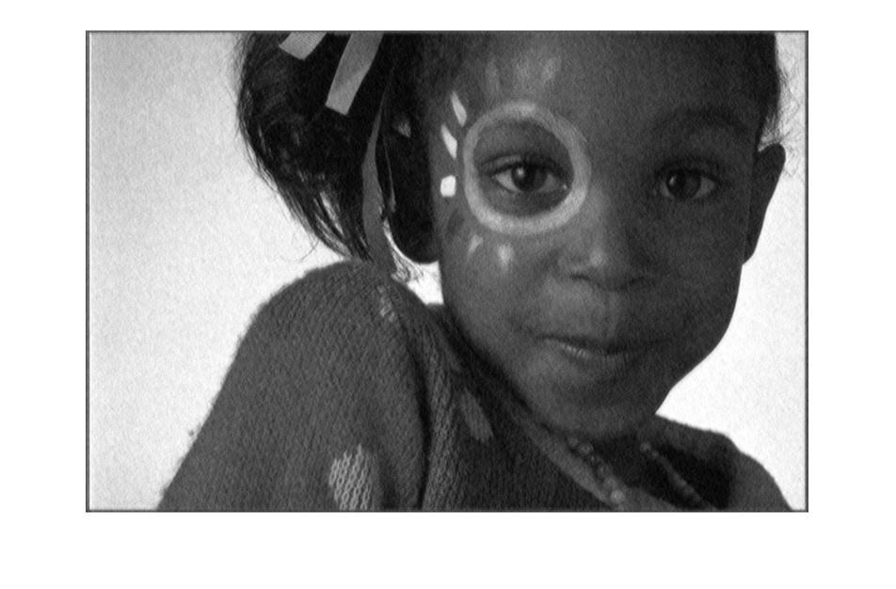

Figure . output from img14gn

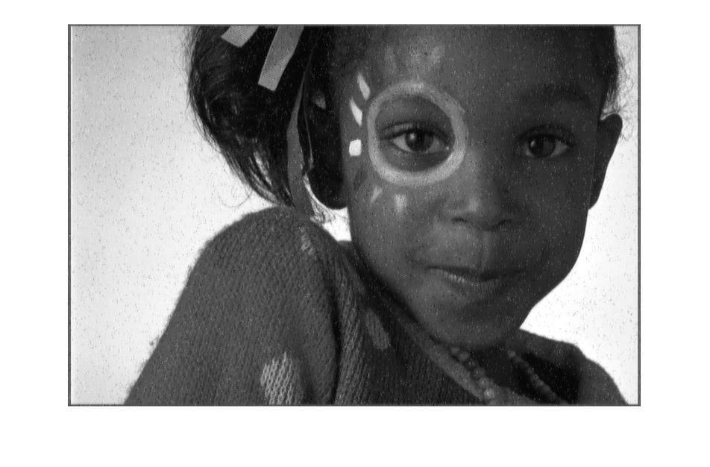

Figure . output from img14sp

3.

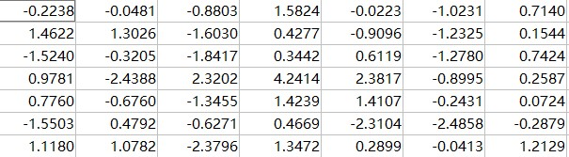

Figure . theta from bl

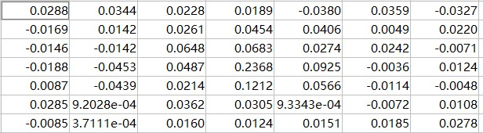

Figure . theta from gn

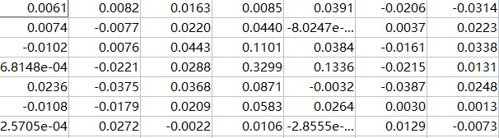

Figure . theta from sp

2 Weighted Median Filtering



Figure . results from gn



Figure . results from sp